

**Computerized Maintenance Management System (CMMS)**

**Project**

**Attachment A1:**

**Functional Requirements**

**September, 2020**

Contents

2 Solution Space 0

2.1 Overview 0

2.2 Key Terms related to CMMS1 0

2.3 Needs Related to Business Objects 1

2.4 Asset Data Analysis 3

3 Requirements 3

3.1 Description 3

3.1.1 General requirements: 3

3.1.2 Assets: 5

3.1.3 GIS Requirements: 7

3.1.4 Work Orders: 8

3.1.5 Condition Scores and Data 10

3.1.6 Photographs (and other attachment files) 10

3.1.7 Planned Maintenance: 11

3.1.8 Safety Measures: 11

3.1.9 Reporting: 11

3.1.10 Administration Oversight: 12

3.1.11 Electronic completions of task checklists: 12

3.1.12 Enforce consistency of data entry: 12

3.1.13 Work Scheduling: 13

3.1.14 Configurable Workflows: 13

3.1.15 Round Sheets: 14

3.1.16 Regulatory Reporting: 15

3.1.17 Data Conversion: 15

3.1.18 General Asset Management Functionality: 15

4 Horizontal Asset Workflows 16

4.1 Investigating a Call from the Public 17

4.1.1 Workflow 17

4.1.2 Description 17

4.1.3 Workflow Entry Point 18

4.1.4 The Required System will: 18

4.2 Leak Repair – Ecologics Logger Detection 19

4.2.1 Workflow 19

4.2.2 Description 20

4.2.3 Workflow Entry Point 20

4.2.4 The Required System will: 20

4.3 Leak Repair – Fluid Conservation Systems (FCS) Leak Detection 21

4.3.1 Workflow 21

4.3.2 Description 22

4.3.3 Workflow Entry Point 22

4.3.4 The Required System will: 22

4.4 Leak Repair – Non-Emergency 23

4.4.1 Workflow 23

4.4.2 Description 24

4.4.3 Workflow Entry Point 24

4.4.4 The Required System will: 24

4.5 Leak Repair –Emergency 25

4.5.1 Workflow 25

4.5.2 Description 26

4.5.3 Workflow Entry Point 26

4.5.4 The Required System will: 26

4.6 Leak Repair – Check Condition 27

4.6.1 Workflow 27

4.6.1 Description 27

4.6.2 Workflow Entry Point 27

4.6.3 The Required System will: 27

4.7 Leak Repair –Potentially Contaminated Soil 28

4.7.1 Workflow 28

4.7.2 Description 29

4.7.3 Workflow Entry Point 29

4.7.4 The Required System will: 29

4.8 Leak Repair –Investigator Identifies Environmental Impact 30

4.8.1 Workflow 30

4.8.2 Description 31

4.8.3 Workflow Entry Point 31

4.8.4 The Required System will: 31

4.9 Main Extension – Site Ready for Extension 32

4.9.1 Workflow 32

4.9.2 Description 32

4.9.3 Workflow Entry Point 32

4.9.4 The Required System will: 32

4.10 Main Extension – Extend Main 33

4.10.1 Workflow 33

4.10.2 Description 33

4.10.3 Workflow Entry Point 34

4.10.4 The Required System will: 34

4.11 Pipeline Replacement 35

4.11.1 Workflow 35

4.11.2 Description 36

4.11.3 Workflow Entry Point 36

4.11.4 The Required System will: 36

4.12 Paving and Concrete after Repair/Replacement of Horizontal Assets 37

4.12.1 Workflow 37

4.12.2 Description 38

4.12.3 Workflow Entry Point 38

4.12.4 The Required System will: 38

4.13 Concrete Surrounding Meter Box 39

4.13.1 Workflow 39

4.13.2 Description 39

4.13.3 Workflow Entry Point 39

4.13.4 The Required System will: 39

4.14 Tracking Shutdowns 39

4.14.1 Description 39

4.14.2 Sample Screenshots 40

4.14.3 The Required System will: 40

4.15 Hydrant Flow Test 42

4.15.1 Description 42

4.15.2 Sample Screen Shots 42

4.15.3 The Required System will: 43

4.16 Proactive Asset Work Orders 44

4.16.1 Description 44

5 Vertical Asset Workflows 45

5.1 Acceptance of New Assets Following Construction Contract (Wastewater) 45

5.2 Entering PM’s, Readings & Rounds, and Daily Logsheet Templates (Wastewater) 46

5.3 Capital Work (Water) 47

5.4 Corrective Maintenance (Water) 48

5.5 Preventative Maintenance which includes a Measureable Asset Characteristic (MAC) (Water) 49

5.6 Predictive Maintenance (Water) 50

6 Reporting 51

6.1 Object Model related to District Assets 51

6.2 Entity Relationships Reporting 52

6.3 Custom Report Generation Tool 52

6.4 Public Records Requests 52

7 Appendix 53

8 Appendix A – Current Horizontal Work Order Creation Screen 53

9 Appendix B – Current Horizontal Work Order Search Screen 56

10 Appendix C – Sample Horizontal Work Order Activity Log 61

11 Appendix D – Horizontal Work Order Situation Status Report 62

12 Appendix E –Employee Leave Report 64

13 Appendix F – Compressed Schedules 66

14 Appendix F – Main Break Report 68

15 Appendix G – ECA Leak Investigation Report 69

16 Appendix H – Daily Check Conditions for Leaks Report 70

17 Appendix I – Main Break Counts by Fiscal Year 71

18 Appendix J – Main Break Counts by Month 72

19 Appendix K – Main Break Counts by Month and Year 73

20 Appendix L – Main Break by Pipe Material, Size, and Year 74

21 Appendix M – Monthly Main Break Report 75

22 Appendix N – Mainline Installation 76

23 Appendix O – Listing of Vertical Assets 80

# Solution Space



## Overview

The above diagram lists the business objects and relationship between these objects needed as part of a CMMS solution (CMMS). The District is looking for a solution which will allow for the lowest cost/most efficient data entry, data modification, and data reporting of these objects.

## Key Terms related to CMMS1

|  |  |
| --- | --- |
| **Term** | **Definition** |
| Asset | Plant, equipment, buildings, property, pipelines, infrastructure and other items that have potential or actual value to the organization. Utility assets are the items that contribute to the production and delivery of the utilities' service to the community or group of customers. While the main focus for Asset Management in the utility industry is around physical assets, assets can also be intangible, such as leases, brands, digital assets, use rights, licenses, intellectual property rights, reputation or agreements. |
| Asset Attribute | A quality or feature that is a characteristic of an Asset, e.g., make, model, serial number, rated capacity, age, length, diameter, material, etc. |
| Asset Class | A logical grouping of Assets from one or more Asset Types that fulfill a similar high-level function and tend to have a common overall Asset Management Strategy. e.g. water mains, pump stations, buildings, fleet. |
| Asset Cohort | A group of Assets within one Asset Type having similar characteristics, such as Useful Life (e.g. cast iron spun pipe, pre-1940 cast iron cast pipe, gate valve, ball valve, pipe of different ANSI values or manufacturer). Assets of the same cohort typically have the same maintenance and renewal plans, even with respect to timing of those activities. |
| Asset Component | A group of Assets within one Asset Type having similar characteristics, such as Useful Life (e.g. cast iron spun pipe, pre-1940 cast iron cast pipe, gate valve, ball valve, pipe of different ANSI values or manufacturer). Assets of the same cohort typically have the same maintenance and renewal plans, even with respect to timing of those activities. |
| Asset Hierarchy | A tiered structure to allow for organized management of Assets and asset data. An Asset Hierarchy typically uses a parent-child relationship. The Asset Hierarchy can be based on asset function or process in which the asset is deployed; Asset Type; asset location; or a combination of these. Grouping by facility is commonly done near the parent level. The lowest child level is typically at the Maintenance Managed Item level. |
| Asset Inventory | A complete list of all physical Assets for which an organization is responsible. |
| Asset Portfolio | A grouping of Assets and facilities for which an organization is responsible that is within the same Asset Management System or program scope. These are typically grouped by major business lines where management authority and funding sources may be separated, e.g. Water Distribution versus Wastewater Collection. |
| Asset Register | A record of asset information, typically held in a spreadsheet, database or software system, including Asset Attribute data (IIMM, 2015)(Modified). Assets may be presented in hierarchy format in the register and are at the Maintenance Managed Item level of detail. This is typically not as comprehensive a list as the Asset Inventory, but contains greater detail on the Assets listed. |
| Asset System | A group of Assets that work together to deliver a required business function or purpose. |
| Asset Type | A group of Assets with similar function or use. This is typically at a more detailed level than Asset Class. e.g. Asset Class = Pump Station, Asset Type = AC Motor. Asset Class = Distribution Water Mains, Asset Type = cast iron pipe. Assets of the same type typically have similar maintenance and renewal plans. |
| Horizontal Asset | Assets which may be configured or networked for the purpose of moving materials or services from one place to another. Also known as linear asset or frequently referred to as below ground asset due to the location of most Horizontal Assets below ground. In the context of the water industry, this includes pipeline assets for water distribution, collection and transmission. |
| Infrastructure | A collection of Assets on which the continuation and growth of a community depends, such as power, roads, wastewater and water plants, and transportation and communication systems. |
| Maintenance Managed Item | An Asset or component that exists generally at the lowest level in the Asset Hierarchy and for which an owner will make management decisions to Repair, rehabilitate, or typically replace instead of running to failure. Non-maintenance managed itemsthat may exist in the Asset Inventory but not the Asset Register may include spare parts, small valves, and other items with low financial value that are Run-To-Failure without any maintenance. |
| Vertical Asset | An Asset within a building and/or facility often comprised of multiple components, also known as an above-ground asset. In the context of the water industry, this typically refers to Assets within pump stations, treatment plants, and may include other facilities, such as storage facilities. |

1 From the AWWA Asset Management Definitions Guidebook: <https://www.awwa.org/Portals/0/AWWA/ETS/Resources/AMGuidebook.pdf?ver=2018-12-13-100101-887>

## Needs Related to Business Objects

|  |  |
| --- | --- |
| **Object** | **Needs** |
| Asset | 1. The ability to record all work done related to the life cycle of an asset:    1. Design    2. Construction    3. Commissioning    4. Operating    5. Maintenance    6. Decommission    7. Disposal 2. An Asset Registry which contains information about the asset and all work performed on it. 3. Assets can be, but aren’t limited to being:    1. Horizontal/linear assets which are part of the District’s water distribution systems (water mains, service laterals, valves, hydrants, etc.)    2. Vertical/fixed assets which above ground assets requiring mechanical and electrical maintenance.    3. Land such as a parcel, road, trail, etc. |
| Location | 1. All assets need to be represented by a GPS/GIS boundaries such as:    1. A line segment for a water main.    2. A point for a valve, hydrant, etc.    3. A polygon for a piece of land.    4. A polygon representing the area of a water treatment plan 2. If an Asset has a specified address, this needs to be captured in the CMMS. |
| Asset Class | 1. Every Asset needs to be associated with an Asset Class 2. The CMMS will provide the ability to configure new Asset Classes without the need of Vendor or District IT resources. |
| Measurable Criteria | 1. Different assets will have different measurements which indicate the operating state of the assets. The CMMS will allow the District to configure different measurement characteristics for each asset class. |
| Asset Measurement | 1. The CMMS needs to store all measurements taken on an asset. 2. The CMMS needs to alert staff when a measurement falls outside of it’s acceptable range. |
| Job/Work Order | 1. A work order can have multiple Work Order Tasks each of which can be performed on a different asset. 2. The CMMS will record all activity related to all work orders. |
| Work Order Task | 1. The CMMS will record all activity related to all task done related to any asset. 2. The CMMS will record time the time it took for a task 3. The CMMS will record whether the work down is Capital Work, Corrective Maintenance, Preventative Maintenance, or Predictive Maintenance. 4. The CMMS will record whether the asset has failed and needs to be replaced. 5. The CMMS will allow staff to specify which Job Procedure (JP) and/or Maintenance plan (MP) needs to be followed on a Work Order task. 6. The CMMS will allow staff to verify that a JP and/or a MP was performed as part of a task. 7. The CMMS will notify staff when Preventative Maintenance is needed based on the maintenance plans established for an Asset Class. |
| Job Procedures | 1. The CMMS will allow the District to easily add job procedures for Asset Classes 2. Any one job procedure could contain text, audio, and/or video. |
| Maintenance Plans | 1. The CMMS will allow the District to easily add maintenance plans for Asset Classes 2. Any one maintenance plan could contain text, audio, and/or video. |
| Activity | 1. The CMMS will record the type of work done on a task: Electrical, Mechanical, etc. 2. The CMMS will allow the District to configure different activities without the need of Vendor or District IT resources. |
| Program/Project | 1. All tasks need to be associated with either a Program or a Project. 2. Programs/Projects can be either Capital or Operating. |
| Material | 1. The CMMS will record the material used for the completion of a task. |
| Equipment | 1. The CMMS will record any equipment used for the completion of a task. |
| Task Artifact | 1. The CMMS will allow for documentation of work completed in the form of:    1. Notes    2. Documents (Word Docs, PDF’s, Spreadsheets, etc.)    3. Video    4. Audio |
| Contractor | 1. The CMMS will record when a contractor completes a task. 2. The CMMS will provide a way to easily schedule and assign Contractors to tasks. |
| Work Authorization | 1. A work authorization can specifies who many hours and Contractor can work and their hourly rate; or a fixed rate. 2. A work authorization is needed before a contractor can perform a task |
| Task Cost Allocation | 1. A contractor may work on multiple tasks as part of its Work Authorization. When this happens the percent of time worked on each task needs to be recorded. |
| Employee | 1. A Work Order Task can be accomplished by one individual. 2. The CMMS will provide a way to easily schedule and assign Employees to tasks. |
| Work Group | 1. A work group is a group of employees assigned collectively to accomplish a task. 2. The CMMS will provide a way to easily schedule and assign Work Groups to tasks. 3. The CMMS will allow away to configure what the work groups are called. E.g. one org might use the term “Shift” and another might use the term “Crew”. |

## Asset Data Analysis

A CMMS that supports the model listed at the beginning of this section will allow the District to answer any question supported by any relationship in the model such as:

1. The number of work orders performed at a location in a specified period of time
2. Assets with frequent CMs
3. The average age of asset failure based on an asset class
4. The amount the District spent on Electrical work for a given asset class at a given location.
5. The number of failures within ### days of a particular job procedure being performed.
6. Job Procedures and Maintenance Plans by asset class
7. Assets which are missing/have no Job Procedures and Maintenance Plans
8. Assets which have a given condition/measurable criteria

# Requirements

## Description

The following requirements have been identified by key workgroups at the District. These are our attempt to add context to how the we envision a CMMS system satisfying our needs. We will rely upon the expertise of the selected vendor and the District Information Systems Department to guide us toward the most efficient solution to satisfy what is implied by these requirements.

### General requirements:

* 1. All actions recorded in this system will require the date, time and employee id to be captured.
     1. All field change history will need to be stored as well.
  2. Users should be able to group actions in the system into classes and then assign permissions to perform those “action classes” to both user groups and individual users.
  3. System should allow the use of Windows, Mac, iOS, and Android devices to allow for access for employees both in the office and in the field.
  4. Be compliant with latest version of HTML (HTML5) and also be scalable to multiple screen sizes.
  5. Provide for the entry/update of information when field users are off-line because network coverage is unavailable, and then to automatically add these entries/updates into the system once network coverage has been reestablished.
  6. Be easy to use and provide a desktop and mobile version. The mobile version should be designed for mobile use. Also, the mobile version should:
     1. Be compatible with District GIS system so both applications can be linked (ex. clicking on an asset in GIS can open the asset management app and vice versa).
     2. Include the ability to scan QR codes, barcodes, and/or RFID’s assigned to assets.
     3. Include a “nearby assets” feature for workgroups that would like this feature.
  7. Provide a dashboard that will allow an At-A-Glance overview, by application, by shop, by individual backlog, etc.
     1. Dashboard should allow for one or more shops to be viewed at one time (for example, Electrical East and Electrical West, or FAC and CMECH)
     2. Dashboard should allow for communication concerning the application, such as “New Features” and “Planned System Outages”, useful links, etc.
     3. Dashboard should provide access to:
        1. User Guides
        2. Quick Start/Reference Guides
        3. Training material including videos
        4. Reports showing standard data, as is found in drop-down lists
        5. FAQs
        6. Glossary
        7. Contact information (for example the Administrators of the system)
        8. Other documents which might be needed in the future.
  8. Provide canned and ad-hoc reporting on all aspects of the system (Assets, work orders, planned maintenance, safety measures, etc.)
     1. Reports should be real time and have the ability to track updates to the data within the reporting time range.
     2. User configurable report(s) should be available to allow reporting on any groups of the dataset.
     3. Users should be able to share reports they create with other users.
  9. Provide easy navigation between aspects of the system without losing the original data (for example, move from assets to work orders and go back to the asset screen you were first looking at – unless it has been refreshed by the user.)
  10. Allow for the creation of new District specific values/attributes once the system has been rolled out:
      1. As the District acquires/builds new assets, allow for new attributes to be captured/created/reported upon which don’t currently exist. And when this happens:
         1. The District would want to configure new attributes without waiting for programming changes.
  11. Provide means to capture attributes associated with work groups (shops), such as:
      1. Asset Class they might typically maintain. This would be used to assist in either providing a list or hierarchy of just the assets they would likely want to track.
      2. List of employees that should receive communications concerning the Shop, such as new work orders created, etc.
      3. Types of work orders that can be created for the shop. Not all shops will have scheduled work (MPs); other shops should never receive Corrective work orders, for example.
      4. Geographic area they typically work in (East, West, Pardee, etc.)
      5. Status of the shop (active or inactive)
      6. Business org for the shop.

### Assets:

* 1. Incorporate and support District’s existing equipment tag numbering system (ESP 130.0 and WESP 130.0)
     1. Provide the means to capture the type of Measureable Asset Characteristics (MAC) associated with an Asset Class.
        1. Any given MAC can be associated with one or more Asset Class.
        2. Any given Asset Class can have zero or many MACs.
     2. Asset Classes are based on ESP 130.0 or WESP 130.0.
  2. Allow for automated/easy entry of assets from a finalized project asset manifest/Equipment Log Spreadsheet.
  3. For every horizontal asset repaired or replaced:
     1. Record the location and depth of the asset
        1. For pipe, this could include recording the location and depth of each joint, appurtenance, valve, etc.
        2. Record the type of repair
     2. Record the pipe properties (e.g.: material type, coating and lining type, size, etc.)
     3. Generate a mapping file so that asset information can be easily entered into the District GIS system.
  4. For every vertical asset newly added, repaired or replaced, record general asset attributes such as (but not restricted to):
     1. ID/Name
     2. Asset type
     3. Asset classification
     4. Asset status
     5. Equipment tag id (if one exists)
     6. Parent
     7. Location
     8. Street address,
     9. Date of Installation
     10. Manufacturer Make and Model
     11. Drawings
     12. Specifications
     13. Capacity
     14. Encroachments
     15. Right-of-Ways
     16. Manufacturer O&M Manual
     17. Asset function (brief optional description of what it does.)
     18. Asset redundancy – with either numbering systems or a separate field, allow means to indicate when multiple assets perform the same function.
     19. Preventative Maintenance Routines
     20. Action
     21. Frequency
     22. Attributes of the specific classification of the asset (such as structure number, pressure zone source, pressure zone served, etc.).
     23. A list of spare parts, including sourcing information, which should always be kept on hand for maintenance and can be associated with multiple assets of the same type in different locations to allow for centralized management.
     24. Provide a way to track common maintenance steps, by shop, to assist with the creation of Job Procedures/Maintenance Plans.
     25. The organization responsible for maintenance of the asset
     26. The organization responsible for the operation of the asset
  5. Provide a way to easily look up and review prior notes on work orders and related work orders to help with trouble shooting and understanding asset history.
  6. Provide easy placement of assets into a hierarchical format such as via drag and drop. And provide:
     1. For alternate views of the hierarchy based on other criteria, such as asset type, asset class, work group, pressure zone, line drawing, functional processes, etc.
     2. Ability to reassign asset to new parent such as when there’s mistake in original hierarchy, or when assets are redeployed.
     3. For grouping of assets into locations or facilities (e.g. by water treatment plant)
  7. Associate electronically stored manuals with assets. This includes manuals stored in the District’s documentation management system (DOCS).
  8. Associate other documents with assets (such as drawings, safety studies [arc flash reports], photos, video, audio, hyperlinks, reports from tests done on assets, etc.)
  9. Record, track, and display readings taken during maintenance and provide reporting and analysis tools.
     1. Provide configuration of valid data ranges and prompt staff if the value entered is out of range of the range specified.
  10. Record, track, and display vendor information and Warranty information, and issue notifications when warranty date is nearing expiration.
  11. Provide flexibility to add additional attributes to assets beyond what might be done when the system is configured
  12. Provide flexibility for end users to create assets and to provide an oversight ability to approve those assets prior to activation or acceptance within the system.
  13. Interface with the District’s FIS system to provide a means by which the actuals costs accrued can be displayed on the asset
      1. The costs from child assets should roll-up to the parent asset.
  14. Provide the ability to clone the asset information (including Job Procedures and Maintenance Plans) of an existing asset to create a new asset, and provide the ability for the District to specify which attributes can be cloned.
  15. Allow for tagging of assets (e.g., RFID) to provide easy look up of assets (e.g., via RFID tag scanning, QR Code/barcode Scanning, etc.)
      1. Allow for tag scanning to be done on mobile devices.
      2. Allow for the creation of work order of an asset by tag scanning
      3. Allow staff to do tag scanning to verify that the correct asset is being worked upon for a work order, and provide the District the ability to specify which work orders require tag scanning.
      4. A scan of a tag should return the following (but allow for the inclusion of additional fields as necessary):
         1. Description of the asset/sub-assets
         2. Available technical information
         3. Cut-sheets
         4. Safety alerts and specific procedures where applicable
         5. Job procedures
         6. Manuals, etc.
         7. Condition status based on last work performed
         8. Active and previous WO information
         9. Supplies, tools and equipment as entered on the job/maintenance plan
  16. Provide trending reports of Expected End of Life of Assets based on measurements of Assets, age of asset, asset condition, etc.
  17. Provide reporting on amount spent to maintain each asset class based on the age of the asset.
      1. Provide a listing of assets that fall outside the standard deviation of this measurement.
  18. Provide a way to look up assets based on facility, type of asset, asset class, functional grouping, unit processes, etc.
      1. The lookup should provide for standard search operations (“AND”,“OR”, “Not”, “>”, etc.) searches on combination of these attributes.

### GIS Requirements:

* 1. Provide data fields for user-uploaded asset geographic coordinates to be used with the District GIS system. Upload can be done manually or through mobile GIS device/phone/computer.
  2. Provide a GIS application that will show and allow District Staff to filter on:
     1. The type of work performed
     2. The date work was performed
     3. Who/which employee, yard, budget unit performed the work
     4. Different types of horizontal assets: Mains (including criticality), valves, hydrants, service laterals, meters, etc.
     5. Customer information (e.g., location, criticality, etc.)
     6. Horizontal assets which are in the District GIS system.
     7. Horizontal assets which are in the solution but have not yet been entered into the District GIS system.
        1. This would be needed in case work was needed on a newly installed asset which had not yet be updated in the District GIS system.
     8. Steps in workflows which are approaching and have exceeded the specified KPI for the step
     9. Steps in the workflows which are approaching the expiration date of a USA Marking or permit.
  3. Provide a GIS application that will allow District Staff to:
     1. View and search for all district facilities or assets (Bay Area, Aqueducts and Up-Country)
        1. Generate work orders and View outstanding work orders at any given facility, asset or shop(s).
        2. Provide driving directions based on location of the asset.
        3. Provide facility specific information
        4. Provide links to stored documents in District DOCs application
        5. Easily identify assets with identified safety hazards (based on the asset itself or the environment surrounding the asset).
        6. Easily identify which assets are close to the staff. I.e. “find assets close to me”.
        7. Generate maps with markups showing user selected information and assets.
        8. Where many assets are located at one location so that drill down is not possible to isolate an attribute, provide an alternative to GIS to easily select a , provide a way to easily select a facility, asset, or shop.
  4. Provide for various layers to be switched on and off or piled one on another.
     1. Provide Filters to restrict information to specified shops
  5. Provide flexibility to expand GIS application based on new technologies and requirements
  6. Allow a user to draw a polygon around a section of the map and allow for drill down of all assets in the area selected.
  7. Store District fence segments, trail bridges, underground pipes at facilities, interceptors, force mains, etc. so that they can be easily seen and so that Work Orders for these can be created.
  8. Provide a way to propagate changes from a Parent asset down to its children, when requested (but not to be done automatically.) Such changes could include:
     1. Asset Status
     2. Notifications (i.e. email addresses)
     3. Linked documents
     4. Diagrams

### Work Orders:

* 1. Provide an easy way to associate assets(s) which need to be worked on as part of the work order.
  2. Allow the District to configure and staff to enter a work order type (corrective maintenance, preventative maintenance, Operations, Safety/Regulatory, etc.)
  3. Any work order created for an asset that is still under warranty, needs to have such notification on the work order.
     1. This notification is needed if any component of the asset is still under warranty.
  4. Provide data validation for entries in the Work Order
  5. Any work order created for an asset that has a safety hazard, needs to have such notification on the work order.
  6. Interface with the District FIS system so that work order can record the costs incurred in the completion of the work such as labor, equipment usage, and materials.
  7. Allow for the tracking of the work order life-cycle through the use of statuses.
  8. Allow the initiator of the work order to indicate operational priority ( E.g. “When convenient”, “As soon as possible”, “Emergency”, etc.)
  9. Allow for the prioritizing a work order based on the type of a work order. E.g. one type might have a priority scale of 1 to 5, others might be 1 to 10.
     1. Allow for the configuration of a description of what each value on each scale means.
  10. Allow for prioritizing a work order based on the product of “likelihood of failure score” and “criticality score”. E.g. if the likelihood of failure range is 1 to 10 and the criticality range is 1 to 8, the priority range will be 1 to 80.
      1. To support this, the system will need the ability to store for each asset, a criticality score.
      2. Allow for prioritization of work orders based on other factors such as regulatory, safety, audit results, community impact etc.
      3. Allow for work order queries to be sorted by priority order
  11. For whichever prioritization method used by an org, provide a way to specifies which priorities need to be tracked as part of a KPI and what the priority maps to. E.g.:
      1. A business unit might track priorities 1-10, but the District might have a KPI related to “High” priority work orders. The business unit would need the ability to specify that priorities 9 and 10 are “High” priority items related to a District KPI.
  12. Allow for the possibility of multiple shops on a single work order (this requirement should be discussed with the various shop supervisors.)
  13. Allow for the configuration on which types of work orders can be re-opened.
  14. Allow for the assignment of work order to specific crew members.
  15. Allow for the Cloning of work orders.
  16. Allow for the creation of Follow-Up work orders.
  17. Allow for the association of work orders to other work orders such as situations where.
      1. Multiple sub work orders need to be completed for different individuals to work on.
      2. A follow up work order might be needed after work is completed.
  18. Allow for tracking of “Problems” and “Causes” for work requested/completed, and allow the District to configure when entry of this information is required.
  19. Allow for recording of measurements on any asset(s) or their parent/children asset(s) within the asset’s full lineage
  20. Provide the ability for the District to configure which types of work orders can contain work for multiple assets.
  21. Provide the ability for the District to specify which types of work order will display a KPI for completion time which can be set based on Hours, Calendar Days, and Business Days. (verify if KPI needs to be down to the hours and if it should be business or calendar days)
      1. This will require the solution to track District Holidays.
      2. Provide for the recalculation of KPI based on change of status/start date
  22. Staff needs to record time spent (labor and/or equipment hours)
      1. The recording of “Time Spent” should be in one place and be viewable in both the District Electronic Timesheet System and the work management system. District staff will not record time spent in both the work management system and on their timesheets.
      2. If Non-District forces are used for the completion of the work order, their time and costs needs to be recorded on the work order.
  23. Staff needs to record material/equipment used
      1. The solution will integrate with the new District Warehouse and Procurement system.
         1. Provide active bin monitoring associated with areas and assets displayed on work orders
         2. Provide usage history and tracking
         3. Provide a way for automatic reordering with and without approvals
         4. Produce a revision count report to cross check fiscal bin count to system count.
         5. The solution will integrate with District system equipment usage tracking application.
      2. For business units which have not yet switched to the new District Warehouse and Procurement system, provide the following functionality in the system (i.e. without interfacing with another system):
         1. Provide active bin monitoring associated with areas and assets displayed on work orders
         2. Provide usage history and tracking
         3. Provide a way for automatic reordering with and without approvals
         4. Produce a revision count report to cross check fiscal bin count to system count.
         5. The solution will integrate with District system equipment usage tracking application.
      3. Provide a means for the shops to reconcile Purchasing and P-card usage to the work order.
      4. Ability to create Purchase Orders from inside of the work management system.
      5. Ability to check that the PR and PO matches when the work order is compete and if it is, then automatically closes the work order, provided other required information has been entered (i.e. Labor hours)
  24. Provide a means to notify the warehouse of materials needed for a work order.
  25. Allow organizations to configure whether:
      1. To allow the ability to do Mass Update/Close/Cancellation of work orders.
         1. And at what stage in a workflow these actions can happen.
      2. Staff needs to explicitly record when work completed
      3. Staff needs to explicitly record travel time.
      4. Staff needs to store electronic photographs, audio, and/or video and associate it with both the asset and the work order and inventory
  26. The ability for staff to enter notes
      1. Provide a generic note (including time and employee) for when explicit notes are not required.
         1. The system shall provide spellchecking and the District configure the length of a note based on the type of work order.
         2. All text entered as part of a note shall be searchable.
         3. Once notes have been entered and saved, notes are not updateable.
  27. Staff needs to enter a project id or have one defaulted in from other documents (such as Maintenance Plan)
      1. Allow the District to specify which types of work orders can be updated/closed even after the project id has been inactivated.
  28. If the new District Financial System supports it, allow staff to enter an Activity Id when needed
  29. Provide the means to do Notifications (e.g.: when work orders are created, etc.):
      1. Provide options on how notifications are sent: UI, email, and/or text.
      2. Staff needs to establish/maintain who/which workgroup should receive the notification
  30. Allow for the entry of the reason for the failure of an asset.
  31. Calculate and record the uptime of an asset by the percent of hours in a year the asset is up and running.
      1. Report on those assets which fall outside of the standard deviation of uptime for a particular asset class.
  32. For work orders that require multiple trades, allow for the configuration of whether one work order managed by a primary business unit and create sub work orders for different business units.
  33. Allow for the configuration by based on business unit and work order type of whether users should be able to modify or cancel a work order once it is issued and indicate the reasons why it was modified or canceled, such as change in equipment status.
  34. Allow for integration of Safe Work Permit requirements to be specified in Work Order by the initiator of the work order.

### Condition Scores and Data

* 1. Allow assignment of condition score for each asset based on editable pull-down menu. Drop-down menu must be editable and may be custom to different asset types.
  2. Provide the ability to make recording condition scores mandatory before a work order may be closed based on business unit, asset class, and type of work order.
  3. Allow field for person who assigned condition and date assigned.
  4. Allow field for notes on condition.
  5. Retain past condition scores and notes so that chronology may be viewed.
  6. Reporting on all of the above
  7. Allow retention of condition assessment information such as pump tests, vibration analysis, or oil analysis. These may be in the form of attached documents that can be stored chronologically, similar to requirements described in the Photographs section. Software should allow attachment of these records and a way to note that they exist for a given asset.

### Photographs (and other attachment files)

* 1. Allow quick upload of photos and association with assets and work orders.
  2. Allow photo to be associated with multiple assets and work orders.
  3. Allow multiple photos for individual assets and work orders
  4. Date photos for chronological viewing
  5. Allow for other file types (such as documents, excel files, and scans to be uploaded and associated easily with assets.)
  6. Capture metadata on photos such as labels, notes, location, etc.
  7. Allow attachments to be stored in an external document management system

### Planned Maintenance:

* 1. Allow District Staff to create maintenance and job plans, and steps to a workflow process and associate them with assets.
     1. Maintenance plan information shall include frequency and ancillary information such as estimated time, craft(s), work order priority, etc.
     2. Allow for the creation for templates for asset Maintenance Plans and Job Procedures to make the creation of the actual plans more efficient.
     3. Allow Maintenance Plans to have several JPs that are sequenced. For example, one JP would create a monthly work order, another JP would create a quarterly work order, another JP would create an annual work order.
        1. Allow the ability to skip a monthly and/or quarterly JP when a quarterly and/or yearly JP covers all the procedures of the monthly and/or quarterly JP.
  2. Include the ability to record and analyze measurements, i.e.: voltage, resistance, humidity and provide the District to specify which tests need to be performed on which assets for different types of work orders.
  3. Include the ability to bring in measurements from the District SCADA systems.
     1. The following measurements on Asset from the Wastewater business unit should include:
        1. Run time
        2. Flow
        3. Pressure
        4. Voltage
        5. Temperature
  4. Allow planned maintenance to be pre-assigned to Crews.
  5. For forecasting and scheduling, allow estimated hours and anticipated job class for planned maintenance
  6. Provide means by which planned work orders can be generated.
  7. Ability to automatically/easily generate a WO based on conditions
  8. Allow the system to identify or generate work orders based on data measurements such as Engine run time, Time since last oil change, etc.
  9. Maintenance plans and job plans should have bulk upload/download capabilities with other software packages such as Word or Excel.
  10. Planned maintenance should be scheduled and generated automatically based on user configurable settings.

### Safety Measures:

* 1. Provide means to track required safety steps to ensure the safety of personnel and equipment/facilities.
  2. Provide the option to store and display safety/lock out/tag out procedures.

### Reporting:

* 1. Provide KPI and exception reports.
  2. Provide an emergency call out report.
  3. Provide District staff with the means to create (and replicate), save, and share with other staff ad-hoc reports and queries.
  4. Provide ability to use excel in conjunction with reports/queries.
  5. Provide the ability to export reports into an Excel format
  6. Typical reports should include:
     1. Production reports (including the monthly performance tracking reports) .
     2. Backlog reports.
     3. KPI reports (user should be able to set and adjust KPI thresholds.
     4. User configurable reports.
  7. All reports should be real time and have the ability to reflect any adjustments or changes to the data set within the reporting period since the last report run.
  8. Ad hoc reports and queries should be able to be saved. The parameters and results should be shareable with others.
  9. All data should be available for nightly extraction to the District’s data warehouse.

### Administration Oversight:

* 1. Provide means by which the integrity of data being entered can be verified and if necessary, updated by Administrator(s) of the system.
     1. Provide means by which “orphan” records can be updated. Such orphan records could include:
        1. Links to manuals/photos that have been removed
        2. Retired or separated employees still assigned on active Maintenance Plans and/or work orders.
        3. Provide an easy way of identifying active Assets with Inactive Parents
  2. Allow for the configuration on which District staff can:
     1. Create job plans.
     2. Create maintenance plans.
     3. Finalize the attachment of job plans to assets.
     4. Finalize the attachment of maintenance plans to assets.
     5. Create, edit, and/or view different types of work orders.
     6. Create/update assets.
     7. The system shall interface with the District Employee Information system so that permissions can be set based on a named staff or a job position.
     8. The system shall provide an approval process to be done by the Administrators of the system prior to any of the above mentioned updates (done by non-Administrators) are activated.

### Electronic completions of task checklists:

* 1. User in the field should be able to view and complete checklists (job plan steps) electronically with minimal or no typing involved.
  2. If unable to complete particular step(s), then the WO cannot be closed, unless each non-completed step has been identified as to why it was not completed.
     1. Based on the reason for the non-completion of a step, a follow-up WO would automatically generate with notification to supervisor who would have the authority to close the work order.

### Enforce consistency of data entry:

* 1. User Interface should allow staff to view and complete checklists (job plan steps) electronically with minimal or no typing involved, whether in the Field or at a desk (e.g. input masks, drop-down lists, combo-boxes, etc. serve to reduce the need for typing and to ensure consistent data entry).

### Work Scheduling:

* 1. Allow the District staff to easily:
     1. Find new corrective maintenance work that needs to be scheduled.
     2. See what staff is working on which assets and where staff is currently located.
     3. See how many work orders are assigned to staff
     4. See work which has not been scheduled
  2. Schedule maintenance staff to work on work orders
  3. Provide a scheduling algorithm which:
     1. Allows for optimal assignment of staff to work orders based on:
        1. Location of staff
        2. Skill set of staff
        3. Availability of staff:
           1. Current workload of staff in a work unit
           2. Number of staff in a work unit
           3. The days and hours when staff is available(includes leave, compressed workweek schedules, etc.)
           4. The hours staff on call
           5. When staff is on vacation
           6. When staff calls in sick
           7. Interface with the District’s timesheet and HR systems so that leave (vacation, sick, etc.) and scheduled hours don’t need to be entered in two systems.
        4. Priority of work
        5. Time remaining to achieve KPI’s:
           1. Many KPI’s are based on a number of business days so the system will need to import the District’s calendar which specifies which days in a year are business days.
     2. Efficiently reshuffles work assignment when an emergency repair interrupts scheduled work.
     3. Schedules Preventative Maintenance work automatically for each asset based on its preventative maintenance schedule.
     4. Allow grouping of generated PM’s into routes based on geographic location.
  4. Where scheduling can’t be accomplished via the system scheduling algorithm allow District supervisors to:
     1. Develop a baseline work calendar that is tailored to each work unit’s specific staff and work schedules
     2. Allow easily assign work on the calendar (such as via drag and drop). And when work is assigned, the system should update and display:
        1. The total hours of work orders assigned in the work unit
        2. The total hours of work orders available to be assigned in the work unit
        3. The total hours assigned to each staff member
        4. The total hours available to be assigned to each staff member.

### Configurable Workflows:

* 1. Allow the District to specify for each step in all workflows:
     1. A KPI for completion time which can be set based on Hours, Calendar Days, and Business Days.
        1. This will require the solution to track District Holidays.
     2. Whether staff needs to record time spent
        1. The solution will integrate with the District Electronic Timesheet System (ETS) so that duplicate entry is not needed in the Solution and ETS
        2. Allow for reporting of labor charged to capital projects to project manager.
     3. Whether staff needs to record material used
     4. Whether staff needs to record equipment used
     5. Whether staff needs to explicitly record the following, for those that do need to be recorded, the system will add these time entries by integrating with ETS:
        1. Travel Time to a location
        2. Work start time
        3. Work completed time
     6. Whether staff needs to explicitly record when work is completed
     7. Whether staff needs to explicitly record travel time
     8. Whether staff needs to document actions taken with a photograph or video
     9. Whether staff needs to enter notes
        1. And when notes are needed, provide the ability to create templates for notes.
     10. Allow the District’s New Business Office (NBO) to record that plans have been finalized.
     11. Concerning project ids:
         1. Determine whether the project is needed.
            1. Provide a means to have a default project id
         2. Whether a staff needs to enter an Activity Id (an Id that specifies the type of work being done)
         3. Whether the project id can be different for the steps or can be allowed for the entire work order.
         4. Whether the project id from the previous steps carries forward to the new step
         5. Whether the project id can be changed at different steps
     12. Whether notifications are required (e.g.: a notification being sent to a yard when an investigator finds an emergency mainbreak) as well as:
         1. How required notifications are sent: UI, email, and/or text.
         2. Who/which workgroup should receive the notification
     13. Which types of permits (USA Marking, City Permits) are required for the permits:
         1. Who is responsible for creating/updating them.
         2. And when required, allow permit information to be visible to staff.
     14. User Interface such as User in the field should be able to view and complete checklists (job plan steps) electronically with minimal or no typing involved.
     15. The next step(s) in a workflow and who should accomplish the next step(s).
  2. Allow District Staff to easily add new steps to a workflow process. E.g.
     1. In the future, the District might want staff to take measurements on specified materials when repairing a main break for a period of 6 months.

### Round Sheets:

* 1. Provide the ability to create round sheet templates for different assets.
  2. Provide the ability to configure which measurements/recordings are required for a particular asset.
  3. Provide the ability to log observations and attach photos along with pre-configured measurements/recordings
  4. Allow staff to enter information in a mobile device while performing a round (as requested above, the entry of information should work if there is no network connection).
  5. Associate measurement/recordings with the appropriate asset
  6. Allow for the configuration of when a particular measurement/recording requires action:
     1. This could be the automatic generation of an corrective maintenance work order
     2. This could also be sending a notification to an individual, distribution list, etc.
  7. Allow for tracking of activities that aren’t related to specific assets tracked by the District (e.g. function checks on emergency showers, fire extinguisher checks, etc.)

### Regulatory Reporting:

* 1. Provide the ability to specify which work orders and asset measurements need to be reported per regulatory requirements.
  2. Provide for a reporting tool that would allow for District staff to generate reports related to these requirements.
     1. Provide for pre-defined (state issued) reports and ad-hoc reporting as the need arises.
  3. Record, track, and display regulatory permits for systems and equipment and their expiration/renewal dates to be linked to the system, and issue notifications when permits are nearing expiration/the need for renewal.

### Data Conversion:

* 1. Import information from the District’s existing asset management/workflow system so that reporting on historic trends and work orders can be done in the new system.

### General Asset Management Functionality:

As part of the RFP process, vendors will be asked to describe how their solution handles the following Asset Management functionality:

* 1. Allowing computation of risk based on consequence of failure (asset criticality) and likelihood of failure, which may be calculated based on a combination of condition, asset type, installation year, work order priority, other.
     1. Allowing flexibility to add to the calculation based on function, location, or other criteria.
     2. Allowing weighting of this calculation by cost.
     3. Allowing roll-up of this calculation by location.
  2. Determining/estimating current replacement costs of key assets
  3. Determining/estimating current rehabilitation costs of key assets
  4. Estimating residual life to replacement/rehabilitation (time to failure)
  5. A replacement/rehabilitation program which includes cash flow requirements
  6. Failure mode analysis of key assets

# Horizontal Asset Workflows

This section describes the main horizontal workflows which the system will need to support. Many of these workflows mention District crews being deployed as part of work orders.

It is also possible that District hired contractors might do some of this work. And when this happens, contractors will need to have access to the system. And the system would need the ability to configure/limit what information and actions contractors have access to

## Investigating a Call from the Public

### Workflow



### Description

The District provides a toll-free phone number which anyone can call to report a water emergency. The District’s Dispatch center fields these calls and if warranted, will send an investigator to the location. If repairs are needed, the District’s yards will perform the repairs.

### Workflow Entry Point

A member of the public notices a potential main break and calls EBMUD to report.

### The Required System will:

1. Allow a Dispatcher to easily see investigation and repair orders in a given area.
2. Allow a Dispatcher to enter notes that can be seen by the investigator going to the potential main break.
3. Allow a Dispatcher to give a rating indicator of the perceived severity based on the call received.
4. Automatically assign an Investigator based on the geographic area the Investigator is covering
5. Notify an Investigator via the solution user interface UI, UI alert and e-mail/text that a new investigation request has been assigned.
6. Allow an Investigator to acknowledge receipt by either:
   1. Updating a screen in the solution
   2. Giving a short reply to the e-mail or text received
7. Allow an Investigator to specify the time they arrived on site by either:
   1. Updating a screen in the solution
   2. Giving a short reply to the e-mail or text received
8. Allow an Investigator to specify:
   1. Whether a Repair is required
   2. Whether the investigator was able to resolve on site with no further work
   3. The flow of the leak so that water loss can be determined and tracked
   4. Whether a USA marking is required and if yes, the location of the marking
   5. Which horizontal devices where turned off/taken out of service (e.g.: Valves, Hydrants, Water Meters, etc.) and when they were turned off.
   6. Specify a severity rating as a KPI for repair time is based on this
   7. In the case of a potential environmental impact (e.g.: creek crossing, contaminated soil), allow an investigator to specify:
      1. BMP’s were deployed
      2. Enter notes/photos/videos related to the deployment of BMP’s.
   8. Enter notes, photos, and videos related to the investigation
   9. Specify when the investigation was complete
   10. Specify whether the repairs required are to a meter
9. Integrate with the District’s timesheet application (ETS) so that investigators only need to enter time in one system.
10. Make a web service call to the District’s Billing System (CW) to create a Meter Repair order in that system so that Dispatchers don’t need to create these manually.
11. Allow a Dispatcher to specify:
    1. The USA ticket number created and the time repairs can start
    2. That the fire department was notified if a Hydrant was taken out of service
12. Notify the appropriate District Yard through solution UI, e-mail, and text of a required repair.
13. Make information about disruption of services available to staff throughout the District (see section 16 “Shutdown Details” below).
14. Provide the ability to easily notify customers via text and e-mail when water is unavailable at their premises.

## Leak Repair – Ecologics Logger Detection

### Workflow



### Description

The District deploys Ecologics loggers to help it detect water main leaks. When a possible leak is detected, an investigator needs to be dispatched to the site.

### Workflow Entry Point

Loggers indicate a potential leak.

### The Required System will:

1. Receive notifications from the Logger System of a possible leak.
2. Automatically assign an Investigator based the geographic area the Investigator is covering
3. Notify an Investigator via the solution user interface UI, UI alert and e-mail/text that a new investigation request has been assigned.
4. Allow the investigator to do the following and to update ETS with the times it took to do the following:
   1. Allow an Investigator to acknowledge receipt by either:
      1. Updating a screen in the solution
      2. Giving a short reply to the e-mail or text received
   2. Allow an Investigator to specify the time they arrived on site by either:
      1. Updating a screen in the solution
      2. Giving a short reply to the e-mail or text received
   3. Allow an Investigator to specify:
      1. Whether a Repair is required
      2. Whether a USA marking is require and if yes, the location of the marking
      3. Which horizontal devices where turned off/taken out of service (e.g.: Valves, Hydrants, Water Meters, etc.) and when they were turned off.
      4. Specify a severity rating as this is need for a District KPI
      5. In the case of a potential environmental impact, allow an investigator to specify:
         1. BMP’s were deployed
         2. Enter notes and photos related to the deployment of BMP’s.
      6. Enter notes, photos, and videos related to the investigation
      7. Specify the time the investigation was complete
      8. Specify whether the repairs required are to a meter
5. Integrate with the District’s timesheet application (ETS) so that investigators only need to enter time in one system.
6. Make a web service call to the District’s Billing System to create a Meter Repair order in that system so that Dispatchers don’t need to create these manually.
7. Allow a Dispatcher to specify:
   1. The USA ticket number created and the time repairs can start
   2. That the fire department was notified if a Hydrant was taken out of service
8. Notify the appropriate District Yard through solution UI, e-mail, and text of a required repair.

## Leak Repair – Fluid Conservation Systems (FCS) Leak Detection

### Workflow



### Description

The District also uses Fluid Conservation Systems (FCS) as a tool to help it identify leaks. Leak Detection Plumbers use this software to determine if there is a leak.

### Workflow Entry Point

Leak Detection Plumbers monitor the software and identify a solution.

### The Required System will:

1. Allow a Leak Detection Plumber to specify that a leak needs to be repaired by the Yards.
2. Allow the Yards to easily find new non-emergency leak repairs which haven’t been scheduled.
3. Allow the Yards to easily see all work that is scheduled by all crews.
4. Allow the Yards to easily schedule a crew to repair the leak based on priority, distance, time to achieve KPI, etc.
5. Allow the Yards to specify:
   1. The USA ticket number created and the time repairs can start
6. Allow the Dispatch Center to specify:
   1. That the fire department was notified if a Hydrant will be taken out of service
7. Record when there is a shutdown of water service and for each shutdown:
   1. When the shutdown began
   2. When the shutdown ended
   3. The number of customers affected

(The above is currently entered in the Districts Shutdown Tracking System and in Sedaru)

1. Record the following and create a time entry in ETS:
   1. When a crew arrived on site
   2. Any horizontal assets taken out of service such as hydrants/valves/etc.
   3. When a line was flushed and:
      1. The location where it was flushed
      2. The length of time of time and PSI to determine water loss related to flushing the line.
      3. Whether a sample was taken.
   4. Record when the repair was completed and service restored.
2. In the case of a potential environmental impact, allow the Yards to specify:
   1. BMP’s were deployed
   2. Enter notes and photos related to the deployment of BMP’s.
3. Allow a crew to:
   1. Enter notes, photos, and videos related to the investigation
   2. Enter hours spent on the repair
   3. Enter materials and equipment used for the repair
4. Integrate with the District’s timesheet application (ETS) so that investigators only need to enter time in one system.

## Leak Repair – Non-Emergency

### Workflow



### Description

When an investigator specifies that a Leak Repair is a Non-Emergency, work is scheduled based on priority, distance, time to achieve a KPI, etc.

### Workflow Entry Point

An investigator has been dispatched to investigate a possible main break.

### The Required System will:

1. Allow the Yards to easily find new non-emergency leak repairs which haven’t been scheduled.
2. Allow the Yards to easily see all work that is scheduled by all crews.
3. Allow the Yards to easily schedule a crew to repair the leak based on priority, distance, time to achieve KPI, etc.
4. Allow the Yards to specify:
   1. The USA ticket number created and the time repairs can start
5. Allow the Dispatch Center to specify:
   1. That the fire department was notified if a Hydrant will be taken out of service
6. Record when there is a shutdown of water service and for each shutdown:
   1. When the shutdown began
   2. When the shutdown ended
   3. The number of customers affected

(The above is currently entered in the Districts Shutdown Tracking System and in Sedaru)

1. Record the following and create a time entry in ETS:
   1. When a crew arrived on site
   2. Any horizontal assets taken out of service such as hydrants/valves/etc.
   3. When a line was flushed and:
      1. The location where it was flushed
      2. The length of time of time and PSI to determine water loss related to flushing the line.
      3. Whether a sample was taken.
   4. Record when the repair was completed and service restored.
2. Allow a crew to:
   1. Enter notes, photos, and videos related to the investigation
   2. Enter hours spent on the repair
   3. Enter materials and equipment used for the repair
3. Integrate with the District’s timesheet application (ETS) so that investigators only need to enter time in one system.

## Leak Repair –Emergency

### Workflow



### Description

When an investigator specifies that a Leak Repair is an Emergency, a crew needs to be assigned immediately.

### Workflow Entry Point

An investigator who has been dispatched to investigate a leak determines that the leak requires an emergency repair.

### The Required System will:

1. Allow an Investigator to notify the yards that an emergency repair is needed.
2. Allow Yards to easily see all work that is scheduled by all crews so the most appropriate crew can be selected.
3. Allow the Yards to dispatch a crew to the site.
4. Allow the Yards to easily update the schedule of a non-emergency repair that will need to be delayed due to a crew needing to fix an emergency leak.
5. Allow the Yards to specify:
   1. The USA ticket number created and the time repairs can start
6. Allow the Dispatch Center to specify:
   1. That the fire department was notified if a Hydrant will be taken out of service
7. Record when there is a shutdown of water service and for each shutdown:
   1. When the shutdown began
   2. When the shutdown ended
   3. The number of customers affected

(The above is currently entered in the Districts Shutdown Tracking System and in Sedaru)

1. Record the following and create a time entry in ETS:
   1. When a crew arrived on site
   2. Any horizontal assets taken out of service such as hydrants/valves/etc.
   3. When a line was flushed and:
      1. The location where it was flushed
      2. The length of time of time and PSI to determine water loss related to flushing the line.
      3. Whether a sample was taken.
   4. Record when the repair was completed and service restored.
2. Allow a crew to:
   1. Enter notes, photos, and videos related to the investigation
   2. Enter hours spent on the repair
   3. Enter materials and equipment used for the repair
3. Integrate with the District’s timesheet application (ETS) so that investigators only need to enter time in one system.

## Leak Repair – Check Condition

### Workflow



### Description

The District monitors leaks which have been marked as needing to be repair in seven business days (a Priority 4 leak) on a daily basis. If the condition significantly worsens, then the leak repair is escalated to an emergency repair.

### Workflow Entry Point

An investigator has marked a leak as needing to be repaired in seven business days.

### The Required System will:

1. Create a daily Check Condition task for an investigator to check on the status of a Priority 4 leak.
   1. The assignment will be based on which investigators are covering areas on days the Check Condition is needed.
2. Remove any daily Check Conditions once a repair has been made.
3. Allow an investigator to easily see what Check Condition tasks need to be completed in a day and where they are.
4. Allow an Investigator to:
   1. Specify when they arrive on site for a Check Condition task.
   2. Specify when they have completed a daily Check Condition task.
   3. Enter notes, photos, and videos related to the Check Condition task.
   4. Notify the yards that an emergency repair is needed.

## Leak Repair –Potentially Contaminated Soil

### Workflow



### Description

If a crew notices a potential unsafe working environment such as possible soil contamination, the will potentially need to be remediated by a Remediation firm contracted with by the District.

### Workflow Entry Point

Repair Crews begin work of repairing a mainbreak.

### The Required System will:

1. Allow a crew to enter notes, photos, and videos of a potentially unsafe working condition.
2. Notify the District Regulatory Compliance Office (RCO) through solution UI, e-mail, and text of a possible issue.
3. Allow RCO to dispatch District Staff to the site.
4. Allow RCO to enter notes, photos, and videos related to the site.
5. Record whether there is no unsafe condition, a possible unsafe condition, an unsafe condition.
6. Allow RCO to indicate whether site can be secured.
7. Allow a crew to specify:
   1. A site was secured
   2. Enter notes, photos, and videos related to securing the site.
8. Allow RCO to indicate that a Remediation Contractor is needed to secure the site.
9. Allow RCO to indicate that the Remediation Contractor has secured the site.
10. Allow RCO to indicate that Remediation work has begun.
11. Allow RCO to indicate that Remediation work has finished.
12. Allow RCO to attach any documentation related to the Remediation
13. Notify the crew assigned to the leak repair through solution UI, e-mail, and text the site has been remediated.

## Leak Repair –Investigator Identifies Environmental Impact

### Workflow



### Description

If there is a leak which can have a potential environmental impact, the District needs to deploy Best Management Practices (BMP’s) to minimize any impact.

### Workflow Entry Point

An investigator has been dispatched to investigate a potential leak and the investigator finds a leak with a potential environmental hazard.

### The Required System will:

1. Record when a crew arrived on site
2. Allow a crew to update BMP’s as needed and when they are updated, allow the yard to enter notes, photos, and videos related to the deployment of BMP’s:
3. Record any horizontal assets taken out of service such as hydrants/valves/etc.
4. Record that a line was flushed
5. Record when the repair was completed and service restored.
6. Notify the District RCO through solution UI, e-mail, and text of a possible issue.
7. Allow RCO to easily find all leaks which have a potential for Environmental Impact.
8. Allow RCO to dispatch District Staff to the site.
9. Allow RCO to enter notes, photos, and videos related to the site.

## Main Extension – Site Ready for Extension

### Workflow



### Description

A land developer can pay the District to extend a main to deliver water to a new development. The first step is to make sure the site is ready for installation.

### Workflow Entry Point

Plans to add more water connections have been finalized.

### The Required System will:

1. Integrate with the District’s Infrastructure Project Tracker (IPT) to allow RCO to easily see which Main Extensions require a site review.
2. Allow RCO to dispatch District Staff to the site.
3. Allow RCO to enter notes, photos, and videos related to the site.
4. Allow RCO to record whether or not remediation is needed.
5. Allow RCO to record if and when remediation was completed.
6. Allow NBO to add a USA Ticket

## Main Extension – Extend Main

### Workflow



### Description

Once the site is prepared for installation, the main is extended, then laterals are installed, and lastly meters are set. Once set, the meter is ready to record use for the first customer receiving water through the meter.

### Workflow Entry Point

The site where new connections are to be installed is ready for main extension/new connections to be installed.

### The Required System will:

1. Allow NBO to let the Yards know that a site is ready to have a main extended.
2. Integrate with the District’s Infrastructure Project Tracker (IPT) and notify the construction division that a main extension has been assigned to the yard and:
   1. Send it copies of the design drawings
   2. Setup up a site visit for a construction division investigator
3. Allow either a Construction Division Inspector or the Yards to specify when material was ordered and when it is ready for delivery
4. Import a GIS mapping file so the District staff will be able to update on completion the as-built version.
5. Allow the Yards to easily see all work that is scheduled by all crews.
6. Allow the Yards to easily schedule extending a main based on priority, distance, time to achieve KPI, etc.
7. Allow the Yards to specify the USA ticket number created and the time repairs can start
8. Record when a crew arrived on site
9. Record all horizontal assets installed (pipe/hydrants/valves/etc.)
10. Record when crew work completed.
11. Integrate with the District’s New Business Application to let the Yards know when laterals can be installed.
12. Allow the Yards to easily see all work that is scheduled by all crews.
13. Allow the Yards to easily schedule a crew to install service laterals based on priority, distance, time to achieve KPI, etc.
14. Allow the Yards to specify the USA ticket number created and the time repairs can start
15. Record when a crew arrived on site
16. Record all service laterals installed.
17. Record when service laterals are installed.
18. Notify NBO when laterals are installed.
19. Allow the NBO to let the Yards know when meters can be set.
20. Allow the Yards to easily see all work that is scheduled by all crews.
21. Allow the Yards to easily schedule a crew to set meters based on priority, distance, time to achieve KPI, etc.
22. Record when a crew arrived on site
23. Record all meters set along with their meter numbers.
24. Record when meters are set.
25. Notify NBO when meters are set.
26. Provide the ability to export a GIS mapping file containing as-built information for all horizontal assets installed.
27. Integrate with the District Billing Systems to inform it of new services and meter numbers which were installed.

## Pipeline Replacement

### Workflow

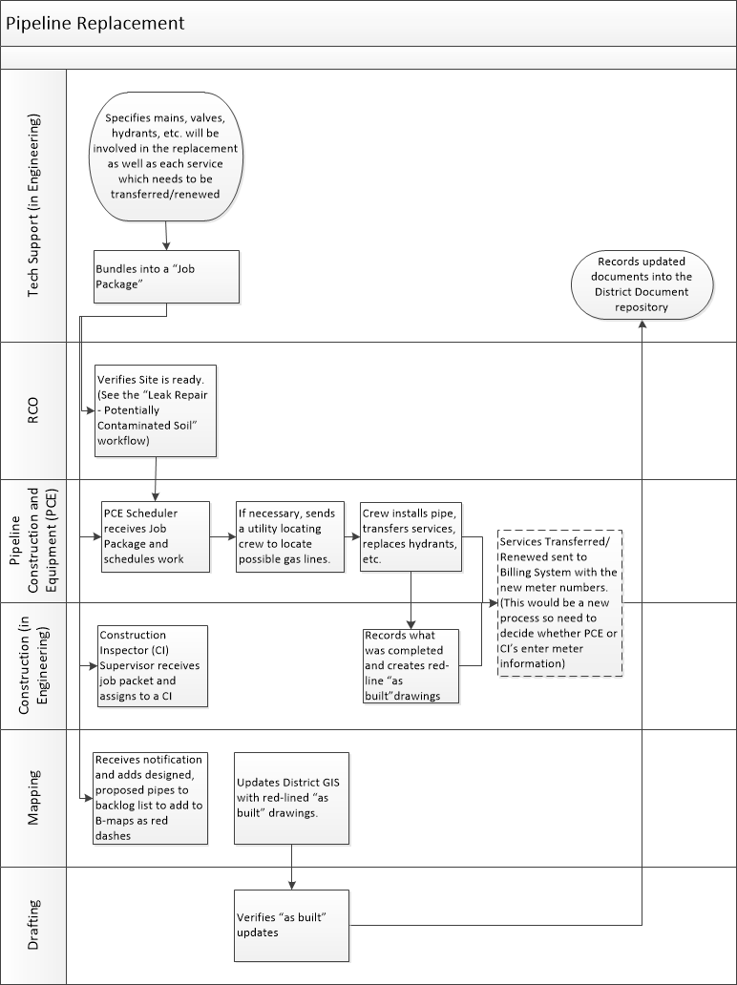

### Description

The District regularly schedules pipe for replacement. The District’s Engineering Department designs work that needs to be done as part of replacing pipe. PCE completes the work. Construction Inspectors (CI’s) verify completed work. Any transferred or renewed customer service accounts need to be updated in the District’s billing system.

### Workflow Entry Point

The main/service laterals for replacement are identified.

### The Required System will:

1. Allow the Tech Support to let RCO know that all design work is finished.
2. RCO follows the steps specified in the “Leak Repair – Potentially Contaminated Soil” workflow above.
3. Import a GIS mapping file so the District staff will be able to update on completion the as-built version.
4. Allow Pipeline to easily schedule replacement work.
5. Allow Pipeline to dispatch a crew for locating possible gas lines if Pipeline deems it necessary.
6. Allow specify the USA ticket number created and the time repairs can start
7. Record when a crew arrived on site
8. Record all horizontal assets replaced/installed (pipe/hydrants/valves/etc.)
   1. Also record information need to renew/transfer any customer services such as account number, address, new meter number, and new meter reading.
9. Record when crew work for each asset is completed.
10. Integrate with the District Billing Systems to inform it of renewed or transferred services.
11. Export a GIS mapping file containing as-built information for all horizontal assets replaced/installed to be imported into the District GIS System.

## Paving and Concrete after Repair/Replacement of Horizontal Assets

### Workflow

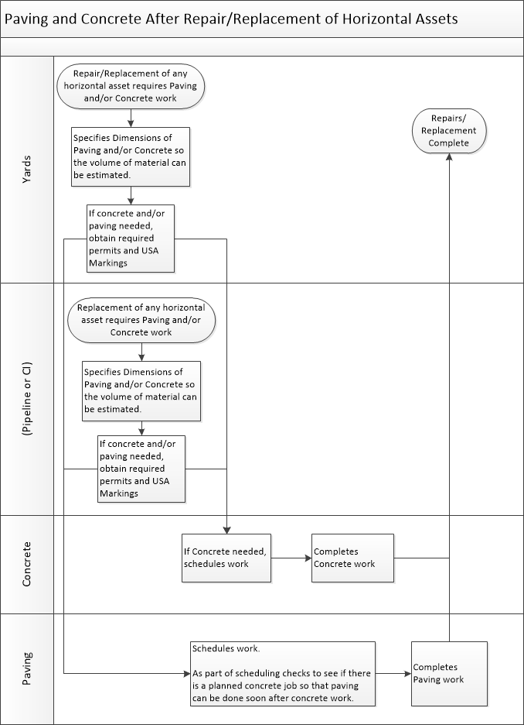

### Description

Any work which requires digging into streets, gutters, or sidewalks will require paving and/or concrete work to finish repairs.

### Workflow Entry Point

Repairs/replacement of water mains/service laterals necessitate paving and/or concrete work.

### The Required System will:

1. Allow for the entry of dimension which can be used to estimate volume of paving and/or concrete materials needed.
2. Allow the Yards, Pipeline, or CI’s to specify:
   1. The USA ticket number created and the time repairs can start and time when repairs must be completed by (when the USA Ticket expires)
   2. A permit number created and the time repairs can start and time when repairs must be completed by (when the permit expires)
3. For concrete:
   1. Allow Concrete to easily schedule based on priority, distance, time to achieve KPI, etc.
   2. Allow Concrete to enter notes, photos, and videos related to work done.
   3. Record when work finished.
4. For paving:
   1. Allow Paving to easily schedule based on priority, distance, time to achieve KPI, etc.
      1. Also allow scheduling based on proximity to Concrete orders.
   2. Allow Paving to enter notes, photos, and videos related to work done.
   3. Record when work finished.

## Concrete Surrounding Meter Box

### Workflow

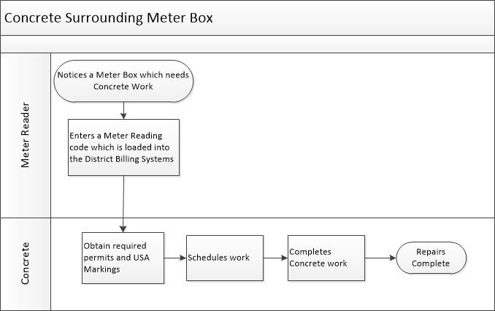

### Description

A meter reader enters a Meter Reader Code in the District meter reading software to indicate concrete around a meter box needs to be repaired. This code is brought into the District billing system. Work is then scheduled and completed.

### Workflow Entry Point

A meter reader notices that the concrete around a meter box needs work.

### The Required System will:

1. Display meters which the District billing system has flagged as needing concrete work
   1. The display will show the locations
2. Allow Concrete to specify:
   1. The USA ticket number created and when repairs can start and time when repairs must be completed by (when the USA Ticket expires)
   2. A permit number created and the time repairs can start when repairs must be completed by (when the permit expires)
3. Allow Concrete to easily schedule based on priority, distance, time to achieve KPI, etc.
4. Record when work finished.
5. Integrate with the District billing system to receive notifications when a meter box needs work and generate a work for Concrete.

## Tracking Shutdowns

### Description

The District maintains an application it calls the Shutdown Tracking System (STS). This system is referenced in several workflows above. It is the District’s intention to sunset this application in favor of a new system.

### Sample Screenshots

#### List of Shutdowns

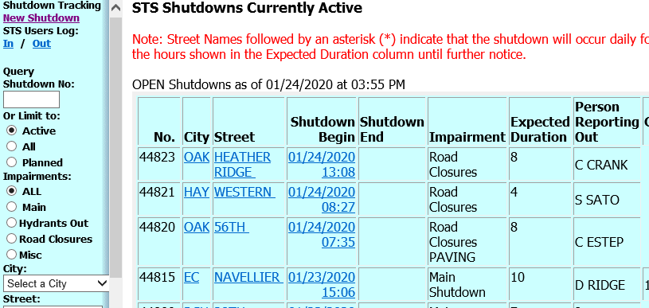

#### Shutdown Details

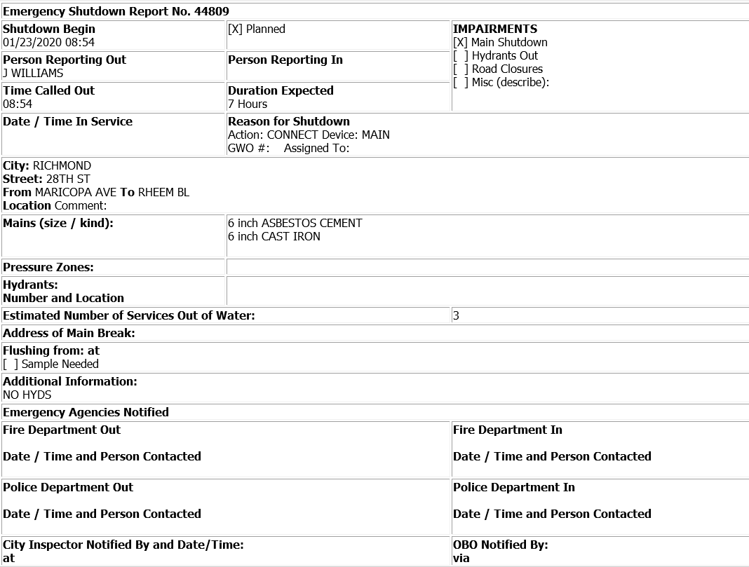

### The Required System will:

1. Allow District staff to query for Shutdown by date, city, type of shutdown, address, city, zip.
   1. The queried list will include:
      1. City, Street
      2. When the shutdown began
      3. When the shutdown ended
      4. Expected duration
      5. The District employee who reported the shutdown
      6. Shutdowns affecting critical customers
         1. Critical customers affected will be highlighted to make it easier to see these customers.
2. Allow District staff to see specifics about a shutdown which will include:
   1. A count of customers affected
   2. A listing of customers affected
      * 1. The solution shall also allow District staff to download a list of affected customers which will include: Customer Name; Customer Account Number; Customer home, work, and cell numbers; whether the customer is a critical customer.
   3. Location
   4. Reason for shutdown
   5. Main size/material
   6. Hydrants affected
   7. Date and time Public Agencies were contacted:
      1. Fire Department
      2. Police Department
      3. City Inspector
   8. Links that allow staff to easily navigate to information about all workflow steps/work orders related to the shutdown.

## Hydrant Flow Test

### Description

The District performs periodic flow tests on Hydrants throughout its District.

### Sample Screen Shots

#### Creating a Flow Test Entry

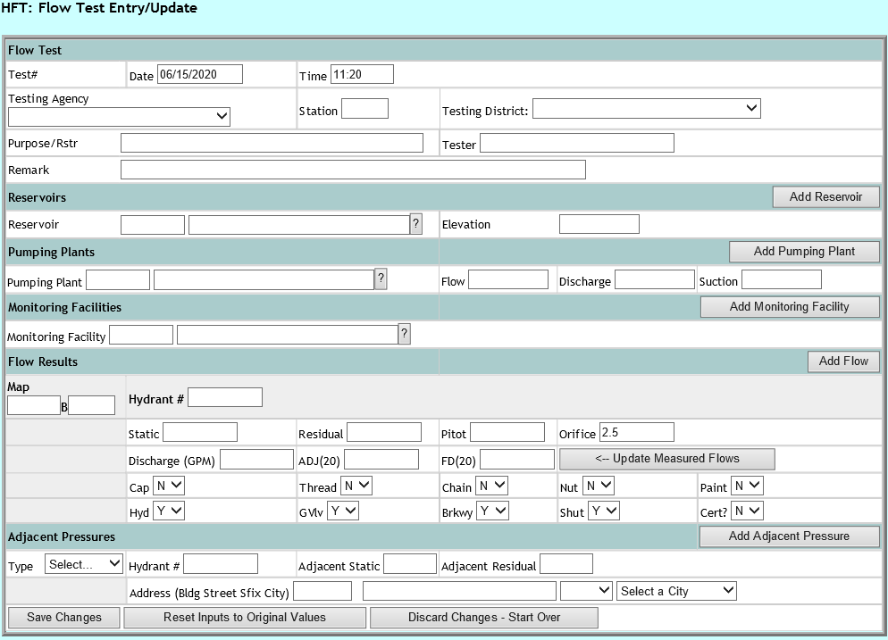

#### Listing of Flow Tests

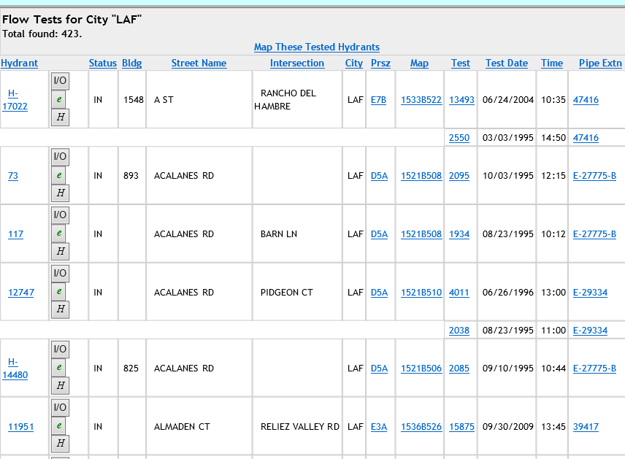

### The Required System will:

1. Allow District staff to query for Hydrant Tests by date, city, location, pressure zone, test number, main/pipe extension number.
2. Allow District Staff to enter Hydrant Flow test information.
   1. **Note:** The requirements list the ability for the District to add new attributes/values into the system without requiring programming changes. This is an example where the District would want this functionality to set up this form in the new system.
3. The provide a scheduling algorithm which allows the District to easily set up a schedule for performing work/tasks on a hydrant (or any asset).
4. Allow the Yards to easily see all work that is scheduled by all crews and employees.
5. Allow the Yards to easily schedule staff (usually an individual) to perform the test.

## Proactive Asset Work Orders

### Description

As the District continues to look for ways to proactively identify and resolve issues with horizontal assets to minimize impacts to customers and to save District resource, it will need to develop work flows to handle new types of preventative work orders; hence the focus on having a configurable system as part of our requirements.

In addition to allowing for the configuration of the workflows, the District will need the ability to set up maintenance schedules, assign work based on the availability and skill set of staff, track KPI’s, etc. without waiting for programming changes.

# Vertical Asset Workflows

The following are common workflows that need to be satisfied by the new system. These are here to add further clarity for the requirements of the system. The District is divided into two main business units: Water and Wastewater. In parenthesis at the end of each header is the business unit to which the work flow applies.

This is not a complete list of all workflows. Also, for the workflows listed, different business units at the District will have variation of these workflows.

Lastly, we expect that these workflows can be modified over time which is the reason for the emphasis in the requirements on having a configurable system.

## Acceptance of New Assets Following Construction Contract (Wastewater)

The following shows assets being added to our current solution. We would want the new system to streamline this process and as mentioned in the requirements above, allow for loading of asset information from an Equipment Tag Spreadsheet.



## Entering PM’s, Readings & Rounds, and Daily Logsheet Templates (Wastewater)

The following shows PM’s, Readings & Rounds lists, and Daily Logsheet Templates being added to our current solution. We would want the new system to streamline this process and allow for plans, round sheets, etc. to be added efficiently into the new system.



## Capital Work (Water)

The following is for Capital projects to replace, refurbish, build, acquire, and/or install assets. As is mentioned in the requirements above, we would want time entered into one system and be shared between the new system and the District Timesheet application.



## Corrective Maintenance (Water)

The following flow is for corrective maintenance on an asset. This is work that is typically unplanned. As with the previous workflow, we would want time entered into one system and be shared between the new system and the District Timesheet application.



## Preventative Maintenance which includes a Measureable Asset Characteristic (MAC) (Water)

The following flow is for preventative maintenance (PM) as required on an asset. This work is to extend the life of an asset. This will often involve taking measurements to understand its working condition and to estimate the Asset’s end of life. The District calls these measurements MAC’s (Measureable Asset Characteristic). The measurements and ranges will vary based on the Asset.

As with the previous workflow, we would want time entered into one system and be shared between the new system and the District Timesheet application.



## Predictive Maintenance (Water)

The following flow happens when a Measureable Asset Characteristic (MAC) indicates that additional work is required for an asset.

As with the previous workflow, we would want time entered into one system and be shared between the new system and the District Timesheet application.



# Reporting

## Object Model related to District Assets



## Entity Relationships Reporting

As was mentioned in Section 1 above, this object model represents key objects and relationships related to assets. Any system would need to support these objects and relationships to in order to for the District to see reports such as:

1. The number of work orders performed at a location is a specified period of time
2. Ratio of PM/CMs
3. Assets with frequent CMs
4. Asset age
5. Labor costs, parts costs, etc.
6. Run times
7. Assets with a specified problem cause
8. Assets with a specified resolution

## Custom Report Generation Tool

The required system will allow District staff to generate custom reports on all objects and relationships listed above without needing to engage the developer on the system and/or third party implementers.

## Public Records Requests

The District needs to produce all information related to any work tracked by the WMS system when requested by a member of the public.

Requests typically fall into two categories. One is a request for a specific location/address on a specific date. The other is a request for information with a description of the location and a time frame.

This will require the WMS system to generate a PDF containing all information related to a specific work order. Or a spreadsheet containing all information for work orders found by searching on any combination of:

1. Date Range
2. City
3. Street Name(s)
4. Street Number Range

# Appendix

# Appendix A – Current Horizontal Work Order Creation Screen

To add context, following is a screen shot of the existing Work Order Creation Screen.

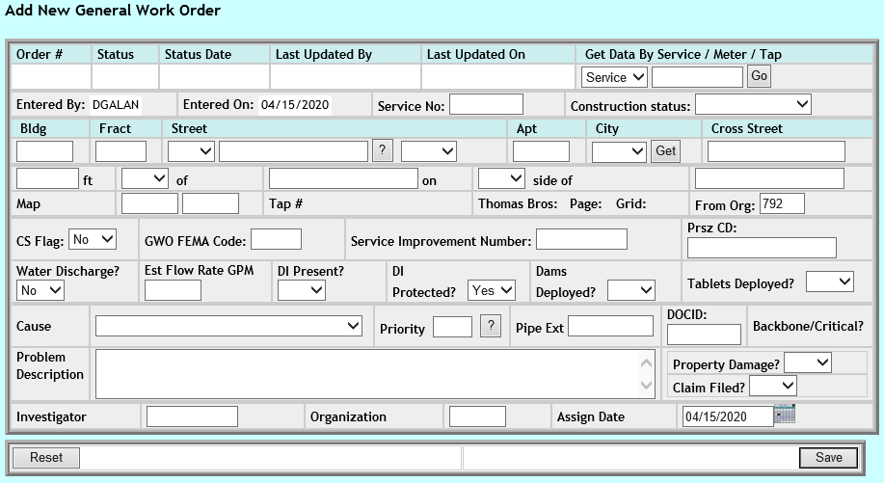

|  |  |
| --- | --- |
| **Field** | **Field Type** |
| Order # | Auto-populated |
| Status | Auto-populated |
| Status Date | Auto-populated |
| Last Updated By | Auto-populated |
| Last Updated On | Auto-populated |
| Get Data By | Select List:  Service/Meter/Tap |
| Service/Meter/Tap (#) | Text |
| Entered By | Auto-populated |
| Entered On | Auto-populated |
| Service No: | Text |
| Construction Status: | Select List:  Short Term Hold/Long Term Hold/Ready Scheduled/In Progress |
| Bldg | Text |
| Fract | Text |
| Street (prefix) | Select List:  E/N/NE/NW/S/SE/SW/W |
| Street (name) | Text |
| "?" (street name search) | Button |
| Street (suffix) | Select List:  AVE/BL/etc. |
| Apt | Text |
| City | Select List:  The cities in the District service area. |
| Get (address info) | Button |
| Cross Street | Text |
| ft | Text |
| of | Select List:  E/N/NE/NW/S/SE/SW/W |
| on | Text |
| side of (direction selection) | Select List:  E/N/NE/NW/S/SE/SW/W |
| side of (Street Name) | Text |
| Map (coordinates) | Text |
| Tap # | Auto-populated |
| Thomas Bros: | Auto-populated |
| Page: | Auto-populated |
| Grid: | Auto-populated |
| From Org: | Text |
| CS Flag: | Select List:  Yes/No |
| GWO FEMA Code: | Text |
| Service Improvement Number: | Text |
| Prsz CD: | Text |
| Water Discharge? | Select List:  Yes/NO |
| Est Flow Rate GPM | Text |
| DI Present? | Select List:  YES/NO |
| DI Protected? | Select List:  YES/NO |
| Dams Deployed? | Select List:  YES/NO |
| Tablets Deployed? | Select List:  YES/NO |
| Cause | Select List: |
| Priority | Text |
| "?" (priority search) | Button which pulls up the following selection list to indicate how quickly repairs need to be made (the number in parenthesis is the priority code):  61+ DAYS (1)  21-60 DAYS (2)  7-21 DAYS (3)  1-7 DAYS (4)  WITHIN 1 DAY (5) |
| Pipe Ext | Text |
| DOCID: | Text |
| Backbone/Critical? | Auto-populated |
| Problem Description | Text |
| Property Damage? | Select List:  YES/NO |
| Claim Filed? | Select List:  YES/NO |
| Investigator | Text |
| Organization | Text |
| Assign Date | Date/Time |
| Reset | Button |
| Save | Button |

# Appendix B – Current Horizontal Work Order Search Screen

To add context, following is a screen shot of the existing Work Order Search Screen. At a minimum, the new system would allow users to search on these fields at a minimum.

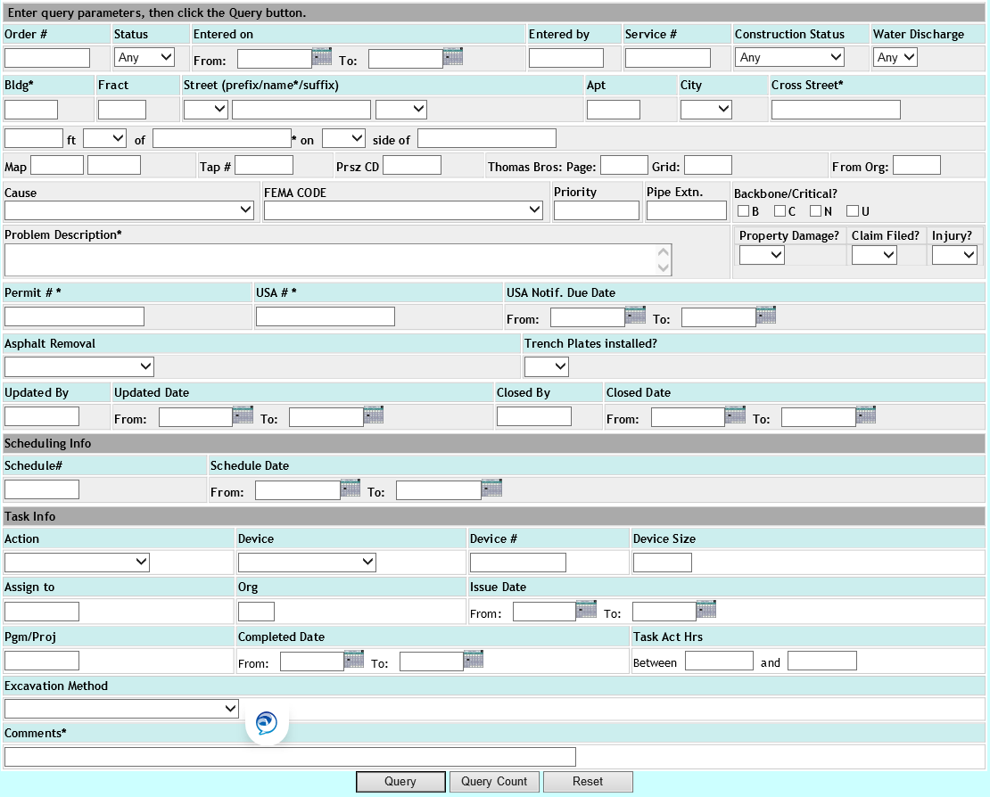

|  |  |
| --- | --- |
| **Field** | **Field Type** |
| Order # | Text |
| Status | Select List:  Closed/Open |
| Entered on | Date |
| Entered by | Text (ideally the new system would provide for direct entry of an employee id and also a search for employees) |
| Service # | Text |
| Construction Status: | Select List:  Short Term Hold/Long Term Hold/Ready Scheduled/In Progress |
| Water Discharge | Select List:  Yes/NO |
| Bldg | Text |
| Fract | Text |
| Street (prefix) | Select List:  E/N/NE/NW/S/SE/SW/W |
| Street (name) | Text |
| "?" (street name search) | Button |
| Street (suffix) | Select List:  AVE/BL/etc. |
| Apt | Text |
| City | Select List:  The cities in the District service area. |
| Get (address info) | Button |
| Cross Street | Text |
| ft | Text |
| of | Select List:  E/N/NE/NW/S/SE/SW/W |
| on | Text |
| side of (direction selection) | Select List:  E/N/NE/NW/S/SE/SW/W |
| side of (Street Name) | Text |
| Map (coordinates) | Text |
| Tap # | Text |
| Prsz CD | Text |
| Page: | Text |
| Grid: | Text |
| From Org: | Text (but could be an org look up in a new system |
| Cause | Select List: |
| FEMA CODE: | Select List: |
| Priority: | Text (this would ideally be selection list of priority codes) |
| Pipe Extn. | Text |
| Backbone/Critical | Checkbox selections for:  **B**ackbone/**C**ritical/**N**ormal/**U**nknown |
| Problem Description | Text |
| Property Damage? | Select List:  YES/NO |
| Claim Filed? | Select List:  YES/NO |
| Injury? | Select List:  YES/NO |
| Permit # | Text |
| USA # | Text |
| USA Notif. Due Date Range | Date |
| Asphalt Removal | Select List:  HOE RAM/NONE/PAVEMENT BREAKER/SAW CUT/UNKNOWN |
| Trench Plates Installed? | Select List:  YES/NO |
| Updated by | Text (ideally the new system would provide for direct entry of an employee id and also a search for employees) |
| Updated Date Range | Date |
| Closed by | Text (ideally the new system would provide for direct entry of an employee id and also a search for employees) |
| Closed Date Range | Date |
| Schedule # | Text |
| Schedule Date Range | Date |
| Action | Select List: |
| Device | Selection List: |
| Device # | Text |
| Device | Size (ideally the new system will have this be a selection list based on the device which was selected. |
| Assigned to | Text (ideally the new system would provide for direct entry of an employee id and also a search for employees) |
| Org | Text (ideally the new system would provide for direct entry of an org id and also a search for org id’s) |
| Issue Date Range | Date |
| Pgm/Proj | Text (ideally the new system would provide for direct entry of an program/project id and also a search for program/project id’s) |
| Completion Date Range | Date |
| Task Act(ual) Hrs | Number |
| Excavation Method | Selection List: |
| Comments | Text |

# Appendix C – Sample Horizontal Work Order Activity Log

To add context, following is a screen shot of an existing Activity Log. This is a type of summary we would want from a new system.

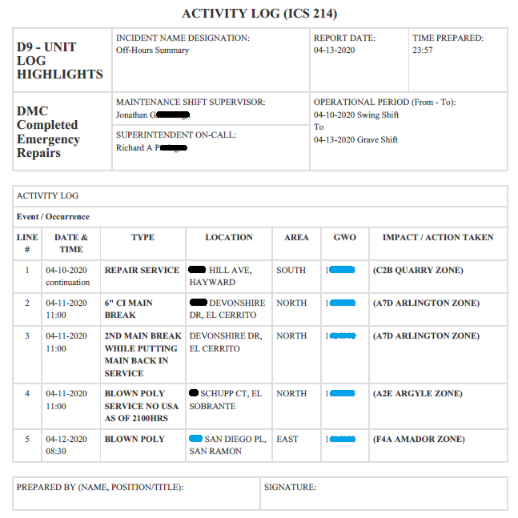

# Appendix D – Horizontal Work Order Situation Status Report

To add context, following is a screen shot of an existing Situation Status Report. This is a type of summary we would want from a new system.

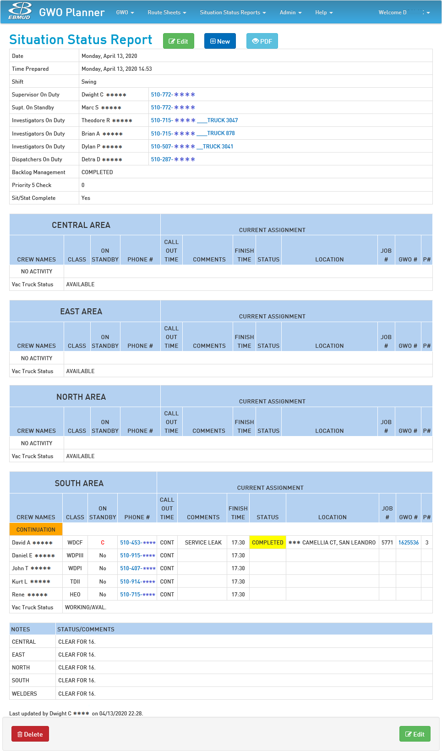

The following is the input for generating the above summary:

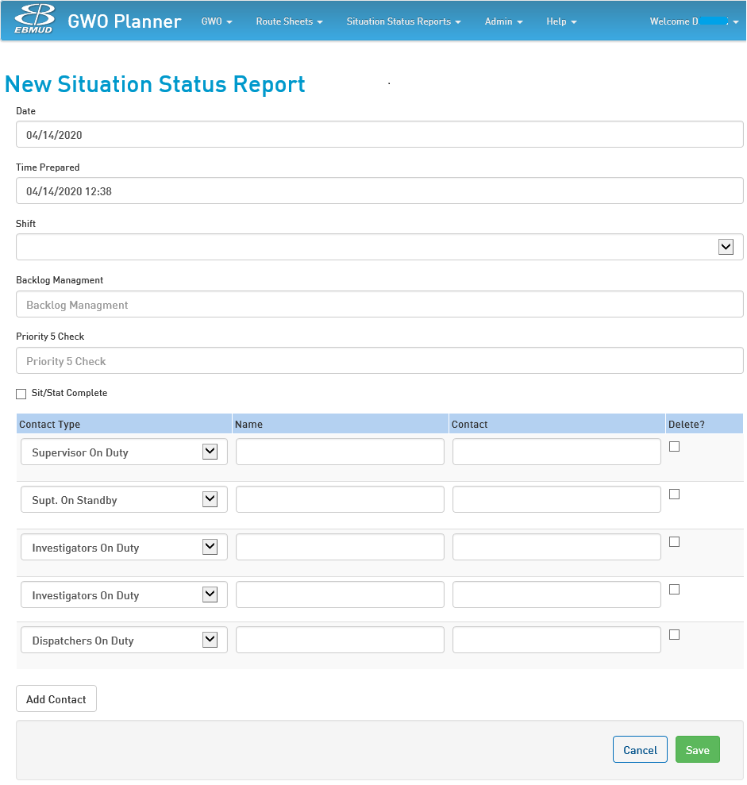

# Appendix E –Employee Leave Report

To add context, following is a screen shot of an existing Employee Leave Report. This is a type of summary we would want from a new system.

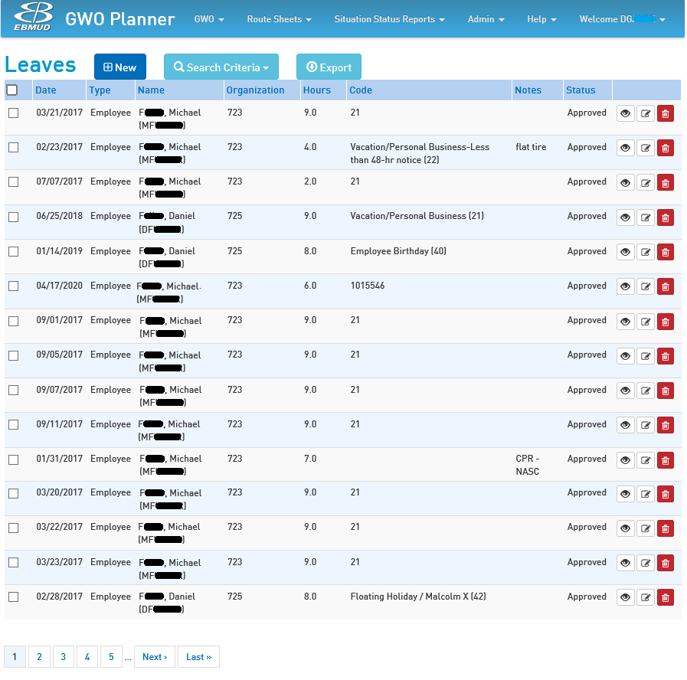

The following is the input for generating the above summary:

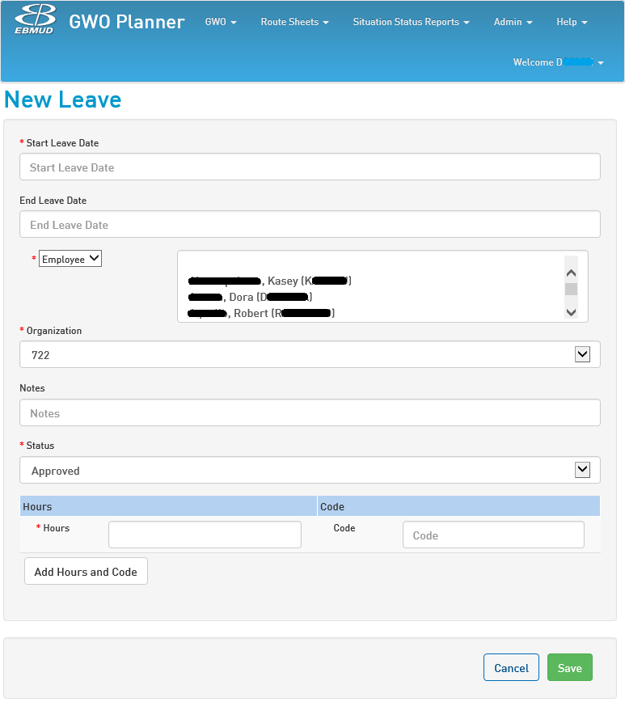

# Appendix F – Compressed Schedules

To add context, following is a screen shot of an existing Employee Compressed Schedule listing. This is a type of summary we would want from a new system.

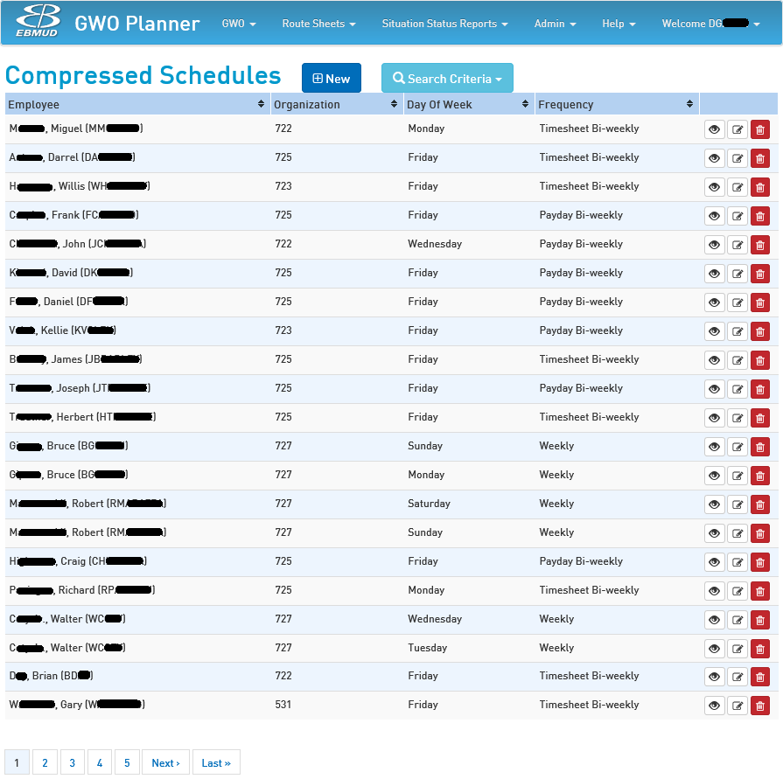

The following is the input for generating the above summary:

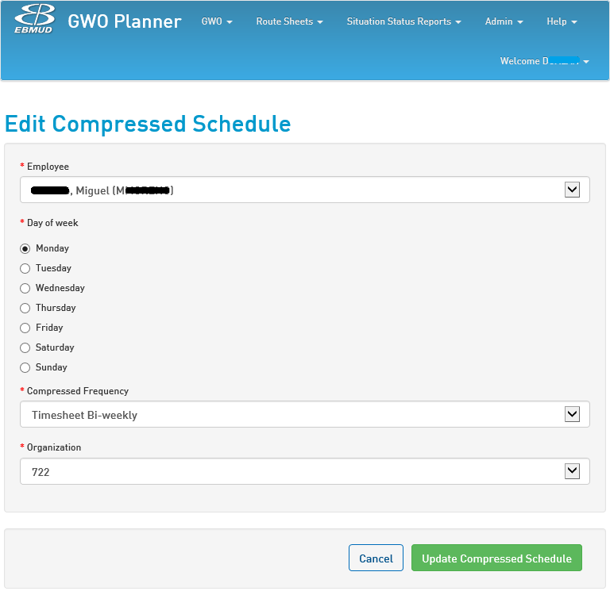

# Appendix F – Main Break Report

To add context, following is a screen shot of an existing Main Break Report. This is created from the District Main Break Web Application. This application uses our existing WMS to generate the following. The new system will need to make this information available to the Main Break Application.

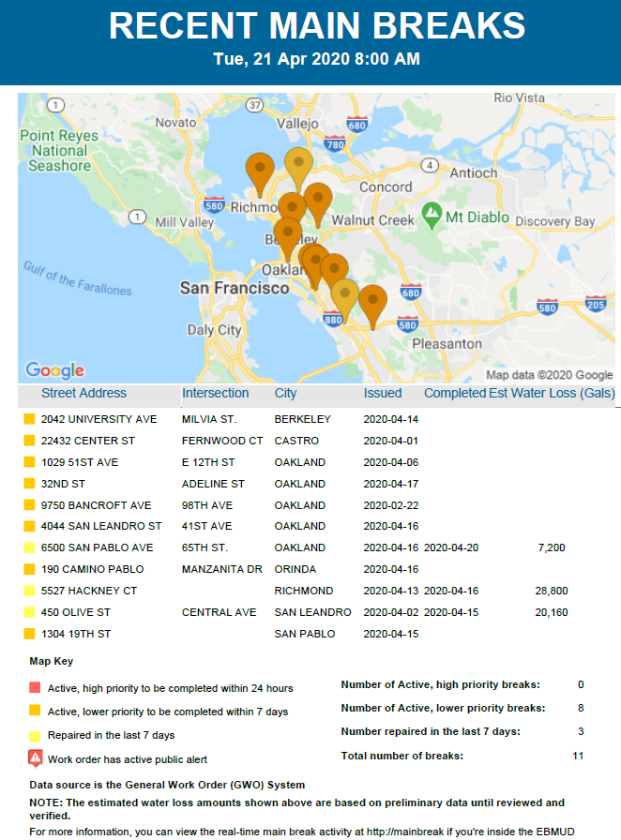

# Appendix G – ECA Leak Investigation Report

To add context, following is a screen shot of an existing Enhanced Compliance Action (ECA) Leak Investigation Report. This is a type of summary we would want from a new system.

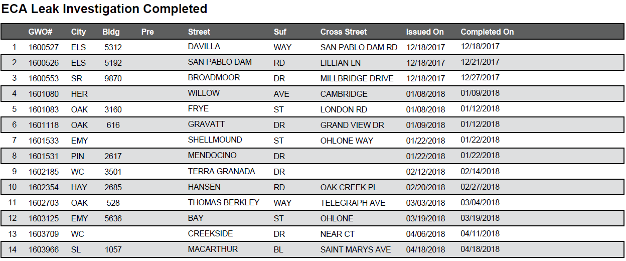

# Appendix H – Daily Check Conditions for Leaks Report

To add context, following is a screen shot of an existing Daily Check Conditions for Leaks Report. This is a type of summary we would want from a new system.

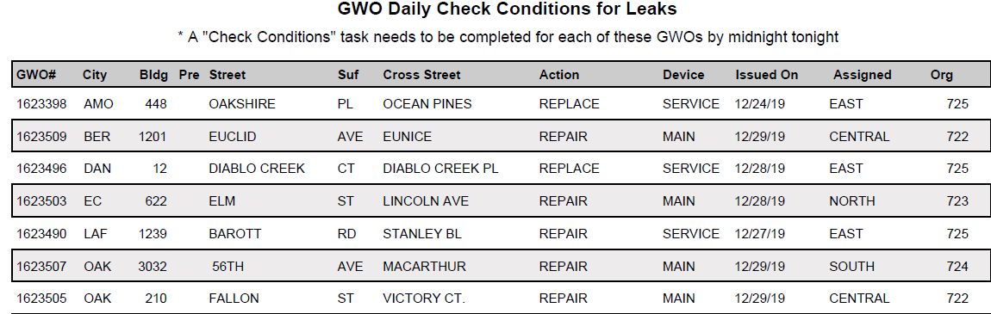

# Appendix I – Main Break Counts by Fiscal Year

To add context, following is a screen shot of an existing Main Break Counts by Fiscal Year Report. This is a type of summary we would want from a new system.

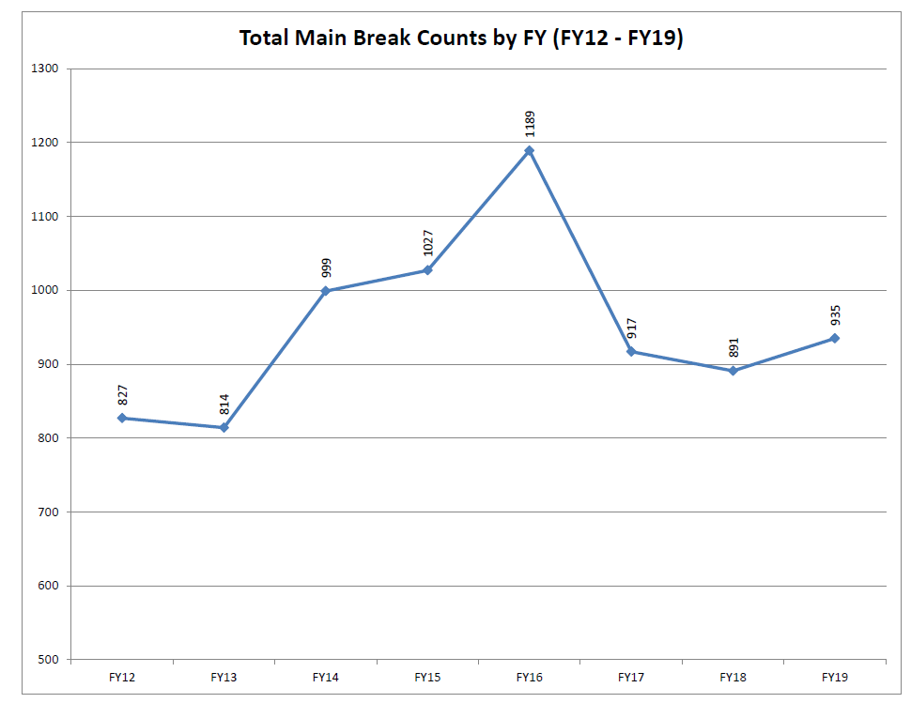

# Appendix J – Main Break Counts by Month

To add context, following is a screen shot of an existing Main Break Counts by Month Report. This is a type of summary we would want from a new system.

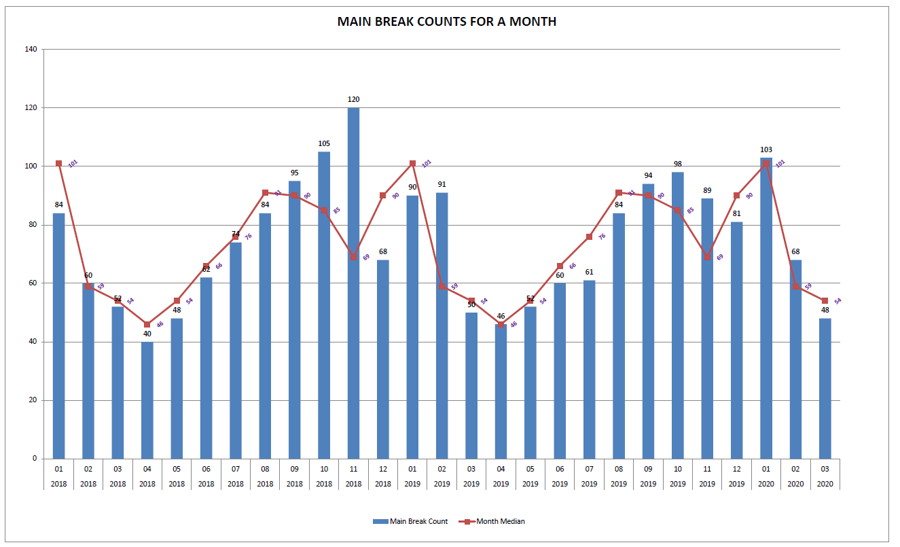

# Appendix K – Main Break Counts by Month and Year

To add context, following is a screen shot of an existing Main Break Counts by Month and Year Report. This is a type of summary we would want from a new system.

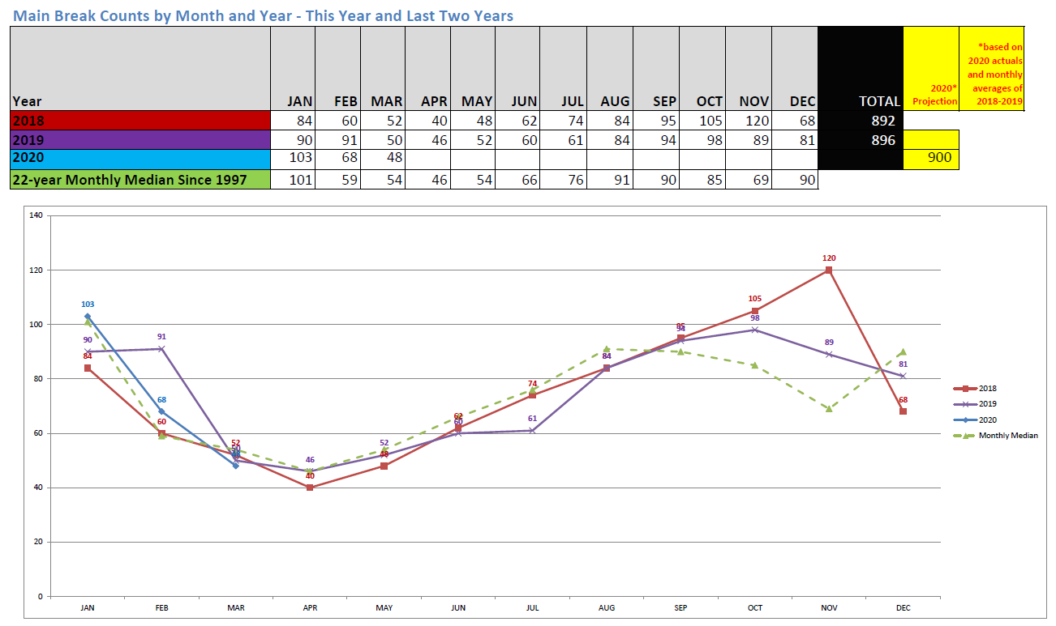

# Appendix L – Main Break by Pipe Material, Size, and Year

To add context, following is a screen shot of an existing Main Break Counts by Pipe Material, Size, and Year Report. This is a type of summary we would want from a new system.

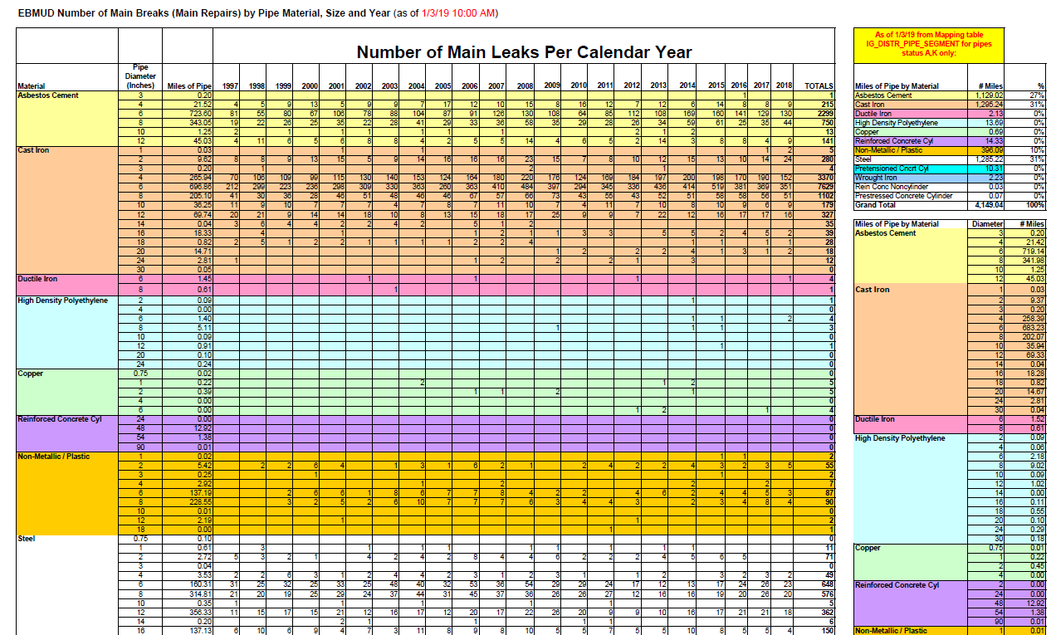

# Appendix M – Monthly Main Break Report

To add context, following is a screen shot of an existing Monthly Main Break Report. This is a type of summary we would want from a new system.

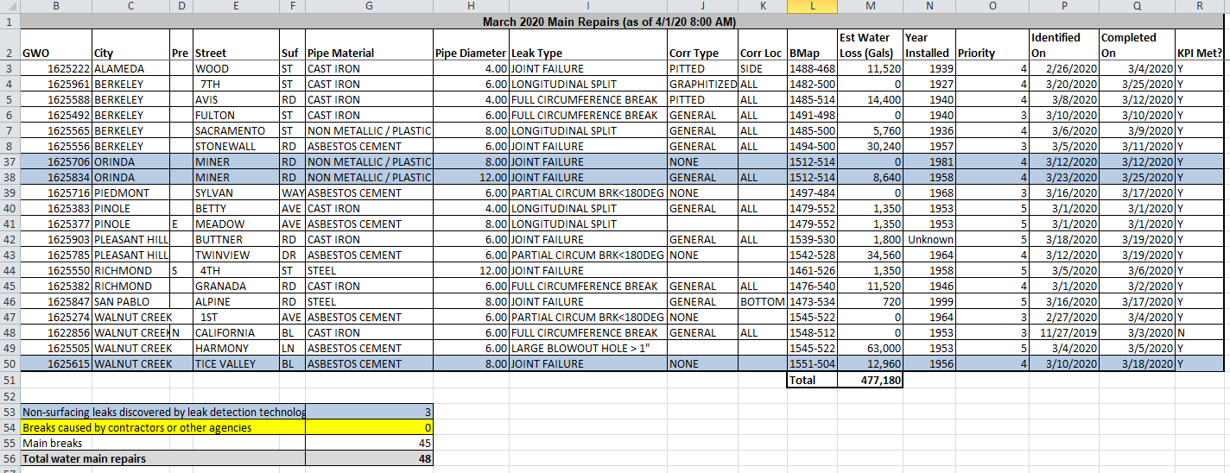

# Appendix N – Mainline Installation

To add more context to the Pipeline Replacement workflow, the following describes textually how this process works.

Mainline Installation

There are too many variables to describe all the possibilities for a "typical" mainline installation, thus the description below is the plan, which is subject to change - many times. The entire [**Sample**](http://idrive/WMS/Process%20Flow%20Diagrams/Pipeline%20IR%20-%20FINAL.vsd) process for infrastructure replacement was captured in 2015.

*Planning Phase*

1. About a year in advance of the job, the ACMS walks it with the Designer and the Construction Inspector (CI). They discuss the design, including but not limited to, pipe alignment, connection points, and if a sewer variance is required. Their primary goal is to anticipate project challenges and make corrections before construction begins, thus minimizing change orders.
2. Scheduler prepare the Encroachment permit about three months in advance of the project expected start date. Schedules permit, soil report, Traffic Control Plan, survey request, and Field Orders, etc. and includes it in the "Job Packet."
3. When a staging area is needed, the GPS/ACMS work with Real Estate Division to procure one.
4. Admin sends customer notification letters to affected residents about one month before construction starts.
5. GPS requests a field meeting with the project City/County Inspector.
6. If working with contaminated soils, GPS may choose to secure a staging area nearby for storing sand and rock. Typically a staging area is not required for projects with uncontaminated soil, as the trucks will do a turn-around by hauling the excavated soils to a District disposal facility (i.e., Briones/Miller Road), where they will load rock or sand. The WDCF/GPS places a weekly order for rock and or sand deliveries to the facilities.
7. GPS/CI place orders for materials: new pipe, service transfers and connections/kills.

*Job Implementation*

1. If needed, set up staging area
2. Mark USA area for EBMUD main and appurtenances, then open a USA ticket
3. No parking signs with QR codes are placed in the area
4. Implement traffic controls
5. As needed, order tow truck to relocate cars on the street
6. Lay out trench lines for saw cutting (if changes to design required, coordinate with Design and Assistant Engineers and call CI)
7. Saw cut asphalt and pot hole to determine locations with utility conflicts (may be contracted out in PCE)
8. On the first or last day of the job, depending on which end of the project you are starting with, make a wet tap and install a clorox tap or a blow-off (Drawing 332-EA)

*Note:* there is a blow-off (whether temporary or permanent) at the end of every installation.

*Mainline Construction Process*

There are four phases of the mainline construction process:

1. Pipe Installation
2. Sanitation (chlorination)
3. Service Transfers
4. Connections/Kills

**1. Pipe Installation** A typical day in Pipeline is laying mainline. The GPS, HEO and leads start the day with walking the job site, followed by a safety tailgate to review the job print, share the days production goals, and discuss potential hazards.

The work continues...

1. Set up traffic control as required by the Traffic Control Plan
2. Strip asphalt and haul to recycler
3. Excavate the trench and manage soil disposal
   1. [Sewer Lateral Repair](http://wiki/water_ops/index.php5/Sewer_Lateral_Repair) information, as needed
4. Prepare pipe for installation. When working with steel pipe: fabricate, Jeep, and tape wrap pipe; support welder.
5. Bed the trench with sand (per Standard Drawing 1992-A)
6. Install pipe
7. Backfill and compact
8. Place temporary asphalt about 2" thick
9. Pick up traffic control for the day.

… the next day, implement traffic controls and start the cycle of laying mainline.

**2. Sanitation**

1. Once the pipe is installed, flush the main to remove entrapped air
2. Pressure test main in accordance with (Standard Spec 02511.1 hydrostatic pressure and leakage test). If it fails, locate the leak and fix it.
3. Preparations are made to chlorinate the main (e.g., order wastewater collection tanks, coordinate with SWQ)
4. SWQ chlorinates the main and the process takes about 3 days: day 1 chlorinate, day 2 sample, and day 3 receive results. Once SWQ confirms the pipe is chlorinated to standards, continue the project

**3. Service Transfer**

1. Excavate at each service transfer location# Transfer all services
2. Upgrade substandard size and or a material (e.g., polyethylene, schedule 40 PVC, polybutylene)
3. Remove the clorox tap and plug it with a screw plug or leave with a corporation stop

Notes:

* The common service connection is 3/4 inch copper
* There are two types of service transfers: long side and short side service.
  + The long service transfer (see "B" on image below) is when the new main service connection crosses the old main and is more involved to make because it requires more digging to lay a longer trench, past the corporation stop, to complete the union of the copper pipe to the new main.
  + The short service transfer (see "A" on image below) is less involved because the copper from the customer exists in the location to be simply transferred. So only a hole is required to be dug, copper crimped, and new connection is made.

[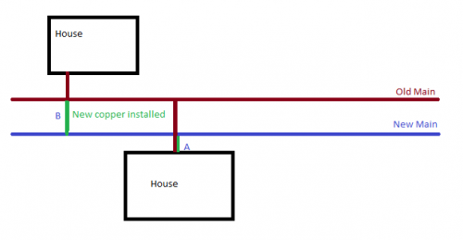](http://wiki/water_ops/index.php5/File:Transfer_Service_Types.png)

Service Transfer Types: A and B

**4. Connections/Kills**

1. Plan for shutdown, place door hangers on customer property at least 48 hours in advance of planned shutdown. Uupdate Sedaru.
2. Shutdown new main and remove blowoff
3. The new main to the distribution system
4. Flush the new main and old valves (via a nearby hydrant, to remove air and sediment from the old valves)
5. Kill the old main by severing the connection to the system. Use a line cap or cut out the tee where it was tied to the main
6. Complete the Punch List [**Sample Punch List**](http://idrive/WMS/Tech%20Train%20Writing%20Admin/Punch%20List%20Memo%20Sample.docx)**,** including:
7. Paving Orders
8. Concrete Orders
9. Abandoned valve pots are to be cut down four inches and backfilled with rock and asphalt (Standard Specifications 3.9C)
10. Prepare all reference points (RP), for example curb markings, for all valves, blow-offs, and air valves
11. Return surplus parts and materials

# Appendix O – Listing of Vertical Assets

Following is a list of Asset Classes which are part of the existing District Work Management Systems:

|  |  |  |  |  |  |  |  |
| --- | --- | --- | --- | --- | --- | --- | --- |
| **Asset Class Code** | **Asset Class Name** |  | **Asset Class Code** | **Asset Class Name** |  | **Asset Class Code** | **Asset Class Name** |
| ACTS | AC Mitigation Test Station |  | 65 | Governor |  | PZ | Pressure Zone System |
| ACF | AC Power Fail |  | GT | Grease Trap |  | PC | Primary Coagulant System |
| ACT | Access Control Terminal |  | GR | Grinder Pump |  | PTS | Primary Treated Sewage |
| ACM | Access Controller Module |  | RES | Grounding Resistor |  | PTS | Primary Treated Sewage System |
| APS | Access Power Supply Unit |  | GWTP | Groundwater Treatment Plant |  | PRNT | Printer |
| ACC | Accumulator |  | GWW | Groundwater Well |  | PWP | Process Water Plant |
| AER | Aerator |  | GWWF | Groundwater Well Field |  | PLC | Programmable Logic Controller |
| ACR | Air Compressor |  | HS | Hand Switch |  | PB | Pull Box |
| ACU | Air Conditioning Package Unit |  | HV | Hand Valve (Isolation) |  | PDR | Pulsation Dampener |
| AF | Air Filter |  | HH | Handhole |  | PMP | Pump |
| AFRG | Air Filter Regulator |  | HX | Heat Exchanger |  | PS | Pumping Station |
| AHU | Air Handling Unit |  | HP | Heat Pump |  | QMS | Quality Monitoring Station |
| ARR | Air Receiver |  | HTR | Heater |  | QMS | Quality Monitoring System |
| AV | Air Valve |  | HVU | Heating Ventilation Unit |  | SPL | RF Splitter |
| ARV | Air-Release Valve |  | HVS | Heating, Ventilation and Air Conditioning System |  | RK | Rack |
| AVV | Air/Vacuum Valve |  | HVS | Heating, Ventilation and Air Conditioning Equipment |  | RAD | Radio Transmitter/Receiver |
| AB | Alarm Buzzer |  | HB | Hose Bib |  | RM | Radio/Microwave Facility |
| ALCU | Alarm Control Unit |  | HWP | Hot Process Water |  | RGS | Rain Gauge Station |
| A | Alpha |  | HWP | Hot Process Water System |  | RP | Ranger/Patrol Facility |
| ALTV | Altitude Valve |  | HMI | Human Machine Interface |  | RCVLV | Rate Control Valve |
| NH | Ammonia Liquid System |  | H | Hydrant |  | RSS | Raw Sewage System |
| AMP | Amplifier |  | HMTR | Hydrant Meter |  | RWPP | Raw Water Pumping Plant |
| AE | Analyzer Element |  | HYA | Hydraulic Actuator |  | RWS | Raw Water System |
| AIC | Analyzer Indicating Controller |  | HCO | Hydraulic Control Oil Equipment |  | RTNK | Raw Water Tank |
| AIT | Analyzer Indicating Transmitter |  | HCO | Hydraulic Control Oil System |  | RCT | Reactor |
| ASH | Analyzer Switch High |  | HCW | Hydraulic Control Water |  | RCV | Receiver |
| ASL | Analyzer Switch Low |  | HCW | Hydraulic Control Water System |  | RMONF | Reclaim Monitoring Facility |
| AI | Analyzing Indicator |  | HOV | Hydraulic Operated Valve (Isolation) |  | RCW | Reclaimed Water System |
| ANO | Anode |  | HP | Hydrogen Peroxide System |  | RA | Recreation Area |
| AWS | Applied Water System |  | HOS | Hypolimnetic Oxygenation System |  | RV | Recreational Vehicle Dump Station |
| AQED | Aqueduct |  | ICM | Ice Machine |  | REC | Rectifier |
| AQED | Aqueduct System |  | FOC | Incident Base |  | RFTR | Recycled Filters |
| AQVLT | Aqueduct Vault |  | IEC | Indirect Evaporative Cooler |  | RPP | Recycled Pumping Plant |
| ASC | Area Service Center |  | IRXR | Infrared Receiver |  | RRES | Recycled Reservoir |
| AED | Automated External Defibrillator |  | IRXT | Infrared Transmitter |  | RWTP | Recycled Water Treatment Plant |
| ASV | Automated Seismic Valve |  | IM | Input Module |  | RGR | Reducing Gear |
| ADT | Automatic Drain Trap |  | IAS | Instrument Air System |  | RDR | Refrigerated Dryer |
| ATS | Automatic Transfer Switch |  | IC | Instrument Cabinet |  | RFU | Refrigeration Unit |
| BFP | Backflow Preventer |  | IP | Instrument Panel |  | RG | Regulator, Voltage |
| BSN | Basin |  | IJ | Insulating Joint |  | RLY | Relay |
| BTR | Battery |  | IJTS | Insulating Joint Test Station |  | RF | Relief Fan |
| BYC | Battery Charger |  | IF | Intake Fan |  | RM | Remote / Reader Module |
| BENT | Bent |  | INT | Interceptor |  | PSP | Remote Circuit Breaker Panel |
| SLDS | Biosolids Processing |  | INSG | Interceptor Segment |  | RDP | Remote Data Port |
| BOPR | Blow Off Pumping Riser |  | IT | Intertie |  | RIO | Remote I/O |
| BOPT | Blow Off Pumping Tee |  | INV | Inverter |  | RSP | Remote Security Panel |
| BLO | Blower |  | IP | Irrigation Pump |  | RSIV | Remote Seismic Isolation Valve |
| BO | Blowoff Valve |  | IWS | Irrigation Water System |  | RSA | Remote Switch Actuator |
| BLR | Boiler |  | ISP | Isolation Surge Protectors |  | RTU | Remote Terminal Unit |
| BKR | Breaker |  | JB | Junction Box |  | REX | Request to Exit Switch |
| BNS | Briones Aqueduct |  | KSW | Key Switch |  | OR | Restricting Orifice |
| BAS | Building Auxiliary System |  | KBD | Keyboard |  | RR | Restroom |
| BMS | Building Management System |  | KVM | Keyboard Video Monitor Switcher |  | RWW | Rewash Water System |
| BF | Butterfly Valve |  | KB | Knox Box |  | ROAD | Road, Access |
| CAB | Cabinet (MSC) |  | LAB | Laboratory |  | ROF | Roof |
| CBL | Cable |  | LF1 | Lafayette Aqueduct No.1 |  | SHR | Safety Shower |
| CT | Calcium Thiosulfate System |  | LF2 | Lafayette Aqueduct No.2 |  | SMTP | Sample Tap |
| CAP | Capacitor |  | LFL | Leach Field Line |  | SAS | Scouring Air System |
| CDS | Carbon Dioxide System |  | LPT | Leach Pit |  | SCN | Screen |
| SCRD | Card Readers |  | LCV | Level Control Valve |  | SGR | Screenings & Grit Removal |
| CTS | Casting Test Station |  | LE | Level Element |  | SCB | Scrubber |
| CPS | Cathodic Protection Station |  | LIC | Level Indicating Controller |  | SLW | Seal Water System |
| CPS | Cathodic Protection System |  | LIR | Level Indicating Recorder |  | STS | Secondary Treated Sewage |
| CA | Caustic Soda System |  | LIT | Level Indicating Transmitter |  | STS | Secondary Treated Sewage System |
| CG | Channels & Galleries |  | LI | Level Indicator |  | SCP | Security Control Panel |
| CV | Check Valve |  | LMS | Level Monitoring Station |  | XRAY | Security X-Ray |
| CHEM | Chemical, Storage, Feed Facility |  | LS | Level Switch |  | SED | Sedimentation |
| CHW | Chilled Water System |  | LSH | Level Switch High |  | SCV | Seismic Control Valve |
| CHU | Chiller Unit |  | LSHH | Level Switch High-High |  | SEP | Separator |
| CBV | Circuit Balance Valve |  | LSL | Level Switch Low |  | TS | Septic Tank |
| CP | Coagulant Polymer System |  | LSLL | Level Switch Low-Low |  | SRV | Server |
| COL | Collector |  | LT | Level Transmitter |  | SC | Service Connection/Cleanout |
| ACV | Combination Air Valve |  | LSE | Life Safety Equipment |  | SL | Service Lateral |
| CBN | Combiner Box |  | LSP | Life Safety Power Supply Equipment |  | JS | Service Lateral Junction Point |
| BS | Combustion Switch |  | LPS | Life Safety Power Supply System |  | SVW | Service Water System |
| COM | Communications System |  | LSS | Life Safety System |  | SVO | Servo Valve & Intergral Operating Cylinder |
| CAS | Compressed Air System |  | LFS | Lift Station |  | SWS | Settled Water System |
| CASE | Compressed Air System Equipment |  | LO | Lift Station Overflow |  | SIL | Silencer |
| CMP | Compressor |  | LCS | Lighting Control System |  | SSS | Site Security System |
| CCU | Compressor Condenser Unit |  | LFE | Lighting Fixture, Exterior |  | SDG | Slide Gate |
| CPU | Computer |  | LFI | Lighting Fixture, Interior |  | SVC | Sludge Vacuum Collector |
| CS | Computer System |  | LP | Lighting Panel |  | SCG | Sluice Gate |
| CNU | Condensate Neutralization Unit |  | LS | Lime Solution System |  | SGT | Sluice/Slide/Weir/Shear/Butterfly Gate/Log |
| COND | Condenser |  | MON | Liquid Crystal Display Monitor (Color or Mono) |  | SDE | Smoke Detector |
| CDU | Condensing Unit |  | LFS | Liquid Fuel Supply System |  | SB | Sodium Bisulfite System |
| CE | Conductivity Element |  | LCR | Load Center |  | SH | Sodium Hypochlorite System |
| CIT | Conductivity Indicating Transmitter |  | LCP | Local Control Panel |  | SFS | Soft Start |
| CI | Conductivity Indicator |  | LOC | Location System |  | SOL | Solenoid |
| CSH | Conductivity Switch High |  | LVR | Louver |  | SV | Solenoid Valve |
| CT | Conductivity Transmitter |  | LOS | Lube Oil System |  | PS | Solids Conditioner Polymer System |
| CON | Conduit |  | MCP | Main Control Panel |  | SDS | Solids Removal System |
| CP | Control Panel |  | ML | Mainline |  | XS | Special Switch |
| CPT | Control Power Transformer |  | CO | Mainline Cleanout |  | XT | Special Transmitter |
| CS | Control Station |  | JP | Mainline Junction Point |  | SPC | Speed Control |
| CLR | Cooler |  | MH | Manhole |  | SIC | Speed Indicating Controller |
| CTW | Cooling Tower |  | MTS | Manual Transfer Switch |  | SI | Speed Indicator |
| CWS | Cooling Water System |  | MW | Manway |  | SE | Speed Sensing Element |
| CLM | Copper Link Module |  | MAS | Matrix Switch |  | SWAY | Spillway |
| CPL | Coupling |  | MVC | Medium Voltage Controller |  | SN | Spray Control Nozzle |
| CRN | Crane |  | MET | Meter |  | SP | Spray Pump |
| CSB | Crash Bar |  | MPL | Meter Panel |  | PSK | Standard PS/2 Keyboard |
| FNC | Cross Fence |  | MWXR | Microwave Receiver |  | MSE | Standard PS/2 Mouse |
| CUL | Culvert |  | MWXT | Microwave Transmitter |  | SPS | Standby Power Supply Equipment |
| II | Current Indicator |  | MDP | Mini Distribution Panelboard |  | SPS | Standby Power Supply System |
| IB | Current Isolator |  | MUS | Mini Unit Substation |  | NL | Status Light |
| XCT | Current Transformer |  | M | Miscellaneous Facility |  | LOG | Stop Log |
| DAM | Dam |  | MX | Mixer |  | STR | Strainer |
| DMP | Damper |  | MODE | Modem |  | SA | Sulfuric Acid System |
| DAR | Data Acquisition Reporting |  | MIT | Moisture Indicating Transmitter |  | SF | Supply Fan |
| DAS | Data Aquisition System |  | ME | Moisture Sensor (or Dew Point) |  | SPP | Supply Pumping Plant |
| DTR | Data Translator |  | MSH | Moisture Switch High |  | SPP | Supply Pumping Plant System |
| DWS | Decant Water System |  | AQ1 | Mokelumne Aqueduct No.1 |  | SRES | Supply Reservoir |
| DEM | Demister |  | AQ2 | Mokelumne Aqueduct No.2 |  | STUN | Supply Tunnel |
| DDR | Dessicant Dryer |  | AQ3 | Mokelumne Aqueduct No.3 |  | SWR | Supply Weir |
| DIF | Diffuser |  | MONF | Monitoring Facility |  | SFW | Surface Wash |
| DVR | Digital Video Recorder |  | MOR | Moraga Aqueduct |  | SFW | Surface Wash System |
| DIS | Disconnect |  | MTR | Motor |  | SRG | Surge Protector |
| DB | Distribution Box |  | MCC | Motor Control Center |  | SWF | Switch, Fused |
| DFC | Distribution Flow Control |  | MG | Motor Generator Set |  | SWN | Switch, Non-Fused |
| DFC | Distribution Flow Control System |  | MOA | Motor Operated Actuator |  | SWB | Switchboard |
| DPP | Distribution Pumping Plant |  | MOD | Motor Operated Damper |  | SWR | Switchgear |
| DPP | Distribution Pumping Plant System |  | MOV | Motor Operated Valve (Isolation) |  | SYP | Syphon |
| DRES | Distribution Reservoir |  | MO | Motor Operator |  | TA | Tamper Alarm |
| DRES | Distribution Reservoir System |  | MS | Motor Starter |  | TNK | Tank |
| DTUN | Distribution Tunnel |  | MPR | Multifunction Protective Relay |  | TELE | Telemetry Facility |
| DVS | Distribution Valve System |  | MPX | Multiplexer |  | TEL | Telephone |
| LOC | District Location |  | UIR | Multipoint Indicating Recorder |  | TVC | Television Camera |
| DS | Diversion Structure |  | UI | Multipoint Indicator |  | TCV | Temperature Control Valve |
| DR | Door |  | UJI | Multipoint Scan Indicator |  | TE | Temperature Element |
| DCM | Door Controller Module |  | NPG | Natural Gas System |  | TIC | Temperature Indicating Controller |
| DRN | Drain |  | NED | Needle / Power Nozzle |  | TIR | Temperature Indicating Recorder |
| DRN | Drain |  | NES | Network Etherswitch |  | TIT | Temperature Indicating Transmitter |
| DF | Drinking Fountain |  | NEH | Network Hub |  | TI | Temperature Indicator |
| DRY | Dryer |  | NER | Network Router |  | TSH | Temperature Switch High |
| EDR | Eductor |  | NPP | Non-Potable Pumping Plant |  | TSHL | Temperature Switch High-Low |
| EDR | Eductor System |  | NRES | Non-Potable Reservoir |  | TSL | Temperature Switch Low |
| EPG | Electric Power Generation Equipment |  | NPW | Non-Potable Water |  | TT | Temperature Transmitter |
| EPG | Electric Power Generation System |  | NPW | Non-Potable Water System |  | JTB | Termination Box |
| EPS | Electric Power Supply Equipment |  | NWTP | Non-Potable Water Treatment Plant |  | TTS | Tertiary Treated Sewage |
| EPS | Electric Power Supply System |  | NZL | Nozzle |  | TTS | Tertiary Treated Sewage System |
| ELEC | Electrical Supply & Distribution |  | OCON | Odor & Air Emission Control |  | TST | Test Station |
| ETS | Electrolytic Test Station |  | OIL | Oil System |  | KC | Time Controller |
| ELEV | Elevator |  | AOV | Operated Valve (Isolation) |  | KIC | Time Indicating Controller |
| EBS | Emergency Bypass System |  | OPS | Operation & Control Center |  | KI | Time Indicator |
| EYW | Emergency Eyewash |  | OIU | Operator Interface Unit |  | KQI | Time Totalizing Indicator |
| EML | Emergency Lights |  | OCC | Opnet Control Center |  | TMR | Timer (Mechanical) |
| EOC | Emergency Operations Center |  | OUTF | Outfall |  | TRL | Trailer |
| ED | Energy Dissipator |  | OT | Outlet Tower |  | XFR | Transformer |
| DSP | Energy Dissipator (Discharge) |  | ORM | Output Relay Module |  | TRP | Trap |
| ENG | Engine |  | OP | Overflow Pipe |  | TPM | Trap Primer |
| NSH | Equipment Switch High |  | OFMS | Overflow Structure Monitoring Station |  | RKE | Trash Rake |
| ESW | Ethernet Switch |  | OXY | Oxygen Production & Reactor Deck |  | TWS | Treated Water System |
| EVP | Evaporator |  | OXS | Oxygen Supply System |  | PT | Treatment Aid Polymer System |
| EXC | Exciter |  | ODR | Ozone Destruct Unit |  | TDV | Triple Duty Valve |
| EAD | Exhaust Air Damper |  | OGS | Ozone Gas System |  | TRB | Turbine |
| EF | Exhaust Fan |  | OGR | Ozone Generator |  | USB | USB Director RS-232 |
| EXPD | Explosives Detector |  | PTA | Packed Tower Aerator |  | UVR | Ultraviolet Reactor |
| ESM | Extended Storage Module |  | PTZC | Pan, Tilt, Zoom Camera |  | UND | Undeveloped Land |
| FCS | Facility Control System |  | PM | Partition Manhole |  | UPS | Uninterruptible Power Supply |
| F | Fail |  | PED | Pedistal |  | USS | Unit Substation |
| FAN | Fan |  | PE | Permanganate System |  | UNK | Unknown Equipment |
| FCU | Fan Coil Unit |  | PEC | Photoelectric Cell |  | UNK | Unknown Facility |
| FDR | Feeder (Dry) |  | PVA | Photovoltaic Array |  | UNK | Unknown System |
| FOR | Fiber Optic Receiver |  | PV | Pilot Valve |  | UPP | Untreated Pumping Plant |
| FOT | Fiber Optic Transmitter |  | PPS | Plant Pumping Station (Inf, Eff, Mid) |  | URES | Untreated Reservoir |
| FP | Field Panel |  | PLS | Plate Settler |  | UTIL | Utilities, Roads & Fences |
| FLT | Filter |  | PLT | Platform |  | VBV | Vacuum Breaker Valve |
| PF | Filter Conditioner Polymer System |  | PNA | Pneumatic Actuator |  | VA | Valve |
| FRPP | Filter Reclaim Pumping Plant |  | PD | Pond |  | VPR | Vaporizer |
| FRTK | Filter Reclaim Tank |  | PFL | Portable Fuel Location |  | VAV | Variable Air Volume Unit |
| FTW | Filter-to-Waste System |  | PPMP | Portable Pump |  | VLT | Vault |
| FWS | Filtered Water System |  | PPU | Portable Pumping Unit |  | VEH | Vehicle |
| FD | Fire Damper |  | PRES | Portable Reservoir |  | VLD | Vehicle Loop Detector |
| FDS | Fire Detection System |  | PWTP | Portable Water Treatment Plant |  | VNT | Vent |
| FEX | Fire Extinguishers |  | PORT | Portal |  | VI | Vibration Indicator |
| FSS | Fire Suppression System |  | ZIT | Position Indicating Transmitter |  | VXE | Vibration Sensor-X |
| FCS | Fish Cleaning Station |  | ZS | Position Switch |  | VYE | Vibration Sensor-Y |
| FISH | Fish Facility |  | ZSL | Position Switch Closed |  | VZE | Vibration Sensor-Z |
| FC | Fixed Camera |  | ZSM | Position Switch Intermediate |  | VS | Vibration Switch |
| FCO | Flexible Connector |  | ZSH | Position Switch Open |  | VSH | Vibration Switch High |
| FEJ | Flexible Expansion Joint |  | ZT | Position Transmitter |  | VSL | Vibration Switch Low |
| FJ | Flexible Joint |  | PIV | Post Indicating Valve |  | VXT | Vibration Transmitter-X |
| FLC | Flocculator |  | XPT | Potential Transformer |  | VYT | Vibration Transmitter-Y |
| FCV | Flow Control Valve |  | PP | Power Distribution Panel |  | VZT | Vibration Transmitter-Z |
| FE | Flow Element |  | PGS | Power Generation Station |  | WRK | Video Rack |
| FIC | Flow Indicating Controller |  | PGS | Power Generation Station System |  | VSR | Video Server Receiver |
| FIR | Flow Indicating Recorder |  | JIC | Power Indicating Controller |  | VST | Video Server Transmitter |
| FIT | Flow Indicating Transmitter |  | JI | Power Indicator |  | EC | Voltage Controller |
| FI | Flow Indicator |  | PMU | Power Monitor Unit |  | EIC | Voltage Indicating Controller |
| FQI | Flow Quality Indicator |  | PSU | Power Supply Unit |  | EY | Voltage Relay |
| FS | Flow Switch |  | JQI | Power Totalizing Indicator |  | ESL | Voltage Switch Low |
| FSH | Flow Switch High |  | JT | Power Transmitter |  | WHS | Warehouse |
| FSL | Flow Switch Low |  | PH | Powerhouse |  | WWS | Wash Water System |
| FT | Flow Transmitter |  | PC | Pressure Controller |  | WASH | Washdown Water System |
| FV | Flow Valve |  | PDIT | Pressure Differential Indicating Transmitter |  | WSPP | Washwater Pumping Plant |
| FL | Fluoride System |  | PDSH | Pressure Differential Switch High |  | WST | Washwater Tank |
| FM | Forcemain |  | PDT | Pressure Differential Transmitter |  | WCS | Waste Chemical System |
| VFD | Frequency Drive |  | PIC | Pressure Indicating Controller |  | WSS | Waste Stream System |
| FDH | Fuel Delivery Hose |  | PIR | Pressure Indicating Recorder |  | WW | Wastewater Facility |
| FL | Fuel Location |  | PIT | Pressure Indicating Transmitter |  | MANT | Wastewater Maintenance Facility |
| GATS | Galvanic Anode Test Station |  | PI | Pressure Indicator |  | TP | Wastewater Treatment Plant |
| GCY | Gas Cylinder |  | PRV | Pressure Relief Valve |  | WWAY | Wasteway |
| GATE | Gate (Vehicle or Personnel) |  | PSV | Pressure Safety Valve |  | WHR | Water Heater |
| GV | Gate Valve |  | PS | Pressure Switch |  | WTP | Water Treatment Plant (Potable) |
| GCM | General Controller Module |  | PSH | Pressure Switch High |  | WTP | Water Treatment Plant System |
| GEN | General Property |  | PSHL | Pressure Switch High-Low |  | WSD | Watershed |
| GEN | General System |  | PSL | Pressure Switch Low |  | WS | Weather Station |
| GEN | Generator |  | PT | Pressure Transmitter |  | WIT | Weight Indicating Transmitter |
| GS | Generator System |  | PCV | Pressure Valve |  | WWF | Wet Weather Facility |
|  |  |  | PVL | Pressure Vessel |  | WKT | Wicket Gate |