Financial Information System (FIS)
And
Material Management Information System (MMIS)
Replacement Project

Request for Information

April 4, 2017

Table of Contents

1.0 General Information 1
1.1 Overview of EBMUD 1
2.0 Project Overview 1
2.1 Introduction to the Project 1
2.2 Request for Information 3
3.0 Current Business Environment 3
3.1 Financial Systems 3
3.2 Purchasing 4
3.3 Vendor Management 5
3.4 Inventory (Warehouse) Management 5
3.5 Budget Planning 6
3.6 Project Management 6
4.0 Functional Business Requirements 7
4.1 Functional Requirements 7
4.2 Reporting Requirements 7
4.3 Proposed Business Workflows 7
5.0 Technical Requirements 7
5.1 Security and Compliance 8
5.2 Risk Management 8
5.3 Interfaces and Standards 8
5.4 Reporting Infrastructure 9
5.5 Data Conversion 9
5.6 Mobile Options 10
6.0 Vendor Requirements 10
6.1 Vendor Information and Experience 10
6.2 Product Information and Hosting Options 11
6.3 Pricing Information 12
6.4 Product Implementation 12
6.5 Training 12
6.6 Ongoing Production Support 13
7.0 Business Function Questions 13
7.1 General Questions 13
7.2 Financial Questions 15
7.3 Purchasing Questions 18
7.4 Vendor Management Questions 20
7.5 Inventory (Warehouse) Management 20
7.6 Budget Planning 21
7.7 Project Management 23
8.0 Vendor Information 25
8.1 Terms and Conditions 25
8.2 Schedule and Contact Information 25
9.0 Appendix 27
9.1 Functional Requirements 27
9.1.1 Common Requirements 27
9.1.1.1 Organization Structure 27
9.1.1.2 Category and Sub-Category 28
9.1.1.3 Activities 29
9.1.1.4 General 29
9.1.1.5 Regulatory/Compliance 31
9.1.1.6 Document Management 33
9.1.1.7 Operations and Maintenance Requirements 33
9.1.2 Financial Systems 34
9.1.2.1 Accounts Payable 34
9.1.2.2 Accounts Receivable 43
9.1.2.3 General Ledger 47
9.1.2.4 Billing (Miscellaneous) 51
9.1.2.5 Asset Management 53
9.1.3 Purchasing 55
9.1.3.1 Purchasing 55
9.1.3.2 Purchase Card (P-Card) 70
9.1.4 Vendor Management 74
9.1.4.1 Vendor Management 74
9.1.4.2 Contract Equity Program 79
9.1.5 Inventory (Warehouse) Management 82
9.1.6 Budget Planning 97
9.1.7 Project Management 113
9.1.7.1 Project Management 113
9.1.7.2 Project Costing 119
9.2 Reporting Requirements 123
9.2.1 Common Requirements 123
9.2.2 Financial Systems 123
9.2.2.1 Account Payable 123
9.2.2.2 Accounts Receivable 130
9.2.2.3 General Financial 138
9.2.2.4 Billing (Miscellaneous) 157
9.2.2.5 Asset Management 157
9.2.3 Purchasing 158
9.2.3.1 Purchasing 158
9.2.3.2 Purchase Card (P-Card) 167
9.2.4 Vendor Management 171
9.2.4.1 Vendor Management 171
9.2.4.2 Contract Equity Program 175
9.2.5 Inventory (Warehouse) Management 183
9.2.6 Budget Planning 198
9.2.7 Project Management 225
9.2.7.1 Project Management 225
9.2.7.2 Project Costing 236
9.2.8 EBMUD Report Engine (The New Hotlist) 245
9.3 Proposed Business Workflows 249
9.3.1 Financial 249
9.3.1.1 AP Invoice Matching Workflow 249
9.3.1.2 Payment Request Workflow 250
9.3.1.3 Payment Issuance Workflow 251
9.3.1.4 Cash Receipt Workflow 252
9.3.1.5 Billing Workflow 253
9.3.1.6 Asset Creation Workflow 254
9.3.1.7 Adjustment Workflow 255
9.3.1.8 Year-End Closing Workflow 256
9.3.2 Purchasing 257
9.3.2.1 Purchase Order Workflow 257
9.3.2.2 Change Order Workflow 258
9.3.2.3 P-Card Workflow 259
9.3.2.4 P-Card Limit Revision Workflow 260
9.3.2.5 RFP & RFQ Workflow 261
9.3.2.6 RFP & RFQ Evaluation Workflow 262
9.3.3 Vendor Management 263
9.3.3.1 Vendor Registration Workflow 263
9.3.4 Inventory (Warehouse) Management 263
9.3.5 Budget Planning 264
9.3.5.1 Budget Plan Development, Review & Approval Workflow 264
9.3.5.2 Budget Adjustment Workflow 265
9.3.5.3 Expenditure Tracking – Operating 267
9.3.5.4 Expenditure Tracking – Capital 267
9.3.6 Project Management 268
9.3.6.1 Project Creation Workflow 268
9.3.6.2 Project Review & Approval (A sub-process of the Project Creation Workflow) 270
9.3.6.3 Project Authorization Workflow 271
9.3.6.4 Phase Review & Approval (A Sub Process of the Project Authorization Workflow) 273
9.3.6.5 Project Revision Workflow 274
9.3.6.6 Job Number Issuance Workflow 275
9.3.6.7 Operating Program Creation Workflow 276
9.4 Glossary 278

General Information

Overview of EBMUD
East Bay Municipal Utility District (“EBMUD”) supplies water and provides wastewater treatment for parts of Alameda and Contra Costa counties on the eastern side of San Francisco Bay in Northern California. Approximately 390,000 accounts representing 1.4M people are served by EBMUD's water system in a 325-square-mile area extending from Crockett on the north, southward to San Lorenzo (encompassing the major cities of Oakland and Berkeley), eastward from San Francisco Bay to Walnut Creek, and south through the San Ramon Valley. The wastewater system serves approximately 177,000 accounts representing 680,000 people in an 83-square-mile area of Alameda and Contra Costa counties along the Bay's east shore, extending from Richmond on the north, southward to San Leandro. The Water System and Wastewater Systems are legally distinct entities managed by the same Board of Directors.
EBMUD is a publicly owned utility formed under the Municipal Utility District Act passed by the California Legislature in 1921. EBMUD has a seven-member Board of Directors publicly elected from wards within EBMUD’s service area. The Board of Directors and management believe that EBMUD has a public responsibility to preserve the region's resources and set industry standards for the way water and wastewater utilities conduct themselves. EBMUD is a customer-oriented and environmentally sensitive public agency, firmly committed to serving people and the environment.

Project Overview

Introduction to the Project
EBMUD’s current financial system is PeopleSoft which was installed in the 1990s with the latest upgrade in early 2000 (version 8.4). PeopleSoft modules in use are accounts receivable, general ledger, asset management, project costing and billing. While this software continues to serve EBMUD, it is currently unsupported by PeopleSoft, and EBMUD is reliant on limited 3rd party support. While continuing support is the primary concern, the application is 16 years old and does not provide the full range of functionality and interoperability that would be available with a modern solution.
While it is EBMUD’s desire to replace the current financial system, it is also an opportunity to evaluate the constellation of EBMUD applications that surround the financial system and extend its functionality. For example, Operations and Maintenance personnel would like detailed reports on material expenditures in an effort to determine the best combination of material, labor, and contract for a particular main repair job. Unfortunately the current system does not provide robust data analytic capability to turn the raw data into useful information in a timely manner. Similarly the budget office wants to find out why there is a spike in a particular expenditure, but useful information is time-consuming to gather due to lack of reporting capability. Engineering staff have similar challenges when it comes to project-level data analysis and expenditure monitoring, tracking, etc. which is why an in-house tool was developed to solve the problem temporarily. There are similar challenges in other work units.
EBMUD is currently using an outdated 1980’s procurement, inventory, and payment (accounts payable) system (“MMIS”) that is supported by a single individual and is difficult to adapt to modern business requirements. The MMIS system is written in a COBOL-based language known as CoreVision. The procurement, inventory, and payment process business needs have changed significantly over the past 26 years, and EBMUD now requires a more robust system that is able to take advantage of the latest technology. Processes that seemed efficient decades ago does not provide the same level of efficiency according to today's standards. For example, the warehouse could use bar code scanning for inventory, material costs could be integrated with our work order systems to aggregate total maintenance costs, purchasing workflows could benefit from online routing of bids and purchase orders and accounts payable could use Automatic Clearing House (ACH) for vendor payments to help increase operational efficiency and reduce human error. However, the current system is limited in its ability to integrate advanced technology in a way that can improve our business functions.
EBMUD budget development is performed by an in-house developed application. The application is a .Net (C#) application and has served EBMUD for over 10 years. The application has its own Oracle tables, and final budget information is uploaded into the PeopleSoft FIS system. Unfortunately, the data are not readily accessible by other applications to perform real-time budget checking. Numerous reports are developed from the data through Oracle SQR scripts.
EBMUD utilizes an in-house developed web application as an external portal and internal application for the management of external vendors. It provides feeds to other applications and allows purchasing staff to approve vendors based on EBMUD criteria. Our goal is to move towards a paperless environment with our vendors to reduce manual work and gain greater insight into vendor performance.
EBMUD utilizes an in-house developed web application called WebPM to assist in monitoring capital project budget and expense tracking. It incorporates EBMUD’s standard capital project organization structure, i.e. reference projects, segments, project authorizations, phases and jobs. It allows for the uploading of MS Project schedules and provides numerous reports and graphs including S-curves. Even with this application, project managers are still using spreadsheets extensively to track project development, contingencies and project progress. Besides capital projects, EBMUD initiates a variety of operational projects, small to medium size, spanning single or multiple business units. Having a tool to address all projects would be beneficial.
EBMUD developed several reporting applications for Purchase Order data and budget to actual year to date using Cold Fusion. Although the applications have met the basic requirements to track and research the most critical data, we are looking for a more user friendly reporting tool to provide more timely interactive information on qualitative and quantitative performance analytics.
EBMUD would like to take advantage of this opportunity to integrate these disparate applications to drive operational efficiencies and prepare for evolving future business needs. Sharing data, defining approval workflows, removing manual steps and lowering costs are some of the objectives of this project. We would like to learn what solutions are available in the industry and how vendors are applying current technologies, such as RFID, and incorporating industry best practices to address these challenges.

Request for Information
EBMUD is considering the implementation of a new information system to address its financial, project management, budgeting, procurement and inventory needs. This Request for Information (RFI) has been prepared to assist EBMUD in fully understanding the functionality and associated services that are available in the marketplace as it relates to these types of information solutions. This RFI is a vehicle for information discovery of existing, deployed solutions and should not be construed as a solicitation.
Vendors are encouraged to respond whether they offer technical solutions for all or some of the business areas documented below. If you provide solutions to some of the business areas, it is critical for you to document how your system would interface with other business areas and existing systems.
Select vendors will be asked to demonstrate their solutions to EBMUD stakeholders. Project requirements may be revised over the course of this discovery process based on any additional information acquired.
(NOTE: A response to this RFI does not constitute a bid; however, any information or demonstration provided in a response to this RFI may be considered as historical data by EBMUD if EBMUD decides to issue a Request for Proposal (RFP).)

Current Business Environment

The information below is meant to provide an overview of our business environment, staffing and volumes. This is not meant to be a comprehensive description of our business processes. This should provide some context as to what we expect from our new solutions. Most of the systems are purchased products but some are custom-developed by external vendors or built by our in-house development staff.

Financial Systems
The Financial Reporting group is the custodian of the District’s financial statements. The staff of six records and verifies accounting entries in the District’s general ledger, Employees’ Retirement System’s (ERS) ledger, joint powers authority (JPA) records and grant claims. This group prepares quarterly and annual financial statements, ERS annual financial statements, the Comprehensive Annual Financial Report and the California State Controller’s reports. The group coordinates the annual financial audit with the external auditors. In addition, the group plays an active role in the design and administering of the District’s financial internal controls.
The District uses separate business units in its Financial Information System (FIS) to account for financial transactions of its two legal and distinct entities – Water and Wastewater. Other business units include the ERS and JPAs. In 2016, the total number of journal vouchers for Water, Wastewater and ERS was close to 4,500 journal vouchers. The District utilizes encumbrances to track expenditures and controls and monitors expenses in the procurement and accounts payable functions. Various periodic and ad hoc reports provide the accounting and other District staff with financial information on both operational and capital activities.
Our Accounts Payable group is responsible for processing vendor and contractor payments efficiently and accurately. Accounts Payable monitors and verifies expenditures against unnecessary or duplicate expenses. Other areas of responsibilities include processing employee reimbursements, sales and use tax reporting, purchase order (PO) and non-PO related transactions and 1099-MISC reporting. This group consists of 8 day-to-day operations staff and 2 additional staff to support system interfaces. The unit processed 68,000 invoices for $340 million and issued more than 20,000 checks this fiscal year.
Our Cash, Accounts Receivable and Miscellaneous Billing group consists of 4 individuals who oversee billing, cash receipts, reconciliation and general ledger interface. For this past fiscal year, over 3,000 invoices were processed for over $98 million; over 4,000 cash receipts were processed for over $526 million. This workgroup is distinct from our Water Service and Wastewater customer billing group. This group also supports the District’s Treasury department in the recording of investments, banking transactions and related general ledger functions. Monthly and quarterly reporting is provided to Treasury on Cash and Securities, Quarterly Investment Reports, and Disbursements Reporting for the Employee’s Retirement Fund.
As a public utility, we acquire and/or create fixed assets on a regular basis. Project financial planning and expenditure tracking are critical functions to EBMUD. Our Project Costing and Fixed Asset group consists of 5 individuals. They oversee capital project expenditure tracking, asset creation, asset retirements and depreciation. The total assets created and adjusted in the past fiscal year were $260 million, and the total intangible assets were $15.6 million. Assets totaling $6 million were retired, and the total depreciation and amortization was $140 million. Capital project expenditures (CIP) from 2,538 projects were $779.8 million, with over 1.7 million transactions. The Project Costing and Fixed Asset group is also responsible for providing capital activity analysis and reporting for various internal work groups at the District.

Purchasing
There are 637 MMIS user accounts of which 11 users are in Purchasing Administration. The Purchasing Administrative staff includes 5 Buyers (process purchase orders), 2 Clerks (enter purchase request info, maintain vendor database and process purchase orders), 1 Accounting Technician (creates and updates purchase card records), 2 Purchasing Contracts Supervisors (MMIS Administration, setup MMIS accounts, and launch reports) and 1 Manager of Purchasing (MMIS administration, setup MMIS accounts and launch reports). The other 626 user accounts correspond to employees throughout the organization who generally access the system on a read-only basis.
There are 85 Purchasing reports generated at present of which approximately 30 are considered critical reports distributed to various units such as the General Manager’s Office, Internal Auditor, Contract Equity, Office of Budget and Rates, Purchasing staff, department directors and managers.
In fiscal year 2016, EBMUD processed the following:
- 4,973 purchase orders totaling $170,155,243
- 24,000 purchase card transactions totaling $10,000,000
- 83 formal request for quotes (22 stocked items and 61 non-stocked items)
- 77 formal requests for proposals.
Some of the purchase order types for FY16 are as follows: 1,215 service purchase orders, 128 consulting purchase orders and 301 board-approved contracts.
There are 7,600 active vendors in MMIS of which 21.76% are out-of-state vendors.

Vendor Management
Our vendor management application is an in-house developed application with external and internal components. The external component is a self-service portal for any vendor to register with EBMUD. The vendor can create their business profile. As regulatory requirements change, we enhance this application to gather any additional information needed from our vendors. The internal component is a web application that allows purchasing staff to search, review and register new vendors.
Associated with vendor management is the Contract Equity Program (CEP). The CEP requires bidders/proposers to conduct outreach to all potential subcontractors to ensure that opportunities to participate in EBMUD contracts are publicized as widely as possible. This outreach is intended to broaden the pool of competitive bidders, lower prices to EBMUD and help achieve diversity among EBMUD contractors and subcontractors. To this end, EBMUD must collect a variety of information on our vendors to allow for analysis and confirmation that vendors meet our program requirements.

Inventory (Warehouse) Management
The Materials & Supply section of the Purchasing Division has a staff consisting of 2 Material Storage Supervisors, 2 Material Storage Foremen, 1 Administrative Clerk and 12 Storekeepers spread throughout 2 main storage distribution centers. These 2 main distribution centers can issue stock directly and replenish smaller scale stockrooms in various service yards. The average net issue dollar amount of the combined distribution centers is $2,009,846. Over 4,000 distinct stock codes are stocked with a total average inventory value of $6,765,296. EBMUD has 60 storage sites to potentially ship-to. The most critical time of year is usually the Spring-Summer-Fall months as that is when construction is at its heaviest.
The Wastewater and Aqueduct Departments also utilize the same Inventory System but their stock items are dedicated to plant maintenance and replacement equipment. Only a small number of commodity items are inter-transferred such as safety equipment, hand tools etc. The inventory of these sites is also maintained by Material Specialists.
The District processes an average of over 31,036 requisitions and 13,519 receipts yearly. Combined warehouse square footage is 16,800 square feet with an additional 14 acres of yard space for pipe, construction material and large objects. 17,478 individual Stores items have been established with 32% listed as critical parts. The grand total of Stock Item Parts average 657,000 yearly. The warehouses and storage yards primarily carry only Stocked Items and non-stocked items are only staged or temporarily stored within these warehouses periodically.

Budget Planning
The Budget Office is responsible to lead the development, implementation and administration of EBMUD’s $1.8 billion biennial operating and capital budget. The Budget Office staff consists of 6 team members and a part-time administrative support resource. The staff provides consultation and support to 15 staffed departments regarding their operating and capital budget development, staffing requirements, budget performance and funding needs.
Preparation for a biennial budget begins two months prior to the launch of the budget development cycle. Currently, preparation for a biennial budget includes seeding the budget tool with capital and operating data from the previous budget, financial information system, and human resource information system. The development cycle takes approximately seven months from data entry by many employees in other departments in the budget tool to presentation to the Board of Directors for consideration. Many steps are involved in the development cycle such as evaluating, assessing and recommending funding requests to the General Manager and senior management, creating a two-volume biennial budget document for the Board of Directors and the public along with coordinating workshops for the Board of Directors to review the proposed budget.
The Board considers adoption of a budget and five-year plan after a public hearing is conducted. If approved, the budget is adopted for the upcoming two fiscal years. After the budget is adopted, administering, tracking, resolving and reporting on budget performance continues, including amending the budget as necessary within the scope of the General Manager’s authority or as part of a mid-cycle adjustment by the Board.

Project Management
Many of the critical activities at EBMUD revolve around capital improvement projects, and the Engineering and Construction Department oversees most of them. Wastewater and Information Systems Departments also initiate capital projects. The Design Division within the Engineering and Construction Department manages, on average, 33 top-level projects at any given time with the average project duration being three years. The scope of the capital projects includes civil, structural, mechanical, and electrical infrastructure such as water treatment plants, tanks, pumping stations, pipelines, and valve facilities. There are approximately 11 project managers who initiate about one half of all projects within Engineering and Construction.
Project managers within the Design Division face several challenges. Several forms used by project managers rely, in part, on hardcopy routing for reviews and approvals. Removing these manual processes would increase efficiency. Some procedures related to project and reference project (top-level of the project organizational structure) management involve duplicate steps. Budget preparation, for example, requires data entry into both spreadsheets and our online budget application.

Functional Business Requirements

Functional Requirements
Please find the functional requirements for the various business units in Appendix 9.1.
- Please indicate whether the requirement specified is included in the out-of-the-box (base) product.
- The asterisk and bold requirement number indicate follow-up questions. Please respond to those questions. Questions can be found in 7.0 Business Function Questions.

Reporting Requirements
Please find the reporting requirements for the various business units in Appendix 9.2.
- Please indicate whether the report specified is included in the out-of-the-box (base) product.
- If not, please specify whether your product offers similar reporting capabilities.

Proposed Business Workflows
Please find proposed business workflows for the various business units in Appendix 9.3.
- Please advise whether our proposed workflows follow industry best practices.
- Please discuss how the workflows in your product differ from our proposed workflows.

Technical Requirements

Security and Compliance
Technical solutions must be designed to protect EBMUD from unauthorized access (in particular, any financial or personally identifiable information) from internal or external parties.
- Please describe the security features of your product. Identify features at the user, application, transaction and data levels.

- Describe the configuration features that allow for EBMUD policies to be consistently enforced throughout the organization.

- Discuss how your solution adheres to Open Web Application Security Project (OWASP) security principles.

- Describe any cryptographic technologies used by your solution in support of data privacy.

- Describe the auditing features of your solution.

- Discuss how your solution uses role-based access control.

- If your application allows for external access (mobile, external customer, vendors, etc.), describe the security features associated with it.

Risk Management
EBMUD plans to run its next procurement, inventory and financial systems for the next 20 years. There are events, however, that could happen that would pose a risk to the support of a system for 20 years. For example, a company providing EBMUD services may go bankrupt; it may be sold to a company not interested in maintaining an existing solution, etc.
- Will the source code of the vendor’s solution be made fully accessible to EBMUD? Will it be readily available to be built or modified by competent EBMUD programmers should EBMUD choose to support the solution in-house? If so, please describe the application development environment and any tools required to enhance the source code?

- Are clients required to upgrade to new versions of your system?
  - Can EBMUD decide to stay on one version of your system?
  - Do you publish end-of-life support dates? Are there paid options for continuing support on non-current software releases?

Interfaces and Standards
EBMUD software environment consists of numerous applications with varying integration requirements. Both FIS and MMIS have numerous interfaces with internal and external systems. External interfaces include data feeds from payment card vendor and banks. Internal interfaces include file transfers using FTP and data transfers from relational database tables using PL/SQL and SQR.
- How does your solution interface with other software systems?
  - Describe the technical architecture of your solution and what type of protocols is used to transfer information.
  - Describe how data are secured while in transit from one system to another.
  - Does your solution utilize protocols to verify the identity of senders and recipients?

- Describe what mechanism you use to manage real-time data transmissions.

- Describe any audit features associated with your interface architecture.

- Describe how data can be exported from your solution to be loaded into EBMUD’s enterprise Oracle database or data warehouse systems.

- Describe any important standards that your solution implements that promotes interoperability with other systems.

- Describe how your system handles electronic documents, i.e. what security does it use, what backup mechanism is employed, what API’s are available. Describe any electronic documents generated by your system, e.g. electronic invoices.

Reporting Infrastructure
- Provide a description on how reporting works in your systems. In particular:
  - What reports are standard with your systems?
  - What reporting software is standard with your systems?
  - What mechanisms are available for EBMUD to generate custom reports? Are there additional costs associated with this? If so, please describe the fee structure.
  - What mechanisms are available for EBMUD to generate ad-hoc reports? Are there additional costs associated with this? If so, please describe the fee structure.
  - What tools are available to schedule report generation?
  - What options are available for internal report distribution?

Data Conversion
Data conversion will be a critical component of this project. Experience in migrating data from proprietary and relational data stores will be important for system adoption. Financial, project management, budget, procurement and inventory data are essential to the day-to-day operations of EBMUD.
- What is your data conversion strategy for transitioning to your solution with minimal business interruption to EBMUD?
  - Please describe the advantages and disadvantages of your strategy.
  - Describe your experience in data conversion or migration activities including staffing requirements and duration.
  - What tools do you utilize for the data mapping phase?
  - How do you ensure data integrity during the transition?

Mobile Options
EBMUD is seeking solutions that take advantage of current technologies to provide real-time access to critical business functionality. In addition, we plan to provide our staff with tools to improve productivity ensure compliance and provide flexibility.
- Describe the extent to which your solution supports mobile access.
  - Which technology platforms are compatible with your solution (e.g. tablets, smartphones, etc.)?

- Describe any additional hardware and software that would be required to implement mobile access to business functionality.
  - Please describe any additional fees associated with your mobile options.
  - Describe what additional maintenance and support activities are associated with your mobile features.

- Describe your application standard response time.

Vendor Requirements

Vendor Information and Experience

EBMUD is especially interested in partnering with a vendor who has demonstrated a successful track record for major financial, project management, budgeting, inventory and procurement implementations. Successful implementations are defined as on-time, at or under budget, meeting all functional and technical requirements and helping the customer take full advantage of the efficiencies provided by the solution for end users and their business units.

- Provide a brief history of your company, its products, and its strategic focus.

- Please provide a brief history of your experience working with governmental agencies within the last five (5) years?

- Please provide a list of all government clients where you have implemented this solution, including the following information:
  - Date of implementation
  - Length of Engagement
  - Contact information for each client (Name, email and phone)

- What makes your company uniquely qualified to provide and implement the solution required? Include a description of the qualifications of your staff, effectiveness of your methodologies and depth of your experience.

- What is the size and financial stability of your company? Provide copies of your annual reports for the last three years. Provide any additional information that you feel would be of significance in evaluating the financial soundness of your company.

- State the nature of any pending litigation, liens or claims involving your organization. Has your company filed Chapter 7 or 11 bankruptcies in the last ten years?

Product Information and Hosting Options

EBMUD is open to exploring all hosting options available by our responding vendors. If you offer several options, please be sure to clearly identify the pricing structure of each.

- If you provide an on-premise solution (a solution hosted in the EBMUD data center), please address the statements below.
  - Describe the technical architecture of your application: presentation tier, application tier, databases supported, operating systems supported, etc.
  - List the hardware specifications required for each tier in your architecture.
  - List the software specifications required for each tier in your architecture: database versions, middleware versions, etc.
  - Does your solution support load balanced, high-availability architecture?
  - Describe how your solutions handle failover or disaster recovery scenarios. Does this require any additional licenses?
  - Describe any system tools included in your solutions that assists in monitoring application performance and stability.

- If you provide a cloud-based solution (a solution not hosted in the EBMUD data center), please address the statements below.
  - Please state where your data centers are located.
  - Please state whether you own and/or lease these data centers. If you do not own this center, describe your contingency plan in the event your hosting partner goes out of business.
  - Describe the size and structure of your information security organization.
  - Describe the physical security associated with your data centers and who is responsible for it.
  - Describe your disaster recovery and business continuity plan.
  - Describe the various methods by which EBMUD can access its data. What costs or fees are associated with accessing our data?
  - Describe the process and timeframe required to export all EBMUD data should we decide to change hosting option or vendor.
  - How does your organization log and monitor system performance?
  - Describe your organization’s data backup strategy.
  - Describe your application, middleware and operating system patching strategy including frequency.
  - Describe your organization’s privacy program.
  - Describe your incident management program.

- Please describe your product roadmap. What features or strategic goals are incorporated within it?

Pricing Information
- Please describe the pricing structure of your solution. If you offer different hosting options, please clearly distinguish the difference between each option.
  - Please itemize the fees for each component.
  - Does your product offer a perpetual license?
  - Please itemize all recurring costs over the first 5 years.
- Describe your implementation fee structure. Please itemize all fees associated with the installation, configuration, data migration, functional, regression and integration testing of your solution.

Product Implementation
Product implementation will require the completion of numerous tasks, including but not limited to testing (functional, regression, integration, acceptance), training (users, administrators) and go-live through post-go-live technical support.

- Please describe your implementation methodology.

- Please provide a high-level schedule for the implementation of your solution.

- Please describe the number and skill sets of EBMUD employees you would need to assist in the implementation of your solution. Please state the time commitment (person hours/weeks/etc.) you would require from each.

Training
The FIS and MMIS Replacement project will impact numerous business units and a large number of end users. These users have a very diverse background, from engineering to finance to materials management to budgeting. EBMUD desires to provide our users all necessary initial and ongoing training to take full advantage of the new software solution.
- Please describe the training you would recommend for your solution.
  - Describe the different training methods you provide (e.g. online, live, etc.).
  - Provide your training fee structure.
  - Describe how many hours of training would be optimal for your solution.
  - Describe what training resources you provide (e.g. manual, reference guides, etc.)

- Describe the components of your training plan.

- Do you conduct a needs assessment before recommending your training options?

- What type of post-implementation or ongoing training do you recommend?

Ongoing Production Support
This replacement project addresses several critical business functions, thus application uptime and stability will be important.
- Provide a summary of your on-going customer service and support programs.
  - What levels of customer support are available? What are the main service level agreement (SLA) components of each?
  - Describe the escalation procedure in the event that the SLA is not met.

- Please describe what is involved in a typical software upgrade (e.g. is any system down-time required, and if so, how long do you typically need)
  - Please identify the typical tasks required for a software upgrade.
  - What would be a standard timeline for an upgrade?
  - How frequently do you release product upgrades?
  - Are release notes included with all your upgrades? Briefly describe the content and structure.
  - What is the process for evaluating and incorporating specific enhancements into your system?
  - What is the process for evaluating and incorporating high priority bug fixes into your system?
  - How often have you released major software upgrades in the last 5 years?

- Please describe what is involved in an emergency software upgrade?
  - What is the notification process for an emergency software upgrade?
  - How often have you released emergency software patches in the past 5 years?

- In the event that an upgrade impacts the existing database schema, describe how data conversion activities will be coordinated.

- Please describe the process of adding additional users to the system including any additional costs.

Business Function Questions

General Questions
- New regulations pass periodically for government agencies to follow. For example, new GASB, GAAP, and FASB are updated periodically.
  - Please describe your approach to compliance with future regulations.
  - Please describe how your product would implement District policies and procedures?
  - Please discuss how does your product incorporate user-defined business rules?
  - Can these policies and business rules be turned on/off?

- The District is audited every year. Hence, we are obligated to produce audit related reports regularly and/or on demand.
  - Please describe what functionality your product offers in respect to meeting audit and compliance requirements.
  - Please describe the standard audit and compliance-related reports that your product offers.

- The District needs to generate many financial reports and conduct analysis to support business decisions.
  - Please describe the overall reporting strategy in respect to generating financial reports knowing these data can reside in various components such as Project Costing, Project Management, Asset Management, etc.
  - Please describe the embedded analytics and reporting tools your product offers.

- The District needs flexibility in selecting data to form new reports for analysis. For example, the Budget Office staff often needs to generate reports that require combining data from various reports to form new ones for the General Manager. So, they need a user-friendly reporting tool that allows them to generate ad hoc reports.
  - Please describe or provide screenshots of the ad hoc reporting capabilities your product offers.
  - Please describe what makes your product a user-friendly reporting tool.
  - What types of training are required to be proficient in using the reporting tool?

- Our current reporting tool doesn't offer many reports related to vendor performance, staff performance, and business performance in general such as number of days to process an invoice, number of days to bill and process payment received, etc.
  - Please describe the out-of-the-box reporting functionality your product offers in respect to the various types of performance mentioned.
  - Please also discuss the exception reporting functionality that your product offers.

- The District captures detailed information about maintenance work performed by various work groups in various work management systems. These work orders are indirectly linked to labor costs through common program and project numbers. Our vision is to have direct linkage between the two systems (CMMS and FIS), where users could drill down from a program or project to see the actual work order details that contributed to the costs.
  - Please describe how your product integrates with commercially available CMMS solutions like Cityworks, Maximo, etc.
  - What are the top three CMMS solutions you’ve integrated your product with in the past five years?

- Many of the District’s reporting needs described in this section could be met by use of a data warehouse and associated analytical tools. Please describe your product’s integration with a data warehouse and provide recommendations on best practices in this area.

- It is desirable to have embedded business workflows in each functional component.
  - Please describe the embedded business workflows available in various components your product offers, including Budget, Project Management Tool, Accounts Payable, Accounts Receivable, Asset Management, Project Costing, Billing, General Ledger, and Procurement.
  - Please discuss the types of training required to be proficient in managing these workflows.
  - What are the current industry best practices in respect to developing these business workflows?

- The organizational structure currently establishes and resides in the FIS and our current budget planning depends on it. From the system architecture standpoint, we would like to ask a couple of questions.
  - Please describe how your system manages organizational structure, and give several options as to the system of record for this structure. For example, can your system manage the structure or does it expect to interface with our HR system?
  - What are your recommendations?

- The District uses PeopleSoft HR system where the position management information is originated. This information will be extracted to support budget planning in FIS. The District currently does not manage delegation of authority in the system, but would like to in the future.
  - Please describe how your system manages authority for workflow, and give several options as to the system of record for authority. For example, can your system manage positions, users, and authority?
  - Can your system interface with an external workflow system or HR system for this information?
  - How do you ensure the data is timely, especially for delegations?
  - What are your recommendations?

- The District currently calculates overhead rates in FIS.
  - Please describe how your system calculates and applies overhead rates. Can your system interface with our HR/Payroll system to get labor information for this purpose?
  - What are your recommendations?

Financial Questions
- The District's current Financial Information System (FIS) processes invoices manually and semi-manually on a daily basis. Review and approval are required for some payment requests and these are manually processed.
  - What are the current industry best practices in respect to the Accounts Payable (AP) process?
  - In general, what would you recommend in respect to improving the AP process efficiently and effectively?
  - Can your product consume and process e-invoices? If yes, please describe how your product will process/consume e-invoices in bulk.
  - Please describe how your product rejects an e-invoice when it encounters unexpected errors. Please describe exception handling/process your product offers.

- The District rents properties and makes payments to landlords monthly (automatic recurring payments). The District also expects scheduled payments to be made for contractors on a regular basis. Currently, these are managed through a manual process.
  - Please describe how your product manages regular payments like those knowing that there may or may not be purchase orders for two-way matching.

- The District currently has a manual process for all Travel & Expense (T&E) reimbursements and wants to move away from this paper-based and manual process to improve efficiency.
  - Please describe the T&E related functionality your product offers.
  - What are the current industry best practices in respect to T&E?
  - There is stand-alone T&E software available on the market. Would you or would you not recommend that? And why?

- The District currently uses Bottomline check printing software and is interested in replacing it.
  - Can your product issue and print checks? If so, please describe what your product offers? If not, what would you recommend in respect to replacing Bottom-Line?

- The District has business needs to create recurring journals, one-time journals for adjustments, etc. These journals are created with justifications, supporting documents, and approvals for audit purposes.
  - What are the industry best practices in respect to providing an audit trail for these types of journals?
  - Please describe how your product documents journals and what approval processes your product offers for these types of journals.
  - Please describe journal search capabilities your product offers.

- The District's current month-end, quarter-end and year-end closing processes require significant labor and many manual processes across functional teams.
  - Please describe how your product manages reconciliation from various sources.
  - Please describe, in detail, the strategy used for month-end, quarter-end, and year-end closing.
  - Please describe how your product notifies/flags issues encountered so that users can take proper actions promptly to avoid delay in these closing related activities.

- With the General Ledger, the District needs the capability to drill down from summary to detail transaction level.
  - Please describe what your product offers to fulfill this need? Please provide examples.
  - Please discuss constraints and/or dependencies that the "drill down" capability entails.

- The District expects that the new system will provide various user roles with multiple levels of permissions for not only the General Ledger component, but all components.
  - Please describe the user role structure your product offers.
  - Please discuss whether these user roles are configurable by super user/system user.
  - Please discuss whether any of these user roles/permissions be hardcoded.

- The District has operating programs and sub-programs for maintenance work. These programs are budgeted through the use of categories like "Labor", "Contract" and "Operations". However, the District wants to track these expenditures by programs in addition to categories and organizational structure.
  - What are the industry best practices regarding tracking operating expenditures?
  - What does your product offer in respect to operating expenditure tracking? How does it tie back to the operating budget?
  - Please also discuss the related reports that support expenditure tracking.
  - Please discuss the expenditure forecasting related functionality your product offers.
  - Please describe the common factors for expenditure forecasting.

- The District is interested in reducing paper and increasing efficiencies thru the use of electronic forms, document routing and electronic approvals. As an example, receiving an electronic bill, routing that bill for review and approval, and paying the bill electronically.
  - Please describe how your product uses electronic methods and automated processes for bill processing and payments.
  - Please provide specific examples of how clients have moved from a manual paper process flow to an automated electronic work flow.

- In addition to rate payers, the District offers goods and services to customers like PG&E, other small businesses, etc. We have separate commercial applications that manage work and generate invoices for these customers. The rollup of these invoices is consumed by the current financial system through system jobs or manual input.
  - Please recommend options of consolidating and managing these billing invoices; please discuss the advantages and disadvantages of each option.
  - Please describe how your product consumes invoices (in various formats such as Excel and PDF) generated by the commercial applications (e.g. LIM) without losing the billing details and communicates the status of invoices back to the originated applications.

- The District leases real estate to customers such as telecom companies. The District bills customers monthly with a fixed amount.
  - Please recommend options of managing these billing invoices and describe the advantages and disadvantages of each option.
  - Please describe how your product manages to avoid late billing to customers and process payments from customers effectively?

- The District is a utility company that has many assets in various categories such as dams, underground pipelines, water treatment plants, reservoirs, etc.
  - What are the industry best practices in respect to categorizing these assets?
  - Please describe the types of asset classifications your product offers that would suit our needs.
  - Please discuss how/if the recommended asset categorization would impact asset depreciation in any way.

- The District uses straight-line depreciation method.
  - What are the industry best practices regarding depreciation methods?
  - Please describe the asset depreciation methods your product offers. Please discuss the advantages and disadvantages of each if more than one method is offered.
  - Please discuss if we can change the method of asset depreciation. Will there be implications?

Purchasing Questions
- The District wants to modernize our procurement and enhance the procurement capabilities to better meet the business needs.
  - What are the current industry best practices in respect to eProcurement?
  - Please describe requisition, bidding, and purchase order related functionality that your product offers.
  - Please also discuss encumbrance, pre-encumbrance, and expense/budget control that your product offers.

- The District's current procurement system does not have on-line approval and workflow.
  - Knowing the on-line approval and workflow process can be different for capital and operating purchases. What is best practice for handling these different ways to approve expenses?
  - What kind of purchase related approval and workflow does your product offer?

- The District is required to keep a history of the three quotes obtained from vendors for a purchase order.
  - How does your product keep track on these quotes from various vendors for each purchase order?
  - What are the industry best practices for retaining formal/informal bid information throughout the process?

- A typical purchase order is initiated by a purchase request. After processing by purchasing staff, it becomes a purchase order to be sent to the supplier. Emergency purchase orders aren't initiated by purchase requests. They are placed directly by District staff. When orders are placed with purchasing acknowledgement, they are considered confirming orders, when without, are considered non-confirming orders.
  - What are the industry best practices of managing these purchase orders?
  - Please describe how your product helps to address the emergency purchasing needs.
  - Please discuss reporting capabilities associated with emergency purchasing needs.

- Some District employees have purchase cards for low-dollar purchases to increase speed and reduce overhead costs.
  - What are the industry best practices of using purchase cards for efficiency?
  - Please describe how your product incorporates purchase cards to improve productivity and efficiency without creating much overhead.
  - Please describe strategy used to track materials purchased for projects when a p-card is used.
  - Please describe strategy used to ensure the p-card purchase details about the item shows up in the project cost report such as the type and quantity of pipe purchased.

- The District is obligated to pay for sales tax on qualified purchases including out-of-state purchases. These sale tax rates may vary from year to year. These transactions are subject to audit.
  - Please describe how your product keeps sales tax rates (in/out-of-state) current.
  - Please describe the strategy used to manage p-card purchases including out-of-state purchases.

- The District expects that the new system will provide areas for user comments or notes where applicable.
  - How big is the user comment area?
  - How does your product manage attachments and user comments/notes? Are there limitations on the type and size of attachments?

- The District allows P-Card holders and reconciler (Admin. Clerk) to reconcile P-Card statements/transactions.
  - What are the industry best practices with regards to P-Card reconciliation?
  - Please describe the reconciliation approach your product offers.

Vendor Management Questions
- The Contract Equity Program (CEP), the District’s disadvantaged business program, ensures that the District offers equal opportunity to all businesses including minority-owned, women-owned business, etc. Therefore, the vendor profile is important to support CEP-related analysis.
  - What are the industry best practices in respect to collecting data to support CEP?
  - Please describe functionality that your product offers to support CEP.
  - Please describe the standard vendor management related reports that your product offers.
  - Please describe the major vendor management functionality your product offers.

Inventory (Warehouse) Management
- The District has warehouses in multiple locations throughout the bay area. We want to better forecast material needs to reduce overhead.
  - What are the industry best practices in respect to just-in-time inventory management?
  - Please describe the methods your product uses to forecast inventory/materials.
  - Please also discuss factors used for just-in-time inventory management.

- The District has waste water and water systems. Each has their own warehouses. While one utilizes a loading charge the other does not.
  - What are the industry best practices regarding warehouse loading charges?
  - What are the advantages and disadvantages of using loading charges?
  - Please discuss if your product offers loading charge calculation related functions.
  - Please describe the analytics and reporting tools your product offers in respect to loading charges.

- The District has multiple warehouse locations and job sites that can receive purchased items or transfers. Some of these areas maybe in remote locations.
  - What is your overall strategy on supporting network needs for handheld devices?
  - Can your product manage functions performed off-line and re-synch later when network connection is reestablished?

- The District would like to implement bar coding and radio frequency identification (RFID) technology to improve inventory tracking, overall asset tracking, detailed project costing, and asset management that support our geospatial strategic plan.
  - Please describe how your product integrates with RFID, what works well and what needs improvement.
  - Please describe any past projects that included integration with RFID. Was it successful and what made it successful? What were the top five challenges encountered? How were they mitigated?
  - Please describe the overall experience of integrating your product with RFID.
  - Please describe how your product uses bar coding technologies.

Budget Planning
- The District uses an organizational structure for operating budget planning and expense tracking. Organizational change is allowed annually.
  - Please discuss if your product offers hierarchical structure that reflects our organizational structure?
  - Please discuss how your product manages org change outside of the fiscal year boundary?
  - How would your product ensure that budget planning and expense tracking are reflected with the latest organizational structure?

- The District calculates paid absence and fringe benefit rates based on labor budget projections.
  - Please describe how your product handles the allocation of employee benefits (Paid Absence and Fringe benefit) to project and operating jobs?

- The District calculates full cost and direct cost based on departmental rates that change year to year and department to department. Our departmental rates are based on prior year's actual expenditures.
  - What are the best practices in respect to calculating full cost and direct cost?
  - What are the advantages and disadvantages of supporting various departmental rates in respect to full/direct cost calculation?
  - Please describe how your product calculates full cost and direct cost.

- The District establishes capital budgets project by project. Each project proposes five to ten years of cash flows. Currently, capital projects have a hierarchical structure starting with top level strategy, program, reference project, segment project, project authorization head (PAH), line item, and phase. Programs group projects together for reporting purposes.
  - What are the current industry best practices with respect to establishing budgets for capital projects?
  - Would you recommend keeping "program" for capital project grouping?
  - We also use program for operating program. What are the industry best practices to classify and distinguish capital projects from operating programs?

- The District's operating budget is established using the organizational structure and category, LABOR, CONTRACT and OPMAI. Note that operating jobs that are not budgeted by project or job.
  - What are the current industry best practices with respect to establishing budgets for operating programs?
  - What is your recommendation with respect to establishing operating budget efficiently and effectively?
  - What would you recommend with respect to addressing the correspondent reporting and audit needs?
  - Please describe how your product maintains the category and sub-category?
  - Please describe how your product controls modifications to category and sub-category that are used by an adopted budget.

- The District is required to keep a history of all adopted budgets, amended budgets, and modifications. (e.g. edits, actions taken with users' IDs.)
  - Please describe how your product retains different versions of budgets and budget plans, as well as compare prior budgets to budget plan under development?
  - What is your recommendation for keeping data long-term?

- The District wants to accurately estimate labor cost because that is an important portion of our budget.
  - What are the industry best practices for establishing salary estimates for operating labor budget?
  - Does your product offer position management? If so, please describe strategy uses and how it helps with labor cost estimates.
  - What are the industry best practices in respect to accurately estimate capital labor budget?

- The District needs processes to manage budget overwrite and budget overrun.
  - What are the best practices for a budget overwrite and budget overrun?
  - It can be expensive to fix budget overwrites. What would you recommend to avoid budget overrun?

- At the District, capital budgets must be approved before project execution. The District currently uses an in-house tool to establish capital budgets. The project management remains a paper-based process.
  - Please describe the advantages and disadvantages of creating a project in the Budget component before moving to the Project Management Tool.
  - Please describe how your product manages project creation and capital budget approval and sequencing of the two.
  - Please describe the communication and project data flow between Budget component and Project Management Tool.

- The District likes to ensure there are sufficient funds prior to submitting a purchase request/purchase order to avoid budget overrun.
  - What are the current industry best practices for budget control without compromising efficiency?
  - Please discuss if you recommend budget checking prior to order placement using P-Card granted that each P-Card has order limit and merchant category restrictions.

- The District processes encumbrances which keep rolling year after year. So, the historic encumbrance information can only be captured in a report. When users want to do a comparison they have to use the pre-executed reports to find out obligations in the previous years to compare with the current year.
  - Please describe how your product solves the issue of comparing current obligations with previous year’s obligations knowing that encumbrances keep rolling from year to year.

Project Management
- The District has recurring capital projects in every budget plan.
  - What are the industry best practices in respect to budgeting, managing, monitoring, and tracking project costs for recurring projects?
  - Please describe how your product budgets, manages, monitors, and tracks expenses for recurring capital projects.

- Often the District estimates projects using full cost (labor cost with overhead) and direct cost (labor cost without overhead). These costs vary year to year.
  - Please discuss elements used to establish project estimates.
  - Does your product use full cost and direct cost in respect to project estimates? If so, please describe with examples.
  - Please describe the strategy used to track expenditures by full cost and direct cost.
  - Please describe relevant reports that are available.

- It is also common to combine projects, split projects, or modify projects.
  - Please describe how your product manages these edits to a project. More importantly, if these edits impact capital budget, how your product manages that?

- The District uses a set of project status values to represent the project progress. It is also common to combine projects, split projects, or modify projects.
  - Please describe the project status values your product offers.
  - Does your product also offer user-defined status values?

- It is typical for a project manager to manage multiple projects concurrently. It will be convenient for them to manage projects and generate reports from this one location.
  - Please discuss if your product offers a single location for managing and monitoring multiple projects/jobs? If so, please describe with examples.
  - Please discuss if projects can be edited at the same location?

- The District asks project managers to provide capital project expense forecast for five to twenty years. However, forecast was hardly used beyond ten years.
  - What are the industry best practices and recommendations in respect to capital project expense forecast?
  - Please describe the project expense forecast capabilities your product offers.
  - Please discuss whether the strategy used for projection vary according to project types. If so, please describe in detail.

- The District has a Project Authorization (PA) process which allows project managers to specify project scope, schedule and estimated costs. The outcome of this process may lead to project budget change.
  - What are the industry best practices in respect to minimizing impact to the original capital budget and managing project modifications effectively?
  - Please describe how your product addresses these cost estimate related project management challenges.

- The District currently uses a combination of the Project Costing module and a paper-based process to manage capital projects.
  - Does your product have both project costing and project management tools in the same module/component? Please discuss the advantages and disadvantages of having both in the same module/component vs. in separate modules/components.
  - What are the industry best practices regarding project costing management?

- The Project Costing and Fixed Asset group in Accounting requires asset definition before issuing a job number to associate assets with jobs for project cost tracking and capitalization. Reviews/approvals are required after asset definition and before job number issuance. Project execution may be delayed if the job numbers are not issued in time.
  - Please describe the strategy used to associate jobs and assets.
  - What are the current industry best practices in respect to associating jobs with assets?
  - Please describe the strategy your product uses to avoid delays in project commencement due to job number issuance.

- The District wants to perform analysis on cost per job by pipe material used, number of valves used, etc.
  - Please describe the job cost tracking strategy that would enable cost analysis by job, materials used, etc.

- The Project Costing and Fixed Asset group in Accounting needs to track the budget funding source versus the GAAP eligible funding source. The budget funding source is how we are going to pay for our projects like using water sales revenue or borrowed funds. There is a cap of 65% max borrowing over a five-year period. The GAAP eligible funding source is the legal identification of capital expenses that "can be" funded with municipal debt. There are rules like the capital must be tangible (i.e. a building) and not intangible assets (i.e. software).
  - What is best practice to track these two different identifications in order to pass an IRS audit?
  - Please describe the strategy used for asset capitalization (i.e. to distribute incurred interests to qualified capital projects.)
  - Please describe the strategy used for tracking capitalization-related costs.

- The District has capital projects and operating programs; both need to be tracked separately.
  - Please describe how your product tracks actual capital expenditure details against the budget plan.
  - Please describe the strategy used to report the actual expenditures vs. budget plans.
  - Please describe the common and standard reports related to project costs.

- Recurring capital projects are tracked by job numbers and job activities.
  - What are the industry best practices in respect to job/activity based accounting?
  - Does your product offer job/activity based accounting? If so, please describe how this is done in detail.
  - Please describe the overall project cost tracking strategy your product uses that enables cost and benefit analysis by project, job, asset, etc.

Vendor Information

Terms and Conditions
- This RFI requests information regarding potential product and services and no contractual obligations on behalf of EBMUD whatsoever shall arise from this RFI process.
- The Respondent shall be solely and fully responsible for all costs associated with the development, preparation, transmittal and submission of any material in response to this RFI.
- Responses to this RFI become the exclusive property of EBMUD upon receipt.
- Responses received in response to this RFI may be subject to the California Public Records Act.
- The Respondent may designate elements in the response which are defined as business or trade secrets and plainly marked as “Confidential,” “Trade Secret,” or “Proprietary.”

Schedule and Contact Information
Please see schedule below. Submit your responses to the address below. Email (electronic documents) and/or hard copies are acceptable. To ensure all vendors have equal access to information regarding this RFI, please submit any questions or requests for clarification to Raymond Lee, IT Project Manager, via email at raymond.lee@ebmud.com and Susan Leiga, IT Supervisor, at susan.leiga@ebmud.com.
Event | Dates
RFI Release | COB, April 3, 2017
Questions Due By | COB, April 17, 2017
Answers Posted By | COB, May 1, 2017
Responses Due By | COB, May 15, 2017

Thank you in advance for your interest in this request.

Send RFI responses to: East Bay Municipal Utility District
Attn: Raymond Lee, IT Project Manager
375 11th Street, MS #302
Oakland, CA 94607-4240

Or email responses to : raymond.lee@ebmud.com and susan.leiga@ebmud.com

Appendix

Functional Requirements

Common Requirements
The common requirements describe the business needs that are shared amongst all functional components stated in this document. They are intended to establish common terminology, attributes and general consistency across the system. These requirements are grouped into several sections including Organization Structure, Category & Sub-Category, Activity, and General Requirement. All functional components shall use these common requirements.
Note that both the asterisk (*) and bold requirement number (R#) indicate follow-up questions for vendors. Please see the list of questions for vendors in the Request for Information (RFI) document.

Organization Structure
R# | Description | Included in base package?
1 | Vendor product shall be able to define single or multiple organization structures to represent the District and other entities managed by the District.
2 | Vendor product shall define organization structure for an individual entity and/or to be shared by multiple organization structures.
3 | Vendor product shall support an organizational structure consisting of organization, division, department, group, and fund; and organizational data will be maintained and rolled up to division, to department, to group, and to fund level for reporting purposes.  For example, rolled up organization budgets to a division budget, division budgets to a department budget, department budgets to a group budget, and finally to a fund level budget. This sequence must be maintained with organization being the lowest level work unit in the District.
4 | Vendor product shall allow modifications (i.e. add a new organization or delete an existing organization, etc.) with effective dates to the defined organizational structure.
5 | Vendor product shall provide an overview (read-only) of the organizational structure definitions.
6 | Vendor product shall be able to associate every employee and contractor with an organization defined in the organizational structure so that transactions and actions taken by an employee can be logged accordingly. An employee can be re-assigned to a different organization throughout the entity, but can only belong to one organization at a time.
7 | Vendor product shall be able to incorporate the existing employee IDs generated by the District to support tracking purposes.
8 | Vendor product shall be able to enforce incurred charges are expendable to users’ assigned organization unless stated otherwise.
9 | Vendor product shall be able to export the organizational structure details with its version number to the requesting components (internal or external) upon request.
10 | Vendor product shall only allow selected users to define or modify organizational structures.

Category and Sub-Category
R# | Description | Included in base package?
1 | Vendor product shall ensure that any changes to category and sub-category occur in a single location where management takes place.
2 | Vendor product shall define configurable categories and sub-categories.  Sample categories for consideration are:  - Labor  - Contract  - Operations  Sample sub-categories for consideration are:  - Labor  - Salaries  - Overtime
3 | Vendor product shall allow users to input and maintain budget dollars at a category & sub-category level to establish budgets for both Operating and Capital.
4 | Vendor product shall enable expenditure tracking and related reporting by category & sub-category.
5 | Vendor product shall allow modifications (i.e., add or delete category or sub-category) to the existing category and sub-category with effective dates at any time.
6 | Vendor product shall provide immediate updates to functional components should there be any modifications to category & sub-category including, but not limited to, the following:  - Budget  - General Ledger  - Procurement  - Project Costing
7 | Vendor product shall log changes to category and sub-category with users’ ID, version number, date and timestamp for reporting and audit purposes.
8 | Vendor product shall export the category and sub-category details in various formats with its version number to the requesting components (internal or external) upon request.

Activities
R# | Description | Included in base package?
1 | Vendor product shall allow users to define sets of activities for project costing and operating expenditure tracking purposes including, but not limited to, the following:  - Planning Activities  - Design Activities  - Construction Activities  - Operating Program Specific Activities  - Software Project Related Activities
2 | Vendor product shall allow users, in a single location, to modify these activities (i.e. add new activities or delete from existing activities, etc.) with effective dates to suit business needs. Alternatively, vendor product shall allow a default value if no specific listed activity is selected.

General
R# | Description | Included in base package?
1 | Import/Export Data
1a | Vendor product shall be able to accept/import/export information in various formats such as Excel, CSV, XML, flat file, JSON, etc.
1b | Vendor product shall be able to import/export information (e.g., position management data) thru various protocols of Web Service, API, SFTP, etc. from other EBMUD applications.
1c | Vendor product shall be able to import/export information between functional components described in this document.
1d | Vendor product shall be able to import employee information such as name, title, position, salary, organization, etc. from Human Resource Information System (HRIS), an existing EBMUD system, to support User Role Management of each component and to support labor costing.
2 | General
2a | Vendor product shall have methods to minimize user errors pertaining to user input or interaction. For example, allow users to select from a drop-down instead of free-form user input.
2b | Vendor product shall support and protect data integrity with transactions for logical units of work, such that for example users can cancel out of any workflow prior to commit and leave the relevant data unchanged.
2c | Vendor product shall ensure that all data of the system are extractable the EBMUD Data Warehouse for reporting purposes.
2d | Vendor product shall provide basic logic and consistency checks to avoid mistakes, for example when moving dollar amounts between From and To while complete a budget adjustment request.
2e | Vendor product shall provide electronic signature functionality to track, retain, and monitor single or multiple review(s) and/or approval(s) simultaneously.
2f | Vendor product shall be able to store and link via URL to documents in various formats including, but not limited to, the following:  - Excel  - PDF  - CSV  - Word  - Etc.
2g | Vendor product shall define and set up financial coding including, but not limited to, the following:  - Organization  - Department  - Fund  - Account  - Category & Sub-Category  - Program (operating)  - Project ID  - Activity ID  - Contract No.  - Job Number  - Work ticket number and/or URL’s  - etc.
2h | Vendor product shall ensure that all changes within system components and configuration occur in a single location where management takes place.
2i | Vendor product shall ensure that data shared with other systems are kept up-to-date.
2j | Vendor product shall use an industry-standard SQL database to serialize all essential data.
2k | Vendor product shall retain all versions of the system and functional-component related configurations for reporting and audit purposes. These configurations include, but are not limited to, the following:  - Organizational Structure  - Category & Sub-Category  - Activity
*2l | Vendor product shall maintain a reportable log or history on all changes made to system and all functional-components related configurations, workflows, budgets, projects, bid-related activities, invoices, payment requests, payments, adjustments, assets, purchase orders, change orders, inventory requisitions/issuances, operating programs and sub-programs, etc. with users’ ID, date and timestamp for reporting and audit purposes. See Executive Summary for functional-components.
3 | Workflow
3a | Vendor product shall allow users to modify suggested workflows specified in each functional component to suit business needs.
3b | Vendor product shall retain reviewers’ comments associated with the subjects to be reviewed and make available for viewing when appropriate. These subjects include, but are not limited to, the following:  - Budget Plan  - Budget Adjustment Request  - Project  - Project Revision Request  - Purchase Request
4 | User Role Management
4a | Vendor product shall provide designated user roles for common requirements setup. These users can be super users with all access privileges to all components described in this document.
4b | Vendor product shall provide various levels of user roles and access privileges with proper permissions for each component(s).
4c | Vendor product shall use employee information to support user role assignments.
4d | Vendor product shall provide options to distinguish employees with the same first and last name.
4e | Vendor product shall provide functionality of viewing and printing various levels of user permissions.
4f | Vendor product shall be able to assign/add/remove/modify employees to a user role. The same employee can have multiple user roles.
4g | Vendor product shall provide delegated administration of user roles, for example allowing designated staff within a department for administer user roles for users within that department, within limits (e.g. cannot promote a use to super user).
4h | Vendor product shall be able to consume and apply the delegation of authority related information from an existing EBMUD system.
4i | Vendor product shall notify selected audience of Delegation of Authority with the following information:  - Duration of the Delegation of Authority  - Delegator’s Name and Title  - Delegatee’s Name and Title  - Department / Organization Number
4j | Vendor product shall be able to set up email alias for Delegation of Authority and subscribe and unsubscribe recipients as appropriate.
4k | Vendor product shall be able to set up and apply business rules to Delegation of Authority.  - Allow delegation of authority occurs at supervisor and above level.  - Allow delegation of authority on top of another delegation of authority for the same position.  - Allow delegation of authority up to a specified period.

Regulatory/Compliance
R# | Description | Included in base package?
1 | Vendor product shall be able to capture and retain vendor Tax ID (see vendor management for details.).
2 | Vendor product shall be able to verify vendor Tax ID.
3 | Vendor product shall display only the last 4 digits of Tax ID to the District. The full Tax ID length is only visible to selected user roles.
4 | Vendor product shall accumulate payments made to vendors in preparation for 1099 (1099-MISC) fillings annually or quarterly.
5 | Vendor product shall be able to issue Tax related documents including, but not limited to, the following:  - 1099 fillings annually and quarterly  - 1099R annual (retirement)  - Sale Tax fillings
6 | Vendor product shall be able to set up rules for tax accrual.
7 | Vendor product shall fulfill IRS and State Franchise Board Reporting needs:  - 1099 report  - Board of Equalization report relevant to EBMUD  - Etc.
*8 | Vendor product shall be compliant to Federal and State regulations.
*9 | Vendor product shall be compliant to the California Municipal Utility District regulations.
10 | Vendor product shall update tax information as appropriate (sales tax, excise tax, use tax, mileage rates, etc.) including tax filing requirement changes.
11 | Vendor product shall capture use tax and sale tax for applicable transactions.
12 | Vendor product shall apply updated tax code and tax rate periodically.
*13 | Vendor product shall be able to provide audit related reports including, but not limited to, the following:  - Cal Emergency Management Agency (EMA) Audit  - Cal Office of Emergency Services (OES) Audit  - IRS Bond Audit  - Grant Audit  - Sales Tax Audit  - Fuel Tax Audit  - JPA, ERS and District Annual Audit
14 | Vendor product shall comply with GASB 34 accounting rules for Asset Management.
15 | Vendor product shall comply with GASB 51 accounting rules for Asset Management.
16 | Vendor product shall be GAAP compliant.
17 | Vendor product shall be able to provide State Controllers Reporting.
18 | Vendor product shall be able to report on Bond disclosure requirements.
19 | Vendor product shall be able to issue 1099 to customers.
20 | Vendor product shall provide annual census.
21 | Vendor product shall ensure that these categories and sub-categories conform to the Public Utilities Code.

Document Management
R# | Description | Included in base package?
1 | Vendor product shall be able to integrate with the existing EBMUD or any other document management systems.
2 | Vendor product shall accept and retain vendors’ submissions in EBMUD’s document management system.  - Vendor AAA registers to do business with EBMUD. He also uploads license and proof of insurance with correspondent expiration date of each to his profile. The system is expected to accept and retain this information in EBMUD’s document management system.
3 | Vendor product shall indicate attachments/addenda where appropriate.  - Purchasing clerk reviews vendor AAA’s profile to see if required information is provided. Looking at the vendor profile, the clerk is able to determine that there are attachments to vendor’s profile.
4 | Vendor product shall be able to retrieve attachments/addenda as appropriate.  - Purchasing clerk reviews vendor AAA’s profile to see if required information is provided. He clicks on the attachment icon and downloads the license for verification.
5 | Vendor product shall capture and retain document expiration date and notify of upcoming expired materials (See Vendor Management for details).
6 | Vendor product shall limit file size and number of files per upload/download.
7 | Vendor product shall be able to lock files to avoid data manipulation without permission.
8 | Vendor product shall allow file upload and download based on user permissions.
9 | Vendor product shall perform security check on all incoming and outgoing files.

Operations and Maintenance Requirements
R# | Description | Included in base package?
1 | Operating Programs General
1a | Vendor product shall allow users to create operating programs and sub-programs where sub-programs roll up to operating programs.
1b | Vendor product shall provide a workflow that represents operating program creation process.  - 9.3.6.7 Operating Program Creation Workflow
1c | Vendor product shall be able to capture the program information including, but not limited to, the following:  - Operating Program Name  - Program Manager  - Lead Department  - Fund  - Description
1d | Vendor product shall be able to capture the sub-program information including, but not limited to, the following:  - Sub-Program Name  - Sub-Program Manager (if applicable)  - Description  - Fund
1e | Vendor product shall allow users to modify these programs and sub-programs anytime.
1f | Vendor product shall allow users to comment on programs/sub-programs in the review process.
1g | Vendor product shall provide an overview of all operating programs and sub-programs created. Vendor product shall be able to export operating programs and sub-programs to requesting applications in various file formats (e.g. excel, CVS, etc.).
1h | Vendor product shall be able to extract all operating programs and sub-programs to the EBMUD Data Warehouse.
2 | User Role Management
2a | Vendor product shall define a user role at each step for the following workflow and each user role has proper user permissions.  - 9.3.6.7 Operating Program Creation Workflow
2b | Vendor product shall allow users to define/modify user permissions for different user roles for the defined workflow.  - 9.3.6.7 Steps in Operating Program Creation Workflow
2c | Vendor product shall be able to assign/add/remove/modify District employees to a user role. The same employee can have multiple user roles.  - 9.3.6.7 Users in Operating Program Creation Workflow

Financial Systems

Accounts Payable
R# | Description | Included in base package?
1 | Accounts Payable Setup
1a | Vendor product shall be able to use the financial coding originated from General Ledger.
1b | Vendor product shall use category & sub-categories as expense categories for payment requests.
1c | Vendor product shall be able to set up reason codes for unmatched invoices.
2 | Accounts Payable Workflows
*2a | Vendor product shall provide a workflow that represents the Payment Request process.  - 9.3.1.2 Payment Request Workflow
2b | Vendor product shall provide a workflow that represents Payment Issuance process.  - 9.3.1.3 Payment Issuance Workflow
2c | Vendor product shall provide a workflow that represents the Invoice Matching process.  - 9.3.1.1 Invoice Matching Workflow
3 | Payment Request with Purchase Order/Invoice
3a | Vendor product shall allow users to submit single or multiple request(s) for payments. These users can be external customers (vendors) or internal customers. External customers shall submit requests for payment thru Vendor Portal in Vendor Management component.
*3b | Vendor product shall accept and retain requests for payments with invoice in various formats including, but not limited to, the following:  - Single or multiple electronic invoices in a file (i.e. file formats XML, excel, CSV, etc.)  - Single or multiple e-Invoices uploaded from vendor portal (see Vendor Management for more details)  - Single or multiple scanned copies of invoices from suppliers (nice to have)  - Single or multiple invoice images uploaded from suppliers (e.g. PG&E) (nice to have)
3c | Vendor product shall be able to collect invoice details including, but not limited to, the following:  - Invoice Number  - Vendor Name  - Amount for each line item  - Tax & Freight  - Discount (given by EBMUD or given by vendor, if applicable)  - Invoice Status  - Comments  - Financial Coding  - Expense category (e.g. labor, contract, operations)  - Purchase Order No.  - Project Name  - Contract No.  - Payment No.  - Contractor  - Total Contract Costs  - Change Orders  - Pay Period (payment terms, i.e. net 30 days)  - Contract Progress Payment This Period  - Payment to Retention/Escrow  - Additional Withholding  - Payment to Contractor  - Indication of Out-of-State Payment  - Invoice Date
3d | Vendor product shall provide options to track expenses associated with existing or future EBMUD systems/applications and reference numbers for reporting and financial analysis purposes.  - The project manager submits a request to purchase a set of valves for a general work order (GWO ticket #12345). After the valves arrived, accounts payable receives the invoice for this order. As the AP clerk enters the invoice information, he/she is able to log the invoice for GWO ticket # 12345. After the payment is made, the project manager is able to generate a report stating that the invoice and dollar amount made for GWO ticket #12345.
3e | Vendor product shall provide options to categorize invoices or payments based on category & sub-category. See Common Requirements.
3f | Vendor product shall provide options to track payments, contract, and its associated purchase order to support reporting and cost analysis.
3g | Vendor product shall update invoice status as they progress through the workflows.  - An invoice from Home Depot is received and entered into the system. The default status is “open”. After Two-Way Matching or Three-Way Matching whichever is appropriate, the invoice status is updated to “authorized” (for payment). After the payment is issued, the invoice status will be updated to “closed”.
3h | Vendor product shall be able to display comments/notes associated with a vendor or specific purchase order.
4 | Payment Request Without Purchase Order/Invoice
4a | Vendor product shall allow users to submit requests for payments (including partial payment and credits). These users can be internal customers.
*4b | Vendor product shall be able to process requests for payments without a Purchase Order (i.e. Disbursement Authorization, Travel & Expenses, etc.).
4c | Vendor product shall be able to collect payment request details including, but not limited to, the following:  - Requestor  - Dollar Amount (show sale taxes if applicable)  - Payment Justification  - Attachments (supporting documents for the requests)
4d | Vendor product shall be able to process taxable and non-taxable requests.
4e | Vendor product shall be able to make reference between advanced payments and the payment requests.
4f | Vendor product shall be able to set reminders for expected reimbursement requests. (i.e. payment requests that already have advanced payment issued.)
4g | Vendor product shall be able to set reminders for requests that are billable to vendor.
4h | Vendor product shall provide functionality to setup recurring request for payments based on pre-configuration or pre-setup terms.  For example, the District rents properties and makes payments to landlord on a monthly basis. The system shall allow users to set up recurring request for payments to pay the landlord for the duration of the lease.
5 | Payment
5a | Vendor product shall be able to issue advanced/partial payment for a payment request.
5b | Vendor product shall be able to prevent duplicate payments.
5c | Vendor product shall be able to cancel payments.
5d | Vendor product shall allow users to verify payment details including, but not limited to, the following:  - Dollar Amount  - Vendor Info (name, address, banking info, etc.)  - Vendor Tax ID (last 4 digits)  - Date and Timestamp
5e | Vendor product shall be able to prevent payments that exceed the payment amount requests.
5f | Vendor product shall provide multiple payment methods including, but not limited to, the following:  - Checks  - Electronic Funds Transfer (EFT)  - Automated Clearing House (ACH)  - Pay Card
5g | Vendor product shall be able to generate single payment or multiple payments in a batch by:  - Payment Method  - Vendor  - Date Range
5h | Vendor product shall provide various options to retain payments:  - Retain by Retainage Percentage  - Retain Dollar Amount (user specified)
5i | Vendor product shall be able to release retained payments.
5j | Vendor product shall be able to flag vendor account with payment restrictions.
5k | Vendor product shall keep a history of all payments issued and details including, but not limited, to the following:  - Vendor  - Dollar Amount  - Payment Justification  - Retained Payment Amount (if applicable)  - Date of Payment Issued  - Method of Payment Issued
5l | Vendor product shall keep a history of all retention-related escrow activities.
5m | Vendor product shall be able to distribute a single payment amount amongst multiple payment requests.
5n | Vendor product shall be able to issue multiple payments for a single payment request.
5o | Vendor product shall allow users to define criteria for payment issuance timing to be in alignment with payment terms.  - Vendor A has Net 30-Day payment terms. The system is set up to generate vendor payment near the Net 30-Day deadline.
5p | Vendor product shall be able to perform real-time budget checking before invoice matching and payment process.
6 | Payment Matching
6a | Vendor product shall enable users to resolve and release unmatched invoices.
6b | Vendor product shall be able to apply reason code to unmatched invoices.
6c | Vendor product shall provide Three-Way Matching and/or Two-Way Matching for invoices and payments reconciliation.
6d | Vendor product shall allow users to specify criteria where Two-Way and/or Three-Way Matching is acceptable.  Criteria for consideration:  - By vendors  - By commodity
6e | Vendor product shall be able to hold unmatched invoices for further investigation.
6f | Vendor product shall be able to summarize matched and unmatched invoices with comments and correspondent reason codes if any.
6g | Vendor product shall be able to present detailed unmatched / hold invoices and associated information upon request for investigation.
6h | Vendor product shall allow users to run Two-Way or Three-Way matching periodically with user defined frequency (default to daily or user-select run, etc.).
7 | Accounts Payable General
7a | Vendor product shall permit single invoice distribution to multiple financial coding.
7b | Vendor product shall be able to validate financial coding.
7c | Vendor product shall allow users to modify financial coding for an invoice or a payment request.
7d | Vendor product shall allow users to identify expenses (i.e. budget category & sub-category) associated with a payment request.
7e | Vendor product shall be able to track payments issued against a project or program or general work order ticket.
7f | Vendor product shall allow users to provide comments to invoices and payment requests.
7g | Vendor product shall be able to “delete” an invoice (function limited to a few users).  - Invoice status can be “deleted”, “cancelled”, “closed”, etc. but will not be purged from database.
7h | Vendor product shall be able to notify invoice sponsors and/or payment requesters that additional information is required to process payment requests.
7i | Vendor product shall able to track and retain approval from invoice sponsors and/or payment requesters.
7j | Vendor product shall allow reviewers to provide approval to payment requests in bulk.
7k | Vendor product shall be able to provide various invoice status.  Recommended invoice status values:  - Open (share with vendor)  - Partial Paid (share with vendor)  - Paid in Full (share with vendor)  - Pending (share with vendor)  - Hold  - Matched  - Unmatched  - Authorized for Payment
7l | Vendor product shall allow users outside of accounting department and EBMUD to look up invoice status.
7m | Vendor product shall be able to keep a history of invoices received, amount paid, and payment method.
7m | Vendor product shall be able to track invoices’ age (number of days in system).
7n | Vendor product shall be able to perform Product Unit Conversions to Product Unit Costs, when necessary, for payment purposes (e.g. convert lbs. to ounces).
7o | Vendor product shall be able to apply credit to invoice/vendor.
7p | Vendor product shall be able to perform accounts payable run for a specific date.
7q | Vendor product shall provide a single location – payment request queue- for all requests for payments (with or without a PO).
7r | Vendor product shall allow users (e.g. supervisors) to assign any requests for payments to any AP staff member for processing.
7s | Vendor product shall provide an overview of AP staff work assignments to supervisors.
7t | Vendor product shall perform real-time process to keep the data current.  - For example, when payments are made for purchase orders, proper general ledger accounts shall be debited/credited real-time to reflect payments made.
7u | Vendor product shall provide double entry accounting functions.
7v | Vendor product shall be able to offset a payment against billing for the same vendor.
8 | Check Payment
8a | Vendor product shall be able to re-print checks upon request.
8b | Vendor product shall provide options to print checks by:  - Payment Batch  - Vendor  - Selected Authorized Payment  - User-select payment
8c | Vendor product shall be able to selectively display information on a check. Information includes, but not limited to, the following:  - Check Number  - Check Date  - Vendor Name/Payee Name  - Vendor Address  - Invoice Number  - Invoice Date  - PO Number  - Amount  - Comment/Memo
8d | Vendor product shall allow users to:  - Set up payment issuance frequency (Schedule check runs)  - Execute payment issuance job manually
8e | Vendor product shall be able to void or re-generate checks as appropriate.
8f | Vendor product shall be able to keep a history of all checks issued including void checks.
8g | Vendor produce shall provide pay check stubs to user-selected payees in various formats including, but not limited to, the following:  - PDF, Excel, etc.  - Individual pay check stub  - Pay check stubs in bulk
8h | Vendor product shall provide options for users to:  - Print out pay check stubs and mail to payees  - Generate electronic pay stubs in bulk and deliver to payees electronically
8i | Vendor product shall allow users to replace or add company logo to the checks and use blank stock, not pre-printed stock, in order to maintain check control.
8j | Vendor product shall be able to generate and deliver a secure positive pay file per batch of checks issued by the District to the District’s financial institution (Wells Fargo Bank).
8k | Vendor shall provide the option to send check requests to an outside vendor clearinghouse or payment center instead of creating the check in-house.
8l | Vendor product shall provide the option to issue payments from any EBMUD bank accounts
9 | Accounts Payable Misc.
9a | Vendor product shall provide options to lookup invoice by:  - Invoice number  - Date Range (invoice date)  - Vendor/Payee  - Purchase Order Number (good to have)
9b | Vendor product shall be able to perform audit cycle (see audit cycle count in Inventory Management section for details.).
9c | Vendor product shall be able to issue payment for “one-time” vendor.
9d | Vendor product shall be able to look up payment requests by:  - Requester  - Request Date Submitted  - Request Status (open, pending, closed, etc.)  - Purchase Order Number (good to have)
9e | Vendor product shall allow external vendors (non-District employees) to lookup their invoices’ status.
9f | Vendor product shall allow users to make adjustments to user-selected payments/invoices.
9g | Vendor product shall provide exception handling capability for unforeseen situations.
10 | Integration with General Ledger
10a | Vendor product shall be able to post reconciled records and correspondent payments to General Ledger.
10b | Vendor product shall be able to present the reconciled records and payments in a generic format (i.e. excel, CSV, etc.) to be accepted by General Ledger.
10c | Vendor product shall allow users to validate batched payments before posting to General Ledger.
10d | Vendor product shall be able to rollback payment operation upon request  - If errors encountered after payments have been applied to G/L, a rollback operation is required to back out all expense recognitions done to G/L.
11 | Integration
11a | Vendor product shall integrate with Procurement System (to enable Two-Way Matching, including P-Card, etc.).
11b | Vendor product shall be able to integrate with Inventory Management (for inventory journal, audit cycle count, Three-Way Matching, etc.).
11d | Vendor product shall be able to integrate with Project Management Tool for project information.
11e | Vendor product shall be able to integrate with Budget Planning for budget checking.
11f | Vendor product shall have standard interface with future or existing EBMUD systems to address Travel & Expense taxation issues.
*11g | Ability to integrate with EBMUD existing check writer (Bottom Line) for check printing (waive if solution comes with check printing capability).
11h | Vendor product shall integrate with Vendor Management component for vendor information.
11i | Vendor product shall be able to accept/process electronic invoice file from a designated file directory or external system.
11j | Vendor product shall be able to update check status (i.e. cashed) by accepting/processing check status file from the bank.
12 | User Role Management
12a | Vendor product shall define a user role at each step for the following workflow and each user role has proper user permissions.  - 9.3.1.2 Payment Request Workflow  - 9.3.1.3 Payment Issuance Workflow  - 9.3.1.1 AP Invoice Matching Workflow
12b | Vendor product shall allow users to define/modify user permissions for user roles defined in the defined workflows.  - 9.3.1.2 Steps in the Payment Request Workflow  - 9.3.1.3 Steps in the Payment Issuance Workflow  - 9.3.1.1 Steps in the AP Invoice Matching Workflow
12c | Vendor product shall allow user roles setup for overseeing the “requests for payments’ queue”. These roles can be assigned to District employees.
12d | Vendor product shall allow user roles setup for processing requests for payments. These user roles will be assigned to District employees.

Accounts Receivable
R# | Description | Included in base package?
1 | Cash Receipt Basic
1a | Vendor product shall be able to validate the financial coding string for an invoice.
1b | Vendor product shall be integrated with general ledger, billing, and project costing modules.
1c | Vendor product shall have pre-defined payment types (i.e. cash, check, etc.) for payment collection.
2 | Cash Receipt Workflow
2a | Vendor product shall provide a workflow that represents the Cash Receipt process.  - 9.3.1.4 Cash Receipt Workflow
3 | Cash Receipt /Payment Collection
3a | Vendor product shall provide various methods to collect and retain payments and bank deposits into the system.  Options include, but are not limited to, the following:  - Scan cash receipts and associated bank deposit slip into the system  - Enter cash receipts and bank deposit slip manually  - Upload a batch of cash receipts and associated bank deposit slip (batched file can be in various file format such as excel, CVS, image, etc.)
3b | Vendor product shall be able to match payments with invoices automatically. Should there be discrepancies vendor product shall be able to highlight the differences.
3c | Vendor product shall allow users to apply payments, partial or full payment, to matched invoices in bulk or one by one, apply payments to whole invoices or individual lines of an invoice, and apply payments to single or multiple funds in a single payment.
3d | Vendor product shall be able to support both invoice and non-invoice payments.
3e | Vendor product shall be able to set up default financial coding for specific customers.
3f | Vendor product shall be able to collect and retain payment details including, but not limited to, the following:  - Payer  - Description (i.e. payment description)  - Payment Received Date (the date that payment was deposited into the bank)  - Payment Entry Date (the date that payment was entered into the system)  - Accounting Date  - Invoice Number (issued by EBMUD) (optional)  - Payment Amount ( two decimal points)  - Payment Type  - Customer Name (required for non-invoice payment)  - Fund  - Financial Coding  - Supporting documents (e.g. word, pdf, image, etc. optional)
3g | Vendor product shall allow users to modify payments information in bulk or one by one without deleting the entire batch and re-entering.
3h | Vendor product shall provide summary of batched receipts entered including, but not limited to, the following:  - Bank deposit slip ID  - Bank deposit slip total  - Total amount of the batch  - List of all receipt information entered:  - Payer  - Amount  - Financial Coding
3i | Vendor product shall be able to carry over the financial coding from billing automatically for received payments. All financial coding shall be editable. Vendor product shall provide double-entry accounting.
3j | Vendor product shall be able to print receipt summary by:  - User selection(s)  - Selected bank deposit ID  - Selected payment entry date range
3k | Vendor product shall be able to associate single or multiple cash receipts with a specific bank deposit slip. Financial coding is required for every cash receipt.
3l | Vendor product shall provide a process that accepts overpayments from customers, allows for credit in their accounts, and applies credit to future balance.
3m | Vendor product shall allow adjustments or write off to invoices that have gone into “collection”, meaning invoices remain uncollected more than X [90] days.
3n | Vendor product shall provide exception handling process for unforeseen scenarios for AR.  - The financial coding is required for every payment received. One of the cash receipts was found without financial coding. The system should notify and allow users to populate the required information before reconciliation, without having to re-enter the entire batch.  - P-Card reimbursements should apply back to specific organization funding.
4 | Payment Distribution
4a | Vendor product shall be able to match multiple payments to a single invoice.
4b | Vendor product shall be able to distribute single payment to multiple invoices.
4c | Vendor product shall allow for partial receipt of an invoice, by line or by amount.
4d | Vendor product shall be able to rollback an applied payment should the users choose to do so.
5 | Payment Review & Modification & Reconciliation
5a | Vendor product shall allow users to review and modify, or remove, single or multiple matched payments before applying payments.
5b | Vendor product shall be able to adjust the batch total and summary as modifications (add/remove payments) made.
5c | Vendor product shall reconcile payments with correspondent invoices.
5d | Vendor product shall allow users to review and modify before posting to general ledger.
5e | Vendor product shall allow users to provide comments to the reconciled payments and correspondent invoices at the time of entry.
6 | Payment Upload to General Ledger
6a | Vendor product shall post matched payments to general ledger individually or in bulk.
6b | Vendor product shall update invoices’ status automatically after posting to general ledger.
7 | Cash Receipt Misc.
7a | Vendor product shall be able to attach supporting documentations (i.e. bank deposit slip, payment slip, etc.) for the batch or single payment entered into the system.
7b | Vendor product shall allow users to inquire an invoice while reviewing payments without losing sight of the current screen.
7c | Vendor product shall be able to search cash receipts by, but not limited to, the following:  - Cash Receipt Number  - Customer Information  - Payment Entry Date Range  - Invoice Information  - Project Identification  - Program Identification
7d | Vendor product shall be able to maintain multiple bank accounts.
7e | Vendor product shall allow cash receipt deposits into various bank accounts.
8 | Collection
8a | Vendor product shall provide a central location for all aging invoices which can be sorted by, but not limited to, the following:  - Collector  - Collector Org  - Billing Group (types of business)  - Aging Severity (90 Days, 60 Days, 30 Days, etc.)
8b | Vendor product shall be able to export all aging invoices in various formats including, but not limited to, the following:  - PDF  - Excel  - CSV
8c | Vendor product shall allow users, other than Billing staff members, to comment and provide supporting documents on these aging invoices. Users’ actions taken against invoices with credentials, date and timestamp will be logged.
8d | Vendor product shall be able to issue dunning letters to aging invoices holders per pre-configured conditions (90day, 60day, 30day, etc.)
8e | Vendor product shall flag invoices for collection when pre-defined conditions are met.
8f | Vendor product shall provide a collection process for aged uncollected payments.
9 | Integration / Interface
9a | Vendor product shall be able to generate a file containing the matched invoice (generated by Billing) and payment(s) on a regular basis. The file content includes, but is not limited to, the following:  - Someone/Company  - Invoice (generated by Billing)  - Payment Received  - Line Item of Each Invoice  - Billing Amount of Each Line Item  - Invoice Status  - Financial Coding  This file can be in various formats such as excel, CVS. etc.
9b | Vendor product shall provide invoice updates by exporting this file, referenced above, to requesting applications, such as Lab Information Management, Truck Track, etc.
9c | Vendor product shall track invoices’ age to determine collection status.
9d | Vendor product shall generate aging reports upon request.
9e | Vendor product shall allow users to comment on aged invoices.
10 | User Role Management
10a | Vendor product shall define a user role at each step for the following workflow and each user role has proper user permissions.  - 9.3.1.4 Cash Receipt Workflow
10b | Vendor product shall allow users to define modify user permissions for defined user roles in the defined workflow.  - 9.3.1.4 Steps in the Cash Receipt Workflow

General Ledger
R# | Description | Included in base package?
1 | General Ledger Basic Setup
1a | Vendor product shall provide multiple calendars (user-defined start/end date) to support business functions and entities.
1b | Vendor product shall allow a calendar to be shared by multiple business functions and entities.
1c | Vendor product shall support multiple independent entities.
1d | Vendor product shall be able to define an organization structure for an individual entity and/or to be shared by entities.
1e | Vendor product shall be able to define a general ledger structure for an individual entity and/or to be shared by multiple entities.
1f | Vendor product shall adopt District organization structure which can be changed over time. See Common Requirements.
1g | Vendor product shall provide an overview of the Chart of Accounts (COA) defined for any entity.
1h | Vendor product shall allow COA be changed over time.
1i | Vendor product shall provide a single location for (COA) management, where add/remove/modify COA occurs.
1j | Vendor product shall allow users to set up financial coding with multiple elements and each is expandable to multiple levels.
 | Workflow
2a | Vendor product shall be to provide a flexible workflow that represents the Adjustment process.  - 9.3.1.7 Adjustment Workflow
3 | General Ledger
3a | Vendor product shall assign a unique reference number to each journal entry systematically.
*3b | Vendor product shall provide options to indicate the source of each journal entry, manual or system, for audit trail and investigation purposes. Vendor product shall allow users to attach supporting documents for each journal entry.
3c | Vendor product shall prevent out-of-balance transactions posted to general ledger.
3d | Vendor product shall allow entries to post to future fiscal year while the current fiscal year is open.
3e | Vendor product shall only allow users with permission to post entries to the future fiscal year while the current fiscal year is open.
3f | Vendor product shall prevent any entries to post to the past periods in the current fiscal year.
3g | Vendor product shall provide a reconciliation process that automates data processing from source to general ledger.
3h | Vendor product shall allow adjustments applied to various levels of journal entries.
3i | Vendor product shall be able to sync up impacted journal entry and its transactions automatically post every adjustment.
*3j | Vendor product shall be able to support month-end, quarter-end, and year-end closing and rollover automatically to set up next fiscal year.
3k | Vendor product shall provide reference for journal entry and its correspondent transactions.
3l | Vendor product shall be able to set up business rules for financial coding.  - Business Rule - Employees in Finance Administration (organization) can only charge time & labor to the Finance Administration operating programs/projects.  - Business Rule – Employees can only charge operating expenses to his organization, division, group, department, and fund.
3m | Vendor product shall be able to validate financial coding based on business rules defined.
3n | Vendor product shall be able to rollback a journal entry posted to general ledger without deleting the original journal entry for audit purposes.
3o | Vendor product shall provide methods to forecast and track actual revenue for a defined entity.
3p | Vendor product shall provide double-sided journal entry.
*3q | Vendor product shall accept and retain transactions from different sources and various levels (detail and summary level) posted to general ledger. Vendor product shall provide options to trace summary transactions back to the detail transactions in the original source.
3r | Vendor product shall import journal entries in various format for data conversion including, but not limited to, the following:  - CSV.  - Excel  - XML
3s | Vendor product shall be able to validate all incoming data to ensure data integrity.
3t | Vendor product shall provide an overview of the chart of accounts (read-only) defined for an entity (the District) and propagate to EBMUD Data Warehouse for reporting purposes.
3u | Vendor product shall be able to track and retain transactions and item transfers between Water System and Wastewater System.
3v | Vendor product shall provide recurring journal voucher functionality and ability to copy prior journals.
3w | Vendor product shall allow reviewers/approvers to review and approve adjustment requests anywhere and anytime.
3x | Vendor product shall allow users/reviewers/approvers to provide comments and supporting documents to the adjustment anywhere and anytime.
3y | Vendor product shall allow users to identify reviewers and/or approvers for the adjustment process.
4 | Expenditure Tracking – General Ledger
4a | Vendor product shall provide multiple levels of expenditure tracking from detail to summary to support financial analysis needs.
4b | Vendor product shall allow users to perform cost analysis by reviewing transactions from top level accounts to low level details pertained to source files and/or supporting documents.
5 | Expenditure Tracking – Operating
5a | Vendor product shall be able to track and validate budget by organization, category, and sub-category.  - 9.3.5.3 Expenditure Tracking - Operating
*5b | Vendor product shall provide additional levels of expenditure tracking in addition to category & sub-category. These levels of expenditure tracking include, but are not limited to, the following:  - Program (e.g. maintenance program, operating program, etc.)  - Sub-Program (optional; sub-program roll up to program for reporting purposes.)  - Activity (lowest level; e.g. small service transfer, weather delay, etc.)  Operating programs, sub-programs, and activities will be provided for initial setup. See Common Requirements for activities.
5c | Vendor product shall be able to generate maintenance/operating expenditure related reports by using single or multiple levels of expenditure tracking mentioned above.
5d | Vendor product shall generate reports using the latest expenditure tracking setup referenced herein.
5e | Vendor product shall also track expenditure by users’ information such as name, employee ID, organization, actions taken, date and timestamp, etc.
5f | Vendor product shall be able to propagate multiple levels of operating expenditure tracking structure to the EBMUD Data Warehouse for reporting purposes.
6 | Integration
6a | Vendor product shall integrate with and accept and retain posts to general ledger from components/applications – internal or external, existing or future - including, but not limited to, the following:  - Accounts Receivable  - Billing  - Accounts Payable  - Budget (operating & capital)  - Procurement  - CIS  - Paving (POS)  - Equipment  - Time & Labor  - BTA/Treasury  - Inter-Fund Billing  - Inventory Management (warehouse)
6b | Vendor product shall integrate with various components for expenditure tracking including, but not limited to, the following:  - Budget  - Project Management Tool  - Project Costing
6c | Vendor product shall be able to extract all financial data to the EBMUD Data Warehouse to support the new “Hotlist” reports.
6d | See more integration/interface in the System Requirements.
7 | User Role Management
7a | Vendor product shall define a user role at each step for the following workflow and each user role has proper user permissions.  - 9.3.1.7 Adjustment Workflow  - 9.3.1.8 Year-End Closing Workflow
7b | Vendor product shall allow users to define/modify user permissions for each user roles defined in the defined workflows referenced above.  - 9.3.1.7 Steps in Adjustment Workflow  - 9.3.1.8 Steps in the Year-End Closing Workflow
7c | Vendor product shall provide various user roles to manage General Ledger and each user role has various user permissions. Only user with proper user role and permissions can setup/configure General Ledger component.

Billing (Miscellaneous)
R# | Description | Included in base package?
1 | Billing Basic
1a | Vendor product shall be able to validate the financial coding for an invoice.
1b | Vendor product shall allow users to define conditions for collection process.
2 | Billing Workflow
*2a | Vendor product shall be able to provide a workflow that represents the billing process.  - 9.3.1.5 Billing Workflow
3 | Billing
3a | Vendor product shall allow users to submit single or multiple request(s) to bill someone/company and generate invoices/bills per billing details.  - Users can create request to generate invoices.
3b | Vendor product shall collect and retain billing details (required information) including, but not limited to, the following:  - Someone/Company’s Information (name, address, etc.)  - Line Items  - Total Balance Due  - Financial Coding for the Invoice, with the capability to code each line separately  - Supporting Documentation  - Collector (employee name and ID)  - Collector/Impacted Organization  - Billing Group (types of business: Truck Track, Lab Service, etc.)
3c | Vendor product shall be able to create accounts for new customers and collect data including, but not limited to, the following:  - Customer Name  - Customer Address  - Customer Contact Information
*3d | Vendor product shall provide a standard interface to consume billing requests from existing and future EBMUD applications including, but not limited to, the following:  - Lab Information Management Systems (LIMs)  - Truck Track  - Travel and Expense (AP)
*3e | Vendor product shall be able to consume and process 3rd party billing requests and generate invoices/bills per billing request details. The details include, but are not limited to, the following:  - Someone/Companies’ Information [company name, account number (3rd party), etc.]  - Line item of each invoice (generated by 3rd party application)  - Billing amount of each line item (generated by 3rd party application)  - Billing total by customer/invoice (generated by 3rd party application)  - Etc.
3f | Vendor product shall allow users (internal to EBMUD and external to Billing staff) to review, modify, monitor, and provide comments to the billing requests.
3g | Vendor product shall provide functionality to support inter-department billings (Waster System and Wastewater System).
3h | Vendor product shall provide options to use credit in customer’s account to offset outstanding billing.
*3i | Vendor product shall provide capability to generate recurring billing per terms and conditions defined.  For example, the District leases real estate to a Telecom Company. We bill the Telecom Company on a monthly basis. The system allows users to set up recurring billing to this Telecom Company based on the length of the lease.
4 | Invoice Generation
4a | Vendor product shall be able to generate single or multiple invoices for single or multiple funds based on single or multiple billing requests with details simultaneously.  - System can generate invoice based on billing request.
4b | Vendor product shall be able to generate invoices in such that the 3rd party application can track individual invoice status.
4c | Vendor product shall be able to interpret and consume billing requests in various file formats, including but not limited to, the following:  - Excel  - CSV
4d | Vendor product shall allow and process multiple billing requests in one file.
4e | Vendor product shall provide various status values to show the life of an invoice.  Invoice status values for consideration:  - Open  - Pending  - Post to G/L  - Closed/Paid  - Cancelled
4f | Vendor product shall be able to generate new invoice from a previous invoice. (copy and modify)
4g | Vendor product shall provide options to print out and issue electronic invoices by:  - Date Range  - Customer Name  - Project or Program (operating)
4h | Vendor product shall be able to send electronic invoices to someone/company.
4i | Vendor product shall ensure that each invoice has a unique identifier.
4j | Vendor product shall allow additional messages in the electronic invoices.  - Vendor product allows District to advertise-pay bills through our website-on the electronic invoice.  - Need multiple message fields (header, each line, end of invoice)
5 | Billing Upload to General Ledger
5a | Vendor product shall be able to upload invoices generated to General Ledger and Accounts Receivable.
5b | Vendor product shall notify users if invoices generated are rejected by GL.
5c | Vendor product shall provide process to handle invoices rejected by GL.
6 | Billing Misc.
6a | Vendor product shall be able to generate customer statements upon request. Statements will be generated from Accounts Receivable module.
6b | Vendor product shall be able to propagate financial coding from Billing to Accounts Receivable to support reconciliation.
6c | Vendor product shall allow users, other than Accounting staff, to look up invoices by, but not limited to, the following:  - Invoice Status  - Date Range  - Someone/Company  - Financial Coding
6d | Vendor product shall allow users, other than Accounting staff, to comment on invoices without changing the invoice amount or status.
7 | User Role Management
7a | Vendor product shall define a user role at each step of the following workflow and each user role has proper user permissions.  - 9.3.1.5 Billing Workflow
7b | Vendor product shall allow users to define/modify user permissions for the defined user roles in the defined workflow.  - 9.3.1.5 Steps in the Billing Workflow
7c | Vendor product shall allow selected user roles to process, comment, and flag aged invoices.

Asset Management
R# | Description | Included in base package?
1 | Asset Management Basic
*1a | Vendor product shall be able to support and set up various asset categories including, but not limited to, the following:  - Tangible Asset  - Building (i.e. pumping plants, pretreatment plants, etc.)  - Equipment  - Pipeline  - Facility  - Land  - Mass Plant  - Portable Equipment  - Intangible Asset  - Software
1b | Vendor product shall be able to set up asset life span (useful life) for each asset category; also be able to change the life span of each asset.
1c | Vendor product shall be able to set up the default method of depreciation (straight-line method of depreciation).
1d | Vendor product shall be able to create and set up asset locations.
1e | Vendor product shall establish asset profiles with, but not limited to, the following:  - Fund (Water System/Wastewater)  - Asset Definition
2 | Asset Definition
2a | Vendor product shall allow users to define assets to be built by identifying, but not limited to, the following:  - Asset Description  - Asset Category  - Life span (useful life) of the associated asset (default value)  - In-Service Date  - Asset Location (i.e. asset address, etc.)
2b | Vendor product shall provide unique asset identification for every asset created.
2c | Vendor product shall have asset in-service date for each asset defined. Multiple assets can be created for a project, each with its own in-service date.
3 | Asset Creation Workflow
3a | Vendor product shall provide a workflow that represents Asset Creation process.  - 9.3.1.9 Asset Creation Workflow
4 | Asset Management General
4a | Vendor product shall allow users to review and modify assets defined and asset in-service date prior to asset creation.
4b | Vendor product shall allow reviewers to comment and attach supporting documents for every asset.
4c | Vendor product shall provide options to create assets:  - Create assets upon project completion  - Schedule jobs to create assets periodically for recurring job (i.e. small services)
4d | Vendor product shall create assets that conform to asset definition.
5 | Asset Depreciation
5a | Vendor product shall book depreciation using the default method of depreciation.
*5b | Vendor product shall allow users to modify the default method of depreciation.
5c | Vendor product shall support that asset changes (i.e., in-service dates, profiles) trigger re-calculation of depreciation schedules. It shall calculate prior period depreciation on assets created with in-services dates older than the current accounting period.
5d | Vendor product shall be able to dispose/retire assets.
5e | Vendor product shall begin depreciation of assets in the month following the asset in-service date.
6 | Asset Management Misc.
6a | Vendor product shall be able to capture and retain asset insurance information.
6b | Vendor product shall be able to assign accountants/users to each asset.
7 | User Role Management
7a | Vendor product shall define a user role at each step of the following workflow and each user role has proper user permissions.  - 9.3.1.9 Asset Creation Workflow
7b | Vendor product shall allow users to define/modify user permissions for the user roles defined in the defined workflow.  - 9.3.1.9 Steps in the Asset Creation Workflow

Purchasing

Purchasing
R# | Description | Included in base package?
*1 | Vendor product shall be able to manage and track EBMUD’s Request for Quote (RFQ), Formal & Informal Bid, and Request for Proposal (RFP) process and related documents.
*1a | Vendor product shall allow users to specify/modify SOW, requirements or specifications.
*1b | Vendor product shall provide capability to specify Bid Schedules for the associated RFP & RFQ, requirements or specifications.  - Line Item #1  - Line Item #2  - Etc.
1c | Vendor product shall allow for attachments and addenda to the RFP or RFQ documents managed within vendor’s system.
1d | Vendor product shall provide capability to enforce submittals – requirements or specifications - as part of RFP or RFQ submission.
2 | RFQ/RFP Workflow
2a | Vendor product shall provide a workflow that presents the RFQ/RFP and Bid process.  - 9.3.2.5 RFP & RFQ Workflow
2b | Vendor product shall provide a workflow that represents the RFP & RFQ Evaluation process.  - 9.3.2.6 RFP & RFQ Evaluation Workflow
*2c | Vendor product shall provide a workflow that represents the purchase order process.  - 9.3.2.1 Purchase Order Workflow
2d | Vendor product shall provide a workflow that represents change order process.  - 9.3.2.2 Change Order Workflow
3 | Bid Management
3.1 | Vendor product shall provide capability to define different bidding rules based on commodity or service for an associated Scope of Work.  - Different rules based on Commodity or Services  - Tracking Bids  - Document Management  - Bid Event Dates: bid walk, “or equal” submittal and evaluation due date, bid opening date, etc.  - Terms and Conditions  - Some documents require signatures and/or seal (image) before bid submission. This condition needs be specified in the terms and conditions to inform bidders.
*3.2 | Vendor product shall provide capability to track and retain informal bid.  For small amount Purchase Requests, the District requires the attempt to obtain three quotes. Often, the RFQ for these purchases may not need to be published online. However, the District needs to capture the following:  - Vendor Information  - Quote  - Low Bid
3.3 | Vendor product shall provide capability to track and retain formal bid.
3.4 | Vendor product shall allow users to specify/modify pre-qualification of a bid including, but not limited to, the following:  - Complete and submit sections A and B of the Employment Data and Certification Instructions form (P-025).  - Submit form P-025 for each subcontractor/vendor/trucker known at the time of bid for work equal or greater than $70k within user defined timeframe.  - List documents that require signatures before bid submission.  - Proof of registration with CA Department of Industrial Relation (DIR).
3.5 | Vendor product shall provide capability to evaluate pre-qualification for specific bid.  - All required documents submitted by vendors.  - Required insurance submitted by vendors.  - Form P-025 submitted by vendors.  - Response qualification questions.
3.6 | Vendor product shall track bid details including, but not limited to, the following:  - RFQ Title and Number (system generated number)  - RFP Name and Number (system generated number)  - Project ID / Program ID  - Begin Date (date & time)  - Due Date (date & time)  - Bidders’ Information (see details in Vendor Management section)  - Bid Amount  - Bid Received Date and Timestamp  - Bid Status (e.g. created, open and closed)
3.7 | Vendor product shall accept and retain bid related documents including, but not limited to, the following:  - Bid specifications  - Vendor credentials  - Pricing Information
3.8 | Vendor product shall allow users to specify/modify evaluation criteria for bids.
3.9 | Vendor product shall apply discount to qualifying vendors as part of evaluation criteria when appropriate.
3.10 | Vendor product shall track discount and Set-Aside for qualifying Bids.
3.11 | Vendor product shall define/modify/lock (at bid opening time) weights of each evaluation criteria.
3.12 | Vendor product shall provide electronic automation of District templates for RFPs & RFQs.  - RFQ for Materials and Supplies  - RFQ for Informal Bids and Formal Bids  - RFP for Services (e.g. professional and general)
3.13 | Vendor product shall provide capability to clone and modify templates related to RFPs & RFQs.
3.14 | Vendor product shall keep a history of bids and bidders’ information up to user defined number of days/years.
3.15 | Vendor product shall provide capability to archive expired RFPs & RFQs older than user defined number of days/years.
3.16 | Vendor product shall give discount to vendors qualified for EBMUD’s Contract Equity Program.  - A publicly traded company submits a bid for $500,000 for a service. A small company in Oakland submits a bid for $ 520,000 for the same service. Because EBMUD gives a 5% discount ($25,000) to the small company, the small company’s bid is more competitive. [Small company’s bid is $520,000 - $25,000 = $495,000.]
3.17 | Vendor product shall be able to define/modify formula to calculate discounted bid for qualified vendors.
3.18 | Vendor product shall allow vendors to download RFQ/RFP documents - forms and addenda -some of which will be maintained in read-only format.
3.19 | Vendor product shall allow vendors to attach bid related documents and addenda with date and timestamp provided by vendors’ system.
3.20 | Vendor product shall allow vendors to respond to bids electronically anywhere and anytime.
3.21 | Vendor product shall allow vendors to respond to individual or all Bid Schedules electronically anywhere and anytime.
3.22 | Vendor product shall allow vendors to acknowledge all communications from EBMUD.  - Acceptance of Terms and Conditions  - Acceptance of auto email notification
3.23 | Vendor product shall keep a history of vendors’ acknowledgements of all relevant communications with EBMUD.
3.24 | Vendor product shall accept electronic (i.e., via internet portal) and non-electronic bids (i.e., uploaded via direct scan) anywhere and anytime.
3.25 | Vendor product shall be able to specify/modify bid acceptance methods (electronic response or non-electronic response or both).
3.26 | Vendor product shall enforce vendor registration before bid submission.
3.27 | Vendor product shall provide lockbox capability for bids submitted prior to RFPs & RFQs due date and time and capability to close bid process after bid due date and time.
3.28 | Vendor product shall notify EBMUD staff of bid activity (i.e., when bid documents have been uploaded by a prospective bidder.).
3.29 | Vendor product shall track the following bid activity before bid due date on dashboard (or equivalent):  - Vendor Name  - Date / Type of Activity  - Total Number of Bids (current)
3.30 | Vendor product shall be able to issue RFI/RFQ documents to selected vendors or all vendors. Also see Vendor Management.
3.31 | Vendor product shall allow for public viewing of RFPs & RFQs without registration.
3.32 | Vendor product shall log bid related activities, user information, date and time automatically.  - A vendor logs on to EBMUD website to view RFQ, checks terms and conditions associated with the RFQ/Scope of Work, submits the bid, attaches relevant documents, and logs out of the system. The system is able to capture this vendor’s information and actions taken against this RFQ/SOW.
3.33 | Vendor product shall notify vendors of future bid opportunities.
3.34 | Vendor product shall be able to copy winning bid details to a Purchase Order.
3.35 | Vendor product shall be able to transfer winning bid details to Contract Template.  - Bidder Information  - Bid Specifications  - Cost
3.36 | Vendor product shall be able to publish RFPs/RFQs on EBMUD’s external website.
3.37 | Vendor product - the customer/vendor facing component - shall be branded with EBMUD’s look and feel.
3.38 | Vendor product shall publish winning bids and bidder’s information through EBMUD external website after the bid award.
3.39 | Vendor product shall be able to specify/modify approval requirements for RFPs/RFQs.
3.40 | Vendor product shall be able to grant user permission to modify RFPs/RFQs.
3.41 | Vendor product shall allow users to review bid contents and comment on bids.
3.42 | Vendor product shall be able to sort bids by date submission, bid amount, etc.
4 | Purchase Orders
*4.1 | Vendor product shall define and manage various purchase order types including, but not limited to, the following:  - Blanket Purchase Order  - Line Item Purchase Order
4.2 | Vendor product shall define and manage purchase types including, but not limited to, the following:  - General Services  - Materials and Supplies  - Professional Service  - Construction
4.3 | Vendor product shall define and manage special order indicators with values including, but not limited to, the following:  - Sole Source (Sole SRC)  - Direct Award  - CEA (Authorized Confirming Order)  - CEU (Unauthorized Confirming Order)  - State Award [Nice To Have]  - BRD (Board order)  - GAS (fuel order)  - Etc.
4.4 | Vendor product shall be able to create purchase orders with the following details:  - Purchase Order Number  - Purchase Order Type (e.g. blanket or line Item)  - Special Order Indicator (e.g. Sole SRC, Direct Award, CEA, CEU, BRD, GAS, etc.)  - Purchase Type (e.g. general services, materials & supplies, professional service, construction.)  - Requisition Requester’s information (e.g. name, contact information: extension, mail slot, and Org number.)  - Fund (WWO, WWC, WSO, and WSC)*  - To Be Used For (input reason code) (optional)  - GHS (Global Harmonized System) Check Box (optional)  - Purchase Maximum  - Deliver To Location  - Expected Delivery Date  - Suggested Vendors Information (optional)  - Item Number/Merchant Category (NIGP or NAICS or EMBUD Specific Code)  - Item Description (allow for attachment/addenda)  - Quantity/Unit  - Financial Coding  - Delivery Required By Date  - Set-Aside (Y/N) (optional)  - Tax Code  - Taxable (Y/N)  - Price (quote)  - Purchase Order Discount (optional)  - Freight Amount (optional)  - F.O.B (e.g. destination or other) (optional)  - PO Expiration/Due Date  - PO Creation Date and Timestamp (capture upon P/O creation)  - Comment Area  - PO Status (created, in progress, dispatched, inspection requirements, etc.)
4.4a | Vendor product shall provide options to track and associate the requesting (existing or future EBMUD) systems/applications and reference numbers (from requesting application such as general work order [GWO] and Maximo order number) with each purchase order for reporting and financial analysis purposes.  - The project manager submits a request to purchase a set of valves for a general work order (GWO ticket #12345). The general order system and ticket # 12345 are captured and associated with the purchase order. The project manager is able to run a report that shows the purchase order made for GWO ticket # 12345 for $x dollars.
4.4b | Vendor product shall provide options to categorize purchases based on category & sub-category.
4.4c | Vendor product shall be able to track contract number and its associated purchase order to support reporting and cost analysis.
4.5 | Vendor product shall be able to perform search in product catalog by item / item description.
4.6 | Vendor product shall be able to define/modify user permission on a Purchase Order.  - Some fields are editable by buyers, some are editable by end users, and a couple of fields are editable by user with special permission.
4.7 | Vendor product shall flag confidential purchase orders. Only users with proper permission can read/write/view these orders.
4.8 | Vendor product shall display the entire purchase order on one page.
4.9 | Vendor product shall be able to collapse or expand line items of each purchase order.
4.10 | Vendor product shall default vendor address to the primary address from vendor profile.
4.11 | Vendor product shall allow buyers to modify vendor address for a PO.
4.12 | Vendor product shall email requisition requester upon receipt of a CEU-Order as a record.
4.13 | Vendor product shall be able to incorporate various catalogs into the system. The catalog information includes, but is not limited to, the following:  - Item Number (Industry Standard Commodity Code: NIGP or NAICS or EBMUD specific commodity code)  - Item Description  - Item Price  - Etc.
4.14 | Vendor product shall link a purchase order number to the corresponding purchase request.
4.15 | Vendor product shall flag similar unfulfilled purchase orders for purchasing staff to review and combine them into a single purchase order if appropriate.  - There are two separate purchase orders with different items but same Deliver to Location and financial coding. The system is intelligent to flag them for Purchasing Staff to review and combine the two.  - There are two separate purchase orders with different items but same Deliver to Location and different the financial coding. The system will not flag them for merging.
4.16 | Vendor product shall be able to expand required fields and collapse optional fields.
4.17 | Vendor product shall be able to distribute charge of a line item into various financial coding.
4.18 | Vendor product shall specify the tax jurisdiction for each line item.
4.19 | Vendor product shall provide sufficient comment area space for a purchase order.
4.20 | Vendor product shall allow purchasing staff to comment on a purchase order and share the comments with Accounts Payable or Warehouse staff, but not viewable by vendors.
4.21 | Vendor product shall indicate qualifying Set-Aside (or equivalent for SB) purchase orders.
4.22 | Vendor product shall be able to apply discount to purchase orders if applicable.
4.23 | Vendor product shall allow users outside of the Purchasing Department to search purchase orders by the following:  - PO Number  - Assignee  - Date Range  - Status  - Etc.
4.23.1 | Vendor product shall provide a single view of all purchase orders in search results.
4.23.2 | Vendor product shall be able to sort purchase orders in search results in ascending or descending order.
4.23.3 | Vendor product shall be able to filter purchase orders in search results by status, vendor, amount, PO type, assignee, approver, commodity, NAICS or NIGP, etc.
4.24 | Vendor product shall be able to render all actions logged against a PO in ascending or descending order.  - There are two change orders made to PO #12345 after PO creation. Upon lookup, the system is able to render all changes made to this PO with the most recent change on top and PO creation at the bottom.
4.25 | Vendor product shall be able to copy and paste POs from purchase history.
4.26 | Vendor product shall allow users to modify unfulfilled Purchase Orders before dispatching to vendors. Should purchase order amount exceed users’ purchase authority the order shall be routed to supervisor for review and approval.  - End User contacts Buyer to change the quantity ordered on a Purchase Order. Buyer makes the change and then submits PO to vendor.
4.27 | Vendor product shall be able to cancel Purchase Orders except if the POs are already sent to vendor or closed.
4.28 | Vendor product shall be able to export Purchase Orders (to various read-only formats, e.g. PDF, etc.).
4.29 | Vendor product shall be able to dispatch POs via various methods (e.g. Fax, Email, Postal Mail, etc.).
4.30 | Vendor product shall provide options not to dispatch POs to vendor (for whatever reasons).
4.31 | Vendor product shall provide exception handling/adjustment for POs.  - The amount of fuel ordered most likely is different than the amount delivered. This will generate discrepancies between PO and Invoice which keeps the PO open. Purchasing staff needs to adjust the actual amount of fuel received to match with invoice in order close the PO.
4.32 | Vendor product shall be able to transfer purchase request details to purchase order automatically.
4.33 | Vendor product shall be able to dispatch purchase orders to vendors without purchasing approval (determined by pre-defined purchase order types).  - Purchasing creates Line Item PO with fixed price and quantity. Warehouse is notified of the Line Item PO Number. As the materials run out, Warehouse Supervisor looks up the Line Item PO and creates a Child PO to vendor by specifying the quantity and ship to location.
4.34 | Vendor product shall be able to track QTY remaining on the line item order.
4.35 | Vendor product shall be able to notify when buyers attempt to order exceed QTY specified on the line item order.
4.36 | Vendor product shall be able to create parent orders.  - Project A requires use of gardening tools which need to be rented from Home Depot. However, it is uncertain the kind of tools and duration of the rental necessary to complete this project. A blanket order (#12345) is created with due date (estimated project end date) and maximum amount of dollar needed to complete this project. This blanket PO is a parent PO.
4.37 | Vendor product shall be able to create child orders associate with a parent PO.  John needs a shovel for project A and he submits a PR for that. Buyer is able to convert the PR to a PO that references the parent PO for project A (PO # 12345). The PO created by buyer is a child order.
4.38 | Vendor product shall be able to track dollar amount remaining on a parent blanket PO.
4.39 | Vendor product shall be able to notify when buyers attempt to order exceed remaining amount on a parent PO.
4.40 | Vendor product shall track the following for Purchase Orders (contracts) generated from formal RFP/RFQs:  - Number of Available Options  - Contract Number  - Contract Term Date (same as PO expiration/due date)  - Contract Review Date  - Remaining Amount  - Estimated Annual Value  - Buyer/User  - Project or Program (operating) or General Work Order  All approved formal RFQ/RFPs will become contracts and eventually convert into purchase orders. Currently, the number of options to renew, contract review date, estimated annual value, etc. are kept manually. Purchasing staff review these POs periodically to identify the ones that need to be renewed or required new bid.
4.41 | Vendor product shall notify buyers in user defined number of months prior to PO expiration.
4.42 | Vendor product shall be able to confirm POs are dispatched to vendor.
4.43 | Vendor product shall notify of purchase orders stuck in a status for more than user defined number of days.
4.44 | Vendor product shall notify approvers of the purchase orders waiting to be approved.
4.45 | Vendor product shall render POs ready for approval upon approvers’ login.
4.46 | Vendor product shall allow approvers to approve/disapprove POs anywhere and anytime.
5 | Purchase Request Management
5.1 | Vendor product shall capture purchase request details including, but not limited to, the following:  - Purchase Request Number (system generated number)  - Purchase Request Type (consulting, services, goods, stores, etc.)  - Requisition Requestor’s information (name, contact information: extension, mail slot, and Org number)  - Fund (WWO, WWC, SO, and WSC)  - To Be Used For (input reason code) (optional)  - MSDS Check Box (optional)  - Purchase Max.  - Deliver To Location  - Organization Number  - Suggested Vendors information (optional)  - Confirming Order (Authorized/Unauthorized) (optional)  - Item Number/Merchant Category  - Item Description (allow attachment to item description)  - Quantity/Unit  - Financial Coding (Account, Program, Project ID, Organization Number, Activity ID, Job Number, Maximo Order Number, etc.)  - Set-Aside (Y/N)  - Delivery Required By Date  - Request Date and Timestamp (capture upon PR creation)  - PR Status (created, in progress, etc.)
5.2 | Vendor product shall allow users to submit requisitions anywhere and anytime.
5.3 | Vendor product shall be able to run on any smart handheld devices (e.g. iPad, smart phone, etc.).
5.4 | Vendor product shall allow users to lookup online catalog while filling out a purchase request.
5.5 | Vendor product shall be able to search purchase requests by, but not limited to, the following:  - PR Number  - Date Range  - Requestor  - Item Price  - Organization Number  - Vendor Name  - Etc.
5.5.1 | Vendor product shall present all search results on a single page.
5.5.2 | Vendor product shall be able to sort purchase requests in search results in ascending or descending order.
5.5.3 | Vendor product shall provide advanced search with criteria such as PR status, vendor, amount, PO type, assignee, approver, commodity, NAICS or NIGP, etc.
5.6 | Vendor product shall be able to search commodity from order history.
5.7 | Vendor product shall allow users/buyers to copy and paste from purchase request history.
5.8 | Vendor product shall allow users to modify unprocessed purchase requests.
5.9 | Vendor product shall be able to export purchase request details.
5.10 | Vendor product shall use and recognize industry standard commodity codes such as NIGP or NAICS.
5.11 | Vendor product shall be able to copy purchase request (PR) details to bid details (i.e. SOW, requirements or specification).  - Informal Bid: There is a request to purchase 20 mops for a project. Buyer reviews the purchase request and copies PR information to bid details (Items, QTY required, suggested vendors, required by date, etc.) to initiate RFQ.  - Formal Bid: There is request to purchase construction materials for a project. Buyer reviews the PR and copies the details to RFQ initiates formal Bid process.
5.12 | Vendor product shall be able to create/modify Purchase Request Templates.
5.13 | Vendor product shall be able to set default value on purchase request templates.  - Set the following default values for the Fuel (unleaded) Request Template:  - Special Order Code = CEA  - Service Type = Materials & Supplies  - Unit = Gal  - Comment Area = the Motion Number  - Price = Add 15% to base price to cover taxes and fees  - Ability to convert a variety of UOMs (i.e., tons to lbs.)
5.14 | Vendor product shall automatically populate purchase requests with the following:  - Requisition Requester’s Information  - PR creation timestamp
5.15 | Vendor product shall flag similar unprocessed purchase requests for purchasing staff to review and combine into a single purchase request.  - There are two separate purchase requests with different items but same deliver to location and financial coding. The system will flag them for review and merging.  - There are two separate purchase requests with different items but same deliver to location and different the financial coding. The system will not flag them for merging.
5.16 | Vendor product shall be able to split charge of a line item to multiple financial coding.
5.17 | Vendor product shall notify PR requestors of any requisition issues.
5.18 | Vendor product shall be able to expand required fields and collapse optional fields pertaining to a purchase request.
5.19 | Vendor product shall allow for the same User Interface (UI) for store requisitions and purchase requisitions.
5.20 | Vendor product shall perform budget checking before PR submission.
5.21 | Vendor product shall notify requestors of insufficient funds.
5.22 | Vendor product shall put PR with insufficient fund on hold.
5.23 | Vendor product shall be able to resolve and release on hold PRs.
5.24 | Vendor product shall allow requestors to attach relevant documents for a requisition.  - Board approval document  - Union approval document  - Quotes related document  - Specification document
5.25 | Vendor product shall flag purchase requests stuck in a status for more than user defined number of days.
5.26 | Vendor product shall notify approvers of the purchase requests waiting to be approved.
5.27 | Vendor product shall present PRs ready for approval upon approvers’ login.
6 | Change Order Management (Contract Management)
6.a | Vendor product shall capture change order details including, but not limited to, the following:  - Change Order Number (unique, system generated number)  - Sequence Number (generated by an external system, EADOC)  - Contract Number (if applicable)  - Change Order Date  - Requested By  - Project ID  - Subject  - Specification Number  - PO Number  - Description of Work To Be Done or Change To Be Made  - Payment To Be Made or Credit To Be Taken:  - Fixed Price Adjustment (agreed price or specified reimbursement)  - Force Account Work  - Time Modification (+/- Days)  - Change Amount (+/-)  - Recommended By  - Title (Recommender)  - Date of Recommendation Provided  - Approved By  - Title (approver)  - Date of Approver Signature  - Contractor Name  - Notes
6b | Vendor product shall allow for multiple change orders to the same PO.
6c | Vendor product shall support change orders for various PO types.
6e | Vendor product shall perform real-time budget checking on all change orders for proper approval. See various scenarios below.  - Requestor submits a change order request - to buy more items for a project - for PO AAA. The system checks remaining funds and rejects the change order due to insufficient funds on the PO.  - Requestor submits a change order and funds on the PO has been increased to greater than 15% [Variable] of the original PO amount. Change order is sent for proper approver for approval [Need board approval].
6f | Vendor product or buyers shall be able to flag change orders that require Board Approval.
6g | Vendor product shall flag POs with change orders.
6h | Vendor product shall log all actions taken against a change order with users’ credentials, date and timestamp.
6i | Vendor product shall be able to attach documents and addenda to change orders.
6j | Vendor product shall render the following information about a change order upon lookup:  - PO Number  - Change Order No  - Sequence Number  - Contract Number (if applicable)  - Project ID  - Subject  - Specification Number  - Requested By
6k | Vendor product shall be able to search for change orders by the following:  - Change Order Number  - CO Creation Date Range  - Project ID
6l | Vendor product shall notify of any rejected change orders.
6m | Vendor product shall automatically notify of change order creation or subsequent changes to change orders. Notification content includes, but is not limited to, the following:  - PO Number  - CO Number  - Detailed Change (Project ID, Amount, Expiration Date, etc.)  - Items Added / Removed  - Org Number  - PO Expiration Date  - Buyer  - Approver
7 | User Role Management
7a | Vendor product shall provide a user role at each step for the following workflows and each user role has proper user permissions:  - 9.3.2.5 RFP RFQ Process  - 9.3.2.6 RFP RFQ Evaluation  - 9.3.2.1 Purchase Order Process  - 9.3.2.2 Change Order Process
7b | Vendor product shall allow users to define/modify user permissions for the defined user roles in the defined workflows.  - 9.3.2.5 Steps in the RFP RFQ Process  - 9.3.2.6 Steps in the RFP RFQ Evaluation  - 9.3.2.1 Steps in the Purchase Order Process  - 9.3.2.2 Steps in the Change Order Process
8 | Configuration – Purchasing
8a | Vendor product shall be able to set up business rules for Purchase Order assignments.  - Set up rules to default all POs related to commodity A to buyer John.
8b | Vendor product shall route unassigned Purchase Orders to the main queue for assignment.
8c | Vendor product shall display relevant POs based on user role.  - Buyer Adam logs on to the system and navigates to the purchase order queue screen. All unprocessed POs assigned to the Buyer will be displayed.
8d | Vendor product shall provide a message center to manage and support communications (constant messages/email content) with vendors and internal users/requestors/approvers/reviewers.  - Create proper terms & conditions for PO templates  - Define and maintain terms and conditions for vendor registration  - Create email content for email template setup  - Define and modify the constant messages/email content as necessary  - Etc.
8e | Vendor product shall be able to create email templates.
8f | Vendor product shall be able to set up values of purchase order attributes. These attributes include, but are not limited to, the following:  - Reason Code (justification for the purchase)  - Deliver To Location (warehouses or jobsites)  - Item Number  - Etc.
8g | Vendor product shall update sales tax codes as required by regulators.
8h | Vendor product shall be able to set up email distribution lists for various notifications. [In this document, the ability to notify means the ability to send email notification.]  - Email Distribution for Change Order Management notifications  - Email Distribution for PR related notifications  - Email Distribution for PO(contract) expiration notification [nice to have]  - Etc.
8i | Vendor product shall allow users to subscribe and/or unsubscribe to these distribution lists.
8j | Vendor product shall re-deliver email up to three times if initial attempt fails.
8k | Vendor product shall be able to set values for variables specified.
9 | Common Between Purchase Request and Purchase Order
9a | Vendor product shall be able to reassign purchaser requests or purchase orders to a different buyer for processing.
9b | Vendor product shall be able to set up business rules for various purchase types. These business rules include, but are not limited to, the following:  - Software, software service, and computer hardware purchases need to be approved by the EBMUD IT department.  - Certain services require union notification.  - Professional Services:  - Division managers can approve purchase amount up to $ 20,000.  - Department Manager/GM Staff can approve purchase amount up to $30,000.  - GM can approve purchase amount up to $70,000.  - Board approval is required for purchase amount over $70,000.  - Materials & Supplies:  - Section Manager can approve purchase amount up to $20,000.  - Division/Department Manager can approve purchase amount up to $30,000.  - GM Staff can approve purchase amount up to $70,000.  - GM can approve purchase amount greater than $70,000 and under $99,999.  - Board approval is required for purchase amount $100,000 and over.  - Legal related PR and PO  - Etc.
9c | Vendor product shall be able to modify/add business rules.  - Division managers can approve purchase amount up to $20,000. Users with permission shall be able to increase the purchase amount to $30,000. Going forward, division manager can approve purchase amount up to $30,000.
9d | Vendor product shall impose restrictions to modify PR/PO.
9e | Vendor product shall provide various status values for purchase order and purchase request.  - Purchase Request Open  - Processing  - Purchase Order Open  - Dispatch To Vendor  - Closed  - Etc.
9f | Vendor product shall recognize PO relationships.  - [Blanket Order - Annual License Renewal] Receive Invoice -> Enter the Blanket PO(child PO) -> Recognize Parent PO -> Request for Approval -> Record Invoice and Financial Coding -> Approve -> Authorize for Payment –> Issue Payment

Purchase Card (P-Card)
# | Description | Included in base package?
*1 | Vendor product shall be able to support Purchase Card (P-Card) transactions.
2 | P-Card Information
2a | Vendor product shall be able to capture information from the financial institution (Wells Fargo Bank) including, but not limited to, the following:  - P-Card transaction details (merchant, dollar amount, transaction date, sales tax, etc.)  - New P-Card initial setup (new card number, card holder name, card expiration date, spending limits, etc.)  - Replacement card details (e.g. card number, etc.)
2b | Vendor product shall be able to set up card holder profile to capture the following:  - Card holder and approver relationship  - Card holder contact information (name, email, phone, address, etc.)
*3 | Tax
3a | Vendor product shall be able to accrue use tax for out-of-state purchases accordingly.
3b | Vendor product shall be able to indicate out-of-state purchases (determined by supplier’s address).
3c | Vendor product shall be able to indicate whether out-of-state purchases are taxable (service purchases are not taxable).
3d | Vendor product shall be able to indicate whether tax is collected on taxable out-of-state purchases.
3e | Vendor product shall be able to update Tax Codes as required by regulator.
4 | Workflow
4a | Vendor product shall provide a workflow that represents P-Card Limit Revision Process.  - [Request To Increase Monthly P-Card Limit]Request to Increase Monthly P-Card Expenditure -> Review and Approve by Card Holder’s Division Manager -> Review and Approve by Purchasing Manager -> Increase P-Card monthly limit by Admin  - 9.3.2.4 P-Card Limit Revision Workflow
4b | Vendor product shall provide a workflow that represents the P-Card Process.  - [Typical P-Card Workflow]Make Purchases -> Notify to Reconcile -> Perform Reconciliation –> Notify to Review – Review and Approve Statement  - [Alternate P-Card Workflow]Make Purchases -> Notify to Reconcile -> Remind to Reconcile -> Reconcile -> Notify to Review -> Remind to Review -> Review and Approve Statement  - 9.3.2.3 P-Card Workflow
5 | P-Card Transaction Management
5a | Vendor product shall allow users to complete a P-Card Transaction anywhere and anytime using a handheld device.
5b | Vendor product shall allow users to provide financial coding for each P-Card transaction.
5c | Vendor product shall be able to distribute charges to multiple financial coding such as organizations, projects, programs, funds, and accounts.
5d | Vendor product shall be able to capture invoice (scanned copy) for each P-Card transaction.
5e | Vendor product shall be able to capture financial coding for each P-Card transaction.
5f | Vendor product shall allow users to determine the approvers for the P-Card transactions.
5g | Vendor product shall allow approvers to review and approve the requests anywhere and anytime.
6 | User Communication Management
6a | Vendor product shall be able to email P-Card holders and reconcilers for reconciliation reminder.
6b | Vendor product shall be able to email supervisors for post purchase approval.
6c | Vendor product shall include application login page link in the reminder email to supervisors.
6d | Vendor product shall remind card holders and reconcilers about unreconciled transactions that required their actions.
6e | Vendor product shall remind approvers about unapproved statements pending their approvals.
6f | Vendor product shall be able to set email and email reminder frequency.
6g | Vendor product shall be able to broadcast messages to all active users (approvers, card holders, etc.).
7 | Integrate with General Ledger
7a | Vendor product shall capture and post reconciled transactions to general ledger. Transaction information includes, but is not limited to, the following:  - Transaction details (item description, amount, employee name, financial coding, vendor name, tax accrual indicator, tax accrued, invoice number, and transaction date.)  - Approver (for the correspondent transactions)  - Indication of reconciled and unreconciled transactions of in the statement  - Indication of tax accrued vs. non-accrued for out of state purchases  - Reference (This comes with each transaction from Wells Fargo.)
7b | Vendor product shall accept transactions incurred by P-Card types including, but not limited to, the following:  - Normal P-Card  - Travel P-Card
8 | P-Card General
8a | Vendor product shall accept electronic format receipts for reconciliation.
8b | Vendor product shall allow users to attach electronic receipts or regular receipt images as supporting documents for reconciliation.
8c | Vendor product shall allow card holders to define /modify the following about items purchased before approval granted:  - Item Description  - Whether Sales Tax is Collected (Y/N)  - Financial Coding (Organization, Account, Program, Project ID, Activity ID, Contract No. etc.) for the transactions  - Invoice Number  - Identify whether goods or services are out-of-state transactions and tax was collected
8d | Vendor product shall allow purchasing staff to modify the following about items purchased after approval granted:  - Item Description  - Whether Sales Tax is Collected (Y/N)  - Financial Coding for the transactions
8e | Vendor product shall be able to match P-Card merchants to vendors registered in Vendor Management component to tabulate total expenditures (P-Card and Regular PO) for a selected vendor.
8f | Vendor product shall be able to identify P-Card merchants who are not registered in Vendor Management component and tabulate total expenditures on these vendors.
8g | Vendor product shall be able to look up P-Card transactions by:  - Card Holder  - Transaction Date  - Out-Of-State Purchases by Date Range  - Merchant  - Etc.
8h | Vendor product shall render P-Card transactions details upon lookup. Details include, but not limited to, the following:  - Card Holder  - Transaction Date  - Quantity  - Item Description  - Transaction Amount  - Invoice Number  - Out-Of-State Purchase  - Tax Accrued  - Approver  - Merchant  - Etc.
8i | Vendor product shall be able to sort rendered P-Card transactions in ascending or descending order.
8j | Vendor product shall be able to sort rendered P-Card transactions by approver.
8k | Vendor product shall be able to provide transaction details for approval (e.g. item description, amount, employee name, financial coding, vendor name, and use tax accrual indicator, tax amount paid, and transaction date.).
8l | Vendor product shall be able to define user types:  - Card Holder  - Approver  - Reconciler  - Administrator
8m | Vendor product shall be able to assign multiple reconcilers to multiple organizations.
8n | Vendor product shall provide options for P-Card transaction approvers to review all their approved transactions, at the summary level, broken down by month, P-Card holder, vendor name, item, financial coding, etc. Vendor product shall also allow approvers to drill down for transaction details.
8o | Vendor product shall restrict card holders to approve any statements or transactions.
8p | Vendor product shall allow auditors to audit all P-Card transactions incurred.
8q | Vendor product shall keep a history of all P-Card transactions up to user defined number of years.
8r | Vendor product shall capture and retain merchant category codes (general ledger code).
8s | Vendor product shall be able to update merchant categories as needed.
8t | Vendor product shall keep a list of active users current automatically.
*8u | Vendor product shall allow users (card holder/reconciler) to perform reconciliation anywhere and anytime.  - Card holder reviews the monthly statement, provides eReceipt/receipt image for the month/transaction and invoice number, indicates the tax amount paid (if applicable), and reconciles the transaction(s).
8v | Vendor product shall indicate recurring charges so that users do not have to provide the same information/data repetitively.
9 | User Role Management
9a | Vendor product shall provide a user role at each step for the following workflows and each user role has proper user permissions:  - 9.3.2.4 P-Card Limit Revision Process  - 9.3.2.3 P-Card Process
9b | Vendor product shall allow users to define/modify user permissions for the defined user roles in the defined workflow.  - 9.3.2.4 Steps in the P-Card Limit Revision Process  - 9.3.2.3 Steps in the P-Card Process

Vendor Management

Vendor Management
R# | Description | Included in base package?
1 | Vendor Profile
*1a | Vendor product shall be able to create vendor profiles with, but not limited to the following:  - Company Name  - Business Address  - Billing Address  - Ability to indicate this is the same as Business Address  - Option to populate Billing Address with Business Address  - Tax ID (TID mask validation)  - SBE (Y/N)  - CA Department of Industrial Relations Registration Number (services requiring prevailing wage compliance)  - Contact Information (name, title, email, website, toll free, fax, etc.)  - Company Ownership type (private, public, non-profit, foreign own, government agency, local business, etc.)  - Company Owner Information (ethnicity, gender, woman owned, disadvantaged, disabled vet, etc.)  - Company Size (Number of employees, Revenue, etc.)[optional]  - Commodities Code offered ( NICP or NAICS / EMBUD Code)  - Acceptance of EBMUD terms and conditions  - Out-Of-State vendor (Y/N)  - Ability to collect Out-Of-State Sales Tax (Y/N)  - Permit Information (Number, Expiration Date, etc.)  - Vendor Link (vendor website)  - Public Works Contractor Registration Number  - Contractor’s License Number  - Etc.
1b | Vendor product shall prevent vendor to modify Tax ID after registration with EBMUD.
1c | Vendor product shall allow selected users to modify vendor’s Tax ID.
1d | Vendor product shall prevent duplicate Tax ID for a single vendor.
1e | Vendor product shall capture vendor’s W-9 for Tax ID verification.
1f | Vendor product shall allow vendors to submit multiple addresses, point of contacts, etc.
1g | Vendor product shall distinguish primary and secondary addresses, primary point of contact and secondary point of contact.
1h | Vendor product shall allow users (EBMUD staff) to create vendor in order to create purchase orders or capture quotes.  - Buyer collects 3 quotes for an informal bid. These quotes are from vendors who have not registered with EBMUD. In the interest of time, purchasing clerk registers vendors by providing the minimal information required.
1i | Vendor product shall automatically remind vendors to complete vendor profile if it is incomplete.  - Buyer collects 3 quotes for an informal bid. These quotes are from vendors who have not registered with EBMUD. In the interest of time, purchasing staff register vendors by providing the minimal information required.  - After the purchase is completed and before payment is issued, the system is expected to send a reminder email to the vendor to complete the vendor profile.
1j | Vendor product shall be able to verify vendor profile information. See vendor profile for details.
1k | Vendor product shall grant vendor permission to upload documents after vendor validation.
1l | Vendor product shall create unique login credential (user name and password) for each vendor’s point of contact (POC).
2 | Vendor Portal
2a | Vendor product shall notify vendors to provide required information such as certification to pursue business with EBMUD.  - Business license  - Resale certification  - Etc.
2b | Vendor product shall allow vendors to upload certifications, proof of insurance, catalog, etc.  - Type of Business Certification(s) with Expiration Date(s)  - Type of Insurance(s) with Expiration Date(s)  - Applicable License(s) with Expiration Date(s) and Name of Qualifying Individual(s)
2c | Vendor product shall capture vendor financial related information including, but not limited to, the following:  - Payment Terms  - Discount (if pay off invoice early) Optional  - Payment Methods (P-Card, Checks, etc.)  - Banking information (encrypted, only viewable/modifiable by vendor) Optional)
2d | Vendor product shall allow vendors to upload invoices into the EBMUD system to initiate request for payment. Invoice formats include, but are not limited to, the following:  - Electronic invoice(s) (e.g. file formats XML, excel, CSV. etc.) in bulk or individual  - Scanned copies of invoices (nice to have)  - Invoice images (nice to have)
2e | Vendor product shall allow vendors to view/specify/update vendor provided information anywhere and anytime.  - Vendors contact information  - License  - Insurance  - Contract
2f | Vendor product shall be able to verify vendor provided information.
2g | Vendor product shall allow users to indicate acceptance on vendor and profile. This means that vendor provided information has been reviewed and validated.
2h | Vendor product shall keep a history of vendor records (up to X years) of doing business with EBMUD. Information includes, but is not limited to, the following:  - Purchase order  - Invoice / Payment (Only if the District decides to offer this.)  - Vendor qualification documents such as proof of insurance, etc.
2i | Vendor product shall be able to log actions taken by vendors with vendors’ ID, date and timestamp.
2j | Vendor product shall retain and associate vendor uploads/attachments/addenda with vendor’s account at the EBMUD Document Management.
2k | Vendor product shall restrict vendors taking actions (View, Modify, etc.) against their own accounts.
2l | Vendor product shall allow vendors to look up purchase order status, invoice status (only if the District offers this to vendor), etc.
3 | Communication with Vendor
3a | Vendor product shall provide a central location for all communications with vendors. This communication center shall allow users to:  - Prepare and update Terms and Conditions for vendors  - Prepare and modify broadcast messages or emails to vendors  - List required information to be qualified to do business with the District
3b | Vendor product shall be able to notify vendors of the following:  - Expiring certification(s) automatically  - Expiring contract(s) automatically  - Expiring insurance automatically
3c | Vendor product shall provide various methods of communication with vendors.  - Email  - Fax
3d | Vendor product shall be able to integrate with EBMUD Outlook for email communications with vendors.
3e | Vendor product shall be able to email attachments to vendors.
3f | Vendor product shall be able to broadcast messages to selected vendors.
3g | Vendor product shall be able to send vendors POs electronically.
3h | Vendor product shall be able to notify vendors of bid opportunities.
3i | Vendor product shall be able to track Invitation For Bid (IFB) sent to responding vendors.
3j | Vendor product shall provide comment area in vendor profile to capture feedback for vendors by EBMUD users.
3k | Vendor product shall provide comment area in vendor profile for EBMUD users but blocked from the PO/vendor.
3l | Vendor product shall allow EBMUD users to attach issued documents to vendor profile. (legal, risk management, Form P-067, etc.)
3m | Vendor product shall notify vendors of complaint filed against them and track internal performance reports.
3n | Vendor product shall be able to look up vendor profile by the following:  - Vendor Name/Firm Name  - Vendor ID/Code  - Tax ID  - Commodity Code (NIGP or NAICS)  - Purchase Order  - Zip Code
3o | Vendor product shall be able to import/export vendor profiles in bulk.
3p | Vendor product shall be able to accept the vendors’ data from the existing EBMUD database.
3q | Vendor product shall enable users to publish vendor related FAQ online (www.ebmud.com).
3r | Vendor product shall be able to evaluate vendors’ eligibility for EBMUD programs (e.g. SBE).
3s | Vendor product shall notify vendors of their eligibility for EBMUD programs automatically.
3t | Vendor product shall notify of any modifications to vendor profile.
3u | Vendor product shall be able to set up email distribution lists for notifications.
3v | Vendor product shall be able to subscribe and unsubscribe users to these distribution lists.
3w | Vendor product shall keep a history of all modifications made to vendor profile.
3x | Vendor product shall provide performance report by vendor.
4 | Configuration – Vendor Management
4a | Vendor product shall allow users to configure required vs. optional fields in the vendor management component.
4b | Vendor product shall allow users to configure auto populate fields.
4c | Vendor product shall provide flexibility in determining additional fields as necessary.  - Vendor A registers online. The question “Will you collect Out-Of-State Sales Tax” is served as he selects “Y” to question “Are you an Out-Of-State Vendor?”  - Vendor B registers online. The question “Will you collect Out-Of-State Sale Tax” is Not served as he selects “N” to question “Are you an Out-Of-State Vendor?”
4d | Vendor product shall be able to specify/change role based security.
4e | Vendor product shall be able to set up/modify/remove ethnicity and non-ethnicity codes values. Also see CEP Section.
4f | Vendor product shall be able to set up vendor ownership type values for vendor selection: (see CEP section)  - Local Business  - Small Business  - Micro Business  - Non-Profit Agency  - Government Agency  - Foreign Owned Business  - Publicly Held Business
5 | Workflow
5a | Vendor product shall provide a workflow that represents the vendor management workflow.  - [Existing Vendor] Inform Vendor Required Information (as needed) -> Upload Required Information -> Validate Provided Information -> Indicate Acceptance on Vendor Profile  - 4.24 Vendor Registration Workflow
5b | Vendor product shall allow users to re-configure the workflow if required by business.
6 | User Role Management
6a | Vendor product shall provide a user role at each step of the following workflow and each user role has proper user permissions.  - 4.24 Vendor Registration Workflow
6b | Vendor product shall allow users to define/modify user permissions for different user roles for the defined workflow.  - 4.24.1 Steps in the Vendor Registration Workflow

Contract Equity Program
R# | Description | Included in base package?
1 | General
1a | Vendor product shall capture retain bidders’ information for every RFP & RFQ.
1b | Vendor product shall capture and retain the number of bids and bidders for every RFP & RFQ.
1c | Vendor product shall capture all RFP & RFQ related data regardless of the result including, but not limited to, the following (in dollar amount):  - Set-Aside  - Discount  - Sole Source  - Direct Award  - State Award [nice to have]
1d | Vendor product shall log vendors received IFG.
1e | Vendor product shall capture the following about a final awarded bid:  - Vendor Information (see Vendor Maintenance for details)  - Sub-Contractors Information (if applicable)  - Winning Bid Amount  - Set-Aside (Y/N)  - Discount Applied (Y/N)  - Discount Amount  - Sole Source (Y/N)  - Project ID / Program ID (or equivalent) associated with the awarded contract  - Direct Award (Y/N)  - Service Type (construction, professional service, general services, or materials & supplies)  - State Award [nice To have]
1f | Vendor product shall capture vendor details regarding gender, ethnicity, company size, ownership type, etc. See Vendor Maintenance for details.
1g | Vendor product shall accept vendor provided payment details (primary and subcontractors), preferred in excel format.
1h | Vendor product shall ensure vendors to provide the following forms to satisfy each bid requirement accordingly:  - P-025 Contract Equity Employment Data & Cert. Instructions  - P-040 Contract Equity Participation  - P-041 Contract Equity Good Faith Efforts Documentation  - P-042 Contract Equity Guidelines Certification  - P-046 Contract Equity Designation of Subcontractors  - P-047 Engineering Subcontractor Payment Report
1i | Vendor product shall track sub-contractor’s information up to three levels from primary.  - The awarded vendor (primary) can hire sub-contractors (level I) who can hire sub-contractors (level II) to complete part of the job awarded. The CEP program is expected to track three levels (primary, level I and II) of sub-contractors information.
1j | Vendor product shall allow vendors to upload/download pre-identified forms to fulfill sub-contractors requirements.
1k | Vendor product shall accept and retain electronic copies of sub-contractors’ payroll payment reports (excel format). These files shall indicate the correspondent vendors/contractors.
1l | Vendor product shall be able to report actual payments of a contract vs. amount awarded to a contract.
1m | Vendor product shall be able to adopt NAICS (preferred) or NIGP codes.
1n | Vendor product shall track activities/expenditures associated with the following vendor categories for reporting purposes:  - Local Business  - Small Business  - Micro Business  - Business Owner Ethnicity (minority is determined by ethnicity)  - Non-Profit Agency  - Government Agency  - Foreign Owned Business  - Publicly Held Business  - Disabled Veteran  - MWBE  - WMBE  - Unclassified  - Etc.
1o | Vendor product shall track activities/expenditures associated with the following service types for reporting purposes:  - Construction  - Professional Service  - Materials & Supplies  - General Services
1p | Vendor product shall notify vendors of the required documents for the duration of the projects/programs.
1q | Vendor product shall notify vendors of the required documents accordingly.  - Vendor A is awarded a contract with EBMUD. He is obligated to provide information of all subcontractors who will participate in the contract.  - Vendor B is awarded a contract with EBMUD. He does not have any sub-contractors participating in the contract. Hence, he is not obligated to provide any subcontractors’ information.
2 | Configuration
2a | Vendor product shall be able to define/setup/modify Ethnicity values for vendor registration.  - White  - White Female  - Black/African American  - Black/African American Female  - Hispanic/Latin American  - Hispanic/Latin American Female  - Asian/Pacific Islander American  - Asian/Pacific Female  - Asian-Indian American  - Asian-Indian American Female  - Native American/Alaskan  - Native American Female  - Mixed Minority  - Mix Female Minority  - Disabled Veteran  - Unknown  - Etc.
2b | Vendor product shall be able to define/setup/modify Gender for vendor registration.  - Male  - Female
2c | Vendor product shall be able to define/setup/modify company ownership type values for vendor registration:  - Private  - Publicly Held  - Non-Profit  - Foreign-Owned  - Government Agency  - Local Business  - Small Business  - White Men-Owned Business  - White Women-Owned Business  - Ethnic Minority –Owned Business  - Micro Business  - Unclassified  - Etc.

Inventory (Warehouse) Management
R# | Description | Included in base package?
1 | Store Requisition General
1a | Vendor product shall be able to create store requisitions anywhere and anytime.
1b | Vendor product shall create store requisitions by providing information including, but not limited to, the following:  - Requisition Number (system generated sequence)  - Transaction Type (issuance, transfer, adjustment, reservation, etc.)  - Destination (requisition submitted to location)  - Financial Coding  - Item Number  - Item Description (short)  - Unit of Measure (feet, each, etc.)  - Quantity Requested  - Required by (date & time) [optional]  - Filled by (storekeeper)  - Date Filled  - Quantity Filled  - Comment Area  - Store Requisition Status
1c | Vendor product shall be able to search for the following:  - Financial Coding  - Item Number (NIGP or NAICS or EBMUD specific Code)  - Item Description (short)  - etc.
1d | Vendor product shall allow for attachments/addenda to items pertained to the store requisitions.
1e | Vendor product shall allow users to access to the store requisition screen within a few clicks from the main menu.
1f | Vendor product shall display all required fields on the same screen.
1g | Vendor product shall be able to complete a store requisition in a few clicks.
1h | Vendor product shall be able to modify store requisition before it is processed by storekeepers.
1i | Vendor product shall be able to generate a new store requisition by coping from an existing store requisition.
1j | Vendor product shall populate the following fields with default value upon user log in or badge scan: (Default value can be changed by user.)  - Requisition Requester’ login (default to employee name, ID, etc.)  - Organization Number (default to logged on user’s org number)  - Date Requested (default to system date)  - Method of Delivery (default to Pick-Up)  - Pick-Up By (requisition requestor)  - Warehouse Origination Location (default to login warehouse)  - Requisition Status (default to submitted)
1k | Vendor product shall provide pre-defined values for the following fields:  - Organization Number  - Method of Delivery (Pick Up or Deliver)  - Warehouse Origination Location
1l | Vendor product shall support various requisition status including, but not limited to, the following:  - Created  - Work In Progress  - Processed  - Backordered  - Reserved  - Cancelled  - Forecast  - Etc.
1m | Vendor product shall be able to scan and accept scanned user ID.
2 | Store Requisition Management
2a | Vendor product shall queue all incoming store requisitions by warehouse and sort store requisitions by priority, date requested. Store requisitions with the same priority will be listed in the order it was received.
2b | Vendor product shall be able to view all store requisitions of all locations.
2c | Vendor product shall filter and sort store requisitions by destination, requisition requester, transaction type, status, etc.
2d | Vendor product shall re-route unfulfilled store requisitions to different warehouse.
2e | Vendor product shall be able to look up requisition by the following:  - Requisition Number  - Requisition Requester  - Date Requested Date Range  - Item Description (short)  - Item Number  - Etc.
2f | Vendor product shall display the current store requisition details.  - John submits a store requisition (#123) for 2 hats. Before the request is processed, he adds a security vest to the same store request. Storekeeper pulls up requisition #123, and it displays request of 2 hats and a security vest.
2g | Vendor product shall combine unfulfilled store requisitions given the same financial coding and requisition requesters.
2h | Vendor product shall define/modify criteria for combining unfulfilled store requisitions.  - Allow system to combine unfulfilled requisitions based on destination and required by date given the same financial coding  - Allow system to combine unfulfilled requisitions based on pick-up user and required by date given the same financial coding
2i | Vendor product shall be able to turn on/turn off combine unfulfilled store requisitions feature.
2j | Vendor product shall be able to reserve inventory for a project/program.
*2k | Vendor product shall forecast inventory needs without deducting On Hand QTY.  - Engineering submits a Material Estimate (ME) #123 to central warehouse for a potential upcoming project. However, the contract has not finalized. Storekeeper enters the ME to forecast material demand. The QTY On Hand won’t be in “reserved” status at this time.
2l | Vendor product shall be able to convert forecast quantity to reserved quantity.  - Central warehouse receives an update that ME #123 has been finalized. Supervisor converts forecast quantity to “reserved” quantity. QTY On Hand is dropped and “reserved” quantity is up by the forecast quantity.
2m | Vendor product shall be able to cancel forecast demand from the system.
2n | Vendor product shall be able to cancel store requisitions. (User has permission to cancel store requisition submitted by him only.)  - John submits a store requisition #123 for 2 hats. Shortly after that, he realizes that the hats are no longer required for the job. So, he cancels unfilled requisition #123.
2o | Vendor product shall allow users with proper permission to cancel store requisitions submitted by anyone.
2p | Vendor product shall be able to undo item reservation upon requisition cancellation.  - Project #12345 reserved 10 units of Pumping Cylinders. A day later, user realizes that this project no longer requires these items. So, he cancels the store requisition which has been processed.  - Pumping Cylinders QTY reserved is down by 10 and QTY On Hand is up by 10.
2q | Vendor product shall allow users with proper permission to undo item reservation.
2r | Vendor product shall notify of complete requests (optional) via email.
2s | Vendor product shall support multiple open windows while maintaining good system performance.
2t | Vendor product shall support multiple concurrent users while maintaining good system performance.
2u | Vendor product shall invoke online catalog to find items to populate store requisition.
2v | Vendor product shall be able to process backordered store requisitions.  - User submits requisition for Pumping Cylinder which is out of stock. This requisition goes into “backordered” status.
2w | Vendor product shall be able to default backordered requisitions with highest priority as commodity replenished.
2x | Vendor product shall be able to process partial fulfillment against a store requisition.  - John submits a store requisition #234 for 10 pairs of gloves. There are 5 pairs in stock. Storekeeper is able to partially fulfill the requisition and leave the requisition status in “backordered”. In this case, there are 5 pairs of gloves in “backordered” status for requisition #234.
3 | Warehouse Issuance
3a | Vendor product shall generate pick wave for selected requisitions from queue.  - Storekeeper selects a requisition from queue to process. A pick wave is generated to include all items of this requisition.
3b | Vendor product shall generate a logical and efficient route for any given pick wave.  - After a pick wave is generated, all items of the requisition will be listed in a sequential order by the item location in the warehouse to allow storekeeper to pick up efficiently.
3c | Vendor product shall be able to schedule pick wave generation in batch mode.  - There are many requisitions requested to be fulfilled by next day. Storekeeper can schedule pick waves to be generated over night so that the manifests can be ready for processing the next morning.
3d | Vendor product shall support that Walk-In store requisition has priority over all other online store requisitions.  - A customer walks in to central warehouse and submits a request #123 for some coppers at the warehouse kiosk. Request #123 has priority over all other store requisitions submitted from other warehouse kiosk or device.
3e | Vendor product shall be able to sort walk-in store requisitions in the order it was received.  - A customer walks in to central warehouse and submits a request #123 for some coppers at the warehouse kiosk. Request #123 has priority over all other store requisitions submitted from other warehouse kiosks or devices.  - Another customer walks in to the same warehouse and submits a request #221 for pumping cylinder at the warehouse kiosk. Requisition #221 has priority over all other store requisitions submitted from other warehouse kiosk or device, but it has lower priority compare to requisition #123.
3f | Vendor product shall be able to process a pick wave anywhere and at any time within the warehouse.
3g | Vendor product shall allow storekeepers to follow the pick wave instruction as they maneuver within the warehouse to process pick wave.
3h | Vendor product shall decrease quantity on hand accordingly as items removed from the storage location.
3i | Vendor product shall update pick wave status accordingly as it gets processed.
3j | Vendor product shall update store requisition status accordingly as it is processed.
3k | Vendor product shall keep store requisition status current to avoid duplicate effort.  - Storekeeper A is processing requisition #123. A pick wave has been created and being worked on. The store requisition status is “locked” so that storekeeper B will not work on the same store requisition.
3l | Vendor product shall provide exception handling capability for store requisitions, pick waves, item handling, etc.  - John, storekeeper, generates a pick wave to work on, half way through the operation, the handheld device runs out of battery and the pick wave is left unfinished. John should be able to find another handheld device to resume work on the unfinished pick wave.
3m | Vendor product shall be able to cancel a Pick Wave anywhere and anytime.
3n | Vendor product shall “unlock” store requisition as its correspondent Pick Wave gets cancelled.
3o | Vendor product shall present an over view of all Pick Waves and the correspondent store requisitions.
3p | Vendor product shall be able to perform the following to a pick wave:  - Print  - Email  - Send to a different device  - Etc.
3q | Vendor product shall be able to default a pick wave to a user-select printer.
3r | Vendor product shall apply loading charges to organizations based on commodity issued.
*3s | Vendor product shall include loading charges by default for all checked-out items exception shall apply to Wastewater inventory items.
*3t | Vendor product shall be able to wave loading charges for any use-select transactions/checkouts.
3u | Vendor product shall provide exception handlings for loading charge.  - User A mistakenly checked out 3000 units of batteries and proper loading charges were applied to this transaction. Later, it was discovered that this was a mistake. Only 300 batteries should have been checked out. The system needs to provide a way to correct the additional loading charges (for 2700 batteries) accordingly.
3v | Vendor product shall allow employees to self-checkout anytime at any warehouse.
3w | Vendor product shall allow users to accumulate items to be checked out as user maneuvers throughout the warehouse.
3x | Vendor product shall allow users to perform self-checkout function efficiently.
3y | Vendor product shall keep a record of all items checked out with users’ information, financial coding, date timestamp, etc.
3z | Vendor product shall decrease QTY On Hand accordingly as items are checked out.
3aa | Vendor product shall be able to record items checked out to and/or installed to. These locations are unique to each item. These items maybe tagged with RFID (read-only or read & writable).
4 | Transfer
4a | Vendor product shall be able to perform transfer function anywhere and anytime within the warehouse.
4b | Vendor product shall be able to perform inter-department inventory transfers, including from Water System to Wastewater System or vice versa.
4c | Vendor product shall be able to transfer inventory in bulk within the same warehouse or between warehouse locations.
4d | Vendor product shall be able to perform transfer function on a handheld device anywhere and anytime.
5 | Receiving
5a | Vendor product shall process receiving using a handheld device.
5b | Vendor product shall be able to look up shipment (with purchase order number) received.
5c | Vendor product shall receive goods against a PO automatically.
5d | Vendor product shall be able find the matching PO, and then receive against that PO.
5e | Vendor product shall be able perform partial receipt against a PO.
5f | Vendor product shall be able to update purchase order status accordingly (complete by the application automatically).
5g | Vendor product shall be able to perform receiving and update the inventory anywhere and anytime.
5h | Vendor product shall log receiver/storekeeper information for actions taken, date and timestamp.
5i | Vendor product shall be able to receive at different warehouses or jobsites.
5j | Vendor product shall automatically flag items for inspection upon receiving.
5k | Vendor product shall be able to direct items to staging area for inspection.
5l | Vendor product shall be able to inspect and update item status accordingly.
5m | Vendor product shall notify inspectors for inspection.
5n | Vendor product shall be able to receive bulk items (gravel, gasoline, chemicals, etc.).
5o | Vendor product shall be able to recognize various units of measures.  - Gasoline in lbs.  - Chemicals in oz.  - Goods in units  - Cubic yard  - Etc.
5p | Vendor product shall capture the actual received volume/quantity of goods up to two decimal points.  - Fuel orders and chemical orders usually don’t come with the exact amount ordered. The actual delivered amount needs to be captured for precise payment.
5q | Vendor product shall allow users to add comments to goods received
5r | Vendor product shall automatically notify the associated vendors, buyers, and requisition requesters when a PO is flagged for reject/return.
5s | Vendor product shall route rejected/returned PO to a queue or flag for follow-up.  - A purchase order of a box of safety glasses arrives at the warehouse. Storekeeper rejects the order because wrong items are delivered. He marks the order rejected, applies proper reason code, and flags this order for follow-up.
5t | Vendor product shall allow users to follow up on rejected/returned PO’s.  - A couple days later, vendor comes and picks up the order flagged “rejected”. Storekeeper updates the order as “picked up by vendor”.
5u | Vendor product shall be able to receive and transfer goods received to another location without going through put away function.
5v | Vendor product shall be able to receive and issue goods without put away function.
5w | Vendor product shall receive and track goods without a PO (for orders purchased using P-Card or items returned for scrap sale).
5x | Vendor product shall be able to receive against a P-Card PO.
5y | Vendor product shall be able to process goods without a PO.  - John, storekeeper, walks around the warehouse and finds some batteries sitting at the corner in the warehouse. There is no matching PO found for these batteries. So, he scans these batteries and puts them in staging area for further investigation.
5z | Vendor product shall be able to re-calculate loading charge as appropriate.
5aa | Vendor product shall follow industry standard to calculate Unit AVG cost (Need to calculate unit average cost to accurately reflect unit price.).
5bb | Vendor product shall be able to receive by the pallet.
5cc | Vendor product shall be able to receive goods with RFID tags and save the tag information (unique to each item/quantity) into the database.
6 | Put Away
6a | Vendor product shall be able to perform put away function anywhere and anytime within the warehouse.
6b | Vendor product shall instruct where to store goods received within the warehouse.  - 10 hats received from a shipment. The system is able to provide the exact location such as zone, isle, shelf, or bin location for storing these hats.
6c | Vendor product shall adjust inventory quantity accordingly as goods check into proper warehouse storage areas.
6d | Vendor product shall log users’ credentials, functions performed, date, and timestamp, etc.
6e | Vendor product shall be able to put away goods with RFID tags and the item inventory shall be adjusted accordingly.
6f | Vendor product shall enforce users to complete inspection per requirements.
7 | Return
7a | Vendor product shall be able to process goods returned to the warehouse.
7b | Vendor product shall be able to reject returned items (for whatever reasons).
7c | Vendor product shall receive materials returned to the warehouse (for whatever reason).
7d | Vendor product shall provide comment area for returned goods.
7e | Vendor product shall provide comment area for return reason codes.
7f | Vendor product shall be able to view all rejected returns within specified date range.
7g | Vendor product shall adjust inventory quantity accordingly as goods return to the proper warehouse storage areas.
7h | Vendor product shall capture financial coding (credit or equivalent) of returned goods.
7i | Vendor product shall provide options to waive or credit loading charges for returned items.
7j | Vendor product shall be able to tabulate number of items returned.
7k | Vendor product shall follow industry standard to calculate item AVG unit price.
8 | Adjustment / Cycle Count
8a | Vendor product shall be able to process disposal of inventory.
8b | Vendor product shall perform inventory adjustment on a handheld device at real-time.
8c | Vendor product shall update inventory in the system anywhere and at any time within the warehouse.
8d | Vendor product shall provide comment area for an adjustment.
8e | Vendor product shall perform inventory cycle count and adjust inventory at real-time as necessary anywhere and at any time within the warehouse.
8f | Vendor product shall provide comment area for cycle count result.
8g | Vendor product shall perform cycle count by location range, item class/category, warehouse, etc.
8h | Vendor product shall distinguish between warehouse cycle count and audit cycle count.
8i | Vendor product shall be able to perform audit cycle count and produce proper reports.
8j | Vendor product shall be able to set up criteria for audit cycle count that is available to Accounting personnel only. Vendor product shall allow for adjustments to inventory resulting from Accounting audit entries.
8k | Vendor product shall provide options to adjust various units of measures.  - Gallons for fuels  - Oz. for chemicals  - Unit for goods  - Cubic yard  - Etc.
8l | Vendor product shall be able to perform unit conversation.
8m | Vendor product shall capture and retain financial coding for an adjustment.
8n | Vendor product shall be able to send the cycle count results back to asset management for bookkeeping.
9 | Item Management (Item Master)
9a | Vendor product shall retain commodity information in the Item Management. This information includes, but is not limited to, the following:  - Item Number (NIGP (12 digit) or NAICS or EBMUD specific Code)  - Item Description (short)  - Item Description (long)  - MFG. Part Number  - Unit of Measure  - Unit Price  - AVG Unit Price  - Expiration Date  - Hazardous Material(Y/N)  - Inspection Required (Y/N)  - Inspection Requirements  - Min QTY On Hand  - Max QTY On Hand  - Order Point (watermark or equivalent)  - Loading Cost  - Lead Time (to replenish)  - Forecast Next Order Date Time  - Inspection Quantity  - Quantity On Hand (at one location)  - QTY Reserved (at one location)  - Total Quantity On Hand (all locations)  - Total QTY Reserved (all locations)  - QTY On Order  - Forecast QTY  - Supplier (the most current one)  - PO (the most current one)  - Comment Area  - Item Status (active/inactive)  - RFID Tag (Y/N)  - RFID Data  - Etc.
9b | Vendor product shall accept and retain item image as part of the item description.
9c | Vendor product shall accept and retain item manufacture information and its website as part of the item description.
9d | Vendor product shall calculate lead time for an item based on recent PO fulfillment turnaround [It can be changed overtime.].
9e | Vendor product shall project next order date time based on:  - Past Usage [can be changed overtime]  - Anticipated Usage [user defined]  - Etc.
9f | Vendor product shall be able to add/update/modify item/commodities.
9g | Vendor product shall render item details upon lookup.
9h | Vendor product shall be able to capture Bill of Materials (BOM).  - End Product: Pumping Cylinder  - BOM:  - Part A QTY: 1  - Part B, QTY: 1  - Part C, QTY: 1  - Part D, QTY: 2
9i | Vendor product shall manage and maintain BOM like any other item.
9j | Vendor product shall process MAC order replenishment.  - MAC order is to take existing items from inventory to manufacture a new product: an example would be creating a Pumping Cylinder.  - As Pumping Cylinders reach order point, a PR for 5 Pumping Cylinders will be generated for replenishment. This PR will include the following:  - End Product: Pumping Cylinder QTY: 5  - BOM:  - Part A, QTY: 5  - Part B, QTY: 5  - Part C, QTY: 5  - Part D, QTY: 10
9k | Vendor product shall set default order point for all items in inventory.
9l | Vendor product shall be able to modify order point by item, commodity, item class, item family, or segment.
9m | Vendor product shall increase QTY On Order automatically for an item as PO dispatches to vendor.
9n | Vendor product shall decrease QTY On Order automatically according to number of items received at warehouse.
9o | Vendor product shall be able to set up/modify cycle count frequency for an item or item category.
9p | Vendor product shall define/modify default number of days to undo reservation of an item.
9q | Vendor product shall be able to set up order point for an item manually (follow the industry standard).
9r | Vendor product shall provide options to determine formula to calculate order point (follow the industry standard).
9s | Vendor product shall provide Inventory Organization Management.  - Item Number/RFID  - Item Description (short)  - Warehouse Code  - Warehouse Address  - Zone  - Row  - Rack  - Shelf  - Bin  - Drawer  - Check-In Timestamp (the latest)  - Check-Out Timestamp  - Destination (the latest location)  - SKU (stock keeping unit)  - SKU Status (in-bin, hold for inspection, in-transit, etc.)  - Etc.
9t | Vendor product shall uniquely identify or tag an item using SKU (Stock Keeping Unit).
9u | Vendor product shall be able to create new locations as inventory increases.
9v | Vendor product shall allow for inventory location rearrangements without impacting financials.
9w | Vendor product shall be able to move items from one location to another within a warehouse without incurring any loading charge.  - John, store supervisor, decides to rearrange seasonal items to a different location within the warehouse. He moves all hats from location A to location B. No loading charges incurred.
9x | Vendor product shall be able to set up new items.
9y | Vendor product shall update/modify items’ locations.
9z | Vendor product shall log all prior items’ destinations.
9aa | Vendor product shall provide item lookup by:  - Item number  - Commodity code
9bb | Vendor product shall automatically update SKU status (hold for inspection, in-bin, in-transit, etc.) according to activities performed.
9cc | Vendor product shall be able to display SKU status upon item SKU look up.  - On shelf  - In Transit  - In Staging  - Under Inspection  - Etc.
9dd | Vendor product shall be able to export product catalog by category.
9ee | Vendor product shall allow users to view inventory located at any warehouse locations and at any time.
9ff | Vendor product shall notify all locations when an item’s order point will be reached within user defined number of days.
9gg | Vendor product shall automatically generate orders of replenishment when order point/watermark is reached. This includes order point for BOM items and asset specific equipment.  - At South Yard, the fuel (Regular gasoline) level reaches order point. The system generates a PR for regular gasoline and forwards that to the warehouse supervisor for review.
9hh | Vendor product shall list all warehouse PRs generated due to order point reached.
9ii | Vendor product shall adjust order point based on quantity on hand, lead time, item usage, etc.
9jj | Vendor product shall track the number of days for items in “reserved” status.
9kk | Vendor product shall automatically release items in reservation for longer than specified period.
9ll | Vendor product shall users to release items with “reserved” status in bulk manually or systematically.
9mm | Vendor product shall allow users to set up custom fields for item management.
9nn | Vendor product shall be able to capture and retain items’ information including, but not limited to, the following:  - Equipment Type  - Manufacturer  - Model  - Manufacturer Part No.  - Serial No.  - Expiration Date  - Etc.
9oo | Vendor product shall be able to retain items’ information from RFID tag.
9pp | Vendor product shall be able to delete/retire items/commodities.
9qq | Vendor product shall automatically release items in “reserved” status if the associated project is cancelled or closed.
9rr | Vendor product shall be able to establish Bill of Materials for asset specific equipment. Vendor product shall provide unique identifier for the equipment and its parts. The equipment is stored in an existing EBMUD application Maximo.
9ss | Vendor product shall reveal all parts that form the finished product (BOM equipment) upon product lookup.
9tt | Vendor product shall reveal finished products (BOM equipment) upon part lookup.
9uu | Vendor product shall reveal all equipment formed by the similar parts.
10 | Inventory Tracking
10a | Vendor product shall apply inventory tracking methods/tools based on cost to benefit ratio.  - Each warehouse stores various goods and materials ranging from cheap items like tissues, safety gloves to expensive items like pipelines and coppers. It needs to employ proper tools for inventory tracking. For example, employ bar code labels to track cheap items like tissues or manufacture parts; employ RFID tags to track expensive goods and materials like copper, pipelines, etc.
10b | Vendor product shall be able to incorporate RFID Tags for inventory tracking and locating.
10c | Vendor product shall be able to incorporate RFID Readers.
10d | Vendor product shall be able to incorporate label/bar code/SKU/2D bar code for inventory tracking and locating.
10e | Vendor product shall be able to incorporate barcode/2D bar code/SKU scanners.
10f | Vendor product shall be able to locate inventory anywhere and anytime.
10g | Vendor product shall locate inventory using a handheld device.
10h | Vendor product shall detect and automatically keep a record of goods and materials departed from the warehouse without proper check-out.  - Item Number/RFID  - Item Status  - Date and Timestamp  - SKU  - Etc.
10i | Vendor product shall be able to log shipped inventory departure date, time, and the last destination.
10j | Vendor product shall be able to track bulk inventory (Gravel, Gasoline, etc.).
10k | Vendor product shall be able to locate materials (pipe, gate valve, copper, etc.) installed underground.  - A lot of construction projects require pipes installed underground. The system shall track and locate the pipe installation location in case of any unexpected events.
10l | Vendor product shall track inventory by project (Material Estimates).
11 | Configuration – Warehouse
11a | Vendor product shall be able to pre-define values for the following:  - Organization Number (see Common Requirements)  - Method Of Delivery (Pick Up, Deliver)  - Warehouse Location (Central, Oakport, South Yard, North Yard, etc.)
11b | Vendor product shall be able to set up destination codes (This captures where the goods shipped to. It can be a project site.).
11c | Vendor product shall accept vendors’ commodity codes (Only industry standard codes such as NICP, NAICS, etc.)
11d | Vendor product shall define/modify criteria (purchase frequency) used to calculate item lead time.
11e | Vendor product shall define/modify the following criteria to project next order date time of an item:  - Past Usage  - Anticipated Usage  - Etc.
12 | Warehouse Setup
12a | Vendor product shall be able to set up/modify warehouse locations.  - Warehouse Code: 01  - Warehouse Location: Central Warehouse  - Warehouse Address: 1200 21st Street, Oakland, CA 94607  - Stores Location: Y/N  - Fuel Location: Y/N
12b | Vendor product shall be able to add/remove warehouse locations.
12c | Vendor product shall be able to add/remove kiosks – terminals that allow users to create store requisition - to locations.
12d | Vendor product shall be able to configure/add/remove printer and email to kiosks.
12e | Vendor product shall be able to test/validate kiosks and warehouses.
12f | Vendor product shall be able to set up/upload Item Number/RFID (Default to industry standard code such as NIGP, NAICS, EBMUD code, etc.) to product catalog. The product catalog shall be in sync and accessible from Purchasing.  - Classification  - Item Number  - Item Description
12g | Vendor product shall be able to copy and set up items manually.
13 | User Role Management
13a | Vendor product shall provide various levels of user roles with various levels of access privileges and permissions.  - Supervisor role has permission to perform all warehouse functions. Material Specialist role has permission to perform more selected warehouse functions. Storekeeper has permission to perform the least selected warehouse functions.
13b | Vendor product shall be able to assign various user roles (storekeeper, supervisor, etc.) to a warehouse location.
14 | Workflow – Warehouse
14a | Vendor product shall be able to process warehouse daily functions:  - Login To Application -> Generate Pick Wave -> Process Pick Wave -> Complete Issuance -> Logout  - Login To Application–> Perform Item Receiving –> Reject Item –> Notify -> Put Away for Follow Up
14b | Vendor product shall be able to run PR through workflow for proper review:  - [Line Item Order]Reach Item Order Point -> Create PR -> Review PR (warehouse) -> Dispatch Order to Vendor -> Confirm PO Email Delivery  - [Typical Inventory Replenishment] Reach Item Order Point -> Create PR -> Review PO (warehouse) -> Review PO (Purchasing) -> Obtain Quotes -> Dispatch PO to Vendor -> Confirm PO Email Delivery
15 | General Requirements – Warehouse
15a | Vendor product shall allow users to log in to the system without manual data input.  - The system recognizes user from scanned badge information.
15b | Vendor product shall allow users to log in by providing user name and password to perform warehouse functions.
15c | Vendor product shall be able to print out product catalog. (with item number & description & item images)
15d | Vendor product shall be able to integrate with any types of handheld devices that can perform warehouse functions.
15e | Vendor product shall be able to integrate with various types of smart label software.  - RFID Tag generator  - Bar code generator  - 2D bar code generator  - RFID tag/SKU generator  - Printer  - Etc.
*15f | Vendor product shall be able to integrate with various types of Radio Frequency (RF) readers/scanners for labels including, but not limited to, the following:  - Bar code  - 2D bar code  - A variety of RFID tags  - SKU
*15g | Vendor product shall be able to integrate with a variety of RFID and bar code software systems and related equipment.
15h | Vendor product shall be able to integrate with a Procurement System.
15i | Vendor product shall be able to integrate or provide a standard interface with Accounts Payable, General Ledger, and Project Costing in a Financial System.
15j | Vendor product shall be able to integrate with EBMUD’s existing system for Project/Program Information.
15k | Vendor product shall provide a standard interface for EBMUD’s existing applications such as Maximo (Asset Management Tool).
15l | Vendor product shall provide sufficient spaces (industry standard) for text, description, comments, etc.
15m | Vendor product shall be able to support multiple active windows and concurrent usage of warehouse functions while maintaining good system performance.
15n | Vendor product shall be able to import existing item catalog and item setup in bulk into the new system.
15o | Vendor product shall adopt industry standard product codes such as NIGP, NAICS, etc.
15p | Vendor product shall support EBMUD product codes for items that are excluded from industry standard product codes.
15q | Vendor product shall provide strong network to support and maintain good warehouse system’s performance anywhere and anytime.

Budget Planning
R# | Description | Included in base package?
1 | Budget Setup
1a | Vendor product shall provide functional support for two types of budget, Operating and Capital. Both budget types will use the same Budget Plan Development, Review & Approval workflow. Vendor product shall also support the differences between them.
*1b | Vendor product shall have a configurable framework consistent with the District’s organizational structure for budget planning.  When the District’s organizational structure changes (e.g., add a new organization, delete an existing organization, etc.), this framework shall be updated accordingly.
1c | Vendor product shall allow users to use the configurable categories and sub-categories defined in the Common Requirements to establish operating and capital budget plans.
1d | Vendor product shall be able to set up pre-defined phases for all types of capital projects.  Projects/Phases include, but are not limited to, the following:  - Construction Project:  - Planning  - Design  - Construction  - Other  - Software Project:  - Discovery  - Planning  - Design  - Development  - Testing  - Rollout
*1e | Vendor product shall store a single fringe benefit rate by fund by fiscal year and apply the rate to the salary budget amount for each individual when computing labor cost.  The formula is %* x base salary = fringe benefits.  *% is a fringe benefit rate which changes from year to year.
*1f | Vendor product shall compute full cost and direct cost on labor using the following formulas:  Direct cost = hourly wage x paid absence* rate x fringe benefit rate**  Full cost = direct cost x departmental rate*** x Administrative and General (A&G) rate****  *Paid absence is a % that changes annually.  ** Fringe benefit is a % that changes annually.  *** Department rate is a % based on last year’s actual expenditures.  **** A&G rate is a % based on last year’s actual expenditures.
2 | Workflow
2a | Vendor product shall provide a configurable workflow that represents the Budget Plan Development, Review and Approval process.  - 9.3.5.1 Budget Plan Development, Review & Approval Workflow
2b | Vendor product shall provide a configurable workflow that represents the Budget Adjustment process.  - 9.3.5.2 Budget Adjustment Workflow
2c | Vendor product shall provide a configurable workflow that represents the Project Creation process.  - 9.3.6.1 Project Creation Workflow
2d | Vendor product shall provide a configurable workflow that represents the Project Review & Approval process that is a sub-process of the Project Creation process.  - 9.3.6.2 Project Review & Approval Workflow
3 | Budget – Capital Basic
3a | Vendor product shall provide a configurable tier model for capital budget planning that includes from the highest level of program, followed by parent-project, child-project, and phase-the lowest level. A child-project can have multiple child-projects which can also have multiple child-projects.
3b | Vendor product shall be able to define single or multiple parent-projects in a program, single or multiple child-projects in a parent-project, single or multiple child-projects in a child-project, and single or multiple phases in a child-project.
3c | Vendor product shall allow creation, development and approval of distinct budget plans to span one or more fiscal years. A budget plan is a portfolio of proposed programs and projects with specific timing, cash flows and financial appropriations. After a period of review and modification, a budget plan is formally adopted, after which the “budget plan” becomes “the budget”, and changes to the budget may require additional approval levels beyond that needed to modify a budget plan.
3d | Vendor product shall allow newly created & approved programs, parent-projects, and child-projects to be included in a particular budget plan.
3e | Vendor product shall ensure that all new programs, parent-projects, and child-projects go through either the Budget Plan Development & Approval Workflow or the Budget Adjustment Workflow to become part of the adopted budget unless exceptions are explicitly made by a user with permissions.
3f | Vendor product shall allow users to create, combine, split, and modify programs, parent-projects, child-projects at any time; the splits, combinations and modifications shall apply only to a specific budget plan.
3g | Vendor product shall trigger Budget Adjustment process if the cost estimates exceed the current approved capital appropriations except during budget development.
3h | Vendor product shall allow fiscal year cash flows to roll up from phase to child-project, and to parent-project.
3i | Vendor product shall allow project cost estimates to roll up from phase to child-project, and to parent-project.
4 | Budget – Capital General
4 | Vendor product shall provide options to pre-populate project portfolios and cash flow estimates for proposed budget plans. These options include, but are not limited to, the following:  - To import selected projects, or all projects, from a prior budget plan or adopted budget.  - For each project, to populate with cash flow estimates (5-10 years) from previous budget plans or adopted budget.  - For each project, to populate prior-year cash flows based on actual expenditures.  - To populate with zero cash flows and appropriation.
4b | Vendor product shall display (read-only) the previous years’ budgeted/planned cash flows (up to ten years), accumulated (Board approved) appropriations and spent since inception for child-project and parent-project.
*4c | Vendor product shall allow users to input proposed cash flows (5- 10 years) for each phase, child-project, and parent-project year by year, to communicate capital budget priorities.
4d | Vendor product shall allow users to choose pre-defined applicable categories and sub-categories to establish the capital budget.
4e | Vendor product shall allow users to input proposed appropriations for a child-project for the next five years, year by year, to communicate capital budget priorities.
4f | Vendor product shall allow designed users to create or modify child-projects pertaining to a child-project or parent-project in the middle of a fiscal year.
4g | Vendor product shall allow designated users with permissions to modify the budget plans. See User Role Management towards the end of the Budget section and workflows for designated users.  Methods to modify:  - Modify manually  - Overwrite by importing pre-defined budget plan
4h | Vendor product shall allow users to edit capital budget plans during Budget Plan Development, Review and Approval process including, but not limited to, the following:  - Modify project description  - Add/remove project phases  - Add/remove projects  - Modify project funding source
4i | Vendor product shall allow users to send selected project(s) back to previous steps for rework prior to any of the checkpoints below:  - Approve (by Department)  - Approve (by the Budget Office)  - Ready for senior management review /approval  - Approve (by the Board)  Should any projects need updates after these checkpoints, proper permissions must be granted to designated users to make changes.
4j | Vendor product shall be able to include recurring projects in every budget plan.
4k | Vendor product shall allow users to provide approval and retain the approval at various levels including program, parent-project, and child-project.
4l | Vendor product shall provide functionality to review and approve multiple projects with a single electronic signature.
4m | Vendor product shall allow users to comment and retain such comments on any projects that are submitted for review and approval.
4n | Vendor product shall provide a single location for users to itemize equipment requests (e.g. vehicle and heavy equipment additions). It shall be able to display a list of different vehicle and equipment types as defined by the District fleet organization.
4o | Vendor product shall be able to generate a variety of budget related reports any time during budget planning. The latest data shall be reflected in these reports.
4p | Vendor product shall be able to exclude closed parent-projects and child-projects based on the status in the financial system.
4q | Vendor product shall provide the current year’s cost projection by phase and by project. This projection will not impact the current year’s cash flows or adopted budget plan.
5 | Budget – Operating
5a | Vendor product shall provide options to seed the (operating) budget plan with data (regardless of the number of years in a budget cycle). These options include, but are not limited to, the following:  - To populate with based on a prior budget plan data, org by org, category by category, and sub-category by sub-category.  - To populate with a prior year’s actual expenditures, org by org, category by category, and sub-category by sub-category, with an optional inflation adjustment factor.  - To populate with zeros.  - To populate with imported data.  - To populate with data calculated by user defined formula. (nice to have)
*5b | Vendor product shall allow users to establish and retain operating budget plan using the applicable category & sub-categories at the organization level.
5c | Vendor product shall roll up operating budgets at a category and sub-category level according to the established hierarchical structure starting with the lowest level being organization, then division, department, group and fund.
5d | Vendor product shall allow department users to modify the budget plans before Budget Office approval.  Methods to modify:  - Modify manually  - Overwrite by importing pre-defined budget plan
5e | Vendor product shall have the capability to forecast operating budget costs for the next five years based on, but not limited to, the following factors:  - Inflation %  - Consumer Price Index  - Fringe benefit rate
5f | Vendor product shall allow users to send selected budget plan(s) back to previous steps for rework prior to the following checkpoints below:  - Approve (by Department)  - Approve (by the Budget Office)  - Ready for senior management team review and approval  - Approve (by the Board)  Should any budget plans need updates after these checkpoints, proper permissions must be granted to designated users to make changes.
5g | Vendor product shall be able to compare by fiscal year at an organization, category and sub-category level and highlight differences between the adopted budget plan or the spending of a prior fiscal year and the budget plan under development. Vendor product shall be able to provide a report to display the comparisons specified in this requirement.
6 | Budget – General
6a | Vendor product shall allow users to define budget plan durations. A typical EBMUD budget plan is prepared every two years, covers two fiscal years in detail and forecasts capital needs for ten or more years.
6b | Vendor product shall support alert setup based on business rules defined.  For example:  - When the actual expenditures exceed a pre-defined percentage of adopted operating budgets or capital appropriations, an alert message is sent to selected users.  - When there are changes made to a budget plan, budget preparers/approvers shall be notified.
6c | Vendor product shall name each fiscal year in the budget plan. For example, there are two fiscal years in one budget plan for operating. User can name year-1, FY18, and year-2, FY19. For capital, there are at least ten years.
6d | Vendor product shall be able to calculate and store fringe benefit rates based on pre-defined formulas, one for the Water System and another for the Wastewater System. See formula details in Budget Setup.
6e | Vendor product shall retain all versions of the detailed adopted budget plans by organization for “seeding”, carried-forward to the next fiscal year, budget preparation, and reporting purposes.
6f | Vendor product shall save, lock and retain the Board approved appropriations by fiscal year at the user defined level (i.e. department for operating and parent and child project for capital) for both operating budget and capital budget.
6g | Vendor product shall provide functionality to look up budget plan status by, but not limited to, the following:  - Budget Year/Fiscal Year  - Fund  - Department  - Category, Sub-category  - Project  - Etc.
*6h | Vendor product shall be able to compare and highlight differences between two different budget plans for a given date or version.
6i | Vendor product shall provide capability to notify designated personnel when a budget plan is marked approved (by Department) and ready for Senior Management Team (SMT) review.
6j | Vendor product shall allow authorized users to modify the capital appropriations and the operating budget appropriations. The authorized levels will vary depending on whether the appropriations are proposed (i.e. part of a budget plan under development) or approved (i.e. part of an adopted budget).
*6k | Vendor product shall allow users during budget plan development to adjust salary based on the following variants after each department approved the budget plan.  Organization Variants  - Salary Total: (cost estimates for capital and operating labor)  - Percentage of Salary Applied to Capital Budget: (forecast %)  - Capital Salary: (capital salary = salary total x percentage applied to capital budget)  - Operating Salary: (operating salary = salary total – capital salary)  - Salary Savings*:  - Shift Differential:  - Jobsite Reporting:  Vendor product shall summarize by organization the adjustments to salary as shown below:  - Salary Total:  - (Less) Capital Salary:  - (Less) Salary Savings:  - (Add) Shift Differential:  - (Equal to) Net Operating Salaries:  Please note that these variants are applicable to salary only, not applicable to other categories or sub-categories.  *Salary savings is a percentage applied to the operating budget salary by organization which reduces the proposed operating salary budget.
6l | Vendor product shall be able to populate Salary Adjustment with default value [$0] at organization level.
6m | Vendor product shall allow users to populate Salary Adjustment by % or dollar amount at organization level.
6n | Vendor product shall allow users to include justification in each category & sub-category by organization and fiscal year when establishing budgets for capital and operating.
6o | Vendor product shall be able to attach or link to supporting documents (e.g. signed document from manager) to the budget plan.
6p | Vendor product shall allow users to enter contract information at the organization level or project/phase level by fiscal year to establish a budget plan in the contract category. This information includes, but is not limited to, the following:  - Contract title  - Contract description/justification  - Contract contact information  - Contract Amount  - Projected spending for the current budget  - Actual spending (inception-to-date for capital and actual spending from prior budget cycle for operating)
*6q | Vendor product shall provide exception handling for budget overrun.
*6r | Vendor product shall provide a process for budget overwrite.
7 | Budget – Misc.
7a | Vendor product shall export capital budget details of all programs, parent-projects, child-projects, and phases and operating budget details at the organization level to EBMUD data warehouse for reporting purposes.
8 | Position Management
*8a | Vendor product shall import position management data for budget planning. Position information shall be edited at each employee or all organization levels.  Position management data include, but are not limited to, the following:  - Employee Name (last name, first name)  - Employee Number (numeric)  - Employee Annual Salary  - Salary Schedule (applicable to the employee’s classification)  - Salary Schedule Step (current paid step) (numeric)  - Employee Organization  - Funded Position/Non-Funded Position (Y/N)  - Included (Y/N)  - Number of Years of Service  - Position Number  - Job Classification  - Appointment Type (fulltime, part-time, limited-term, temporary, etc.)  - Etc.  Vendor product shall be able to accurately estimate employee’s future salary by fiscal year based on the District’s salary schedule including cost of living and step increases.
9 | Budget Adjustment – Capital
9a | Vendor product shall be able to process changes to approved capital budgets. The process includes proposal of changes, review and approval.
9b | Vendor product shall retain capital budget adjustment request details as well as the overall impact. A capital budget adjustment request includes, but is not limited to, the following:  Capital Budget Adjustment  - Date  - Budget Adjustment Requestor  - Program/Project Manager  - Reason for Adjustment  FROM & TO  - Lead Department  - Impacted Fund (e.g. Water System, Wastewater System, Contingency or Additional Appropriation)  - Available Funds: (required for Contingency Funds)  - Additional Funds Amount: (required for Additional Funds)  - Impacted  - Program  - Parent-Project  - Child-Project  - Appropriation Amount Original  - Appropriation Amount Revised  - Appropriation Amount Change  - Phase (optional)  - Cost Estimates Original  - Cost Estimates Revised  - Cost Estimates Change  Vendor product shall allow the required information to be changed over time.
10 | Budget Adjustment – Operating
10a | Vendor product shall be able to process operating budget adjustments.
10b | Vendor product shall retain operating budget adjustment request as well as the overall impacts. An operating budget adjustment request includes, but is not limited to, the following:  Operating Budget Adjustment  - Date  - Budget Adjustment Requestor  - Reason for Adjustment  FROM & TO  - Impacted Fund (e.g. Water System, Wastewater System, Contingency or Additional Appropriation)  - Available Funds (required for Contingency)  - Additional Funds Amount (required for Additional Funds)  - Impacted  - Department  - Division  - Organization  - Category  - Sub-Category  - Budget Amount Original  - Budget Amount Revised  - Budget Amount Change  Vendor product shall allow the required information to be changed over time.
11 | Budget Adjustment – General
11a | Vendor product shall have functionality to support capital and operating budget adjustments with exceptions including, but not limited to, the following:  - When the “Impacted Fund” of FROM is either “Contingency” or “Additional Appropriation”, then the impacted information of FROM is not required.  - When the “Impacted Fund” of FROM is “Additional Appropriation”*, then “Appropriation Amount Original” and “Budget Amount Original” can be blank. In this case, the adjusted dollar amounts between FROM and TO will not be equal though typically they are.  - Please note that the “Additional Appropriation” is dedicated to hold funds that are approved by the Board after the budget is approved, hence the original amount is blank.  *Additional Appropriation refers to funds that are approved by the Board in addition to the typical budget cycle.
11b | Vendor product shall allow single or multiple fund sources in FROM to fulfill the single or multiple demand(s) in target TO.
11c | Vendor product shall validate that the “Appropriation Amount Original” consolidated and the “Budget Amount Original” consolidated have sufficient funding in the FROM to fulfill the requesting amount in the TO.
11d | Vendor product shall notify requestors when the accumulated adjustment amount(s) of the source FROM and target TO do not equal. Errors must be corrected before proceeding to the next step. The only exception is that the source has additional appropriation.
11e | Vendor product shall be able to accept and retain attachments or a linkage to supporting documents for any budget adjustment.
11f | Vendor product shall notify budget adjustment requestors via email after the request is approved or disapproved.
11g | Vendor product shall notify approvers via email when a budget adjustment request is pending for approval.
11h | Vendor product shall notify the budget adjustment requestors via email after the approval is granted and the budget is amended.
11i | Vendor product shall amend the budget after the budget adjustment request is approved.  Going forward, there will be adopted budget plan and amended budget plan. Subsequent approved budget adjustments will amend the amended budget so that there is only one amended budget per budget year. [This is true for Operating.]  Please note that the cash flow remains unchanged, as indicated only the appropriation amount is modified for Capital budget adjustments.
11j | Vendor product shall adjust the appropriation amounts and budgets for both impacted (FROM and TO) capital projects accordingly.
11k | Vendor product shall adjust the budget dollar amount for both impacted (FROM and TO) operating budgets at the appropriate levels accordingly.
11l | Vendor product shall provide flexibility to report budget adjustments within a given period of time for each fund.
11m | Vendor product shall provide search capabilities for budget adjustment requests.  Search criteria for consideration:  - Impacted Organization, Department, or Fund  - Budget Adjustment Request Date Range  - Category or Sub-Category
11n | Vendor product shall be able to issue unique identification to track each budget adjustment request.
11o | Vendor product shall allow users to set up business rules about budget adjustment including, but not limited to, the following:  - Budget transfer between two different parent-projects requires division managers’ approval  - Budget transfer within the same child-project does not require division managers’ approval
11p | Vendor product shall notify the selected users (i.e. Budget Office staff members) when a budget adjustment request is submitted.
12 | Project Creation – Setup
12a | Vendor product shall allow previously completed and approved projects (e.g. programs, parent-projects, child-projects and projects) to appear as existing programs/projects in the Project Creation Workflow.
12b | Vendor product shall allow users to associate a project with one or more funding sources and assign a percentage to each, adding up to 100%:  - Revenue (rate payer)  - Grant  - Bond/Debt  - Reimbursable  - Other
13 | Project Creation – General
13a | Vendor product shall allow users to create programs, parent-projects, and child-projects, and phases as additions to the existing programs, parent-projects or child-projects at any time. Depending on user privilege some changes require additional approvals that the vendor product must facilitate.
13b | Vendor product shall log all changes made to projects/phases with users’ IDs, date and timestamp.
13c | Vendor product shall retain required information for every program created.  This information includes, but is not limited to, the following:  - Requestor Name  - Program Name  - Fund  - Program Manager (optional)  - Program Objective (Program description)  - Program Status  - Etc.
13d | Vendor product shall retain required information for every parent-project created.  This information includes, but is not limited to, the following:  - Requestor Name  - Program Name  - Lead Department  - Fund  - Parent-Project Name  - Accumulated Appropriation (placeholder, to be populated by roll up appropriations approved by the Board over the parent-project life)  - Spent since Inception (placeholder, to be populated by roll up expenditures over the parent-project life)  - Cash Flow (multiple years, 5-10 years)  - Parent-Project Manager  - Parent-Project Objective (Parent-project description)  - Parent-Project Justification  - Parent-Project Original Start Date  - Parent-Project Original End Date  - Parent-Project Status  - Funding Source (source from child-projects and aggregate to 100%)  - In-Service Date (source from child-projects)
13e | Vendor product shall retain required information for every child-project created.  This information includes, but is not limited to, the following:  - Requestor Name  - Fund (inherit from parent-project)  - Parent-Project Name  - Child-Project Name  - Accumulated Appropriation (placeholder, to be populated by roll up appropriations approved by the Board over the child-project’s lifetime)  - Spent since Inception (placeholder, to be populated by roll up expenditures over the child-project lifetime)  - Cash Flow (multiple years, 5-10 years)  - Child-Project Manager  - Child-Project Objective (Child-project description)  - Child-Project Justification  - Child-Project Original Start Date  - Child-Project Original End Date  - Child-Project Status  - Cost Change Story  - Funding Source  - In-Service Date
13f | Vendor product shall retain required information for every phase created.  This information includes, but is not limited to, the following:  - Requestor Name  - Fund (inherit from child-project)  - Project Name  - Project Manager  - Phase Name (see budget setup)  - Cash Flow (multiple years, 5-10 years)  - Phase Cost Estimate (roll up to project)  - Labor Estimate  - Involved Departments/Organizations (see Common Requirements)  - Estimated Direct Cost (without overhead)  - Estimated Full Cost (with overhead)  - Contract Estimate (one or multiple contracts)  - Contract Title  - Description/Justification  - Contact  - Projected Spending  - Actual Spending (from prior budget cycle)  - Operations Estimate  - Phase Start Date  - Phase End Date  - Phase Status
13g | Vendor product shall allow users to create multiple phases for the same project or recurring project. Required information is retained for each phase accordingly.
13h | Vendor product shall allow users to edit project description and updates shall be available for reference to existing and/or future EBMUD applications. Various levels of approvals may be required for modifications to approved projects.
13i | Vendor product shall provide options for users to estimate costs including, but not limited to, the following:  - Allow users to provide estimates using the budget category & sub-category for a phase (labor cost can be full cost or direct cost.)  - Allow users to provide lump sum cost estimates for a phase  - Allow users to copy cost estimates from another project/phase  - Allow users to provide lump sum cost estimates for a project
13j | Vendor product shall provide functionality to search for projects based on selected single or multiple criteria.  Search criteria:  - Fund Name  - Lead Department Name  - Program Name  - Parent-Project Name  - Child-Project Name  - Project Manager Name
13k | Vendor product shall notify requestors via email whether the newly created program/project is approved or disapproved.
13l | Vendor product shall notify reviewers (Department staff or Budget staff) via email if there is a request waiting for their review.
13m | Vendor product shall allow users to select reviewers for the Project Review and Approval process.  Please note that reviewers may vary from project to project.
13n | Vendor product shall provide exception handling where some projects only require director level approval.
*13o | Vendor product shall be able to propagate approved* details of the programs, parent-projects, child-projects, and phases to the Project Management Tool.  *Approved means that the programs/projects completed the Project Creation Workflow.
14 | User Role Management
14a | Vendor product shall provide User Role Management for the following workflows:  - 9.3.5.1 Budget Plan Development, Review & Approval Workflow  - 9.3.5.2 Budget Adjustment Workflow  - 9.3.6.1 Project Creation Workflow  - 9.3.6.2 Project Review & Approval Workflow
14b | Vendor product shall provide a user role at each step in the workflows below:  - 9.3.5.1 Users in Budget Plan Development, Review & Approval Workflow  - 9.3.5.2 Users in Budget Adjustment Workflow  - 9.3.6.1 Users in Project Creation Workflow  - 9.3.6.2 Users in Project Review & Approval Workflow
14c | Vendor product shall allow users to define/modify user permissions for user roles defined in the defined workflows.  - 9.3.5.1 Steps in Budget Plan Development, Review & Approval Workflow  - 9.3.5.2 Steps in Budget Adjustment Workflow  - 9.3.6.1 Steps in Project Creation Workflow  - 9.3.6.2 Steps in Project Review & Approval Workflow
14d | Vendor product shall allow users/reviewers/approvers to provide comments or attach supporting documents to the requests.
15 | Integration
15a | Vendor product shall be able to export the adopted budget details to the requesting applications, current and future applications of the EBMUD systems.  The adopted budget details refer to the dollar amount of the budget category and sub-category at the lowest organization level for Operating; the dollar amount of the category and sub-category and/or cash flows at each phase of a project for Capital.

R# | Description | Included in base package?
1 | Budget Checking
1a | Vendor product shall be able to perform real-time budget checking for both operating and capital at various levels including, but not limited to, the following:  - Budget category, sub-category  - Organization, division, department, fund  - Child-Project (appropriation), Parent-Project (appropriation)  - Purchase Order (blanket order)
1b | Vendor product shall allow users to define the business rules to perform budget checking at the various levels referenced above.
1c | Vendor product shall allow users to configure the follow-up actions per business rules defined should budget check fails.  For example,  Business Rule: If insufficient fund (at org level) is encountered, purchase order shall be ceased.  Follow-Up Action: Budget shortfall must be corrected prior to order placement.
*1d | Vendor product shall perform real-time budget check at various steps in the procurement process such as purchase request, purchase order, and change order request.
1e | Vendor product shall provide alert message(s) if the remaining funds are approaching 10% (user defined percentage).
1f | Vendor product shall provide budget check results in real-time to requesting applications.
1g | Vendor product shall provide budget check results in real-time through including, but not limited to, the following protocol:  - Web Service  - API
1h | Vendor product shall be able to provide options for users/external systems to obtain budget check results during system down-time.
1i | Vendor product shall perform budget checking on all budget impact workflows including, but not limited to, the following:  Exhibits:  - 9.3.1.2 Payment Request Workflow  - 9.3.2.1 Purchase Order Process Workflow  - 9.3.2.2 Change Order Process Workflow
1j | Vendor product shall be able to stop a purchase order if its order amount exceeds the appropriation (capital or operating).
*2 | Committed Funds - Basic (Encumbrance)
2a | Vendor product shall allow users to define qualifiers (i.e. purchase order types) for committed funds.
2b | Vendor product shall allow users to commit funds by user defined duration.
2c | Vendor product shall allow users to modify committed funds dollar amount.
2d | Vendor product shall allow users to commit funds by dollar amount.
3 | User Role Management
3a | Vendor product shall provide various user roles for Budget Checking/Committed Funds component. Each user role has a defined set of user permissions.

Project Management

Project Management
R# | Description | Included in base package?
1 | Project Management Tool Setup
1a | Vendor product shall populate the “Select a Program”, “Select a Parent-Project”, and “Select a Child-Project” in the Project Authorization Workflow with previously approved programs/projects.  - 9.3.6.3 Project Authorization Workflow
*1b | Vendor product shall allow users to indicate recurring projects. Recurring projects and associated phases will occur in multiple budget plans.
1c | Vendor product shall import all project budget details including cost estimates at each phase from the Budget component into PMT.
1d | Vendor product shall have projects estimate and actual cash flows at each phase and roll up to project, to child-project, and to parent-project.
*1e | Vendor product shall be able to set up various departments hourly rates for estimating direct (labor) cost. The department hourly rates can change over time.
*1f | Vendor product shall be able to set up various overhead hourly rates for estimating District labor (full cost). The overhead hourly rates can change over time.
1g | Vendor product shall be able to set up qualified reviewers for the Project Authorization requests and Project Revision requests.
2 | Workflow
2a | Vendor product shall provide a configurable workflow that represents the Project Authorization process.  - 9.3.6.3 Project Authorization Workflow
2b | Vendor product shall provide a configurable workflow that represents the Project Review and Approval process, a sub-process of the Project Authorization Workflow.  - 9.3.6.4 Project Authorization – Sub Process: Project Review & Approval
2c | Vendor product shall provide a configurable workflow that represents the Project Revision process to administer changes to an approved project or projects.  - 9.3.6.5 Project Revision Workflow
3 | Project Authorization – General
3a | Vendor product shall provide various options for users to propose and gain approval to complete work connected to a project. A “Project Authorization” (PA) is the vehicle to describe specific scope, schedule and estimated cost and gain concurrence, prior to significant resources being expended.
*3b | Vendor product shall allow users to edit (add, delete, combine, split, and modify) imported project and phase information from the “Budget” component including name, start date, end date, associated cost estimates, etc.
3c | Vendor product shall be able to complete PA workflows. Future modifications to projects need to go through the Project Revision process where another round of proper review and approval takes place.  - 9.3.6.3 Project Authorization Workflow  - 9.3.6.5 Project Revision Workflow
3d | Vendor product shall be able to notify PA requestors via email when a request is approved or disapproved.
3e | Vendor product shall allow requestors to select the proper reviewers for the PA request.
3f | Vendor product shall notify reviewers by email that something is waiting for their review and approval.
3g | Vendor product shall allow reviewers to review and approve the PA requests anywhere and anytime.
3h | Vendor product shall allow reviewers to comment and attach and provide URL linkage to supporting documents to any PA requests.
4 | Project Management – General
*4a | Vendor product shall provide various project status values to represent project progress.  Project Status values for consideration:  - Open  - Active  - Inactive  - 10% complete  - 50% complete  - 100% complete  - Approved  - Closed  - In-Service  - Revised  - Etc.
4b | Vendor product shall provide comment area for users to describe the current status for each project/phase.
4c | Vendor product shall provide project lookup capability:  Project lookup criteria for consideration:  - Program  - Parent-Project  - Child-Project  - Phase  - Project Manager  - Project Identification*  - Lead Department  - Project Location  *Project identification is something that uniquely identifies a project. It can be numeric, alphanumeric or characters.
4d | Vendor product shall be able to display project details upon lookup.
*4e | Vendor product shall provide “project dashboard” where project details are viewable and it shall reveal projects according to users’ permission and project ownership. The project information to be displayed includes, but is not limited to, the following:  - (expand/collapse) Program Name  - (expand/collapse) Parent-Project Name  - Project Location  - Lead Department  - Parent-Project Objective  - Accumulated Appropriation (to be populated by roll up appropriations approved by the Board over the parent-project life)  - Spent since Inception (to be populated by roll up expenditures the parent-project life)  - (expand/collapse) Child-Project Name  - Child-Project Objective  - Accumulated Appropriation (to be populated by roll up appropriations approved by the Board over the child-project life)  - Spent since Inception: (to be populated by roll up expenditures over the child-project life)  - (expand/collapse) Project Revisions (if applicable)  - (expand/collapse) Phase Name  - Phase Cost Estimate  - Cash Flows  - Percentage of Expenditure (total-cost-to-date)  - (expand/collapse) Phase Total-Cost-To-Date Expenditure  - (expand/collapse) Phase Year-To-Date Expenditure  - Project Manager  - Phase Start Date  - Phase End Date  - Project Status  - Project Comments (user input)
4f | Vendor product shall expand/collapse to reveal more/less details upon users’ actions.
4g | Vendor product shall allow users to view more project details by expanding sections. For example, user expands the “Phase Year-To-Date Expenditure” under a phase, it shows the details as follow:  - Phase: (i.e. Planning, Design, Construction)  - (expand/collapse) Phase Year-To-Date Expenditure:  - Labor Expenditure  - Water Distribution: $xxx (district cost); $xxx (full cost);  - Distribution System: $xxx (district cost): $xxx (full cost);  - Contract Expenditure  - Contract # - Purchase Order ### - $XXX  - Contract Title  - Description / Justification  - Contact  - Projected Spending: $XXX  - Actual Spending (inception-to-date): $XXX  - Material Expenditure  - Purchase Order ### - $XXX  - Purchase Order ### - $XXX
4h | Vendor product dashboard shall provide a graphic representation of actual project expenditures vs. project cost estimates over time.
4i | Vendor product shall be able to export the project details to a file.
4j | Vendor product shall provide a summary on hours spent on each project phase.
4k | Vendor product shall provide graphic representation of all project related reports.
4l | Vendor product shall allow designated users to close a project phase. Vendor product shall also enforce that no future transactions are allowed to charge to “closed” projects.
4m | Vendor product shall allow users to determine when and who can charge to a project/phase.
4n | Vendor product shall notify the supervisor when the project manager’s employment status becomes retire or inactive.
4o | Vendor product shall notify project manager when the end date is within specified time period.
4p | Vendor product shall notify project manager when the project’s actual total cost-to-date reaches 90% of the project cost estimates.
4q | Vendor product shall only allow designated users to update projects. Some actions such as creating and closing projects, moving child-projects to a different parent, etc. require a higher level of privilege than routine actions.
5 | Project Management – Misc.
5a | Vendor product shall be able to track project expenditures by phase, by categories and sub-categories. See more in Project Costing component.
*5b | Vendor product shall provide project spending forecast with regards to cost estimates and project resources based on pre-defined criteria such as project start date, end date, phase, contract, etc. (See details in Reporting and Analytics section.)
6 | Project Revision - General
*6a | Vendor product shall be able to process Project Revision requests.
6b | Vendor product shall capture project revision request details including, but not limited to, the following:  Project Revision Attributes for consideration:  - Project Revision Requester (default to login user): (i.e. project manager.)  - Date Request (default to current date): (user input)  - Cost Change in*(user input): (e.g. Planning Phase, Design Phase, Construction Phase, Recurring Project, etc.)  - Project Revision Request Justification (user input):  - Current Expenses (Phase) (populated by the system): (i.e. year-to-date expenses charged to the phase.)  - Estimate to Complete (Phase) (user input): (i.e. add/remove cost estimates in dollars.)  - Total Cost (Phase) ** (calculated by the system): (this is the revised phase cost estimates.)  - Total Project Cost (calculated by the system): (i.e., sum of all phase cost estimates.)  - Current Budget (phase) (populated by the system): (i.e., requested phase cost estimates at project authorization.)  - Budget Change (phase) (user input): (i.e., add/remove cost estimates/cash flows.)  - Revised Budget (Phase) (calculated by the system):  - Total Project Budget (calculated by the system): (i.e., sum of all revised phase budgets.)  - Original In-Service Date (populated by the system): (i.e. month/year provided during project creation.)  - Revised In-Service Date (user input): (month/year)  - Reviewers:  - Attachments: (allow users to attach or provide a URL linkage to documents to this project revision request.)  **The Total Cost (phase) must equal to Revised Budget (phase).
6c | Vendor product shall allow modifications to single phase or multiple phases in a single project revision request and collect cost estimates and budget detail information to support the project revision request.
6d | Vendor product shall initiate budget adjustment when project revision request impacts capital appropriation.
6e | Vendor product shall allow users to identify proper reviewers for the project revision request.
6f | Vendor product shall notify reviewers via email that a project revision request is waiting for their review and approval. All reviewers shall be notified at the same time when a request is submitted. Department head level reviewers will be notified after all other approvals are obtained.
6g | Vendor product shall present project information, prior project revisions approved, and the current project revision request details upon request. All relevant program/project associated comments and attachments shall also be made available.
6h | Vendor product shall notify project revision requestors that the request is either approved or disapproved.
6i | Vendor product shall finalize and complete the project revision request. The project budget will be updated accordingly.
6j | Vendor product shall keep a history of all changes to the project cost estimates.
6k | Vendor product shall allow reviewers to comment and/or attach supporting document to the project revision requests.
6l | Vendor product shall allow reviewers to review and approve project revision anywhere and anytime.
7 | User Role Management
7a | Vendor product shall define user role at each step of the following workflow and each user role has proper user permissions.  - 9.3.6.3 Project Authorization Workflow  - 9.3.6.4 Project Authorization Sub Process – Project Review & Approval  - 9.3.6.5 Project Revision
7b | Vendor product shall have user role defined at each step in the workflows below:  - 9.3.6.3 Users in Project Authorization Workflow  - 9.3.6.4 Users in Project Authorization Sub Process  - 9.3.6.5 Users in Project Revision Workflow
7c | Vendor product shall allow users to define/modify user permissions for each user roles defined in the defined workflows below:  - 9.3.6.3 Steps in Project Authorization Workflow  - 9.3.6.4 Steps in Project Authorization Sub Process  - 9.3.6.5 Steps in Project Revision Workflow
8 | Integration
8a | Vendor product shall accept and retain all approved programs/parent-projects/child-projects with budget details from the Budget component. Please see project creation – general section in Budget.
8b | Vendor product shall export the current project status and start & end date include, but are not limited to, the following:  - Project Costing component  - Electronic Timesheet System (ETS)  - Other requesting systems  Vendor product shall provide the project costing control functionality that takes project status and start & end date into consideration. See Project Costing component for details.

Project Costing
R# | Description | Included in base package?
1 | Project Costing Basic
*1a | Vendor product shall be able to use an asset definition as defined in Asset Management.
*1b | Vendor product shall import (from Project Management Tool) all approved and active projects and their associated phases for users.
1c | Vendor product shall be able to import asset profiles as defined in the Asset Management component.
2 | Job Number and Project/Phase and Asset Reference
2a | Vendor product shall ensure that each job number must associate with a project or a project phase.
2b | Vendor product shall allow users anytime to issue single or multiple job numbers for open projects or project phases.
3 | Job Number(s) Issuance
3a | Vendor product shall provide a workflow to represent job number issuance process.  - 9.3.6.6 Job Number Issuance Workflow
3c | Vendor product shall identify asset, new or existing, for every job number issued. Asset identification includes, but is not limited to, the following:  - Asset Definition (see Asset Management for details)  - Fund (Water System/Wastewater System)
3d | Vendor product shall be able to generate single or multiple job numbers for a project/recurring project or project phase.
*3e | Vendor product shall allow users to associate project(s) and job number(s) with all assets produced by the project(s).
3f | Vendor product shall allow users to review and modify association between assets and correspondent project/ phase and job number(s).
3g | Vendor product shall allow users to accept and retain attachments and comments that support the asset & project/job number(s) association.
3h | Vendor product shall ensure that all job numbers created are unique.
3i | Vendor product shall be able to display all job numbers issued for a project, recurring project, or phase.
3j | Vendor product shall prevent job number issuance without association with any asset pre-definition information.
3k | Vendor product shall associate project(s) with at least one asset before completion.
*3l | Vendor product shall provide options to allow users to specify job attributes (optional) at the time of job number issuance in an effort to support cost benefit analysis and related reporting. Job attributes include, but are not limited to, the following:  - Job Start Date  - Job End Date  - Job Location  - Projected Pipe Length Installed (ft.)  - Projected Pipe Diameter Used (in.)  - Projected Pipe Material Used (PVC, Aqua-Pipe CIPP)  - Projected Number of Valves Used  - Job Status (open, work in progress, closed, re-open, etc.)  - Etc.
3m | Vendor product shall allow only designated users to re-open a job that has been closed.
4 | Project Costing Misc.
4a | Vendor product shall be able to distribute project costs amongst assets that are produced by the same project(s).
4b | Vendor product shall provide options for project cost distribution amongst similar assets:  - By dollar amount  - By % (must add up to 100%)
*4c | Vendor product shall provide various options to calculate and distribute capitalized interest to applicable projects including, but not limited to, the following:  - Calculate and distribute by percentage (user defined)  - Calculate and distribute by dollar amount (user defined)
*4d | Vendor product shall provide options to keep track of applicable capitalized interest costs that vary according to assets’ funding source and In-Service Date. Vendor product shall only distribute applicable capitalized interest costs to capital projects that are debt funded.
4e | Vendor product shall be able to adjust distributed capitalized interest costs to projects with reasons based on changes to in-service date or funding source.
4f | Vendor product shall allow users to comment and/or attach supporting documents (e.g. Word, PDF, Excel, etc.) for capitalized interest adjustments.
*4g | Vendor product shall be able to distinguish capital project costs from operating costs and track them separately. Currently, capital projects are tracked through projects and operating costs are tracked through program codes (see Operations & Maintenance section).
4h | Vendor product shall allow users to set up qualifiers for distributing capitalized interest. These qualifiers include, but are not limited to, the following:  - Funding Source (A project attribute carried over from Project Management Tool. Values include Grants, Debt, Bond, Revenue, etc.)  - In-Service Date
4i | Vendor product shall be able to validate the funding source value and allow users to provide and save supporting documents (e.g. word, pdf, excel, etc.) for funding source.
4j | Vendor product shall provide exception handling for unforeseen scenario.  - Projects that are terminated prior to completion  - Project funding source change  - Rate changes for Capitalized Interest calculation  - Project has missing data (i.e., bad legacy data)
4k | Vendor product shall allow users to provide and retain supporting documents for the exception handling process.
4l | Vendor product shall support the capitalization process.  - Move a summary total of project costs to Asset Management when the asset construction is complete
4m | Vendor product shall keep a history of all project costing related records, actions taken by users for at least x (user defined) years.
4n | Vendor product shall provide options to allow users to specify when to charge to the job number.  - User specifies charging can begin based on start date of the phase/project.
4o | Vendor product shall provide options to set up business rules for staff members charging to the job including, but not limited to, the following:  - Only staffers from the user-selected organizations can charge to the job. See project authorization in PMT for detailed user-selected organizations for a phase/project.
5 | Expenditure Tracking – Capital Project
5a | Vendor product shall be able to track project costs in such that enables users to perform cost analysis by:  - Fund  - Project  - Project Phase  - Job Number  - Location  - Asset  - Category & Sub-Category
5b | Vendor product shall simplify project cost tracking so that District staff members can easily report project related expenses anywhere and anytime.
*5c | Vendor product shall provide options to track project costs using, but not limited to, the following:  - Job numbers  - Assets  - Activities  See Common Requirements for activities.
5d | Vendor product shall provide options to track other capital project related charges including, but not limited to, the following:  - Purchase Order  - Contract  - Materials  - Labor & Equipment  - Other
5e | Vendor product shall track capital expenditure by users’ information such as name, employee ID, organization, actions taken, date timestamp, etc. in addition to references mentioned above.
5f | Vendor product shall be able to generate capital reports using various levels of tracking combinations referenced herein. See Project Management Tool Report for details.  - 9.3.5.4 Expenditure Tracking – Capital
6 | Project Costing User Role Management
6a | Vendor product shall have a user role defined at each step in the workflow.  4.12.1 Steps in the Job Number Issuance Workflow
7 | Integration
7a | Vendor product shall integrate with Asset Management to support including, but not limited to, the following:  - Asset pre-definition  - Capitalization process

Reporting Requirements

Common Requirements

R# | Description | Included in base package?
*1 | Vendor product shall provide a central location for users to generate reports.
2 | Vendor product shall be able to export reports generated to various file formats including, but not limited to, the following:  - Excel  - PDF  - CSV  - Flat File  - etc.
3 | Vendor product shall provide visual representation (charts, bar graph, etc.) of all reports generated (if applicable) for analysis.
4 | Vendor product shall provide report title, report run date and timestamp, and time interval the report covers for every report.
5 | Vendor product shall be able to generate reports based on user-selected values. Vendor product shall allow single or multiple selections from each input parameter.
6 | Please note that report requirements shown in the Report section are sample reports; Vendor product shall be able to provide variations of each report type shown herein based on user-selected values.
7 | Vendor product shall allow users to set up input values for the reporting criteria and report content/attributes can be determined by user-selected value(s).
8 | Vendor product shall be able to retain data permanently to support reporting and audit purposes.
*9 | Vendor product shall provide ad hoc reporting functionality in addition to the requirements described in the section below.
10 | Vendor product shall allow users to schedule selected reports to be generated periodically (weekly, bi-weekly, monthly, quarterly, etc.) and deliver a copy of the report to their inbox, designated email address, or file directory accordingly.
11 | Vendor product shall allow users to sort report contents.

Financial Systems

Account Payable
R# | Description | Included in base package?
 | Report – Accounts Payable
1 | Report on Unmatched/On Hold Invoices  Report Title  - Report Title  - Reporting Period (daily, weekly, monthly, etc.)  - Report Date  Report Body  - Vendor Name  - Vendor Tax ID (last 4 digits)  - Invoice Date  - Invoice Number  - Invoice Amount  - Number of Days In System (in days)  - PO Number  - Buyer Name  - Reason for on hold (system generated if available)  - Comments  - A/P Clerk Name  - Grand Total Invoice Amount
2 | Report on matched invoices and POs  Report Title  - Report Title  - Reporting Period (daily, weekly, monthly, etc.)  - Report Date  Report Body  - Vendor Name  - Vendor Tax ID (last 4 digits)  - Invoice Date  - Invoice Number  - Invoice Amount  - PO Number  - A/P Clerk Name  - Grand Total Invoice Amount
3 | Report on Payment Register  Report Title  - Report Title  - Reporting Period (weekly)  - Report Date  Report Body  - Vendor Name  - Vendor Tax ID (last 4 digits)  - Invoice Number  - Invoice Amount  - Payment Method (check, ACH, etc.)  - Payment Date  - Payment Amount  - Total Invoice Amount  - Total Check Amount
 | Ad Hoc Reports
4 | Report on Tax Accrual up to date (active vendors)  Ability to input date range to generate the report  Report Title  - Report Name  - Reporting Period (date range, etc.)  - Report Date  Report Body  - Vendor Name  - Vendor Tax ID (last 4 digits)  - Total Tax Accrued (for the vendor)  - Grand Total Tax Accrued (for the District)
5 | Report on 1099 by vendor (active vendors)  Ability to input date range to generate the report  Report Title  - Report Name  - Reporting Period (date range, etc.)  - Report Date  Report Body  - Vendor Name  - Vendor Tax ID (last 4 digits)  - Total Payment (for the vendor)  - Grand Total Payment (for the District)
6 | Report on POs with Payment Retention  Ability to input date range or project ID to generate the report  Report Title  - Report Title  - Reporting Period (date range)  - Report Date  Report Body  - PO Number  - Vendor Name  - PO Amount/Contract Amount  - Project ID  - Project Name  - Retention Amount/Percentage  - Payment Issued
7 | Report on A/P Clerk Workload  Ability to input date range to generate this report  Report Title  - Report Title  - Reporting Period (date range)  - Report Date  Report Body  - A/P Clerk Name  - Number of Invoices Processed  - Number of Invoices Cancelled  - Number of Invoices On Hold  - Number of Aged Invoices  - Total Invoice Amount
8 | Report on Re-Print Check  Ability to input date range to generate this report  Report Title  - Report Title  - Reporting Period (date range, Etc.)  - Report Date  Report Body  - Check Number  - Check Date  - Payee/Vendor Name  - Vendor Number  - Check Amount  - Total Check Amount
9 | Report on Void Checks  Ability to input date range to generate this report  Report Title  - Report Title  - Reporting Period (date range, etc.)  - Report Date  Report Body  - Check Number  - Check Date  - Void Date  - Payee/Vendor Name  - Vendor No.  - Check Amount  - Total Check Amount
10 | Report on Aged Invoices  Ability to input invoice’s age in number of days to generate this report.  Report Title  - Report Title (invoice older than X days)  - Reporting Period (date range, etc.)  - Report Date  Report Body  - Invoice Number  - Vendor Name  - Vendor No.  - Invoice Date  - Days in System  - Comment  - A/P Clerk Name
11 | Need a report to pick up all late expense reports – expected but was not submitted for some reasons.
12 | Report on cancelled invoices  Ability to input date range to generate this report  Report Title  - Report Title  - Reporting Period (date range)  - Report Date  Report Body  - Invoice Date  - Invoice Number  - Invoice Amount  - PO Number  - Buyer Name  - Reason code  - Comments  - A/P Clerk User  - Grand Total Invoice Amount (for the District)
13 | Report on Disbursement Authorization payments  Ability to input date range to generate this report  Report Title  - Report Title  - Reporting Period (date range)  - Report Date  Report Body  - DA Category Name  - DA Requester Name  - DA Approver Name  - Check Number  - Check Date  - Payee/Vendor Name  - Vendor Number  - Check Amount  - Total DA Payment (for the Category)
14 | Report on DA payments by Division & Department  Ability to input date range to generate this report  Report Title  - Report Title  - Reporting Period (date range)  - Report Date  Report Body  - Department  - Organization  - Vendor Number  - Check Amount  - Total DA Payment (for Organization)  - Grand Total DA Payment (for Department)
15 | Ability to report on individual travel & expense transactions greater than X dollar  Ability to input date range and dollar amount to generate this report  Report Title  - Travel & Expense Transactions Greater Than X Dollar Amount  - Reporting Period  - Report Date  Report Body  - T & E Purpose  - Payee Name  - Total Amount  - Grand Total Amount
16 | Accounts Payable Aging Report  Ability to input date range to generate this report  Report Title  - Accounts Payable Aging Report  - Reporting Period  - Report Date  Report Body  - Vendor Name  - Vendor Number  - Invoice Number  - Invoice Date  - Invoice Amount  - Past Due Over 90 Days  - Past Due Over 60 Days  - Past Due Over 30 Days  - Current  - Total for the Vendor  - Grand Total for the District
17 | Vendor product shall provide Lobbyist Report quarterly.

Accounts Receivable
R# | Description | Included in base package?
 | Cash Receipt
1 | Cash Receipt Summary Report  Vendor product shall be able to generate this report by input date range.  Report Title  - Receipt Summary Report  - Reporting Period (user input date range)  - Report Date  Suggested Report Body  - Bank Deposit Number/ID  - Fund  - Payer Name  - Payment Amount  - Payment Received Date  - Invoice Number (if applicable)  - Total Bank Deposit Amount  - Grand Total of Payment Amount
2 | Detailed Reconciled Payment Received With Invoice Report  Vendor product shall be able to generate this report by input date range.  Report Title  - Detailed Reconciled Payment Received With Invoice Report  - Reporting Period (user input date range)  - Report Date  Suggested Report Body  - Fund  - Payer Name  - Payment Amount  - Payment Received Date  - Payment Entry Date  - Payment Type  - Invoice Number  - Total Payment Amount for the Invoice (sum for partial payments)  - Grand Total of Payment Amount
3 | Detailed Payment Received Without Invoice Report  Vendor product shall be able to generate this report by input date range.  Report Title  - Detailed Payment Received Without Invoice Report  - Reporting Period (user input date range)  - Report Date  Suggested Report Body  - Fund  - Payer Name  - Payment Amount  - Payment Received Date  - Payment Entry Date  - Payment Type  - Total of Payment Amount
4 | Detailed Adjustment Report  Vendor product shall be able to generate this report by input date range.  Report Title  - Detailed Adjustments Report  - Reporting Period (user input date range)  - Report Date  Suggested Report Body  - Fund  - Impacted Invoice  - Adjustment Amount  - Adjustment Date  - Adjustment Reason  - Total Adjustment Amount
5 | Report Title: Accounts Receivable Aging Detail by Fund  Reporting criteria for consideration:  Fund: Input value  Report Run Date: Input value  Report attributes for consideration:  - Fund (determine by user-select value)  - Invoice Number  - Line in Invoice Count  - As Of  - Entry Type/Reason  - Terms  - Document  - Future  - Current  - 31 – 60 Days  - 61 – 90 Days  - 91 – 180 Days  - Other  - Total Future Amount  - Total Current Amount  - Total 31 – 60 Days  - Total 61 – 90 Days  - Total 91 – 180 Days  - Total Other
6 | Report Title: Accounts Receivable Aging Summary by Fund by Customer  Reporting criteria for consideration:  Fund: Input value  Customer Name: Input value  Report Run Date: Input value  Report attributes for consideration:  - Fund (determine by user-select value)  - Customer (determine by user-select value)  - Future  - Current  - 31 – 60 Days  - 61 – 90 Days  - 91 – 180 Days  - Other  - Total Future Amount  - Total Current Amount  - Total 31 – 60 Days  - Total 61 – 90 Days  - Total 91 – 180 Days  - Total Other
7 | Report Title: Accounts Receivable Aging Report by Customer  Reporting criteria for consideration:  Customer Name: Input value  Department: Input value  Report Run Date: Input value  Report attributes for consideration:  - Department (determine by user-select value)  - Customer Name (determine by user-select value)  - Organization  - Invoice Number  - Invoice Date  - Invoice Amount  - Customer Balance  - 31 – 60 Days  - 61 – 90 Days  - 91 – 180 Days  - Other  - Total Invoice Amount  - Total Customer Balance  - Total 31 – 60 Days  - Total 61 – 90 Days  - Total 91 – 180 Days  - Total Other
8 | Report Title: Accounts Receivable Payment Detail  Reporting criteria for consideration:  Fund: Input value  Report Date Range: Input value  Post Status: Input value  Report attributes for consideration:  - Fund (determine by user-select value)  - Accounting Date  - Payment ID (wire, cash)  - Payer Name  - Payment Amount  - Payment Status  - Invoice Number (if applicable)  - Entry Type/Reason  - Post Status (determine by user-select value)  - Pending Invoice Amount  - Total Payment Amount  - Total Pending Invoice Amount
9 | Report Title: Invoice Register by Fund by Bill-To Customer  Reporting criteria for consideration:  Fund: Input value  Bill-To Customer Name: Input value  Report Date: Input value  Report attributes for consideration:  - Fund (determine by user-select value)  - Invoice Number  - Invoice Date  - Bill Type (WWO, TVD, WSO)  - Bill-To Customer Name (determine by user-select value)  - Invoice Type  - Invoice Amount  - Final Date  - Total Invoice Amount  - Total Number of Invoices
10 | Report Title: Accounts Receivable History by Customer  Reporting criteria for consideration:  Customer Name: Input value  Report Date: Input value  Report attributes for consideration:  - Customer Name (determine by user-select value)  - Invoice Number  - Accounting Date (invoice)  - Invoice Amount  - Entry Amount  - Bank Deposit ID  - Payment  - Accounting Date (payment)  - Balance Amount  - Total Invoice Amount  - Total Entry Amount  - Total Balance Amount
11 | Report Title: Cash Receipts Report By Fund  Reporting criteria for consideration:  Fund: Input value  Organization: Input value  Accounting Date Range: Input value  Report attributes for consideration:  - Fund (determine by user-select value)  - Organization (determine by user-select value)  - Bank Deposit ID (if applicable)  - Accounting Date  - Operating Program  - Account  - Project ID  - Deposit Amount  - Total Deposit Amount (fund level)  - Grand Total of Deposit Amount (if applicable)
12 | Report Title: Accounts Receivable Monthly Deposits By Fund  Reporting criteria for consideration:  Fund: Input value  Accounting Date Range: Input value  Report attributes for consideration:  - Fund (determine by user-select value)  - Bank Deposit ID (if applicable)  - Accounting Date  - Payment ID (wire, cash)  - Payer  - Invoice Number  - Account  - Journal Id  - Journal Line Number  - Deposit Amount  - Total Deposit Amount (fund level)  - Grand Total of Deposit Amount (if applicable)
13 | Report Title: Listing of Billing Invoices by Fund  Reporting criteria for consideration:  Fund: Input value  Report attributes for consideration:  - Fund (determine by user-select value)  - Type  - Department  - Operating Program  - Account  - Invoice Amount  - Invoice Number  - Accounting Date  - Period  - Year  - Total Due From  - Total Due To
14 | Report Title: Invoices Report by Journal Voucher (JV)  Reporting criteria for consideration:  Journal Voucher: Input value  Report attributes for consideration:  - JV (determine by user-select value)  - Invoice Number  - Invoice Amount  - Accounting Date  - Posted  - Customer Name  - Entry Type  - Account  - Department  - Fund  - Operating Program
15 | Report Title: Invoices Paid Report by Journal Voucher (JV)  Reporting criteria for consideration:  Journal Voucher: Input value  Report attributes for consideration:  - Journal Voucher (determine by user-select value)  - Invoice Number  - Invoice Amount  - Accounting Date  - Period  - Account  - Department  - Fund  - Operating Program  - Bank Deposit ID
16 | Report Title: Direct Journal Payments Report by Journal Voucher (JV)  Reporting criteria for consideration:  Journal Voucher: Input value  Report attributes for consideration:  - JV (determine by user-select value)  - Amount  - Accounting Date  - Period  - Account  - Department  - Fund  - Operating Program  - Bank Deposit ID

General Financial
R# | Description | Included in base package?
 | Budget Plan vs. Actual Expenditure Reports
1 | Vendor product shall provide summary and detailed reports on Capital expenditures and appropriations by program, parent-project and child-project by fiscal year. See Capital reports below for details.
2 | Vendor product shall provide reports on Total-Expense-To-Date (TETD) by pre-defined program, parent-project, and child-project.  Report title: TETD vs. Accumulated Appropriations by Program/Parent-Project/Child-Project  Reporting criteria for consideration:  Fund Name: Input value  Lead Department Name: Input value  Program Name: Input value  Parent-Project Name: Input value  Child-Project Name: Input value  Report attributes for consideration:  - Program Name: (determine by user-select value)  - Parent-Project Name: (determine by user-select value)  - Child-Project Name: (determine by user-select value)  - TETD: (running total of all actual expenses charged to the child-project or parent-project)  - Encumbrance: (accumulated encumbrances, roll-up from projects)  - Accumulated Appropriation.: (running total of appropriations, roll-up from child-projects)  - Available Accumulated Appropriation: (available accumulated appropriation = accumulated appropriation – total-expense-to-date - encumbrance)  - % Used Accumulated Appropriation: [% used accumulated appropriation = (total- expense-to-date + encumbrance) / accumulated appropriation]  Sample Reports:  Fund Name: Water Systems  Lead Department Name: Engineering  Program Name: N/A  Parent-Project Name: All  Child-Project Name: N/A  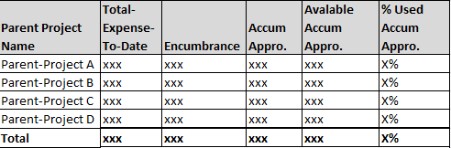
3 | Vendor product shall provide reports on planned cash flow vs. actual cash flow by pre-defined program, parent-project, or child-project.  Report title: Planned/Actual Cash Flow by Parent-Project/Child-Project  Reporting criteria for consideration:  Budget Year: Input value  Date Range: Input value  Fund Name: Input value  Lead Department Name: Input value  Parent-Project Name: Input value  Child-Project Name: Input value  Report attributes for consideration:  - Parent-Project Name: (determine by user-select value)  - Child-Project Name: (determine by user-select value)  - Planned Cash Flow (selected fiscal year, roll-up from project)  - Actual Cash Flow (selected fiscal year, roll-up from all actual expenses charged to the project)  - Remaining (planned cash flow – actual cash flow = remaining)  - Percent Spent (actual cash flow/planned cash flow = percent spent)  Sample Report  Budget Year: 2016  Date Range: 7/1/2016 to 6/30/2016  Fund Name: Wastewater Systems  Lead Department Name: Wastewater  Parent-Project Name: Digester Upgrade  Child-Project Name: All  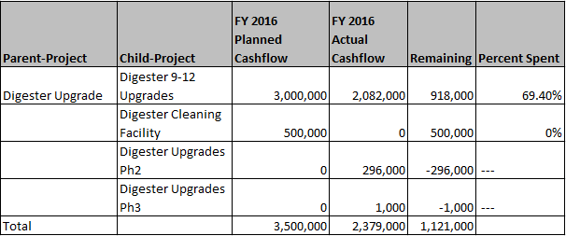
4 | Vendor product shall provide summary and detailed reports on amended/adopted budget vs. obligation based on criteria such as a date range, Fund, Department, Division, and/or Organization. See below for details for Operating reports.
5 | Vendor product shall provide summary (Operating) reports on amended/adopted budget vs. obligation based on criteria such as a date range, Fund, Department, Division, and/or Organization.  Report Title: Summary Operating Budget vs Obligation by Fund/Dept./Div/Org  Reporting criteria for consideration:  Date Range: Input value (from & to)  Fund Name: Input value  Department Name: Input value  Division Name: Input value  Organization Name: Input value  Category Name: Input value  Report attributes for consideration:  - Fund Name (determine by user-select value)  - Department Name (determine by user-select value)  - Division Name (determine by user-select value)  - Organization Name (determine by user-select value)  - Category Name (determine by user-select value)  - Adopted Budget (same as Baseline Budget, approved by the Board)  - Amended Budget (amended budget = adopted budget + budget adjustment)  - Encumbrance (the current fiscal year)  - Expenses (all actual expenses incurred in labor, contract and operations determined by user-select values and date range specified)  - Obligation (obligation = encumbrance + expenses)  - % Obligation (% obligation = obligation / amended budget)  - Avail Funds (avail funds = amended budget – obligation)  - Total (determine by user-select value)  - Grand Total (determine by user-select value)  Sample Report  Date Range: From: 1/1/2014 To: 12/31/2014  Fund Name: Water Systems  Department Name: ISD, Finance, O&M  Division Name: N/A  Organization Name: N/A  Category: All  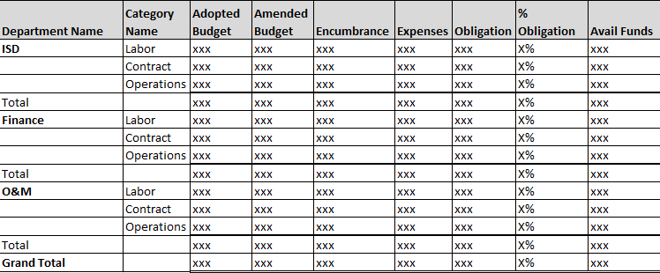  Note that the report format can vary.
6 | Vendor product shall provide detailed Operating reports on budget vs obligation based on criteria such as a date range, fund, department, division, or organization.  Report title: Detailed Operating Budget vs Obligation by Fund/Dept./Div/Org  Reporting criteria for consideration:  Date Range: Input value (from & to)  Fund Name: Input value  Department Name: Input value  Division Name: Input value  Organization Name: Input value  Category Name: Input value  Sub-Category Name: Input value  Sub-Sub-Category Name: Input value  Report attributes for consideration:  - Category Name (determine by user-select value)  - Sub-Category Name (determine by user-select value)  - Sub-Sub-Category Name (determine by user-select value)  - Adopted Budget (same as Baseline Budget, approved by the Board)  - Amended Budget (amended budget = adopted budget + budget adjustment)  - Encumbrance (the current fiscal year)  - Expenses (all actual expenses incurred in labor, contract and operations determined by user-select values and date range specified)  - Obligation (obligation = encumbrance + expenses)  - % Obligation (% obligation = obligation / amended budget)  - Avail Funds (avail funds = amended budget – obligation)  - Total (determine by user-select value)  - Grand Total (determine by user-select value)  Sample Report:  Date Range: From 1/1/2014 To 12/31/2014  Fund Name: Water Systems  Department Name: ISD  Division Name: N/A  Organization Name: Data Center  Category Name: All  Sub-Category Name: All  Sub-Sub-Category Name: N/A  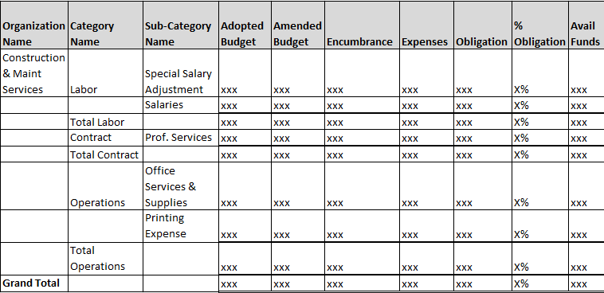
 | Operating Reports – Operating Programs & Sub-Programs
7 | Vendor product shall provide reports on Year-To-Date expenses by pre-defined operating programs, sub-programs, category, and sub-category.  Report Title: YTD Spent by Program, Sub-Program, Category, and Sub-Category  Reporting criteria for consideration:  Fund Name: Input value  Department Name: Input value  Division Name: Input value  Organization Name: Input value  Program Name: Input value  Sub-Program Name: Input value  Category: Input value  Sub-Category: Input value  Report attributes for consideration:  - Organization Name: (determine by user-select value)  - Program Name: (determine by user-select value)  - Sub-Program Name: (determine by user-select value)  - Department Name: (determine by user-select value)  - Division Name: (determine by user-select value)  - Category  - Amended Budget  - Actual Expenses  - % Actual/Planned  - Sub-total  - Total  Sample Report  Fund Name: Water Systems  Department Name: N/A  Division Name: N/A  Organization Name: FM&O  Program Name: Maintain Mains  Sub-Program Name: N/A  Category: All  Sub-Category: N/A  Fund Name: Water Systems  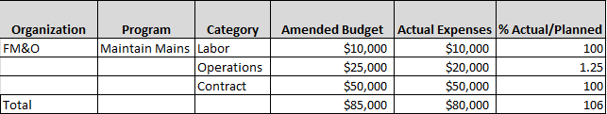
8 | Vendor product shall provide reports on Year-To-Date expenses by pre-defined operating programs and sub-programs.  Report Title: Year-To-Date Spent by Program and Sub-Program  Reporting criteria for consideration:  Fund Name: Input value  Program Name: Input value  Sub-Program Name: Input value  Department Name: Input value  Division Name: Input value  Organization Name: Input value  Category: Input value  Sub-Category: Input value  Report attributes for consideration:  - Program Name: (determine by user-select value)  - Sub-Program Name: (determine by user-select value)  - Department Name: (determine by user-select value)  - Division Name: (determine by user-select value)  - Organization Name: (determine by user-select value)  - Category: (determine by user-select value)  - Sub-Category: (determine by user-select value)  - Amended Budget (amended budget = adopted budget + budget adjustment)(from Budget component)  - YTD Encumbrance (the current fiscal year)  - YTD Expenses (all YTD actual expenses incurred in labor, contract and operations)  - Obligation (obligation = YTD encumbrance + YTD expenses)  - Avail Funds (avail funds = amended budget – obligation)  - Total (determine by user-select value)  - Grand Total (determine by user-select value)  Sample Report  Fund Name: Water Systems  Program Name: Maintain Mains  Sub-Program Name: N/A  Department Name: N/A  Division Name: N/A  Organization Name: All  Category: Labor, Contract, Operations  Sub-Category: N/A  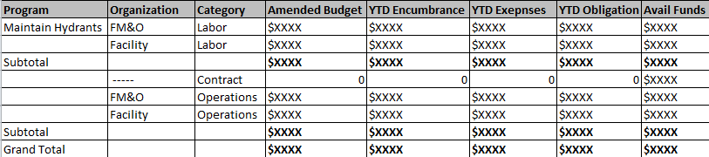
9 | Vendor product shall provide reports on expenses by pre-defined operating programs and/or sub-programs for a specified date range.  Report Title: Program and/or Sub-Program Expenses by Date Range  Reporting criteria for consideration:  Date Range: Input value  Fund Name: Input value  Program Name: Input value  Sub-Program Name: Input value  Department Name: Input value  Division Name: Input value  Organization Name: Input value  Category: Input value  Sub-Category: Input value  Report attributes for consideration:  - Program Name: (determine by user-select value)  - Sub-Program Name: (determine by user-select value)  - Department Name: (determine by user-select value)  - Division Name: (determine by user-select value)  - Organization Name: (determine by user-select value)  - Category: (determine by user-select value)  - Sub-Category: (determine by user-select value)  - Amended Budget (amended budget = adopted budget + budget adjustment)(from Budget component)  - Encumbrance (the current fiscal year, up to specified date range)  - Expenses (all actual expenses incurred in labor, contract and operations during specified date range)  - Obligation (obligation = encumbrance + expenses)  - Avail Funds (avail funds = amended budget – obligation)  - Total (determine by user-select value)  - Grand Total (determine by user-select value)  Sample Report  Date Range: 01/01/2016 To 03/31/2016  Fund Name: Water Systems  Program Name: Maintain Hydrants, Maintain Mains  Sub-Program Name: N/A  Department Name: N/A  Division Name: N/A  Organization Name: All  Category: Labor  Sub-Category: N/A  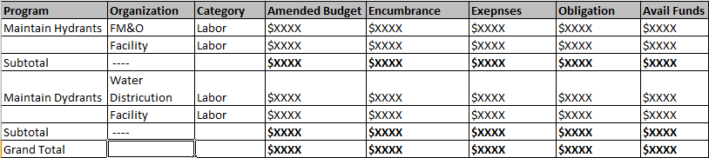
10 | Report Title: Program and/or Sub-Program Cost Analysis by Date Range  Reporting criteria for consideration:  Date Range: Input value  Fund Name: Input value  Program Name: Input value  Sub-Program Name: Input value  Department Name: Input value  Division Name: Input value  Organization Name: Input value  Category: Input value  Sub-Category: Input value  Report attributes for consideration:  - Program Name: (determine by user-select value)  - Sub-Program Name: (determine by user-select value)  - Department Name: (determine by user-select value)  - Division Name: (determine by user-select value)  - Organization Name: (determine by user-select value)  - Category: (determine by user-select value)  - Sub-Category: (determine by user-select value)  - Transaction Detail  - Transaction Date  - Vendor  - Quantity  - Direct Cost  - Full Cost  - Total Quantify  - Total Direct Cost (determine by user-select value)  - Total Full Cost (determine by user-select value)
11 | Vendor product shall provide reports on expenses by the month and organization for pre-defined operating programs and/or sub-programs.  Report Title: Monthly Expense by Organization, Program and/or Sub-Program  Reporting criteria for consideration:  Date Range: Input value  Fund Name: Input value  Program Name: Input value  Sub-Program Name: Input value  Department Name: Input value  Division Name: Input value  Organization Name: Input value  Report attributes for consideration:  - Program Name: (determine by user-select value)  - Sub-Program Name: (determine by user-select value)  - Department Name: (determine by user-select value)  - Division Name: (determine by user-select value)  - Organization Name: (determine by user-select value)  - Amended Budget (amended budget = adopted budget + budget adjustment)(from Budget component)  - July Expense (all actual expenses incurred in labor, contract and operations during specified date range)  - Aug Expense (all actual expenses incurred in labor, contract and operations during specified date range)  - Sept Expense (all actual expenses incurred in labor, contract and operations during specified date range)  - Oct Expense (all actual expenses incurred in labor, contract and operations during specified date range)  - Nov Expense (all actual expenses incurred in labor, contract and operations during specified date range)  - Dec Expense (all actual expenses incurred in labor, contract and operations during specified date range)  - Jan Expense (all actual expenses incurred in labor, contract and operations during specified date range)  - Feb Expense (all actual expenses incurred in labor, contract and operations during specified date range)  - Mar Expense (all actual expenses incurred in labor, contract and operations during specified date range)  - Apr Expense (all actual expenses incurred in labor, contract and operations during specified date range)  - May Expense (all actual expenses incurred in labor, contract and operations during specified date range)  - Jun Expense (all actual expenses incurred in labor, contract and operations during specified date range)  - Subtotal  - Grand Total  Sample Report  Date Range: 07/01/2014 To 06/30/2015  Fund Name: Water System  Program Name: All  Sub-Program Name: N/A  Department Name: N/A  Division Name: N/A  Organization Name: FM&O, Facility, Water Treatment  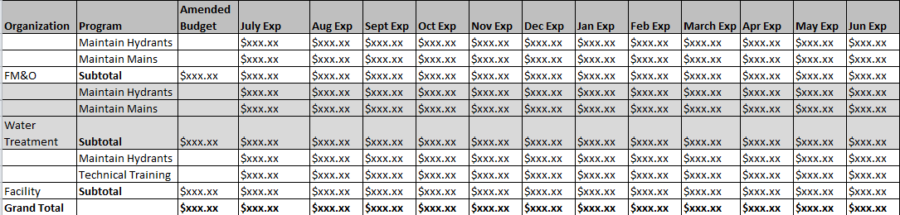
12 | Vendor product shall provide reports on comparing the actual expenditure of the current year to the prior fiscal year actuals based on criteria such as fund, department, division, organization, category, sub-category and sub-sub-category.  Report Title: Operating Summary Current Expenses vs. Prior Fiscal Year Actuals  Reporting criteria for consideration:  Current Year:  Prior Fiscal Year:  Fund Name: Input value  Department Name: Input value  Division Name: Input value  Organization Name: Input value  Category Name: Input value  Attributes for consideration:  - Category Name (determine by user-select value)  - Prior Fiscal Year: (determine by user-select value)  - Adopted Budget (same as Baseline Budget, approved by the Board)  - Amended Budget (amended budget = adopted budget + budget adjustment)  - Encumbrance (it shall reflect encumbrance for the user-select year)  - Expenses (all actual expenses incurred in labor, contract and operations of the entire prior fiscal year, determined by user-select value)  - Obligation (obligation = encumbrance + expenses)  - % Obligation (% obligation = obligation / amended budget)  - Avail Funds (avail funds = amended budget – obligation)  - Current Year: (determine by user-select value)  - Adopted Budget (same as Baseline Budget, approved by the Board)  - Amended Budget (amended budget = adopted budget + budget adjustment)  - Encumbrance (it shall reflect encumbrance for the user-select year)  - Expenses (all year-to-date actual expenses incurred in labor, contract and operations of the current year, determined by user-select value)  - Obligation (obligation = encumbrance + expenses)  - % Obligation (% obligation = obligation / amended budget)  - Avail Funds (avail funds = amended budget – obligation)  - Total (determine by user-select value)  Sample Report:  Current Year: FY 2014  Prior Fiscal Year: FY 2013  Fund Name: Water Systems  Department Name: N/A  Division Name: N/A  Organization Name: N/A  Category Name: All  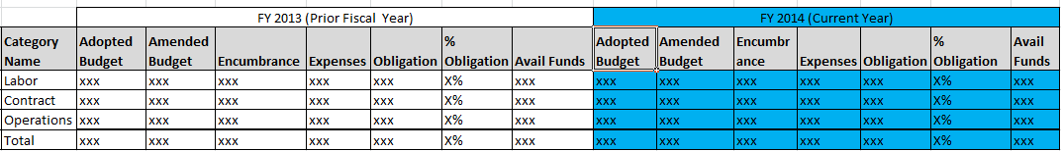  Please note that the sample report shows only 2 years of data. However, multi-years comparison also can be presented in this report.
 | Capital Reports – Monthly Expenses by Project by Category & Sub-Category
13 | Vendor product shall provide monthly reports on expenses by project by category & sub-category.  Report Title: Monthly Expenses by Project, Category, and Sub-Category  Reporting criteria for consideration:  Date Range: Input value  Fund Name: Input value  Parent-Project Name: Input value  Child-Project Name: Input value  Category Name: Input value  Sub-Category Name: Input value  Report attributes for consideration:  - Fund Name: (determine by user-select value)  - Parent-Project Name: (determine by user-select value)  - Child-Project Name: (determine by user-select value)  - Category Name: (determine by user-select value)  - Sub-Category Name: (determine by user-select value)  - July Expense (all actual expenses incurred in labor, contract and/or operations during specified date range)  - Aug Expense (all actual expenses incurred in labor, contract and/or operations during specified date range)  - Sept Expense (all actual expenses incurred in labor, contract and/or operations during specified date range)  - Oct Expense (all actual expenses incurred in labor, contract and/or operations during specified date range)  - Nov Expense (all actual expenses incurred in labor, contract and/or operations during specified date range)  - Dec Expense (all actual expenses incurred in labor, contract and/or operations during specified date range)  - Jan Expense (all actual expenses incurred in labor, contract and/or operations during specified date range)  - Feb Expense (all actual expenses incurred in labor, contract and/or operations during specified date range)  - Mar Expense (all actual expenses incurred in labor, contract and/or operations during specified date range)  - Apr Expense (all actual expenses incurred in labor, contract and/or operations during specified date range)  - May Expense (all actual expenses incurred in labor, contract and/or operations during specified date range)  - Jun Expense (all actual expenses incurred in labor, contract and/or operations during specified date range)  - Subtotal  - Grand Total  Sample Report  Date Range: 07/01/2014 To 06/30/2015  Fund Name: Water System  Parent-Project Name: All  Child-Project Name: All  Category Name: Contract  Sub-Category Name: N/A  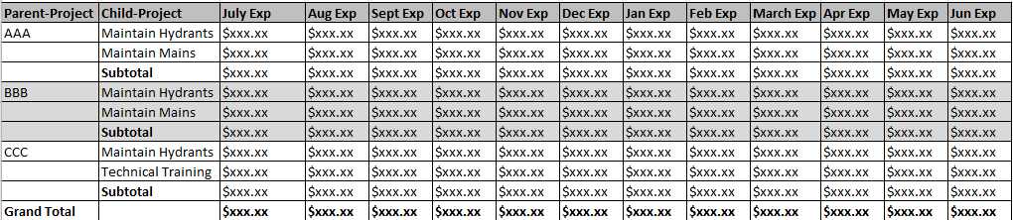
14 | Report Title: Project Cost Analysis by Date Range  Reporting criteria for consideration:  Date Range: Input value  Fund Name: Input value  Parent-Project Name: Input value  Child-Project Name: Input value  Category Name: Input value  Sub-Category Name: Input value  Report attributes for consideration:  - Fund Name: (determine by user-select value)  - Parent-Project Name: (determine by user-select value)  - Child-Project Name: (determine by user-select value)  - Category Name: (determine by user-select value)  - Sub-Category Name: (determine by user-select value)  - Employee Name  - Employee ID  - Transaction Detail  - Transaction Date  - Vendor  - Quantity  - Direct Cost  - Full Cost  - Total Quantity  - Total Direct Cost  - Total Full Cost
 | Operating/Capital Labor Expenses Summary
15 | Vendor product shall provide reports on actual labor expenses for operating vs. capital for the user-select fiscal year.  Report title: Operating/Capital Labor Expense Summary  Reporting criteria for consideration:  Fiscal Year: Input value  Fund Name: Input value  Category Name: Input value  Sub-Category Name: Input value  Report attributes for consideration:  - Fund Name: (determine by user-select value)  - Category Name: (determine by user-select value)  - Sub-Category Name: (determine by user-select value)  - Operating Labor:  - Budget Year Amended Budget (from Budget component)  - % of Total Budget (% of total budget = operating amended budget / total amended budget)  - Actual Expended To Date (actual labor charges to operating)  - % of Actual Expended (% of actual expended = operating actual expended to date /total actual expended to date)  - Actual vs. Budget ([operating] actual expended to date / operating amended budget)  - Capital Labor:  - Budget Year Amended Budget (from Budget component)  - % of Total Budget (% of total budget = capital amended budget / total amended budget)  - Actual Expended To Date (actual labor charges to capital)  - % of Actual Expended (% of actual expended = capital actual expended to date / total actual expended to date)  - Actual vs. Budget (capital actual expended to date / capital amended budget)  - Total Labor:  - Budget Year Amended Budget (operating + capital)  - % of Total Budget (100%)  - Actual Expended To Date (operating + capital)  - % of Actual Expended (100%)  - Actual vs. Budget (total actual expended to date / total amended budget)  - Total  Sample Report  Fiscal Year: FY2015  Fund Name: Water System  Category Name: N/A  Sub-Category Name: Salaries, Overtime, Employee Benefits  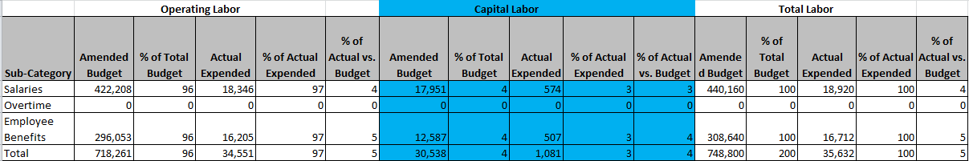
 | Reports require integration with LIMs
16 | Vendor product shall provide reports on invoice status by FIS Account Number.  Report Title: Invoice Status by FIS Account No.  Reporting criteria for consideration:  FIS Account No.: Input value  Client Name: Input value  Invoice Status: Input value  Report attributes for consideration:  - FIS Account No: (determine by user-select value)  - Client Name: (determine by user-select value)  - Invoice Status: (determine by user-select value)  - Client Invoice No.  - Total Invoice Amount  - Comments (user comments from FIS)  - Total  Sample Report:  FIS Account No.: EABA2251  Client Name: N/A  Invoice Status: N/A  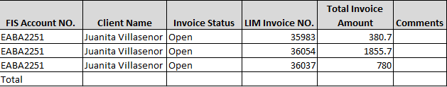
 | Reports require integration with General Work Order
17 | Vendor product shall provide reports on expenses by pre-defined operating programs and sub-programs and general work order.  Report Title: YTD Expense by Program and Sub-Program and GWO  Reporting criteria for consideration:  Fund Name: Input value  Program Name: Input value  Sub-Program Name: Input value  GWO No: Input value  Report attributes for consideration:  - GWO Number (determine by user-select value)  - PO Number  - Program Name: (determine by user-select value)  - Sub-Program Name (determine by user-select value)  - Purchase Total  - Requestor  Sample Report:  Program Name: Maintain Mains  Sub-Program Name: All  GWO No: All  Fund Name: Water System  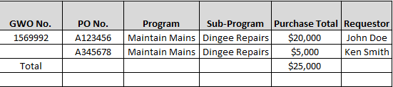
18 | Vendor product shall provide reports on journal vouchers.
19 | Vendor product shall provide reports on monthly encumbrance for vehicle replacement projects.
20 | Vendor product shall provide detail reports on actual cost vs. full cost for vehicle replacement projects by analysis type.
21 | Vendor product shall provide reports on certification source related expenditures including inception-to-date direct cost and inception-to-date full cost.

Billing (Miscellaneous)
R# | Description | Included in base package?
1 | Vendor product shall be able to produce aging report on all outstanding invoices greater than X [user defined] number of days.  Please see Report (Accounts Receivable) Requirements for aging reports.
2 | Vendor product shall be able to sort aging report by user-select criteria, but not limited to:  - Someone/Company  - Impacted Organization  - Collector  - Invoice Date  - Invoice Amount

Asset Management
R# | Description | Included in base package?
1 | Vendor product shall be able to report on netbook values of all assets created.  Columns to be considered:  - Asset types  - Associated life span  - Location  - Netbook value (by asset)  - Total Netbook values
2 | Vendor product shall be able to report on all assets created with, but not limited to, the following:  Columns to be considered:  - Asset types  - Associated life span  - Location  - Job Numbers  - Current Project Cost (by job number)  - Total Project Costs
3 | Vendor product shall provide summary reports on Asset Management by transaction types including addition, adjustment, and retirement.
4 | Vendor product shall provide detail reports on assets by various parameters including job, transaction, category, etc.
5 | Vendor product shall provide reports on monthly depreciation by transaction types including addition, adjustment, and retirement.
6 | Vendor product shall provide reports on District asset (vehicle) sales.
7 | Vendor product shall provide reports on asset (vehicle) offsets.
8 | Vendor product shall provide reports on asset costs by various parameters including fund, department, org, etc.

Purchasing

Purchasing
R# | Description | Included in base package?
1a | Ability to schedule/modify reports by specifying the following:  - Report Name  - Report Frequency  - Reporting Period (date range)  - Identify Recipient (email distribution list)  - Subscribe Recipients to the Report Distribution List
1b | Ability to generate Ad Hoc Reports  - User is able to select attributes to compose new reports to fulfill ad hoc business needs. User is also able to export ad hoc reports (in various formats) like other schedule reports.
1c | Ability to re-deliver reports as needed  - The Weekly Purchase Requests Without Activity Report was sent. However, there were issues with the mail server and the report was never delivered successfully. Admin user can re-generate and re-send the report anytime.
1d | Ability to define/modify Report Title
1e | Ability to create/modify Report Distribution List of each report
1f | Need to have page number on all reports
1g | Ability to export report to various read-only format (excel, PDF, etc.)
1h | Ability to sort report content in ascending or descending order
1i | Need Ad Hoc Reporting capability for all Purchasing, Inventory Management, Vendor Management, Accounts Payable, CE Program, etc. See Ad Hoc report examples in Ad Hoc Report section below.
2 | Purchasing Related Reports
2.1 | Purchase Requests Without Activity For More Than X [Variable] Days (or equivalent). Report content is but not limited to:  Report Title  - Purchase Requests Without Activity For More Than X Days  - Reporting Period  - Report Date  Report Body  - Purchase Request Number  - PR Amount  - End User/Requisition Requester  - Buyer Assigned  - PR Creation Date  - PR Last Updated  - Reason Code  - PR Status  - Total Number of Unprocessed PR
2.1.1 | Ability to specify report in ascending or descending order by PR Creation Date, End User, Buyer Assigned, etc. before report generation.
2.1.2 | Ability to define/modify the X [Variable] Days of the report
2.2 | Overdue Purchase Orders by Org. Report. Report content is but not limited to the following:  Report Title  - Over Due Purchase Orders by Org  - Reporting Period (weekly, monthly, etc.)  - Report Date  Report Body  - Org Number  - Organization Name  - PO Number  - PO Creation Date  - PO Expiration Date  - Vendor Name  - Initial PO Amount  - Remaining PO Amount  - Reason Code  - End User/Requisition Requester  - Buyer Name  - Grand Totals of Initial PO Amount  - Grand Totals of Remaining PO Amount
2.2.1 | Ability to sort the report in ascending or descending order by PO Creation Date, Vendor Name, PO Number, etc. before report generation
 | Employee Performance
2.3 | Buyer Purchase Order Turnaround Report. Report content including but not limited to the following:  Report Title  - Buyer Purchase Order Turnaround Report by Order Type  - Reporting Period (weekly, monthly, etc.)[This should limit to only look at POs created in this period of time, not counting all POs created in the past.]  - Report Date  Report Body  - Order Type  - Employee Name  - PO Count Processed In 7 [Variable] Days (for the period)  - % of PO Processed In 7 [Variable] Days (for the period)  - PO Count takes more than 21 [Variable] Days To Process  - % of PO takes more than 21 [Variable] Days To Process  - Average Number of Days Required to Process a PO (from the day of PO assignment to PO dispatched to vendor )
2.3.1 | Ability to adjust the number of days that drives the report
2.4 | Monthly Unauthorized Confirming Orders by Buyer. Report content including but not limited to the following:  Report Title  - Unauthorized Confirming Order and Confirming Order by Buyer  - Reporting Period (weekly, monthly, etc.)  - Report Date  Report Body  - Buyer Name  - Total Number of unauthorized POs  - Total CEU PO Amount  - Total Number of Confirming Order (CEA) POs  - Total CEA PO Amount  - Grand Totals of CEU PO Amount  - Grand Totals of CEA PO Amount
2.5 | Pending Stores Purchase Requisition by buyer. Report content including but not limited to the following:  Report Title  - Pending Stores Purchase Requisition by Org [WS and WW]  - Report Period  - Report Date  Report Body (recommend the following)  - Organization Number (WS or WW)  - PR Number  - PR Creation Date  - Days on System Unprocessed  - Comments on PR  - Total PR Amount  - PR Count (for the Organization)  - Grand Totals of Pending PR Count  - Grand Totals of PR Amount
 | Organization Performance
2.6 | Purchasing Activity by Organization Report. Report content including but not limited to the following:  Report Title  - Purchasing Activity By Organization  - Reporting Period (weekly, monthly, etc.)  - Report Date  Report Body [recommend the following]  - Organization No.  - Total PO Count  - Total PO Amount  - Sole SRC PO Count  - Total Sole SRC PO Amount  - Percentage of Sole SRC PO Amount (over total PO amount for the Org)  - Direct Award PO Count  - Total Direct Award PO Amount  - Percentage of Direct Award PO Amount (over total PO amount for the Org)  - Grand Totals of PO Amount (for the District)  - Grand Totals of Sole SRC PO Amount (for the District)  - Percentage of Grand Totals Sole SRC PO Amount (for the District)  - Grand totals of Direct Award PO Amount (for the District)  - Percentage of Grand Totals of Direct Award PO Amount (for the District)
2.6.1 | Ability to detail POs in the Purchasing Activity by Organization Report upon request. [This report will be executed as a separate report from 2.6 above.]  Report Title  - Purchases For A Given Organization No./Name  - Reporting Period (weekly, monthly, etc.)  - Reporting Org. [Variable]  - Report Date  Report Body  - PO Number  - Vendor Name  - Vendor Code  - Buyer Name  - End User Name  - Total PO Amount  - Total Paid Amount  - Order Status
2.7 | Blanket Orders Nearing Expiration Or Low Amount Remaining by Org. Condition: Blanket POs expire in less than 45 days [Variable] or amount remaining less than 20% [Variable]. Report content including but not limited to the following:  Report Title  - Blanket Orders Nearing Expiration Or Low Amount Remaining by Org  - Reporting Period  - Report Date  Report Body  - Org. Number  - Purchase Order Number  - Vendor ID  - Vendor Name  - Original Granted Amount  - Remaining Amount  - PO Start Date  - PO Expiration/Due Date  - End User / Requisition Requester  - Total Original Granted Amount (for the Org )  - Total Remaining Amount (for the Org.)
2.8 | Unauthorized Confirming Orders by Org. Report content including but not limited to the following:  Report Title  - Unauthorized Confirming Order by Org  - Reporting Period (for the month of X, represents the Month)  - Report Date  Report Body  - Org Number  - Org Name  - Total Number of unauthorized POs  - Total PO Amount  - Grand Totals of PO Amount
2.8.1 | Ability to configure recipients of this report, Unauthorized Confirming Order by Org
2.8.2 | Ability to subscribe organization directors to receive this report
2.9 | Buyer Performance Report. Report content including but not limited to the following:  Report Title  - Buyer Performance Report  - Reporting Period  - Report Date  Report Body  - Employee Name  - Change Order Count (for the employee)  - CO Percentage (for the employee)  - Purchase Order Count (for the employee)  - PO Percentage (for the employee)  - Total Order Count (for the employee)  - Order Count Percentage (for the employee)  - Total CO Count  - Total CO Percentage  - Total PO Count  - Total PO Percentage  - Grand Totals of Total Order Count
2.10 | Blanket Order Amount Expended Report by Org. Report content including but not limited to the following:  Report Title  - Blanket Order Amount Expended Report by Org.  - Reporting Period  - Report Date  Report Body  - Org. No.  - Org. Name  - PO Number  - Vendor Name  - Vendor Code  - PO Creation Date  - PO Expiration/Due Date  - Service Type  - Original Amount  - Balance Remaining Amount  - Expended Amount  - Buyer Name  - Requisition Requester
2.11 | Contract Abeyance Report  Report Title  - Contract Abeyance  - Reporting Period (monthly)  - Report Date  Report Body  - RFP/RFQ Title  - Buyer  - RFQ/RFP Number  - Vendor  - Price Adjustment Effective Date  - Contract Term Date  - Contract Review Date  - Number of Available Options  - Estimated Annual Value  - Remaining Amount (of the PO)  - Remarks (same as PO comment)  - Purchase Order (parent PO)
3 | Ad Hoc Report – Purchasing
3.1 | Non-Board purchases coded to Account travel-material. Report content includes, but is not limited to, the following:  Ability to specify the following parameters in order to generate this report:  - Account (travel-material)  - Report Period (date range)  - Report Title  Report Title  - Purchases Coded To Travel-Material  - Reporting Period  - Report Date  Report Body  - Account Description  - Vendor Name  - PO Number  - PO Amount  - Total PO Amount for the Account
3.2 | Purchases by Date Range. Report content includes, but is not limited to, the following:  Report Title  - Purchases by Date Range  - Reporting Period (weekly, monthly, etc.)  - Report Date  Report Body  - PO Type  - PO Service Type  - Special Order Indicator  - PO Number  - PO Creation Date  - Vendor Name  - PO Amount Without Tax  - Tax %  - Tax Amount  - Total PO Amount Without Tax  - Total Tax Amount
3.3 | Most Active Vendor Report. Report content includes, but is not limited to, the following:  Ability to specify PO Amount range to generate this report  Report Title  - Most Active Vendor Report  - Reporting PO Amount [Variable]  - Reporting Period  - Report Date  Report Body  - Vendor Name  - Vendor Code/ID  - PO Count  - Total PO Amount  - Grand Totals of PO Count  - Grand Totals of PO Amount
3.4 | Payment By Project. Report content includes, but is not limited to, the following:  Ability to generate report for specific project ID or project name  Report Title  - Payment By Project  - Reporting Period  - Report Date  Report Body  - Project ID  - Project Name  - PO Number  - Total PO Amount  - Total Paid Amount  - Grand Totals of PO Amount (for the District)  - Grand Totals of Paid Amount (for the District)
3.5 | Payment By Program. Report content includes, but is not limited to, the following:  Ability to generate report for specific program.  Report Title  - Payment By Program  - Reporting Period  - Report Date  Report Body  - Program Number  - Program Name  - PO Count  - Total PO Amount  - Total Amount Paid  - Grand Totals of PO Amount (for the District)  - Grand Totals of Amount Paid (for the District)

Purchase Card (P-Card)
R# | Description | Included in base package?
1 | Report on P-Card transactions by FIS coding for a given transaction date range (Organization and Project ID)  Report Title  - P-Card Purchases By FIS Coding  - Reporting Period (date range)  - Report Date  Report Body  - FIS Coding (Organization, Project ID, etc.)  - Card Holder Name  - P-Card Number (last 4 Digit)  - Merchant Information (name, state, etc.)  - Transaction Date  - Posting Date  - G/L Code (merchant category)[nice to have]  - Item Description  - Total Billed Amount(by Org)  - Grand Total
2 | Report on P-Card transactions by P-Card holder for a given transaction date range  Report Title  - P-Card Purchases By Card Holder  - Reporting Period (date range)  - Report Date  Report Body  - Card Holder Name  - P-Card Number (last 4 Digit)  - Merchant Information (name, state, etc.)  - Transaction Date  - Posting Date  - G/L Code (merchant category)  - Item Description  - Total Billed Amount(by P-Card holder)  - Grand Total
3 | Report on P-Card transactions by Grouped Purchases for a given transaction date range  Report Title  - P-Card Purchases by Group  - Reporting Period (date range)  - Report Date  Report Body  - Group (Org No., job classification, etc.)  - P-Card Number (last 4 digit)  - Merchant Information (name, state, etc.)  - Transaction Date  - Posting Date  - G/L Code (merchant category)  - Item Description  - Total Billed Amount (by Group)  - Grand Totals of Billed Amount
4 | Report on P-Card holder with unreconciled transactions for a given date range  Report Title  - Unreconciled Purchases by Card Holder  - Reporting Period (date range)  - Report Date  Report Body  - Card Holder Name  - Last 4 Digits of P-Card  - Reconciler  - Approver  - Merchant Information (name, state, etc.)  - Transaction Date  - Posting Date  - G/L Code (merchant category)  - Total Billed Amount (by P-Card holder)  - Grand Total
5 | Report on unreconciled purchases summary for a given date range  Report Title  - Unreconciled Purchases Summary  - Reporting period (date range)  - Date of Report Generation  Report Body  - Card Holder Name  - Last 4 Digits of P-Card  - No. of Unreconciled Transactions  - Approver  - Reconciler  - Total Unreconciled Amount (by P-Card holder)  - Grand Totals of Unreconciled Amount
6 | Report on P-Card holder received email reminder regarding unreconciled transactions for a given date range  [on second thought, this is a duplicate of report 19.4]
7 | Report on approvers with approval pending requests for a given date range  Report Title  - Pending Approval Statements Summary  - Reporting Period (date range)  - Report Date  Report Body  - Approver Name  - Number of Requests Pending for Approval  - Total Unapproved Amount (by approver)  - Grand Totals of Unapproved Amount
8 | Report on approvers received email reminder regarding approval pending requests for a given date range
9 | Report on taxable out-of-state P-Card transactions for a given posting date range:  Report Title  - Taxable Out-Of-State P-Card Purchases  - Reporting Period (date range)  - Report Date  Report Body  - Card Holder Name  - P-Card Number (last 4 digits)  - Merchant Information (name, state, etc.)  - Transaction Date  - Post Date  - G/L Code (merchant category)  - Item Description  - Tax Collected (Y/N)  - Billed Amount  - Accrued Tax Amount  - Non-accrued Tax Amount  - Total Billed Amount (by P-Card holder)  - Total Tax Accrued Amount (by P-Card holder)  - Total Tax Non-accrued Amount (by P-Card holder)  - Grand Totals of Billed Amount  - Grand Totals of Accrued Tax Amount  - Grand Totals of Non-accrued Tax Amount
10 | Report on District wide P-Card expenditures for a given date range  Report Title  - District P-Card Expenditures  - Reporting Period  - Report Date  Report Body  - Total Billed Amount  - Total Number of Transactions  - Total Tax Accrued  - Total Tax Non-accrued
11 | Report on Purchases grouped by P-Card and Merchant for a given date range and Transaction Amount  Report Title  - P-Card Purchases by Transaction Amount within Date Range  - Reporting Period (date range)  - Transaction Amount Range [Variable]  - Report Date  Report Body  - P-Card Number (last 4 digits)  - Card Holder Name  - Merchant Name/Vendor Name  - Merchant Code  - Item Description  - Transaction Date  - Post Date  - Transaction Amount  - Total Amount for that Merchant  - Grand Total Amount of the P-Card
12 | Need Ad-Hoc reporting capability on P-Card transactions
13 | Ability to setup/modify scheduled reports
14 | Ability to roll up total year end P-Card expenditure by organization, project, and accounts.
15 | Ability to report on reconciliation done by reconcilers vs. card holders

Vendor Management

Vendor Management
R# | Description | Included in base package?
1 | Reporting – Vendor Management
1.1 | Report on vendors’ activities by ethnicity code for a given date range excluding selected organization.  Report Title  - Vendor Activity by Ethnicity Code (for a given month)  - The Reporting Period (weekly, monthly, etc.)  - Report Date  Report Body  - Ethnicity Code  - Ethnicity Name  - Vendor Count (belongs to this ethnicity code)  - Sole Source PO Count (for this ethnicity)  - Direct Award PO Count (for this ethnicity)  - Discount PO Count (for this ethnicity)  - Total PO Count for this Ethnicity Code  - Total PO Amount for the Ethnicity Code  - Grand Totals of Sole Source PO Count  - Grand Totals of Direct Award PO Count  - Grand Totals of Discount PO Count  - Grand Totals of PO Amount
1.1.1 | Ability to display the detailed correspondent information (vendor name, PO number, PO amount) in the “Vendor Activity by Ethnicity Code Report” by expanding one of the following:  - Vendor Count  - Sole Source PO Count  - Direct Award PO Count  - Discount PO Count  - PO Count for the Ethnicity
1.2 | Report on vendors’ activities by vendor name for a given date range.  Report Title  - Vendor Activity by Vendor Name  - The Reporting Period (weekly, monthly, etc.)  - Report Date  Report Body  - Vendor Name  - Vendor Code  - Commodity Code(NIGP or NAICS/EBMUD Code)  - PO Count for Sole Source  - PO Count for Direct Award  - PO Count for Construction Service Type  - PO Count for Professional Services Service Type  - PO Count for Materials & Supplies Service Type  - PO Count for General Services Service Type  - Total PO Count for the Vendor  - Total PO Amount for the Vendor  - Grand Totals PO Amounts
1.2.1 | Ability to display the detailed correspondent information (commodity code, PO number, PO amount) in the “Vendor Activity by Vendor Name Report” by expanding one of the following on report:  - PO Count for Sole Source  - PO Count for Direct Award  - PO Count for Construction Service Type  - PO Count for Professional Service Type  - PO Count for Materials & Supplies Service Type  - PO Count for General Services Service Type  - Total PO Count for the Vendor
1.3 | Ability to report on “Vendors Activity by Ethnicity Code” for an organization with a given date range.  Report Title  - Vendor Activity by Ethnicity Code within the Organization  - The Reporting Period (weekly, monthly, etc.)  - Report Date  Report Body  - Organization Number  - Ethnicity Code  - Organization  - Sole Source PO Count for this Ethnicity within the Org  - Direct Award PO Count for this Ethnicity within the Org  - Discount PO Count for this Ethnicity within the Org  - Set-Aside PO Count for this Ethnicity within the Org  - Total PO Count for the Ethnicity within the Org  - Total PO Amount for the Ethnicity within the Org  - Total PO Count for the Org  - Total PO Amount for the Org
1.3.1 | Ability to display detailed correspondent information (ethnicity, PO number, PO amount) in the “Vendor Activity by Ethnicity Code” for the Organization by expanding one of the following in the report:  - PO Count for the Ethnicity Code  - Sole Source PO Count for the Ethnicity  - Direct Award PO Count for the Ethnicity  - Discount PO Count for the Ethnicity  - Set-Aside PO Count for the Ethnicity  - Total PO Count for the Ethnicity  - Total PO Count for the Organization
1.4 | Report on commodity code/NIGP or NAICS / EBMUD code by vendor [Single vendor can offer multiple commodity codes.]  Report Title  - Commodity Code by Vendor  - Reporting Period (weekly, monthly, etc.)  - Date of Report Generation  Report Body  - Vendor Name  - Vendor Code  - Commodity Code/NIPG or NAICS/EBMUD Code  - Vendor Status (active/inactive)
1.5 | Report on vendors (in alphabetical order) with the following information:  Report Title  - Vendor List  - Reporting Period (weekly, monthly, etc.)  - Date of Report Generation  Report Body  - Vendor Name/Firm Name  - Vendor Code/ID  - Business Location  - Contact Information (name, title, email, website, toll free, fax, etc.)  - Company Ownership type (private, public, non-profit, etc.)  - Ethnicity Code  - Company Size (number of employees, revenue, etc.)  - Commodity Code / NIGP or NAICS / EBMUD Code  - SBE (Y/N)  - Payment Terms  - Tax ID  - Date of Registration  - Vendor Status (active/inactive)
1.6 | Need Ad-Hoc reporting capability for vendor related reports.
1.7 | Report on consulting and service orders of $70K or less by vendor for vendors with more than $70K of YTD purchases.  Report Title  - Consulting and Service Orders of $70K or Less for Vendors With More Than $70K of YTD Purchases  - The Reporting Period (monthly, yearly, etc.)  - Report Date  Report Body  - Vendor Code  - Vendor Name  - PO Number  - Service Type  - PO Creation Date  - PO Expiration Date  - PO Status  - Total PO Dollar Amount for the Vendor  - Grand Total PO Amount for the District
1.7.1 | Ability to define/modify the dollar amount threshold of this report
1.8 | Report on purchase order types by ethnicity for the Organization.  Report Title  - Purchase Types by Ethnicity with the Organization  - Reporting Period (weekly, monthly, etc.)  - Report Date  Report Body  - Organization Number  - Organization Name  - Ethnicity Code  - Ethnicity  - PO Count for Blanket PO Type (for the ethnicity within the Org.)  - PO Count for Proposal PO Type (for the ethnicity within the Org.)  - PO Count for Template PO Type (for the ethnicity within the Org.)  - PO Count for Fuel PO Type (for the ethnicity within the Org.)  - PO Count for Annual PO Type (for the ethnicity within the Org.)  - PO Count for Line Item PO Type (for the ethnicity within the Org.)  - PO Count for Board PO Type (for the ethnicity within the Org.)  - Total PO Dollar Amount for the Ethnicity within the Org.  - Total PO Dollar Amount for the Organization  - Ethnicity Percentage of the Grand Totals PO Amount  - Grand Totals of PO Amount
1.9 | Ability to run and print Deadbeat parent report on required state forms
1.10 | Ability to report on unmatched Tax Identification Number (TIN) and vendor name

Contract Equity Program
R# | Description | Included in base package?
1 | Ability to retain CE Program related reports for X [Variable] years
2 | RFP Solicitation Report.  Report Title  - RFP Solicitation Report  - Reporting Period (monthly, quarterly, etc.)  - Report Date  Report Body  - Service Type (construction, professional services, materials and supplies, and general services)  - Number of RFP/RFQ for the Service Type  - Number of Bid Opportunity Announced to Public for the Service Type  - Number of Bid Opportunity Announced by Invitation Only (sent to suggested vendors only) for the Service Type  - Total Number of RFP/RFQ for all Service Types  - Total Number of Bid Opportunity to Pubic for all Service Types  - Total Number of Bid Opportunity by Invitation Only for all Service Types
2.1 | Detailed RFP Solicitation Report.  Report Title  - Detailed RFP Solicitation Report  - Reporting Period (monthly, quarterly, etc.)  - Report Date  Report Body  - Service Type  - RFP Number / RFQ Number  - RFP Name / RFQ Name  - Vendor Name (vendor by public notification)  - User-select Vendor Name (vendor by invitation)
3 | Report on analysis on bid participants.  Report Tile  - Bid Analysis Report  - Reporting Period  - Report Date  Report Body  - Service Type  - Number of RFQ/RFPs for the Service Type  - Number of Bids Received for the Service Type  - Number of Non-SBE Bids for the Service Type  - Non-SBE Bid Percentage for the Service Type  - Number of SBE Bids for the Service Type  - SBE Bid Percentage for the Service Type  - Number of MBE Bids for the Service Type  - MBE Bid Percentage for the Service Type  - Number of Local Business Bids for the Service Type  - Local Business Percentage for the Service Type  - Number of Set-Aside for the Service Type  - Set-Aside Percentage for the Service Type  - Number of Discount Applied for the Service Type  - Discount Percentage for the Service Type  - Total Number of RFQ/RFP for all Service Types  - Total Number of Bid Received for all Service Types  - Total Number of Non-SBE Bids for all Service Types  - Total Non-SBE Bid Percentage for all Service Types  - Total Number of SBE Bids for all Service Types  - Total SBE Bid Percentage for all Service Types  - Total Number of MBE Bids for all Service Types  - Total MBE Bid Percentage for all Service Types  - Total Number of Local Business Bids for all Service Types  - Total Local Business Bid Percentage for all Service Types  - Total Number of Set-Aside for all Service Types  - Total Set-Aside Amount for all Service Types  - Total Set-Aside Percentage for all Service Types  - Total Number of Discount Applied for all Service Types  - Total Discount Percentage for all Service Types
4 | Report on analysis on bid result.  Report Title  - Bid Result Analysis Report  - Reporting Period  - Report Date  Report Body  - Service Type  - Number of RFP/RFQs for the Service Type  - Number of Bids Received for the Service Type  - Number of Winning Bids by Non-SBE for the Service Type  - Winning Amount by Non-SBE for the Service Type  - Winning Bid Percentage by Non-SBE for the Service Type  - Number of Winning Bids by SBE for the Service Type  - Winning Amount by SBE for the Service Type  - Winning Bid Percentage by SBE for the Service Type  - Number of Winning Bid by MBE for the Service Type  - Winning Amount by MBE for the Service Type  - Winning Bid Percentage by MBE for the Service Type  - Number of Winning Bids by Local Business for the Service Type  - Winning Amount by Local Business for the Service Type  - Winning Bid Percentage by Local Business for the Service Type  - Total Number of RFP/RFQs  - Total Number of Bids Received  - Total Number of Winning Bids by Non-SBE  - Total Winning Amount by Non-SBE  - Total Winning Bid Percentage by Non-SBE  - Total Number of Winning Bid by SBE  - Total Winning Amount by SBE  - Total Winning Bid Percentage by SBE  - Total Winning Bid by MBE  - Total Winning Amount by MBE  - Total Winning Bid Percentage by MBE  - Total Winning Bid by Local Business for all Service Types  - Total Winning Amount by Local Business for all Service Types  - Total Winning Bid Percentage by Local Business for all Service Types
5 | Report on vendor analysis.  Report Title  - Vendor Analysis (active vendor)  - Reporting Period  - Report Date  Report Body  - Ethnicity Name  - SBE Non-Local Business Count (per ethnicity)  - SBE Local Business Count (per ethnicity)  - Non-SBE Non- Local Business Count (per ethnicity)  - Non-SBE Local Business Count (per ethnicity)  - Total Vendor Count (per ethnicity)  - Total Vendor Count (per gender/male)  - Total Vendor Count (per gender/female)  - Total SBE Non-Local Business Count (CA)  - Total SBE Non-Local Business Count (out-of-state)  - Total SBE Local Business Count  - Total Non-SBE Non-Local Business Count  - Total Non-SBE Local Business Count  - Total Overall Vendor Count  - Total Vendor Count (roll-Up)  - Total Vendor Count (male)  - Total Vendor Count (female)
6 | Report on purchases by service type.  Report Title  - Purchases by Service Type  - Reporting Period  - Report Date  Report Body  - Construction PO Amount  - Percentage (construction)  - Materials and Supplies PO Amount  - Percentage (materials and supplies)  - Professional Service PO Amount  - Percentage (professional service)  - General Services PO Amount  - Percentage (general services)  - SBE PO Amount (construction)  - SBE Percentage (construction)  - SBE PO Amount (materials and supplies)  - SBE Percentage (materials and supplies)  - SBE PO Amount (professional service)  - SBE Percentage (professional service)  - SBE PO Amount (general services)  - SBE Percentage (general services)  - LBE PO Amount (construction)  - LBE Percentage (construction)  - LBE PO Amount (materials and supplies)  - LBE Percentage (materials and supplies)  - LBE PO Amount (professional service)  - LBE Percentage (professional service)  - LBE PO Amount (general services)  - LBE Percentage (general services)  - MWBE PO Amount (construction)  - MWBE Percentage (construction)  - MWBE PO Amount (materials and supplies)  - MWBE Percentage (materials and supplies)  - MWBE PO Amount (professional service)  - MWBE Percentage (professional service)  - MWBE PO Amount (general services)  - MWBE Percentage (general services)  - Minority PO Amount (construction)  - Minority Percentage (construction)  - Minority PO Amount (materials and supplies)  - Minority Percentage (materials and supplies)  - Minority PO Amount (professional service)  - Minority Percentage (professional service)  - Minority PO Amount (general services)  - Minority Percentage (general services)  - WMBE PO Amount (construction)  - WMBE Percentage (construction)  - WMBE PO Amount (materials and supplies)  - WMBE Percentage (materials and supplies)  - WMBE PO Amount (professional service)  - WMBE Percentage (professional service)  - WMBE PO Amount (general services)  - WMBE Percentage (general services)  - SBE Non-Local PO Amount (construction)  - SBE Non-Local Percentage (construction)  - SBE Non-Local PO Amount (materials and supplies)  - SBE Non-Local Percentage (materials and supplies)  - SBE Non-Local PO Amount (professional service)  - SBE Non-Local Percentage (professional service)  - SBE Non-Local PO Amount (general services)  - SBE Non-Local Percentage (general services)  - SBE Local PO Amount (construction)  - SBE Local Percentage (construction)  - SBE Local PO Amount (materials and supplies)  - SBE Local Percentage (materials and supplies)  - SBE Local PO Amount (professional service)  - SBE Local Percentage (professional service)  - SBE Local PO Amount (general services)  - SBE Local Percentage (general services)
7 | Report on SBE, Discount and Set-Aside purchases analysis by Org.  Report Title  - SBE, Discount, Set-Aside Purchases Analysis by Org. Report  - Reporting Period  - Report Date  Report Body  - Organization No.  - Organization Name  - SBE Set-Aside PO Amount  - SBE Non-Set-Aside and Non-Discount PO Amount  - SBE Discount PO Amount  - Non-SBE PO Amount  - Total (SBE Set-Aside PO amount)  - Total (SBE Non-Set-Aside and Non-Discount PO amount)  - Total (SBE discount PO amount)  - Total (Non-SBE PO amount)
 | CE Program Ad Hoc Reports
8 | Report on SBE, Discount, and Set-Aside purchases analysis by Department.  Ability to input department number to generate this report.  Report Title  - SBE, Discount, Set-Aside Purchases Analysis by Department  - Reporting Period  - Reporting Department  - Report Date  Report Body  - Organization No.  - Organization Name  - SBE Set-Aside PO Amount  - SBE Non-Set-Aside and Non-Discount PO Amount  - SBE Discount PO Amount  - Non-SBE PO Amount  - Total (SBE Set-Aside PO amount)  - Total (SBE Non-Set-Aside and Non-Discount PO amount)  - Total (SBE discount PO amount)  - Total (Non-SBE PO amount)
9 | Report on purchases by service type by ethnicity.  Ability to input Ethnicity to generate this report.  Report Title  - Purchases by Service Type by Ethnicity  - Reporting Period  - Reporting Ethnicity  - Report Date  Report Body  - Construction PO Amount  - Percentage (construction)  - Materials and Supplies PO Amount  - Percentage (materials and supplies)  - Professional Service PO Amount  - Percentage (professional service)  - General Services PO Amount  - Percentage (general services)  - SBE PO Amount (construction)  - SBE Percentage (construction)  - SBE PO Amount (materials and supplies)  - SBE Percentage (materials and supplies)  - SBE PO Amount (professional service)  - SBE Percentage (professional service)  - SBE PO Amount (general services)  - SBE Percentage (general services)  - LBE PO Amount (construction)  - LBE Percentage (construction)  - LBE PO Amount (materials and supplies)  - LBE Percentage (materials and supplies)  - LBE PO Amount (professional service)  - LBE Percentage (professional service)  - LBE PO Amount (general services)  - LBE Percentage (general services)  - MWBE PO Amount (construction)  - MWBE Percentage (construction)  - MWBE PO Amount (materials and supplies)  - MWBE Percentage (materials and supplies)  - MWBE PO Amount (professional service)  - MWBE Percentage (professional service)  - MWBE PO Amount (general services)  - MWBE Percentage (general services)  - Minority PO Amount (construction)  - Minority Percentage (construction)  - Minority PO Amount (materials and supplies)  - Minority Percentage (materials and supplies)  - Minority PO Amount (professional service)  - Minority Percentage (professional service)  - Minority PO Amount (general services)  - Minority Percentage (general services)  - WMBE PO Amount (construction)  - WMBE Percentage (construction)  - WMBE PO Amount (materials and supplies)  - WMBE Percentage (materials and supplies)  - WMBE PO Amount (professional service)  - WMBE Percentage (professional service)  - WMBE PO Amount (general services)  - WMBE Percentage (general services)  - SBE Non-Local PO Amount (construction)  - SBE Non-Local Percentage (construction)  - SBE Non-Local PO Amount (materials and supplies)  - SBE Non-Local Percentage (materials and supplies)  - SBE Non-Local PO Amount (professional service)  - SBE Non-Local Percentage (professional service)  - SBE Non-Local PO Amount (general services)  - SBE Non-Local Percentage (general services)  - SBE Local PO Amount (construction)  - SBE Local Percentage (construction)  - SBE Local PO Amount (materials and supplies)  - SBE Local Percentage (materials and supplies)  - SBE Local PO Amount (professional service)  - SBE Local Percentage (professional service)  - SBE Local PO Amount (general services)  - SBE Local Percentage (general services)

Inventory (Warehouse) Management
Note, the year in the inventory management related reports refer to fiscal year.
R# | Description | Included in base package?
1 | Ability to report storekeepers performance
1.1 | Report Title  - Storekeeper Performance for a Given Warehouse  - Warehouse Location  - Reporting Period (monthly)  - Report Date  Report Body  - Employee Name  - Number of Receipts Processed (for the employee)  - Number of Received Items Processed (for the employee)  - Number of Transfers Processed (for the employee)  - Number of Transferred Items Processed (for the employee)  - Number of Returns Processed (for the employee)  - Number of Returned Items Processed (for the employee)  - Number of Cycle Counts Processed (for the employee)  - Total Number Receipts Processed (for the warehouse location)  - Total Number of Received Items Processed (for the warehouse location)  - Total Number of Transfers Processed (for the warehouse location)  - Total Number of Transferred Items Processed (for the warehouse location)  - Total Number of Returns Processed (for the warehouse location)  - Total Number of Returned Items Processed (for the warehouse location)
2 | Report Title  - Yard Stock Combined Status  - Reporting Period (monthly)  - Report Date  Report Body  - Warehouse Location  - Item Number (sort by item number)  - Item Description  - Unit of Measure  - Unit Price  - QTY On Hand (of the location)  - QTY Reserved (of the location)  - On Hand Value (of the location)  - Reserved Value (of the location)  - Total Inventory Value (of the location)  - Year To Date QTY Issued  - Year To Date QTY Returned  - Year To Date QTY Disposed  - Total QTY On Hand (of all locations)  - Total QTY In Reserved (of all locations)  - Total QTY On Hand in Dollar Amount (of all locations)  - Total QTY Reserved in Dollar Amount (of all locations)  - Total Year To Date QTY Issued in Dollar Amount  - Total Year To Date QTY Returned in Dollar Amount  - Total Year To Date QTY Disposed in Dollar Amount
2.1 | Ability to generate the “Yard Stock Combine Status Report” by Specific Location.
 | Ad Hoc Reports – Inventory
3 | This report identifies all items nearly reaching order point based on input lead time and order point.  Ability to input one or more of the following parameters to generate the report:  - Lead Time (number of days)  - Percentage within order point (For example, the order point is 100. Within 10% of order point means QTY On Hand is 110.)  - Date Range  Report Title  - Items Nearly Reaching Order Point  - Reporting Period (date range)  - Report Date  Report Body  - Item Number  - Item Description  - QTY On Hand  - QTY Reserved  - QTY On Order  - QTY Forecast  - Order Point  - Lead Time (to order)
4 | Ability to input one or more of the following parameters to generate this report:  - Number of days  - Warehouse Location (central, south yard, all location, etc.)  - Date Range  Report sort by Item Number  Report Title  - New Items Added In the Last X [Variable] days  - Reporting Period (date range)  - Report Date  Report Body  - Item Number  - Item Description  - Warehouse Location  - Unit of Measure  - Unit Price  - QTY On Hand
4.1 | Ability to sort by warehouse location and item if more than one location is specified.
5 | Report on items without activities in the last 12 month.  Ability to input warehouse location(s) to generate this report.  Report Title  - Infrequently Issued Inventory  - Report Date  Report Body  - Warehouse Location  - Item Number  - Item Number Description (short)  - Unit of Measure  - Unit Price  - On Hand QTY  - On Hand Value  - The Most Current Issue Date
6 | Issuance By Employee  Ability to specify one or more of the following to generate this report:  - Organization  - Item Number  - Employee Number  - Date Range for the report  For Example: Specified Employee Number  Report Title  - Issuance By Employee  - Reporting Period (date range)  - Report Date  - Employee Name (and/or Organization)  Report Body  - Item Number  - Item Description  - Quantity Issued  - Total Checked Out Value  - Number of Transactions
6.1 | Ability to sort report content by organization no.
7 | Ability to input specified number of days and date range to generate this report.  Report Title  - Unprocessed Store Requisition Older Than X [variable] Days  - Reporting Period (date range)  - Report Date  Report Body  - Requisition Number  - Requisition Submission Date  - Transaction Type  - Destination  - Item Description (short)  - QTY Requested  - Required By  - Project ID  - Org Number  - Comment
8 | This report identifies all items that are due for inventory.  Ability to input one or more of the following parameters to generate this report:  - Warehouse location  - Category  - Storage Location  Report Title  - Inventory Cycle Count – Items Due To Be Counted  - Reporting Period (date range)  - Report Date  Report Body  - Warehouse Location (central, south yard, etc.)  - Item Number  - Item Description (short)  - Storage Location (zone, row, etc.)  - Unit of Measure  - Total Number of Item Due for Inventory Count
9 | Ability to compare inventory usage this time of the year and this time of the prior year.  Ability to input category or item number to generate this report.  Report Title  - Usage Compare to Prior Year  - Reporting Period (last 12 months)  - Report Date  Report Body  - Item Number  - Item Description  - Unit Of Measure  - Unit Price  - Year-To-Date QTY Issued  - Prior Year, Year-To-Date QTY Issued  - Delta in Percentage (formula: (year-to-date QTY issued – prior year year-to-date QTY)/prior year year-to-date QTY issued X 100%)
10 | Ability to input warehouse location to generate this report.  Report Title  - Product Catalog by Location (warehouse location)  - Report Date  Report Body  - Item Number  - Item Description (short)  - Item Description (long)  - Unit of Measure  - Expiration Date  - Hazardous Material (Y/N)  - Inspection Required (Y/N)  - Order point  - End Product (Y/N) [This indicates if the item is a manufactured item.]  - Supplier (current vendor)
10.1 | Ability to generate the same report, sort by Item Description (long)
11 | Report Title  - Product Catalog Report  - Report Date  Report Body  - Product Category  - Item Number  - Item Description (short)  - Item Description (long)  - Unit of Measure  - Expiration Date  - Hazardous Material (Y/N)  - Inspection Required (Y/N)  - Order point  - End Product (Y/N)[This indicates if the item is manufactured item.]  - Supplier (current vendor)
11.1 | Ability to sort or re-run report “Product Catalog” by item number or item description (short).
12 | This report provides summary of what and how many items have been used for a project.  Ability to input Project ID to generate this report.  Report Title  - Material Usage for A Specific Job  - Reporting Period  - Reporting Job Name  - Report Date  Report Body  - Project ID  - Item Number  - Item Description  - Unit of Measure  - Total QTY  - Total Amount  - Loading Charge  - Total Cost (amount + loading charge)  - Grand Total of Total Amount  - Grand Total of Total Loading Charge  - Grand Total of Total Cost
13 | Ability to report on “Open Line Item” POs.  Ability to input date range to generate this report.  Report Title  - Open Line Item by Item  - Reporting Period (date range)  - Report Date  Report Body  - Item Number  - Item Description  - PO Number (line item order)  - PO Created Date  - PO Due Date  - QTY Ordered  - QTY Remaining  - Vendor Name (the last vendor)  - Vendor Phone Number  - Vendor Email
13.1 | Ability to sort report “Open Line item by Item” by vendor name.
14 | Report on past due “Line Item” POs.  Ability to input date range to generate this report.  Report Title  - Late Line Item by Item  - Reporting Period (date range)  - Report Date  Report Body  - Item Number  - Item Description  - PO Number (line item order)  - PO Created Date  - PO Due Date  - QTY Ordered  - QTY Remaining  - Vendor Name (the last vendor)  - Vendor Phone Number  - Vendor Email
14.1 | Ability to sort report “Late Line item by Item” by vendor name.
15 | Report on past due “Line Item” POs with remaining quantity where Item is out-of-stock.  Ability to input date range to generate this report.  Report Title  - Late Line Item by Item  - Reporting Period (date range)  - Report Date  Report Body  - Item Number  - Item Description  - PO Number (line item order)  - PO Created Date  - PO Due Date  - QTY Ordered  - QTY Remaining  - Vendor Name (the last vendor)  - Vendor Phone Number  - Vendor Email
16 | Ability to input warehouse location(s) to generate this report.  Report Title  - Item Out-Of-Stock Report (by warehouse location)  - Reporting Period (date range)  - Report Date  Report Body  - Item Number  - Item Description  - Unit of Measure  - QTY On Hand  - Order Point  - Last PO Number  - Last PO Status  - QTY Backordered  - QTY Reserved  - QTY On Order
17 | Ability to report on inventory by warehouse in descending order, value from high to low.  Ability to input warehouse location and date range to generate this report.  Ability to sort by warehouse location and Total On Hand Value from high to low.  Report Title  - Product Inventory List  - Reporting Period (date range)  - Report Date  Report Body  - Warehouse Location  - Item Number  - Item Description  - Unit of Measure  - Unit Price  - QTY On Hand  - Total On Hand Value
18 | Ability to report on inventory by warehouse location.  Report Title  - Product Inventory  - Reporting Period (date range)  - Report Date  Ability to input warehouse location and date range to generate this report.  Report Body  - Warehouse Location  - Category  - Item Number  - Item Description (long)  - QTY On Hand  - QTY Reserved  - QTY Backordered  - QTY On Order  - QTY Forecast
19 | This report lists all items in “Reserved” greater than specified number of days and sort by item number.  Report Title  - Items in Reserved Greater Than X [Variable] days  - Report Date  Report Body  - Item Number  - Item Description  - Item Expiration Date  - Unit of Measure  - Unit Price  - QTY in Reserved  - Total Amount in Reserved  - Number of Days in Reserved  - Project ID  - Requisition Requester
19.1 | Ability to generate this report and sort by project ID.
20 | This report lists all items in “Reserved” and sort by item number.  Report Title  - Items in Reserved  - Report Date  Report Body  - Item Number  - Item Description  - Item Expiration Date  - Unit of Measure  - Unit Price  - QTY in Reserved  - Total Amount in Reserved  - Number of Days in Reserved  - Project ID  - Requisition Requester
20.1 | Ability to generate the same report, sort by Project Id
21 | This report lists all items “Reserved” by inactive/closed project.  Report Title  - Items in Reserved  - Report Date  Report Body  - Project ID  - Project Status  - Project Expired/Closed Date  - Item Number  - Item Description  - Item Expiration Date  - Unit of Measure  - Unit Price  - QTY in Reserved  - Total Amount in Reserved  - Number of Days in Reserved  - Requisition Requester
22 | Inventory Material Distribution by Organization.  Report Title  - Inventory Distribution by Organization (Org)  - Reporting Period (date range)  - Report Date  Ability to input the following to generate this report:  - Organization number  - Date range for this report  Report Body  - Program Number  - Project ID  - Account ID  - Item Number  - Item Description (short)  - Quantity Used  - Quantity in Dollar Amount  - Loading Charge  - Total of Amount  - Grand Total for the Program/Project combination  - Grand Total for the Program/Account combination  - Grand Total for the Program  - Grand Total for the Organization
 | Analysis Report - Inventory
23 | Ability to forecast inventory needs for the coming year based on last X years’ usage.  Ability to input number of years to generate this report.  Report Title  - Inventory Usage Projection Report  - Based On The Last X Number Of Years  - Report Date  Report Body  - Category  - Item Number  - Item Description (long)  - Usage (QTY) Prior Year  - Usage Current Year  - Forecast Usage Next Year
 | Asset & Audit Related Reports
24 | Vendor product shall provide reports on inventory assets.  Report Title: Stocked Items Received But Unpaid by Account  Reporting criteria for consideration:  Warehouse Location: Input Value  Fund Name: Input value  Report Date: Input value  Account Name: Input value  Report attributes for consideration:  - Purchase Order  - Item Number  - Item Description  - Vendor Code  - Unit Price  - Tax Rate  - Discount  - QTY Unpaid  - Amount Unpaid  - Total Amount Unpaid
25 | Report Title: Item Activity by Location  Reporting criteria for consideration:  Warehouse Location: Input Value  Fund Name: Input value  Transaction Date Range: Input value  Report attributes for consideration:  - Item Number  - Item Description  - Issues/Sales  - Returns  - Adjustments  - Price Adjustment (invoice)  - Price Adjustment (purchase order)  - Total Issues/Sales  - Total Returns  - Total Adjustments  - Total Price Adjustment (invoice)  - Total Price Adjustment (purchase order)  - Total Receipts
26 | Report Title: Item Activity Summary by Location  Reporting criteria for consideration:  Warehouse Location: Input Value  Fund Name: Input value  Transaction Date Range: Input value  Report attributes for consideration:  - Issues/Sales  - Returns  - Adjustments  - Price Adjustment (invoice)  - Price Adjustment (purchase order)  - Total Issues/Sales  - Total Returns  - Total Adjustments  - Total Price Adjustment (invoice)  - Total Price Adjustment (purchase order)  - Total Receipts
27 | Report Title: Inventory Stock Detailed Status by Location  Reporting criteria for consideration:  Warehouse Location: Input Value  Transaction Date Range: Input value  Report attributes for consideration:  - Item Number  - Item Description  - Unit  - Unit Price  - Receipts (driven by input transaction date range)  - On Hand Quantity (driven by input transaction date range)  - On Hand Value (driven by input transaction date range)  - QTY Issues (driven by input transaction date range)  - QTY Transfers (driven by input transaction date range)  - QTY Returns (driven by input transaction date range)  - Prior Year Issues  - 2nd Prior Year Issues  - Total On Hand Quantity  - Total On Hand Value  - Total QTY Issues  - Total QTY Transfers  - Total QTY Returns
28 | Report Title: Inventory Stock Status Summary by Location  Reporting criteria for consideration:  Warehouse Location: Input Value (all locations)  Transaction Date Range: Input value  Report attributes for consideration:  - On Hand Quantity (driven by input transaction date range)  - On Hand Value (driven by input transaction date range)  - QTY Issues (driven by input transaction date range)  - QTY Transfers (driven by input transaction date range)  - QTY Returns (driven by input transaction date range)  - Number of Items Out of Stock  - Prior Year Issues  - 2nd Prior Year Issues  - Total On Hand Quantity  - Total On Hand Value  - Total QTY Issues  - Total QTY Transfers  - Total QTY Returns
29 | Report Title: Inventory Replenishment by Account  Reporting criteria for consideration:  Account: Input Value  Transaction Date Range: Input value  Report attributes for consideration:  - Purchase Order  - Item Number  - Item Description  - Receipt Dollar Value  - Total Receipt Dollar Value
30 | Report Title: Purchase Order Caused Price Change to Inventory by Account  Reporting criteria for consideration:  Account: Input value  Transaction Date Range: Input value  Report attributes for consideration:  - Item Number  - Item Description  - Adjustment Description  - Transaction Amount  - QTY On Hand  - Transaction Date  - Total Transaction Amount
31 | Report Title: Invoice Cause Price Change to Inventory by Account  Reporting criteria for consideration:  Account: Input value  Transaction Date Range: Input value  Report attributes for consideration:  - Item Number  - Item Description  - Adjustment Description  - Transaction Amount  - QTY On Hand  - Transaction Date  - Total Transaction Amount
32 | Report Title: Inventory Audit Report  Reporting criteria for consideration:  Warehouse Location: Input value  Inventory Counted Date Range: Input value  Report attributes for consideration:  - Item Number  - Item Description  - Shelf Count  - Book Balance  - Difference  - Item Cost  - Unit  - Amount Adjusted  - Total Value  - Total Items Counted  - Total Shelf Count  - Total Book Balance  - Total Difference  - Total Amount Adjusted  - Grand Total Value

Budget Planning
There are four main categories in this report requirement section.
- Reports on budget plan
- Reports on budget adjustment
- Reports on actual expenditure vs. budget
- Ad Hoc Reports

R# | Description | Included in base package?
1 | Vendor product shall provide various detailed and summary reports on Capital budget plans.
 | Capital Budget: 5-Year & 10-Year Cash Flow by Project
2 | Vendor product shall provide reports on 5 year cash flows (capital) with project description by pre-defined program, parent-project, child-project, etc.  Report Title: 5-Year Cash Flow by Project with Description  Reporting criteria for consideration:  Fiscal Year: Input Value  Fund Name: Input value  Lead Department Name: Input value  Program Name: Input value  Parent-Project Name: Input value  Child-Project Name: Input value  Report attributes for consideration:  - Program Name  - Parent-Project Name  - Child-Project Name  - Child-Project of a Child-Project Name  - Cash Flows for the next 5 years (starting from the selected fiscal year)  - 5 Year Total  - Total Child Project  - Total Parent Project  - Total Program  Sample Report  Fiscal Year: FY2016  Fund Name: Water Systems  Lead Department: Engineering  Program Name: A  Parent-Project Name: All  Child-Project Name: All  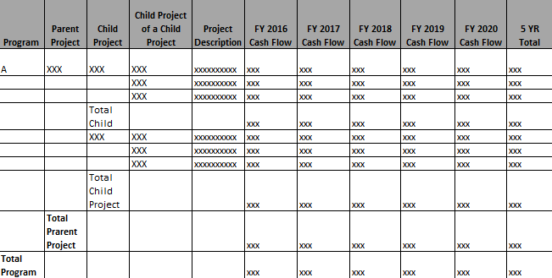  Note that cash flows are prepared at the lowest project level and roll up to the program level.
3 | Vendor product shall provide reports on 5-Year/10-Year cash flows (capital) by pre-defined program, parent-project, child-project, etc.  Report Title: 5-Year/10-Year Cash Flow by Program/Parent-Project/Child-Project  Reporting criteria for consideration:  Fiscal Year: Input Value  Fund Name: Input value  Lead Department Name: Input value  Program Name: Input value  Parent-Project Name: Input value  Child-Project Name: Input value  Report attributes for consideration:  - Program Name: (determine by user-select value)  - Parent-Project Name: (determine by user-select value)  - Child-Project Name: (determine by user-select value)  - Cash Flows for the next 5 years/10 years (starting from the user-select fiscal year)  - 5-Year/10-Year Total  - Total (determine by user-select value)  Sample Report  Fiscal Year: FY 2016  Fund Name: Water Systems  Lead Department Name: Engineering  Program Name: N/A  Parent-Project Name: All  Child-Project Name: All  Child-Project of a Child-Project Name: All  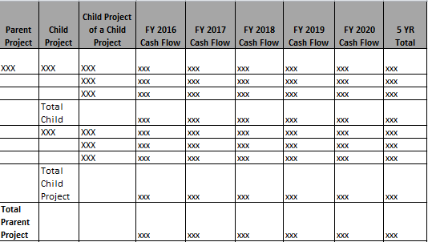
4 | Vendor product shall provide reports on 5-year cash flows with budget category by pre-defined program, parent-project, child-project, etc.  Report Title: 5-Year Cash Flow by Project/Budget Category  Reporting criteria for consideration:  Fiscal Year: Input value  Fund Name: Input value  Lead Department Name: Input value  Program Name: Input value  Parent-Project Name: Input value  Child-Project Name: Input value  Child-Project Name: Input value  Category: Input value  Report attributes for consideration:  - Program Name  - Parent-Project Name  - Child-Project Name  - Child-Project of A Child-Project Name  - Current Year Projected Cash Flow  - Cash Flows for the next 5 years (starting from the selected fiscal year)  - 5-Year Total  - Total Child Project  - Total Parent Project  - Total Program  Sample Report  Fiscal Year: FY2015  Fund Name: Water Systems  Lead Department: Engineering  Program Name: N/A  Parent-Project Name: N/A  Child-Project Name: XXXX  Child-Project Name: All  Category: All  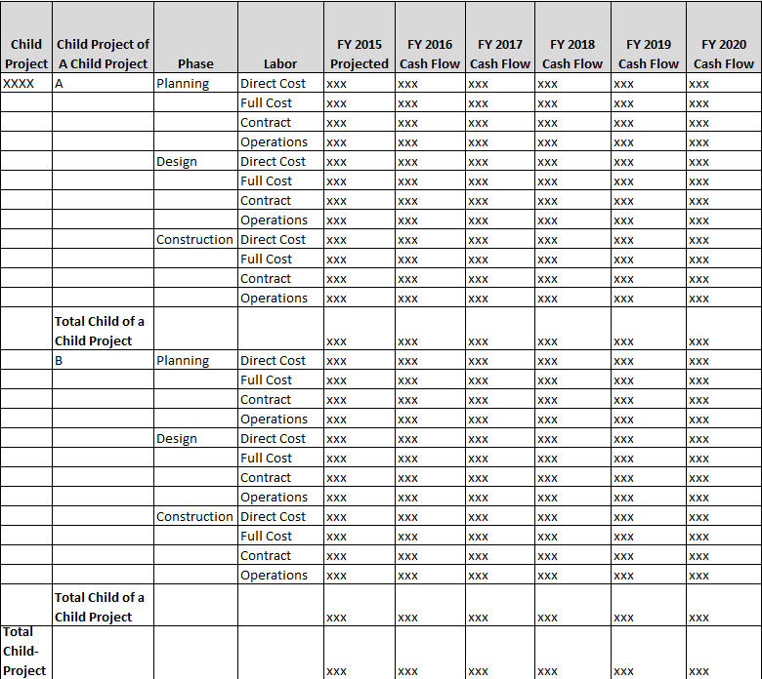
 | Capital Budget: 5-Year & 10-Year Project Current Budget vs. Previous Budget
5 | Vendor product shall provide reports to compare the 5-Year/10-Year cash flows between current budget and previous budget.  Report Title: 5-Year/10-Year Cash Flow Current Budget vs. Previous Budget (same years)  Reporting criteria for consideration:  Current Budget: Input Value  Previous Budget: Input Value  Fund Name: Input value  Lead Department Name: Input value  Program Name: Input value  Parent-Project Name: Input value  Child-Project Name: Input value  Report attributes for consideration:  - Program Name: (determine by user-select value)  - Parent-Project Name: (determine by user-select value)  - Child-Project Name: (determine by user-select value)  - Previous Budget Year’s 5 Year/10 Year Cash Flows  - 5 Year/10 Year Total  - Current Budget Year’s 5 Year/10 Year Cash Flows  - 5 Year/10 Year Total  - Total  Sample Report  Current Budget: FY 2016  Previous Budget: FY 2014  Fund Name: Water Systems  Lead Department Name: Engineering  Program Name: N/A  Parent-Project Name: All  Child-Project Name: N/A  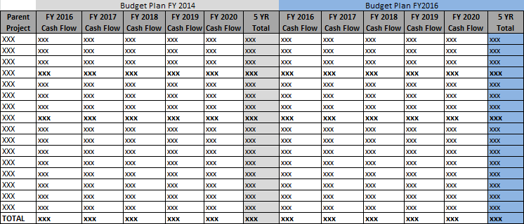
6 | Vendor product shall provide reports to compare the 5-Year/10-Year cash flows between current budget and previous budget(s).  Report Title: 5-Year/10-Year Cash Flow Current Budget vs. Previous Budget (different years)  Reporting criteria for consideration:  Current Budget: Input Value  Previous Budget: Input Value  Fund Name: Input value  Lead Department Name: Input value  Program Name: Input value  Parent-Project Name: Input value  Child-Project Name: Input value  Report attributes for consideration:  - Program Name: (determine by user-select value)  - Parent-Project Name: (determine by user-select value)  - Child-Project Name: (determine by user-select value)  - Previous Budget Year’s 5 YR Cash Flows  - 5 Year Total  - Current Budget Year’s 5 YR Cash Flows  - 5 Year Total  - Total  Sample Report  Current Budget: FY 2016  Previous Budget: FY 2014  Fund Name: Water Systems  Lead Department Name: Engineering  Program Name: N/A  Parent-Project Name: All  Child-Project Name: N/A  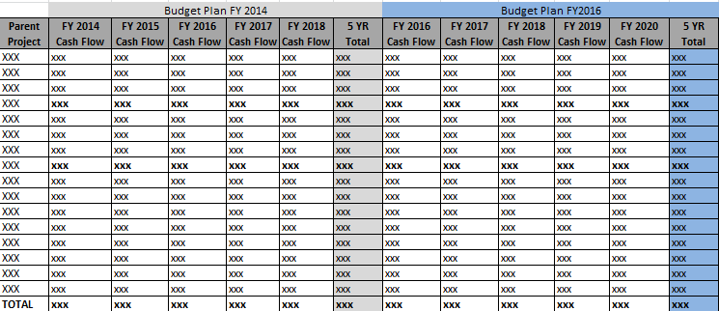
7 | Vendor product shall provide reports on capital cost change story compared to previous 5-year cash flow plan. This capital report intends to compare the two budget plans.  Report Title: Capital Cost Change Story 5-Year Cash Flow  Reporting criteria for consideration:  Fund Name: Input value  Lead Department Name: Input value  Parent-Project Name: Input value  Child-Project Name: Input value  Current Budget: Input value  Future Budget: Input value  Report attributes for consideration: (Capital Reports)  - Parent-Project Name: (determine by user-select value)  - Child-Project Name: (determine by user-select value)  - Expended Inception through FY (year-1 of the current budget cycle)  - Projected cash flow (year-2 of the current budget cycle)  - 5 YR cash flows of current budget  - 5 YR total – current budgets  - 5 YR cash flows of future budget  - 5 YR total – future budgets  - FY14 vs. FY 16 (FY16/17 only) Dollar change current budget vs. future budget (sum of future budget years – sum of current budget years)  - % FY14 vs. FY16 (FY16/17 only) % change current budget vs. future budget [(sum of future budget years – sum of current budget years)/sum of current budget years]  - Cost Change Story  Sample Report:  Fund Name: Water Systems  Lead Department Name: Engineering  Parent-Project Name: XXX  Child-Project Name: All  Current Budget: FY 2014  Future Budget: FY 2016  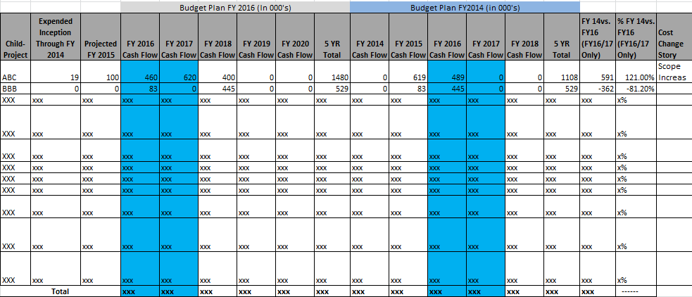
 | Capital Budget: 5-Year Project Appropriations, 5-Year Project Cash Flow and Appropriations Report
8 | Vendor product shall provide reports on 5-Year appropriations for every project.  Report Title: 5-Year Appropriations by Fiscal Year  Reporting criteria for consideration:  Fiscal Year: Input Value  Fund Name: Input value  Lead Department Name: Input value  Program Name: Input value  Parent-Project Name: Input value  Child-Project Name: Input value  Report attributes for consideration:  - Program Name: (determine by user-select value)  - Parent-Project Name: (determine by user-select value)  - Child-Project Name: (determine by user-select value)  - 5-YR Appropriations  - 5-Year Total  - Total  Sample Report  Fiscal Year: FY 2016  Fund Name: Water Systems  Lead Department Name: Engineering  Program Name: N/A  Parent-Project Name: All  Child-Project Name: N/A  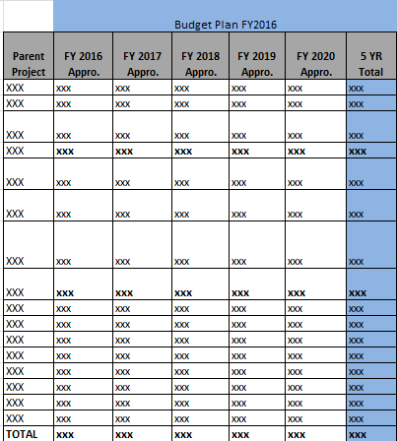
9 | Vendor product shall provide reports to show the 5-Year cash flows and 5-Year appropriations for every project.  Report Title: 5-Year Cash Flows vs. Appropriations by Fiscal Year  Reporting criteria for consideration:  Fiscal Year: Input Value  Fund Name: Input value  Lead Department Name: Input value  Program Name: Input value  Parent-Project Name: Input value  Child-Project Name: Input value  Report attributes for consideration:  - Program Name: (determine by user-select value)  - Parent-Project Name: (determine by user-select value)  - Child-Project Name: (determine by user-select value)  - 5 YR Cash Flows  - 5 Year Total  - 5 YR Appropriations  - 5 Year Total  - Total  Sample Report  Fiscal Year: FY 2016  Fund Name: Water Systems  Lead Department Name: Engineering  Program Name: N/A  Parent-Project Name: All  Child-Project Name: N/A  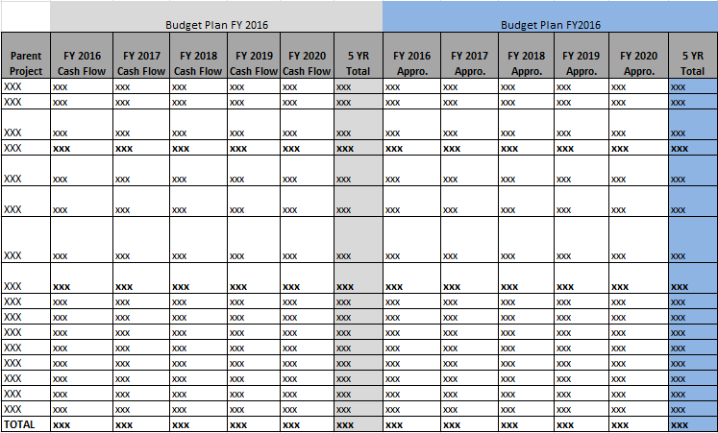
 | Capital Budget: Project Detail Reports
10 | Vendor product shall provide reports on project details.  Report Title: Project Details  Reporting criteria for consideration:  - Lead Department: (determine by user-select value)  - Parent-Project Name: (determine by user-select value)  - Child-Project Name: (determine by user-select value)  - Begin with Fiscal Year: (determine by user-select value)  Report Attributes for consideration:  - Parent-Project Name: (determine by user-select value)  - Child-Project Name: (determine by user-select value)  - Funding Source (child-project level)  - Child-Project Name  - Project Manager  - In-Service Date  - Project Description  - Project Phase  - Current Year Cost Projection  - Total Expenses To-Date (e.g. spent through 2016)  - Cash Flows: 5-Year Cash Flow (start with the current year; e.g. 2012)  Sample Report  Lead Department: Engineering  Parent-Project Name: XXX  Child-Project Name: All  Begin with Fiscal Year: FY2016  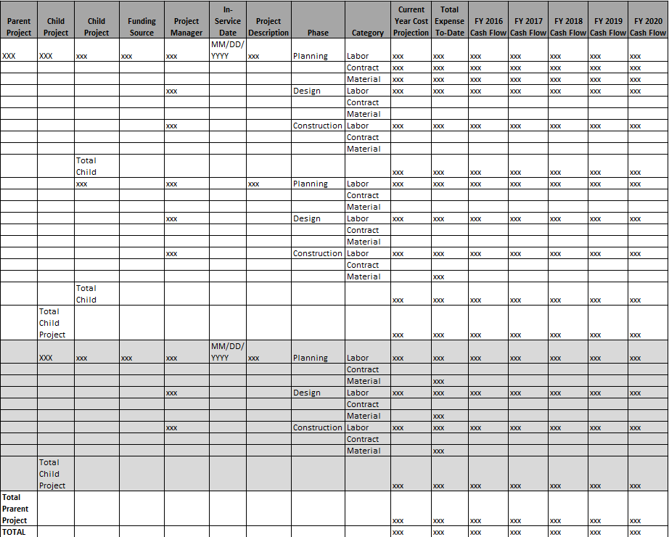
11 | Vendor product shall provide reports on program, parent-project, and child-project descriptions.  Vendor product shall be able to display data according to user-select values. Vendor product shall allow multiple selections from each reporting criteria.  Report title: Active Project Justifications  Reporting criteria for consideration:  Fund Name: Input value  Lead Department Name: Input value  Parent-Project Name: Input value  Child-Project Name: Input value  Report attributes for consideration:  - Parent-Project Name: (determine by user-select value)  - Child-Project Name: (determine by user-select value)  - Objective:  - Justification:
12 | Vendor product shall provide various detailed and summary reports on Operating budget plans. See below for details.
 | Operating Budgets: Budget Details /Summary by Organizational Structure
13 | Vendor product shall provide detailed reports on Operating budget by pre-defined District organization structure such as Fund, Department, Division, Organization, etc. See Common Requirements for Organization Structure.  Report Title: Operating Budget Details by Fund/Dept./Div/Org by Fiscal Year  Reporting criteria for consideration:  Fiscal Year: Input value  Fund Name: Input value  Department Name: Input value  Division Name: Input value  Organization Name: Input value  Report attributes for consideration:  - Category Name  - Sub-Category Name  - Fund Name: (determine by user-select value)  - Department Name: (determine by user-select value)  - Division Name: (determine by user-select value)  - Organization Name: (determine by user-select value)  - Total  - Grand Total  Sample Report:  Fiscal Year: FY 2016, FY 2017  Fund Name: Water Systems, Wastewater  Department Name: N/A  Division Name: N/A  Organization Name: N/A  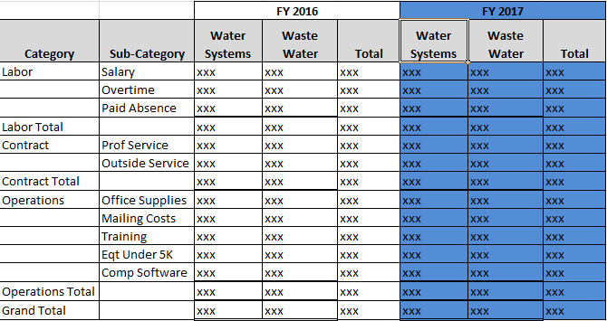
14 | Report Title: Operating Budget Details With Prior Fiscal Years  Reporting criteria for consideration:  Prior Fiscal Year: Input value  Fiscal Year: Input value  Fund Name: Input value  Department Name: Input value  Division Name: Input value  Organization Name: Input value  Report attributes for consideration:  - Category Name  - Sub-Category Name  - Fund Name: (determine by user-select value)  - Department Name: (determine by user-select value)  - Division Name: (determine by user-select value)  - Organization Name: (determine by user-select value)  - Category Total  - Total  - Grand Total  Sample Report:  Prior Fiscal Year: FY 2011, FY 2012  Fiscal Year: FY2013, FY2014, FY2015  Fund Name: Wastewater  Department Name: N/A  Division Name: N/A  Organization Name: N/A  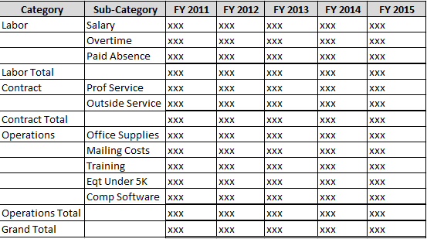
15 | Vendor product shall provide summary reports on Operating budget by pre-defined District organization structure such as Fund, Department, Division, and Organization.  Report Title: Operating Budget Summary by Fund/Dept./Div/Org by Fiscal Year  Reporting criteria for consideration:  Fiscal Year: Input value  Fund Name: Input value  Department Name: Input value  Division Name: Input value  Organization Name: Input value  Report attributes for consideration:  - Category Name  - Organization Name  - User Selections (See drop-down above)  - Total  - Grand Total  Sample Report:  Fiscal Year: FY 2016, FY2017  Fund Name: Water Systems  Department Name: ISD  Division Name: None  Organization Name: Data Center, App Dev  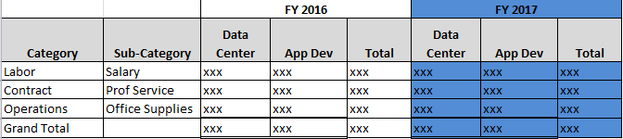
 | Capital and Operating Budget: Contract Related Reports
16 | Vendor product shall provide reports on planned contracts by pre-defined parent-project and child-project. (capital projects)  Vendor product shall be able to display data according to user-select values. Vendor product shall allow multiple selections from each reporting criteria.  Report title: Planned Contracts by Parent-Project/Child-Project  Reporting criteria for consideration:  Fiscal Year: Input value  Fund Name: Input value  Lead Department Name: Input value  Parent-Project Name: Input value  Child-Project Name: Input value  Report attributes for consideration:  - Parent-Project Name: (determine by user-select value)  - Child-Project Name: (determine by user-select value)  - Contract Title:  - Contract Description/Justification  - Contact:  - Cost Estimate:  - Total  Sample Report  Fiscal Year: FY 2019  Fund Name: Water Systems  Lead Department Name: Engineering  Parent-Project Name: Digester Upgrade  Child-Project Name: All  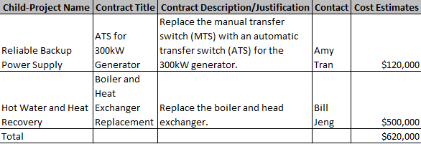
17 | Vendor product shall provide reports on planned contracts by pre-defined organization, department, etc. (operating reports)  Vendor product shall be able to display data according to user-select values. Vendor product shall allow multiple selections from each reporting criteria.  Report title: Planned Contracts by Organization/Division/Department  Reporting criteria for consideration:  Fiscal Year: Input value  Fund Name: Input value  Department Name: Input value  Division Name: Input value  Organization Name: Input value  Category Name: Input value  Report attributes for consideration:  - Department Name: (determine by user-select value)  - Division Name: (determine by user-select value)  - Organization Name: (determine by user-select value)  - Category Name: (determine by user-select value)  - Contract Title:  - Contract Description/Justification  - Contact  - Cost Estimates  See sample report layout below.  Fiscal Year: FY 2014  Fund Name: Water Systems  Department Name: OMD  Division Name: N/A  Organization Name: Construction & Maint Services  Category Name: Contract  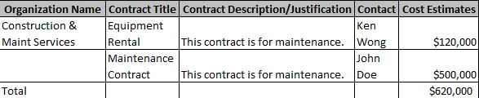
 | Capital and Operating Budget: Labor Reports
18 | Vendor product shall provide reports on the allocated salary dollars proposed budgeted for capital & operating for the budget plan under development.  Report title: Operating / Capital Labor Summary  Reporting criteria for consideration:  Fiscal Year: Input value  Fund Name: Input value  Department Name: Input value  Division Name: Input value  Organization Name: Input value  Category Name: Input value  Sub-Category Name: Input value  Report attributes for consideration:  - Department Name: (determine by user-select value)  - Division Name: (determine by user-select value)  - Organization Name: (determine by user-select value)  - Category Name: (determine by user-select value)  - Sub-Category Name: (determine by user-select value)  - Budget Year-1 Proposed Budget:  - Budget Year-2 Proposed Budget:  - Year-1 vs. Year-2: (year-2 – year-1)  - % Change Year-1 vs. Year-2: [(year-2 – year-1)/year-2]  Sample Report  Fiscal Year: FY2016 (year-1), FY2017(year-2)  Fund Name: Water System  Department Name: N/A  Division Name: N/A  Organization Name: Water Distribution Planning  Category Name: N/A  Sub-Category Name: Salaries, Overtime, Employee Benefits  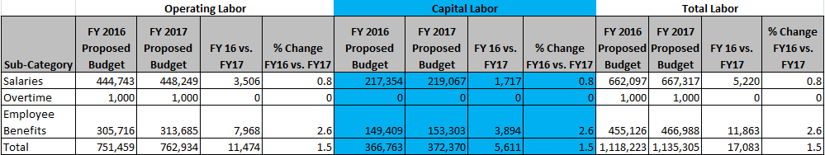
19 | Vendor product shall provide reports on salary adjustment that shows detailed salary adjustments for the user-select fiscal year. These values are input by users.  Report title: Salary Adjustment  Reporting criteria for consideration:  Fiscal Year: Input value  Fund Name: Input value  Department Name: Input value  Division Name: Input value  Organization Name: Input value  Report attributes for consideration:  - Fund Name: (determine by user-select value)  - Department Name: (determine by user-select value)  - Division Name: (determine by user-select value)  - Organization Name: (determine by user-select value)  - Original Operating Total: (labor cost estimates)  - % Applied to Capital: Input value  - Capital Salary: Input value  - Operating Salary: (operating salary = salary total – capital salary)  - Salary Savings %: (salary savings % = salary savings / salary total)  - Salary Savings: Input value  - Operating Salary – Salary Savings:  - Shift Differential: Input value  - Net Operating Salary: (salary total – capital salary – salary savings + shift differential = net operating salary)  - Total  Sample Report  Fiscal Year: FY2016  Fund Name: Water System  Department Name: N/A  Division Name: N/A  Organization Name: Contract Equity Office  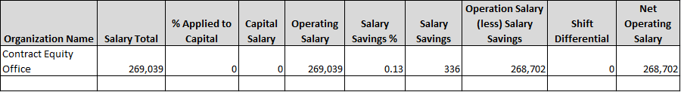
 | Capital and Operating Budget: Adjustment Reports
20 | Vendor shall provide reports on all approved Capital budget adjustments by program by selected fiscal year.  Report Title: Budget Adjustment Summary by Program by Fiscal Year  Reporting criteria for consideration:  Fiscal Year: Input value  Impacted Program: Input value  Report attributes for consideration:  - Impacted Program  - Lead Department  - BA original (From)  - BA revised (From)  - BA change (From)  - BA original (To)  - BA revised (To)  - BA change (To)  - Total BA change (From)  - Total BA change (To)  - Reason for Adjustment  Sample Report:  Fiscal Year: FY 2014  Impacted Program: All  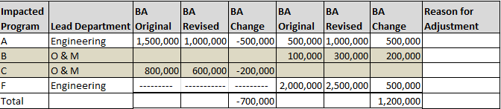
21 | Vendor product shall provide reports on all approved Capital budget adjustments sort by project manager by fiscal year.  Report Title: Budget Adjustment Summary by Project Manager by Fiscal Year  Reporting criteria for consideration:  Fiscal Year: Input value  Project Manager: Input value  Report attributes for consideration:  - Project manager  - Impacted project  - Lead Department  - BA Requested  - BA Obtained  - Total BA Requested  - Total BA Obtained  - Reason for Adjustment  Sample Report:  Budget Year: FY 2015  Project Manager: All  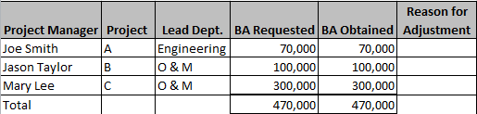
22 | Vendor product shall provide reports on approved Operating budget adjustments which are sorted by department by fiscal year.  Report Title: Operating Budget Adjustment Summary by Department Category by Fiscal Year  Reporting criteria for consideration:  Fiscal Year: Input value  Impacted Department: Input value  Report attributes for consideration:  - Impacted Department  - Category  - BA original (From)  - BA revised (From)  - BA change (From)  - BA original (To)  - BA revised (To)  - BA change (To)  - Total  Sample Report:  Fiscal Year: FY 2014  Impacted Department: O&M  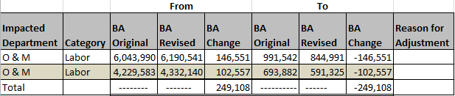
 | Position Management Report
23 | Vendor product shall be able to provide a variety of reports on job position information by budget year by user-select fund, department, division and organization. The salary and position seeding information is imported from where the position management information is retained and managed. Vendor product shall accept this information and allow modifications to the labor budget planning. This report shall be based on the updated data in the Budget component.  Vendor product shall be able to generate labor budget reports for the past fiscal years.  Report Title: Labor Budget by Position by Department by Fiscal Year by Fund/Dept./Div/Org  Reporting criteria for consideration:  Fiscal Year:  Fund Name: Input value  Department Name: Input value  Division Name: Input value  Organization Name: Input value  Report attributes for consideration:  - Job Code  - Position Number  - Job Classification  - Employee ID  - Employee Name  - Step (step in salary table)  - Month (month in position)  - FTE  - Annual Budget  - Fringe Benefits (this is a % of the annual salary budget)  - Total Cost (annual budget + fringe benefits)  - Salary Plan  - Action (new, etc.)  - Funded (Y/N)  - Included (Y/N; Y means position is in budget; N means position is being deleted.)  - Grand Total  - Number of Funded Positions  - Number of Unfunded Positions  - Total Positions  - Included Positions  - Excluded Positions (i.e. proposed for deletion)  Sample report  Fiscal Year: FY 2014  Fund Name: Water Systems  Department Name: N/A  Division Name: N/A  Organization Name: N/A  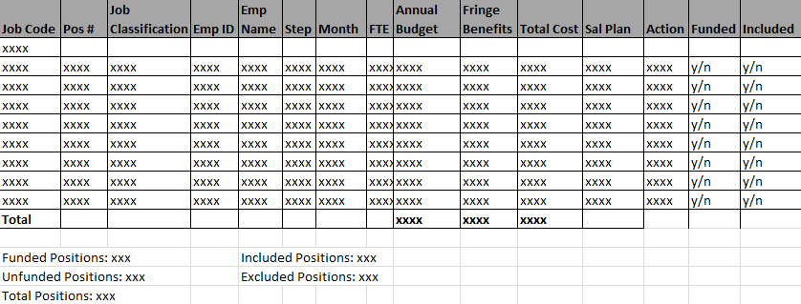
24 | Vendor product shall provide report on user actions taken with users’ credentials, date and timestamp, etc. at every step of the workflow (Budget Development, Review & Approval) referenced.
 | Ad Hoc Reports
25 | Vendor product shall provide a reporting tool that allows users to choose data attributes from the Budget component to form a new report. Users can specify a date range for these reports.
26 | Vendor product shall be able to generate capital reports mentioned above by providing various fiscal year /date range. The historic data shall be kept permanently.
27 | Vendor product shall be able to generate operating reports mentioned above by providing various reporting criteria and fiscal year/date range. The current and historic budget and actual expense data shall be kept permanently.
28 | Vendor product shall forecast year-end expenses for both capital and operating. Expenditure projection can be based on various elements including salaries burn rate, % spent to-date, existing service contract costs, P-Card expenses, etc.

Project Management

Project Management
R# | Description | Included in base package?
1 | Vendor product shall provide reports on actual year-to-date expenditures break down by involved organizations and category for a project phase. Vendor product shall allow users to choose multiple categories for the report.  Report Title: Year-To-Date Expenses by Project Phase by Category  Reporting attributes for consideration:  Fund Name: Input value  Program Name: Input value  Parent-Project Name: Input value  Child-Project Name: Input value  Child-Project Name: Input value  Phase Name: Input value  Category: Input value  Report attributes for consideration:  - Project Phase  - Organization  - Category  - Cost Estimates (provided at Project Authorization)  - Actual Expenses  - % Actual/Cost Estimates (actual expenses/cost estimates)  - Total  Sample Report  Fund Name: Water System  Program Name: Reservoir Rehab/Maintenance  Parent-Project Name: Res Rehab/Maint Coating  Child-Project Name: Steel Reservoir  Child-Project Name: Steel Reservoir Part I  Phase: Planning  Category: Labor, Operations  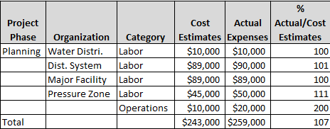
2 | Report Title: Year-To-Date Expenses by Project Phase by Category  Reporting attributes for consideration:  Fund Name: Input value  Program Name: Input value  Parent-Project Name: Input value  Child-Project Name: Input value  Child-Project Name:  Phase Name:  Category:  Report attributes for consideration:  - Project Phase (determine by user-select value)  - Organization  - Category (determine by user-select value)  - Cost Estimates (provided at Project Authorization)  - Actual Expenses  - % Actual/Cost Estimates (actual expenses / cost estimates)  - Total  Sample Report  Fund Name: Water System  Program Name: Reservoir Rehab/Maintenance  Parent-Project Name: Res Rehab/Maint Coating  Child-Project Name: Steel Reservoir  Child-Project Name: Steel Reservoir Part I  Phase: Planning, Design, Construction (All)  Category: Labor, Contract, Operations  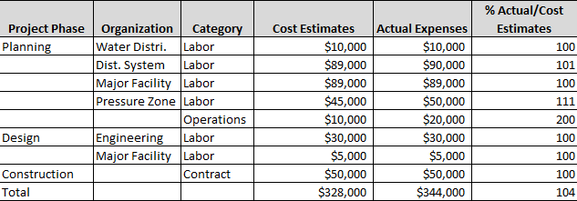
3 | Vendor product shall provide reports on actual year-to-date expenditure transactions by category and sub-category for a project phase.  Report Title: YTD Purchases by Category by Sub-Category  Reporting attributes for consideration:  Fund Name: Input value  Program Name: Input value  Parent-Project Name: Input value  Child-Project Name: Input value  Child-Project Name:  Phase Name:  Category:  Sub-Category:  Report attributes for consideration:  - Category (determine by user-select value)  - Sub-Category (determine by user-select value)  - Purchase Order No./P-Card Order (if it is a purchase order, display PO number; else display P-Card order)  - Order Amount  - PO Requestor/P-Card Owner  - Total  Sample Report  Fund Name: Water System  Program Name: Reservoir Rehab/Maintenance  Parent-Project Name: Res Rehab/Maint Coating  Child-Project Name: Steel Reservoir  Child-Project Name: Steel Reservoir Part I  Phase: Planning  Category: Operations, Contract  Sub-Category: Material, Prof. Serv.  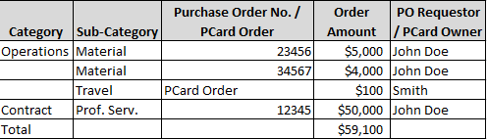
4 | Vendor product shall provide reports on detailed transactions charged to the project phase.  Report Title: YTD Purchases by Project Phase  Reporting attributes for consideration:  Fund Name: Input value  Program Name: Input value  Parent-Project Name: Input value  Child-Project Name: Input value  Child-Project Name:  Phase Name:  Report attributes for consideration:  - Purchase Requestor / P-Card Owner  - Order Date  - Purchase Order No./P-Card Order (if it is a purchase order, display PO number; else display P-Card Order)  - Order Amount  - Vendor Name  - Invoice Date  - Invoice Paid Date  - Total  Sample Report  Fund Name: Water System  Program Name: Reservoir Rehab/Maintenance  Parent-Project Name: Res Rehab/Maint Coating  Child-Project Name: Steel Reservoir  Child-Project Name: Steel Reservoir Part I  Phase Name: Planning  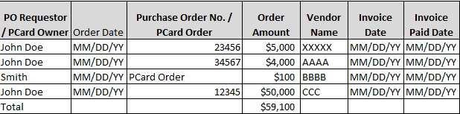
5 | Vendor product shall provide reports on detailed labor charges against each involved organization for a project phase.  Report Title: YTD Detailed Labor Expenses by Project Phase  Reporting attributes for consideration:  Fund Name: Input value  Program Name: Input value  Parent-Project Name: Input value  Child-Project Name: Input value  Child-Project Name: Input value  Phase Name: Input value  Date Range: Input value  Report attributes for consideration:  - Employee Name  - Title  - Organization  - Hours Spent (actual regular hours charged to the project phase)  - OT Spent (overtime hours charged to the project phase)  - YTD Charges (hours spent + OT Spent)  - Total  Sample Report  Fund Name: Water System  Program Name: Reservoir Rehab/Maintenance  Parent-Project Name: Res Rehab/Maint Coating  Child-Project Name: Steel Reservoir  Child-Project Name: Steel Reservoir Part I  Project Phase: Planning  Date Range: MM/DD/YYYY – MM/DD/YYYY  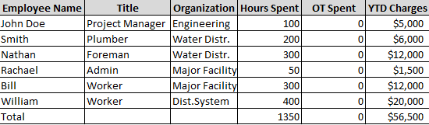  Please see data collection from Expenditure Tracking requirements.
6 | Vendor product shall provide detailed reports on actual year-to-date expenditures comparing to project cost estimates, appropriation and accumulated appropriations.  Report Title : YTD Project Expenses vs. Cost Estimates/Appropriation/Accumulated Appropriations  Reporting criteria for consideration:  Fund Name: Input value  Lead Department Name: Input value  Program Name: Input value  Parent-Project Name: Input value  Child-Project Name: Input value  Child-Project Name: Input value  Phase Name: Input value  Report attributes for consideration:  - Phase Name: (determine by user-select value)  - Actual Expenses (YTD) (running total of actual expenses of the phase)  - Cost Estimates (provided at Project Authorization)  - Appro. (current fiscal year)  - Accumulated Appro. (running total of appropriations)  - Avail Appro. (avail. appro. = accumulated appro. – running total of actual expenses)  Sample Report  Fund Name: Water System  Program Name: Reservoir Rehab/Maintenance  Parent-Project Name: Res Rehab/Maint Coating  Child-Project Name: Steel Reservoir  Child-Project Name: Steel Reservoir Part I  Project Phase: Planning  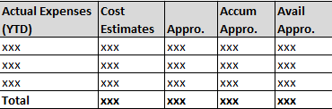
7 | Vendor product shall provide detailed reports on actual year-to-date expenditures comparing to project cost estimates, appropriation and accumulated appropriations.  Report Title : YTD Project Expenses vs. Cost Estimates/Accumulated Appropriations  Reporting criteria for consideration:  Fund Name: Input value  Lead Department Name: Input value  Program Name: Input value  Parent-Project Name: Input value  Child-Project Name: Input value  Child-Project Name: Input value  Phase Name: Input value  Report attributes for consideration:  - Phase Name: (determine by user-select value)  - Actual Expenses (YTD) (running total of actual expenses of the phase)  - Cost Estimates (provided at Project Authorization)  - Accumulated Appro. (running total of appropriations)  - Avail Appro. (avail. appro. = accumulated appro. – running total of actual expenses)  Sample Report  Fund Name: Water System  Program Name: Reservoir Rehab/Maintenance  Parent-Project Name: Res Rehab/Maint Coating  Child-Project Name: Steel Reservoir  Child-Project Name: Steel Reservoir Part I  Project Phase: All  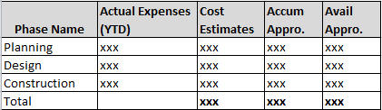
8 | Vendor product shall be able to accept pre-defined expense patterns to generate projection on future expenditures by date range.  To be consumed (by vendor product):  - Project start date and end date.  - The pre-defined S-Curve spending pattern for the project type.  - Additional adjustment (if any)  Report Title: Future Expenses Projection  Reporting criteria for consideration:  Date Range: input value (mm/dd/yy – mm/dd/yy)  Category: (i.e. contract, etc.)  Report attributes for consideration:  - Project Name  - Phase Name  - Start Date  - End Date  - Cost Estimates  - Future Expenses by the month (for the budget year)
 | Ad Hoc Reports
9 | Vendor product shall provide ad hoc reports on child-projects by project manager.  Report Title: Projects by Project Manager  Reporting criteria for consideration:  - Project Manager  - Fund Name: Water System  Attributes for consideration:  - Child-Project Name  - Project Phase  - Start Date  - End Date  - Total Cost To Date (TCTD) Actual Expenses  - Cost Estimates (provided at Project Authorization)  - % of Actual Expenses / Cost Estimates (provided at Project Authorization)  Sample Report  Project Manager: John Doe  Fund Name: Water System  Child-Project Name: A  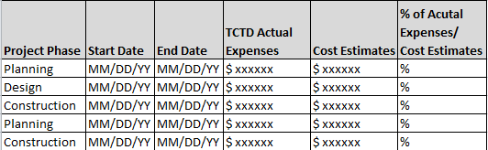
10 | Report Title: Parent-Projects by Project Manager  Reporting criteria for consideration:  - Project Manager:  - Fund Name: Water System  - Lead Department Name: Input value  Attributes for consideration:  - Project Manager (determine by user-select value)  - Parent-Project Name  - Accumulated Appropriations  - Actual Expenses Prior to FY  - Planned Cash Flow (current FY)  - YTD Actual Expenses  - % Actual Expenses / Planned Cash Flow  - ITD Actual Expenses (actual expense inception-to-date)  Sample Report  Project Manager: All  Fund Name: Water System  Lead Department Name: Engineering  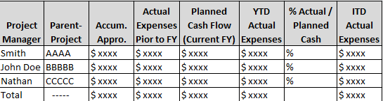
11 | Report Title: Monthly Project Status Report  Reporting criteria for consideration:  - Child-Project Name:  - Fund Name: Input value  - Lead Department Name: Input value  - Month: Input value  Attributes for consideration:  - Child-Project Name (determine by user-select value)  - Project Manager  - Project Objective  - Phase  - Phase Cost Estimate  - YTD Actual Expenses (actual expenses for the fiscal year)  - % Spent (% spent = YTD actual expenses / phase cost estimate)  - Project Status  - Project Comments  Sample Report  Child-Project Name: All  Fund Name: Water System  Lead Department Name: Engineering  Month: Jan. 2016  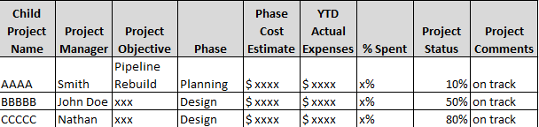

Project Costing
R# | Description | Included in base package?
1 | Vendor product shall provide reports on projects that have allocated capitalized interest by funding source.  Report Title: Projects with Allocated Capitalized Interest by Funding Source  Reporting attributes for consideration:  Fund Name: Input value  Parent-Project Name: Input value  Child-Project Name: Input value  Funding Source: Input value  Report attributes for consideration:  - Parent-Project (determine by user-select value)  - Child-Project (determine by user-select value)  - Funding Source (determine by user-select value)  - Allocated Capitalized Interest (dollar amount)  - Subtotal  - Grand Total  Sample Report:  Fund Name: Water System  Parent-Project Name: All  Child-Project Name: All  Funding Source: Debt  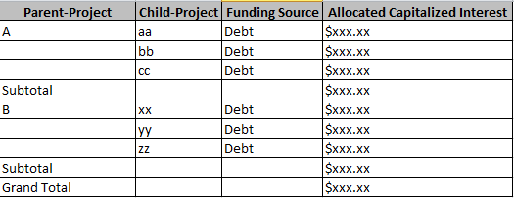
2 | Vendor product shall provide purchase reports by project/job number etc.  Report Title: Purchases by Project/Phase/Job Number  Reporting attributes for consideration:  Fund Name: Input value  Parent-Project: Input value  Child-Project Name: Input value  Project Name: Input value  Phase Name: Input value  Job Number: Input value  Report attributes for consideration:  - Parent-Project (determine by user-select value)  - Child-Project (determine by user-select value)  - Project Name (determine by user-select value)  - Phase Name (determine by user-select value)  - Job Number (determine by user-select value)  - PO Number  - Item Description  - Quantity/Unit  - PO Amount  - Invoice Payment  - Subtotal  - Grand Total  Sample Report:  Fund Name: Water System  Parent-Project: N/A  Child-Project Name: N/A  Project Name: Steel Reservoir Part I  Phase Name: N/A  Job Number: All  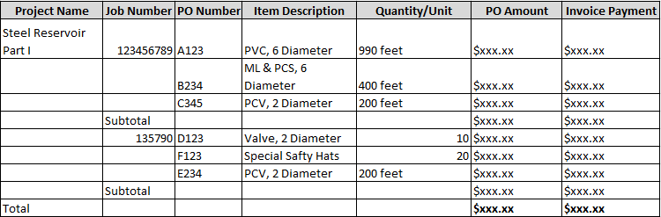
3 | Vendor product shall provide cost analysis reports by job number.  Report Title: Cost Per Foot by Job Number  Reporting attributes for consideration:  Fund Name: Input value  Parent-Project: Input value  Child-Project Name: Input value  Project Name: Input value  Phase Name: Input value  Job Number: Input value  Report attributes for consideration:  - Parent-Project (determine by user-select value)  - Child-Project (determine by user-select value)  - Project Name (determine by user-select value)  - Phase Name (determine by user-select value)  - Job Number (determine by user-select value)  - Job Location  - Projected Pipe Length  - Pipe Diameter  - Projected Material Used  - Project No. of Valves used  - Cost by Job Number (full Cost: actual expenditure accumulated for this job)  - Cost/Ft (cost/Ft = full cost / projected pipe length)  - Total  Sample Report:  Fund Name: Water System  Parent-Project: N/A  Child-Project Name: N/A  Project Name: Steel Reservoir Part I  Phase Name: N/A  Job Number: All  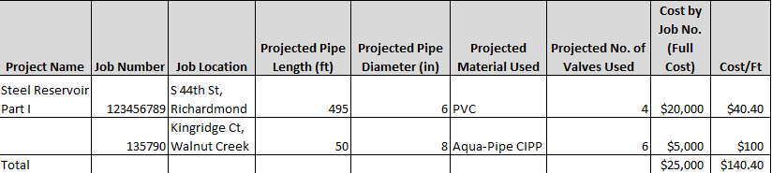
4 | Vendor product shall provide labor expense reports by activity and by project/phase/job number etc.  Report Title: Labor Expenses by Activities by Project/Phase/Job Number  Reporting attributes for consideration:  Report Date Range: DD/MM/YYYY to DD/MM/YYYY or Incept to Current Date  Fund Name: Input value  Project Name: Input value  Phase Name: Input value  Job Number: Input value  Activities: Input value  Category: Input value  Sub-Category: Input value  Report attributes for consideration:  - Project Name (determine by user-select value)  - Phase Name (determine by user-select value)  - Job Number (determine by user-select value)  - Organization  - Activities (determine by user-select value)  - Activity Description  - Category (determine by user-select value)  - Sub-Category (determine by user-select value)  - Direct Costs  - Full Costs  Sample Report  Report Date Range: 01/01/2016 to 03/31/2016  Fund Name: Water System  Project Name: N/A  Phase Name: N/A  Job Number: 12345, 23456  Activities: Construction Activities  Category: Labor  Sub-Category: N/A  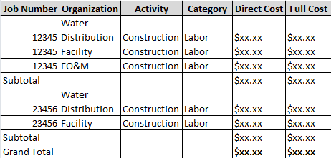
5 | Vendor product shall provide labor expense reports by activity and by project/phase/job number etc.  Report Title: Labor Expenses by Activities by Project/Phase/Job Number  Reporting attributes for consideration:  Report Date Range: DD/MM/YYYY to DD/MM/YYYY or Incept to Current Date  Fund Name: Input value  Project Name: Input value  Phase Name: Input value  Job Number: Input value  Activities: Input value  Category: Input value  Sub-Category: Input value  Report attributes for consideration:  - Project Name (determine by user-select value)  - Phase Name (determine by user-select value)  - Job Number (determine by user-select value)  - Organization  - Activities (determine by user-select value)  - Activity Description  - Category (determine by user-select value)  - Sub-Category (determine by user-select value)  - Direct Costs  - Full Costs  Sample Report  Report Date Range: 01/01/2016 to 03/31/2016  Fund Name: Water System  Project Name: Steel Reservoir Part I  Phase Name: N/A  Job Number: All  Activities: All  Category: Labor  Sub-Category: N/A  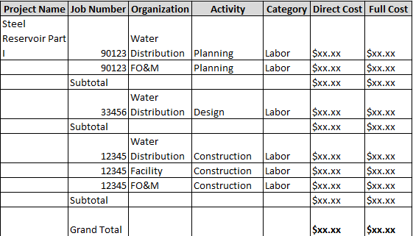
6 | Vendor product shall provide total expense reports by activity and by project/phase/job number etc.  Report Title: Total Expenses by Activities by Project/Phase/Job Number  Reporting attributes for consideration:  Report Date Range: DD/MM/YYYY to DD/MM/YYYY or Incept to Current Date  Fund Name: Input value  Project Name: Input value  Phase Name: Input value  Job Number: Input value  Activities: Input value  Category: Input value  Sub-Category: Input value  Report attributes for consideration:  - Project Name (determine by user-select value)  - Phase Name (determine by user-select value)  - Job Number (determine by user-select value)  - Organization  - Activities (determine by user-select value)  - Activity Description  - Category (determine by user-select value)  - Sub-Category (determine by user-select value)  - Direct Costs  - Full Costs  Sample Report  Report Date Range: 01/01/2016 to 03/31/2016  Fund Name: Water System  Project Name: Steel Reservoir Part I  Phase Name: N/A  Job Number: All  Activities: All  Category: Labor, Contract, Operations  Sub-Category: N/A  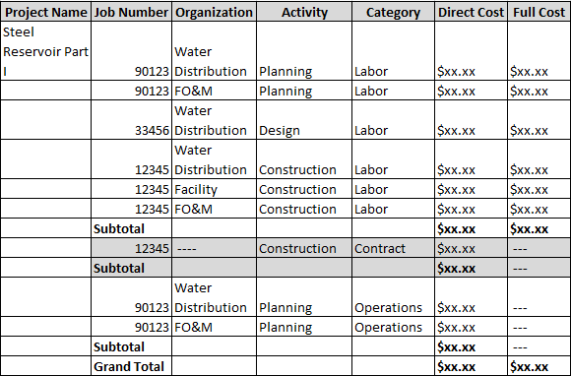
7 | Vendor product shall be able to provide reports on Allocation of Costs by Construction In Progress (CIP)  Report Title: Asset Predefinition & Allocation of Costs by CIP  Reporting attributes for consideration:  CIP: Input value  Report attributes for consideration:  - CIP (determine by user-select value)  - Category  - Asset Creation Date  - Project ID  - In-Service Date  - Profile  - Location  - Asset Description  - Adjustment Percentage  - Percentage  - QTY  - Allocated Cost  - Project Total Percentage  - Project Total Allocated Cost  - Grand Total Allocated Cost
8 | Vendor product shall provide reports on project costs by various parameters including fund, project, job number, job attributes, project status, etc.
9 | Vendor product shall provide project cost related reports by asset category.
10 | Vendor product shall provide monthly summary reports on construction work in progress (CIP) projects by various parameters including fund, project, etc.
11 | Vendor product shall provide reports on project cost, capitalized project cost, percentage of capitalized project cost, etc. by project(s).

EBMUD Report Engine (The New Hotlist)

R# | Description | Included in base package?
1 | Vendor shall identify and propagate all data sets that form the FIS/MMIS reports to EBMUD data warehouse, a data source of the EBMUD report engine.
2 | The EBMUD report engine shall use data from FIS/MMIS systems and existing and future EBMUD systems/applications to perform financial analytics and produce performance analysis to meet business needs.
3 | The EBMUD report engine shall provide reports on purchases based on user-selected programs (operating), sub-programs, and general work order no. It shall be able to generate reports according to user-selected values.  Report Title: Purchases by Program/PO No/GWO No  Reporting criteria for consideration:  Fund Name: Input value  Program Name: Input value  Sub-Program Name: Input value  Category: Input value  Sub-Category: Input value  Report attributes for consideration:  - GWO No:  - Purchase Order No:  - Program Name: (determine by user-select value)  - Sub-Program Name: (determine by user-select value)  - Purchase Total:  - Requestor:  - Total  Sample Report:  Fund Name: Water System  Program Name: Maintain Mains  Sub-Program Name: All  Category: N/A  Sub-Category: N/A  Fund Name: Water System  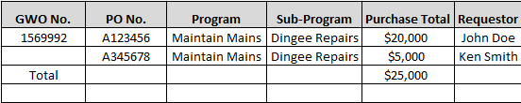
4 | Report Title: Labor Cost by Program/Sub-Program/GWO No.  Reporting criteria for consideration:  Fund Name: Input value  Program Name: Input value  Sub-Program Name: Input value  Report attributes for consideration:  - Program Name: (determine by user-select value)  - Sub-Program Name: (determine by user-select value)  - GWO No: (determine by user-select value)  - Hours Charged  - Labor Cost  - Grand Total  Sample Report  - Program Name: Maintain Mains  - Sub-Program Name: All  - GWO No: All  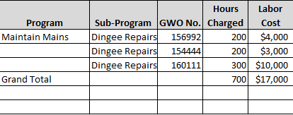
5 | The EBMUD report engine shall provide report on invoice status for a user-select client or account number. It shall be able to generate report according to user-select values and allow multiple selections from each reporting criteria.  Report Title: Invoice by Client/Account No  Reporting criteria for consideration:  Client Name: Input value  FIS Account No: Input value  Report attributes for consideration:  - Client Name : (determine by user-select value)  - FIS Account No: (determine by user-select value)  - Client Invoice No:  - Total Invoice Amount:  - Invoice Status:  - Total  Sample Report:  Client Name: Juanita Villasenor  FIS Account No: N/A  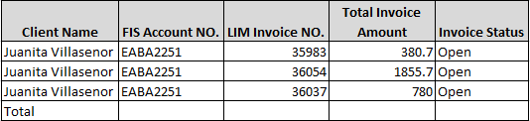

Proposed Business Workflows

Financial

AP Invoice Matching Workflow
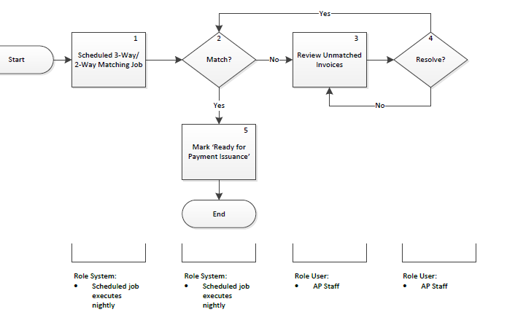
Steps in the AP Invoice Matching Workflow
Step 1 – The System executes the scheduled Two-Way/Three-Way Matching job.
Step 2&5 – The system flags the unmatched invoices & payment requests for further investigation and updates the matched ones for payment issuance.
Step 3-4 – User reviews and resolves the unmatched invoices & payment requests for another round of scheduled Two-Way/Three-Way Matching job. User provides comments appropriately.

Payment Request Workflow
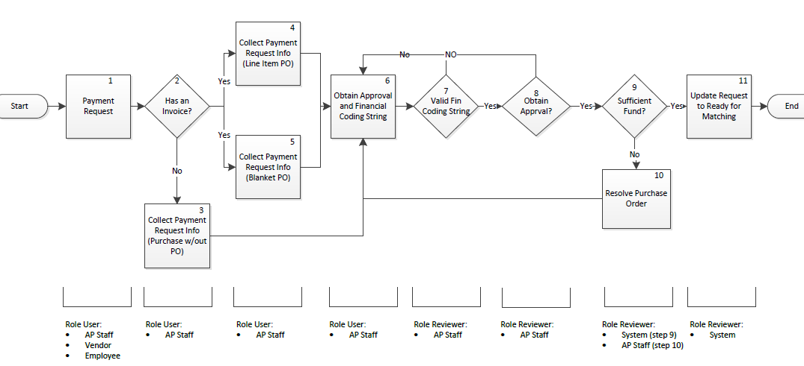
Steps in the Payment Request Workflow
Step 1 – User submits a payment request(s) and provides required information, invoice or disbursement authorization, to support the request.
Step 2 – User determines if there is an invoice for the payment request.
Step 3-5 – User provides required information for the request based on the answer at the previous step.
Step 6 – User requests approval and financial coding if not already provided previously.
Step 7 – Reviewer validates the required information – financial coding - and directs requests back to previous step if required data isn’t collected. Reviewer provides comments appropriately.
Step 8 – Reviewer validates whether proper approval is obtained and directs request back to previous steps if required approval isn’t present. Reviewer provides comments appropriately.
Step 9 – System/Reviewer determines if there is sufficient funds for the request and directs request back to previous steps for resolution as necessary.
Step 10 – System updates the request ready for Two-Way/Three-Way Matching.

Payment Issuance Workflow
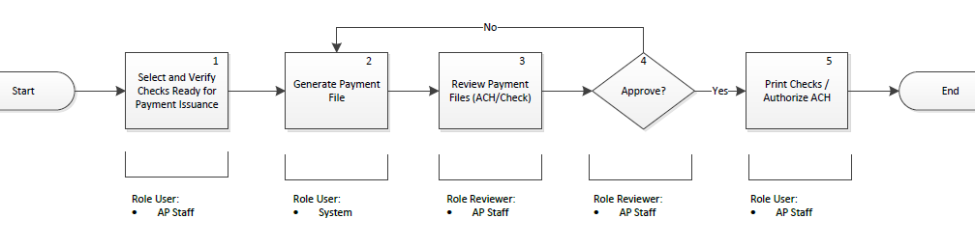
Steps in the Payment Issuance Workflow
Step 1 – User selects the checks that are ready for printing and authorizes for payment file generation.
Step 2 – The system generates the payment file.
Step 3 – Reviewer reviews the payment file for errors and/or unexpected issues and provides comments appropriately.
Step 4 – Reviewer approves or disapproves the payment file and directs disapproved payment files back to previous steps for resolution.
Step 5 – User authorizes check printing and/or ACH.

Cash Receipt Workflow
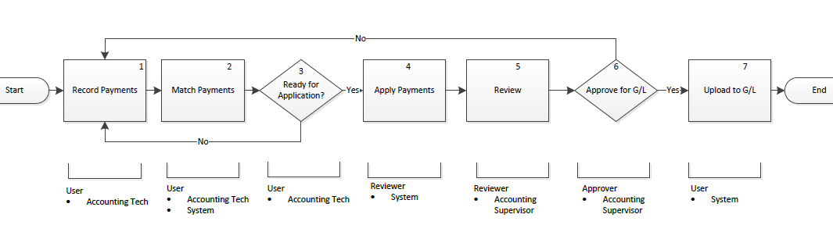
Steps in the Cash Receipt Workflow
Step 1 – User records cash payments.
Step 2 – User matches cash payments with invoice.
Step 3 – User determines if matched payments are ready for application and directs payments with issues back to previous steps for reprocessing. User provides comments appropriately.
Step 4 – The system applies payments that are matched.
Step 5 – Reviewer reviews the applied payments.
Step 6 – Approver approves or disapproves applied payments with comments for General Ledger or reprocessing respectively.
Step 7 – The system uploads the applied payments to General Ledger.

Billing Workflow
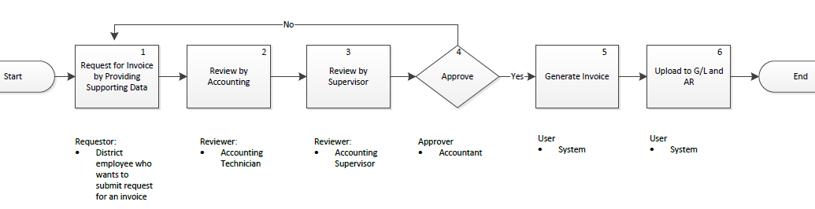
Steps in the Billing Workflow
Step 1 – Requestor submits request for invoice by providing support data.
Step 2 – Reviewer reviews the request and supporting data.
Step 3 – Reviewer (Supervisor) reviews the request and provides comments as necessary.
Step 4 – Approver approves or disapproves the request with comments for next step or reprocessing respectively.
Step 5&6 – The system generates the invoice and uploads to General Ledger and Accounts Receivable.

Asset Creation Workflow
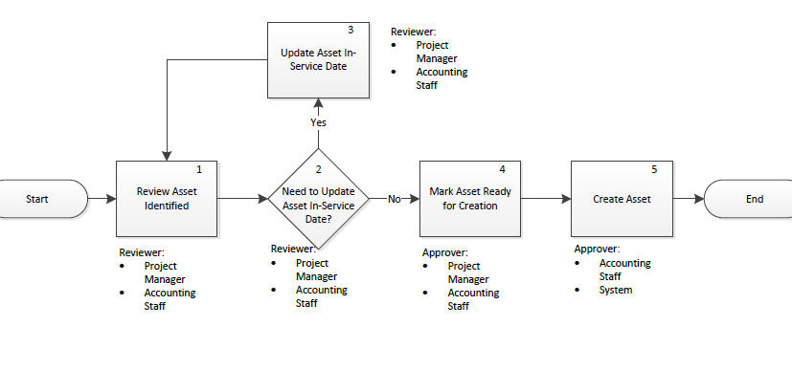
Steps in the Asset Creation Workflow
Step 1 – Reviewer reviews the completed project costs of a master job and all of its subordinates, along with the asset pre-definition of each asset identified and the percentage of total project costs for specific dollar amount.
Step 2 – Reviewer determines if the asset in-service date needs to be updated and provides comments as appropriate.
Step 3 – Reviewer updates the in-service date and sends the asset back to previous steps for re-evaluation.
Step 4 – Approver marks the asset ready for creation.
Step 5 – Approver creates the asset identified.

Adjustment Workflow
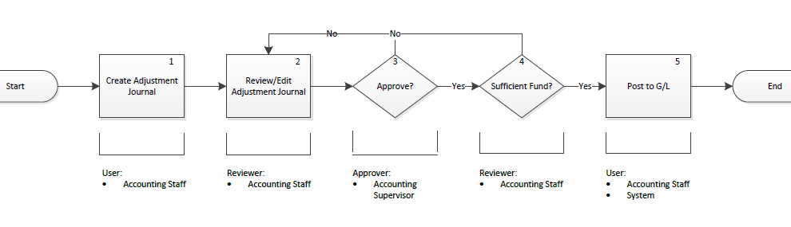
Steps in the Adjustment Workflow
Step 1 – User creates an adjustment journal and attaches supporting documents for review.
Step 2 – Reviewer reviews the adjustment journal and provides comments as appropriate.
Step 3 - Approver approves or disapproves the request and provides comments as appropriate. Approver sends the disapproved request back to previous steps for re-processing.
Step 4 – Reviewer checks if there are sufficient funds for the adjustment and provides comments as appropriate. Reviewer sends request with insufficient funds back to previous steps for re-processing.
Step 5 – User posts the adjustment journal to G/L.

Year-End Closing Workflow
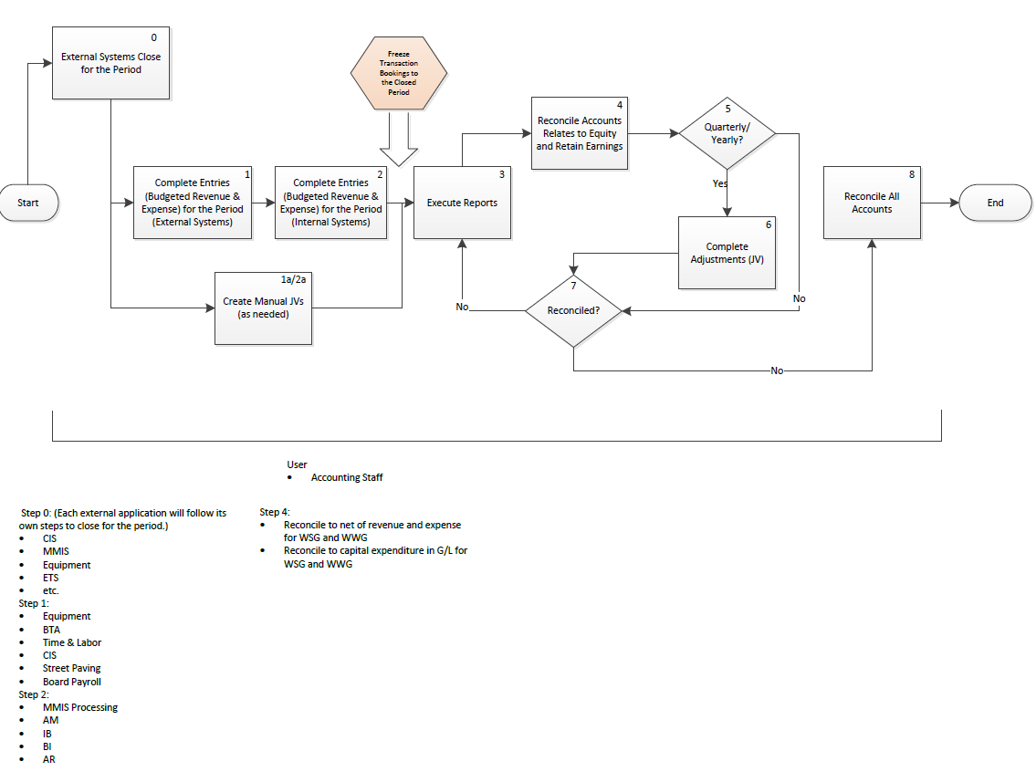
Steps in the Month/Quarter-End Closing Workflow
Step 0 – External systems – that are external to the current financial system - will follow their own steps to close for the period.
Step 1 – Users complete the external systems’ budgeted revenue and expense entries for the period.
Step 2 – Users complete the internal systems’, systems internal to current financial system, budgeted revenue and expense entries for the period.
Step 1a/2a – Users, mostly accountants, will create Journal Vouchers for adjustments as needed throughout step 1 and step 2.
Step 3 – Users generate accounting reports for verification.
Step 4 – Users reconcile accounts to determine income/loss for the period.
Step 5-7 – If it’s to perform quarterly closing, then complete adjustment journal vouchers as needed until accounts related to equity and retain earnings are reconciled; otherwise, users will repeat step3, step4 and step7 until they are reconciled.
Step 8 – users are to reconcile all accounts.

Purchasing

Purchase Order Workflow
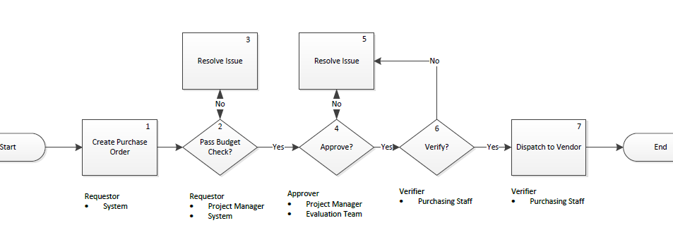
Steps in the Purchase Order Workflow
Step 1 – The system creates a purchase order with required information.
Step 2 & 3 – Requestor resolves issues if it does not pass budget check and provides comments as necessary.
Step 4 &5 – Approver reviews and approves the purchase order and provides comments as necessary.
Step 6 – Purchasing staff verify the purchase order and relevant information are compliant and sufficient to place the order. Otherwise, purchase order will be sent back to previous steps for re-processing.
Step 7 – Purchasing staff dispatch order to vendor.

Change Order Workflow
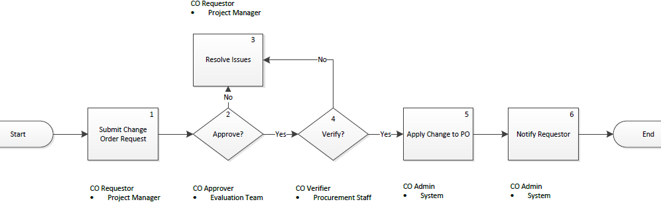
Steps in the Change Order Workflow
Step 1 – Change Order requestor submits a request to make changes to an order and provides supporting information.
Step 2&3 – Change Order approver approves or disapproves the request and provides comments as necessary. Disapproved requests will be sent back to previous steps for re-processing.
Step 4 – Purchasing staff verify that sufficient supporting information is compliant to apply changes. Otherwise, request will be sent back to previous steps for re-processing.
Step 5 – The system applies changes automatically.
Step 6 – The system notifies the requestor about the status of the Change Order Request automatically.

P-Card Workflow
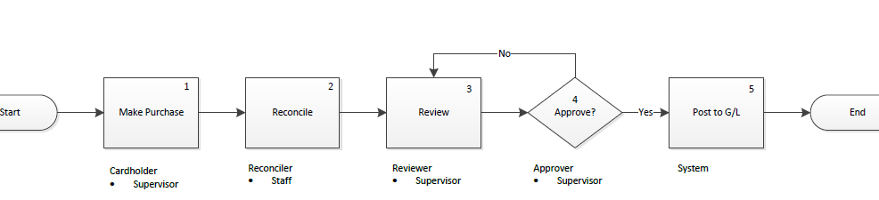
Steps in the P-Card Workflow
Step 1 – Cardholder makes purchases within the P-Card limit.
Step 2 – Reconciler reconciles purchase orders, order receipts, and bank statement for purchases made.
Step 3 – Reviewer reviews the reconciled transactions and provides comments as necessary.
Step 4 – Approver approvers or disapproves the purchases made and provides comments as necessary.
Step 5 – The system posts the reconciled transactions to G/L after approval.
Step 6 - Reconciler/ Cardholder updates financial coding as needed.

P-Card Limit Revision Workflow
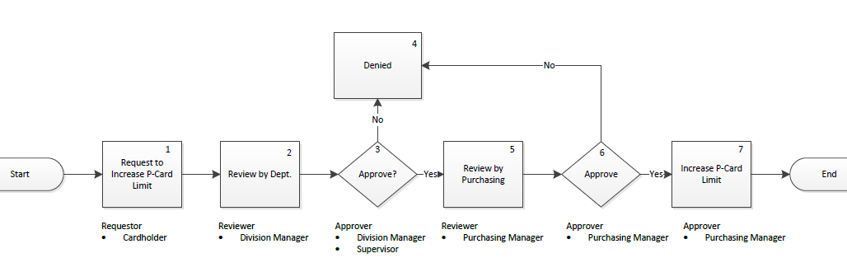
Steps in the P-Card Limit Revision Workflow
Step 1 – Requestor submits request to increase P-Card Limit.
Step 2 – Reviewer reviews the request and provides comments as necessary.
Step 3 & 4 – Approver approves or disapproves the request and provides comments as necessary.
Step 5 – Reviewer reviews the request and provides comments as necessary.
Step 6 – Approver approves or disapproves the request and provides comments as necessary.
Step 7 – Approver increases the P-Card limit.

RFP & RFQ Workflow
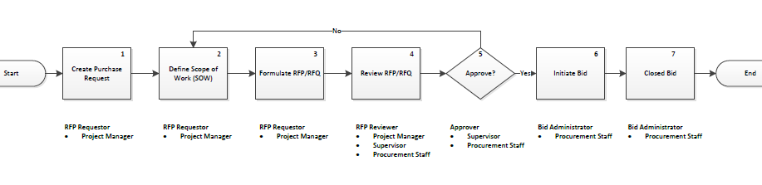
Steps in the RFP & RFQ Workflow
Step 1 – RFP/RFQ Requestor submits a purchase request.
Step 2 – RFP/RFQ Requestor compiles project/product specifications, related scope and any District specifications and forwards to Project Manager.
Step 3 – Project Manager compiles the information from Step 1 and inserts into the District standard RFP/RFQ template.
Step 4 – Project Manager forwards RFP/RFQ Draft to all stakeholders including the requestor and Risk Management.
Step 5 – Project Manager gains approval on the RFP/RFQ draft from all stakeholders.
Step 6 – Project Manager has finalized bid packet advertised per District Procedure 464.
Step 7 – Upon the bid due date/time proposals are stamped as received on time and no further proposals are accepted.

RFP & RFQ Evaluation Workflow
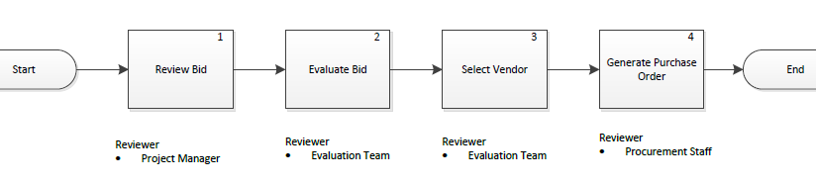
Steps in the RFP & RFQ Evaluation Workflow
Step 1 – Project Manager reviews bids for completeness and determines that they are responsive and responsible.
Step 2 – Project Manager determines winning bid per the acceptance and award procedures outlined in the RFP/RFQ document.
Step 3 – Vendor is selected and all award documents are processed (i.e. Board letter, reccomendation letter, notification letters to all bidders, etc.).
Step 4 – After the appropriate awarding body (Board, GM, Management, etc.) approves, a purchase request is processed, award documents are attached, and the packet is given to the Purchasing Division for creation of a purchase order.

Vendor Management

Vendor Registration Workflow
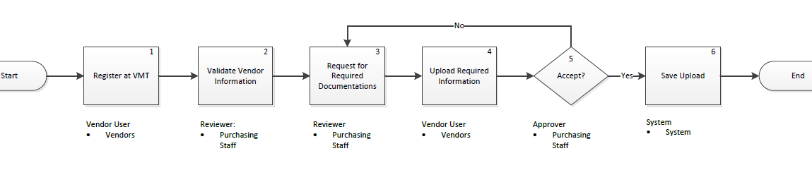
Steps in the Vendor Registration Workflow
Step 1 – Vendor User registers through vendor portal and provides required information.
Step 2 – Validator reviews and validates user provided information and provides comments as necessary.
Step 3 – Validator informs vendor users of what supporting documentation to provide in order to complete vendor registration.
Step 4 – Vendor User uploads required documentation.
Step 5 – Approver accepts or rejects the uploaded documentation. Rejects will be kicked back to validator to communicate with vendor user for resolution.
Step 6 – The system saves the uploaded information and completes vendor registration.

Inventory (Warehouse) Management

Budget Planning

Budget Plan Development, Review & Approval Workflow
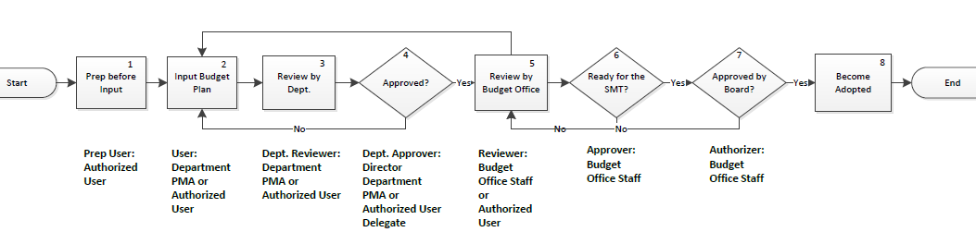
Steps in the Budget Plan Development, Review & Approval Workflow
Step 1 – This step allows user to prepare for budget plan by naming the budget year and budget cycle. User also has various options to pre-populate the plan before departments begin their budget plan development. Pre-population of budget plan will be done District-wide.
Step 2 – This step allows user to edit budget plan. For example, after the budget plan is pre-populated with a prior year’s budget, user can modify the pre-populated funding to meet the needs of each department.
Step 3 – This step allows user to review the budget plan with supervisors or a director and enter modifications as needed.
Step 4 – This step allows user to approve the budget plan at the department level. If the plan is not approved, it will be sent back to previous steps for modification. Once the plan is approved, it is ready for the next step.
Step 5 – This step allows Budget Office staff to analyze budget plan submitted by a department. Only Budget Office staffers are allowed to make modifications to the plan in this step.
Step 6 – This step allows Budget Office staff to flag budget plan that is ready for Board approval. If the plan is not ready, it will be sent back to the prior step for modification. After the plan is marked “ready for Board approval”, no other edits are allowed; this is solely controlled by the Budget Office and only selected Budget Office staff is allowed to make changes.
Step 7 – If the Board does not approve the plan, it will be sent back to step 5 for modification. After the Board approves the plan, the selected Budget Office staff will mark the plan approved.
Step 8 – After Board approval is granted (in step 7), the budget plan becomes the adopted budget. Changes can only be made thru the budget adjustment process.
Users in the Budget Plan Development, Review & Approval Workflow
Step 1: Prep User – Employee with this user role prepares/pre-populates budget plan for the District. For example, Budget Office staff can have this user role.
Step 2: User – Employee with this user role modifies budget plan for the department. For example, department PMA or staff who prepares budget for the department can have this user role.
Step 3: Dept. Reviewer – Employee with this user role reviews the budget plan with the department head and makes edits as necessary. For example, department PMA can have this user role.
Step 4: Dept. Approver – Employee with this user role can approve the budget plan. This user role will have both read and write permissions. For example, director, delegate or department PMA can have this user role.
Step 5: Reviewer – Employee with this user role can modify budget plan or appropriation on behalf of the Budget Office. Budget Office staffers are good candidates for this role.
Step 6: Approver – Employee with this user role can mark the budget plan ready for Board approval. Only selected staff from the Budget Office is suitable for this user role.
Step 7: Authorizer – Employee with this user role can indicate in the system that the Board has approved the budget. Only selected staff from the Budget Office is suitable for this role.

Budget Adjustment Workflow
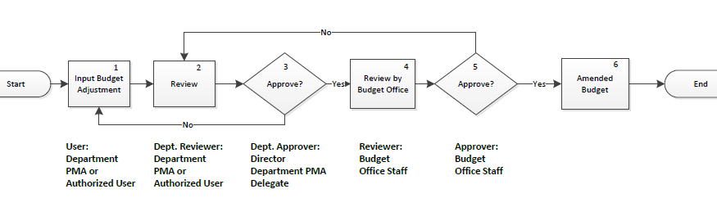
Steps in the Budget Adjustment Workflow
Step 1 – User inputs a budget adjustment request for review.
Step 2 – Dept. Reviewer reviews the budget adjustment request with the proper audience.
Step 3 – Dept. Approver approves the budget adjustment request after obtaining approval from proper personnel.
Step 4 – The Approved budget adjustment request is reviewed by the Budget Office.
Step 5 – The Budget Office staff approves the request.
Step 6 – The System will automatically amend adopted budget to reflect the adjustment.
Users in the Budget Adjustment Workflow
Step 1: User – Employee with this role can create request for budget adjustment. For example, department PMA or project manager should have this user role.
Step 2: Dept. Reviewer – Employee with this user role reviews budget adjustment and provides comments as necessary. For example, supervisor, sr. project manager, etc. can have this user role.
Step 3: Dept. Approver – Employee with this user role can approve the budget adjustment request after all required personnel have reviewed and approved the request. For example, department PMA and department manager can have this user role.
Step 4: Reviewer – Employee with this role reviews the budget adjustment request and provides comments as necessary. Budget Office staff will have this role.
Step 5: Approver – Employee with this user role can mark budget adjustment request approved after reviewing the request. Budget Office staff will have this role.

Expenditure Tracking – Operating
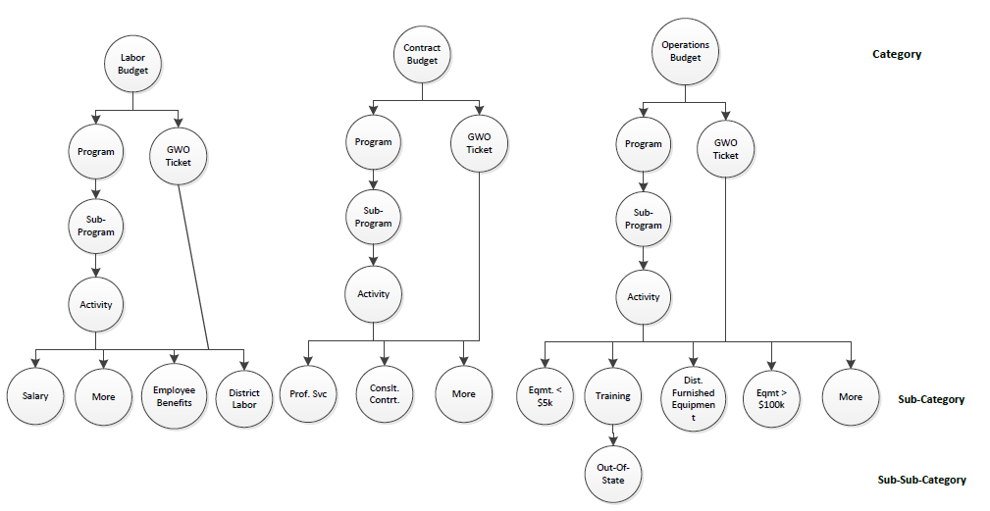

Expenditure Tracking – Capital
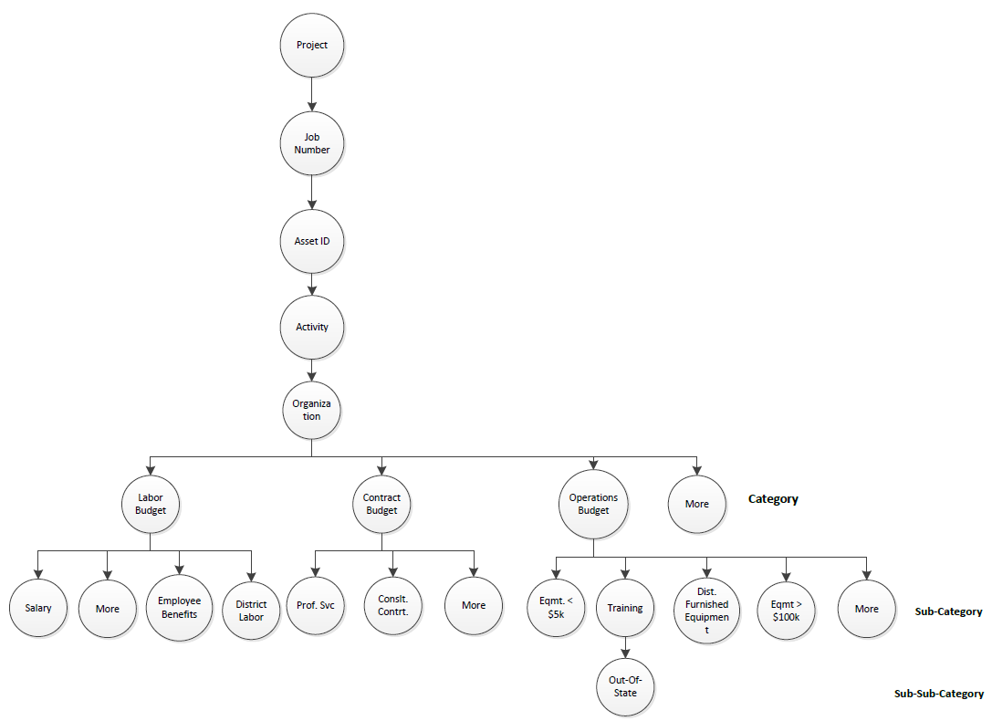

Project Management

Project Creation Workflow
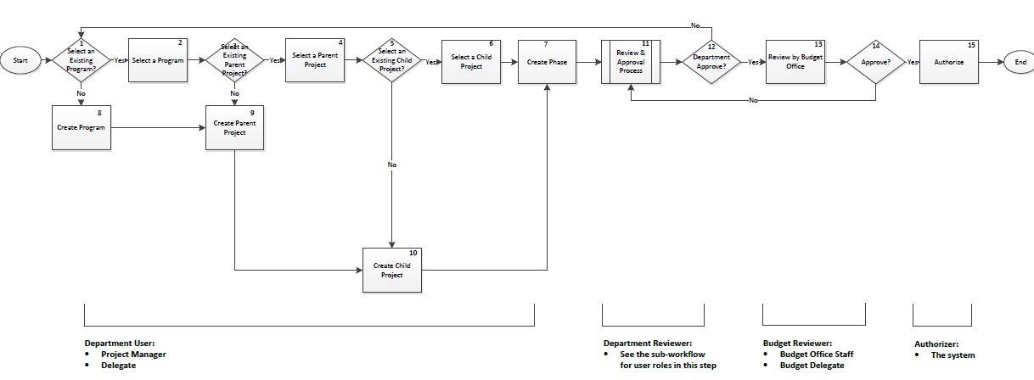
Steps in the Project Creation Workflow
Step 1 – User determines to either select from a list of existing programs or create a new program.
Step 2 – User selects a program from a list of existing programs.
Step 3 – User determines to either select a parent-project from a list of existing parent-projects or create a new parent-project.
Step 4 – User selects a parent-project from a list of existing parent projects.
Step 5 – User determines to either select a child-project from a list of existing child-projects or create a new child-project.
Step 6 – User selects a child-project from a list of existing child-projects.
Step 7 – User creates a new phase, or phases.
Step 8 – User creates a new program.
Step 9 – User creates a new parent-project.
Step 10 – User creates a new child-project.
Step 11 – The new program, parent-project, child-project, and phase will be reviewed in this step; this step is a sub-workflow.
Step 12 – The Dept. reviewer approves or disapproves the program, parent-project, child-project, and phase(s). If approved, it will be forwarded to the next step in the process; if not, it will be directed to the beginning of the process for modification.
Step 13 – Budget Office staff reviews the program/project.
Step 14 – Budget office staff approves or disapproves the program, parent-project, child-project, and phase(s). If approved, it will be forwarded to the next step in the process; if not, it will be directed back to previous steps of the process for modification.
Step 15 – The system authorizes and saves the newly approved programs/projects. These programs/projects can be included in the Capital budget plan development or budget adjustment process. Project identification will be generated after approval and be available for reference.
Users in the Project Creation Workflow
Department User – Employee with this user role can create a brand new program, parent-project, child-project, project and phase. For example, project managers are common users who have this role.
Department Reviewer – There are multiple reviewers in the sub-process, Project Review and Approval.
Budget Reviewer – Employee with this user role reviews, approves or disapproves the request. Budget Office staffs will have this user role.
Authorizer – After the request is approved, the system will automatically generate the program/project/phase identification information that is available for reference.

Project Review & Approval (A sub-process of the Project Creation Workflow)
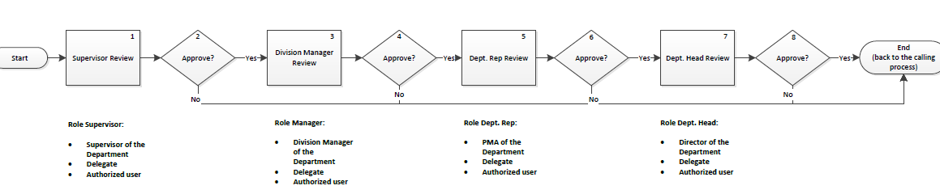
Steps in the Project Review & Approval Workflow
Step 1 – Supervisor reviews the information provided in the Project Creation Workflow and provides comments as appropriate.
Step 2 – Supervisor determines if approval can be granted. If not, it will be forwarded to end of the sub-process; otherwise, it will advance to the next step in the process.
Step 3 – Division manager reviews the information provided in the Project Creation Workflow and provides comments as appropriate. Reviewers’ comments are available for viewing throughout the entire process.
Step 4 – Division manager approves or disapproves the request based on information provided.
Step 5 – Dept. Rep. reviews the information provided in the Project Creation Workflow and provides comments as appropriate. Reviewers’ comments are available for viewing throughout the entire process.
Step 6 – Dept. Rep. approves or disapproves the request based on information provided.
Step 7 – Dept. Head reviews the information provided in the Project Creation Workflow and provides comments as appropriate. Reviewers’ comments are available for viewing throughout the entire process. Note, adding project phases during budget development won’t be reviewed by director.
Step 8 – Dept. Head approves or disapproves the request based on information provided.
Users in the Project Review & Approval Workflow
Step 1 & 2: Role Supervisor – Employee with this user role reviews, provides comments and approves/disapproves the request. For example, a supervisor in the department is suitable for this role.
Step 3 & 4: Role Division Manager – Employee with this user role reviews, provides comments and approves/disapproves the request. For example, a Division Manager in the department is suitable for this role.
Step 5 & 6: Role Dept. Rep - Employee with this user role reviews, provides comments and approves/disapproves the request. For example, the PMA in the department is suitable for this role.
Step 7 & 8: Dept. Head - Employee with this user role reviews, provides comments and approves/disapproves the request. For example, a department Director or delegate is suitable for this role.

Project Authorization Workflow
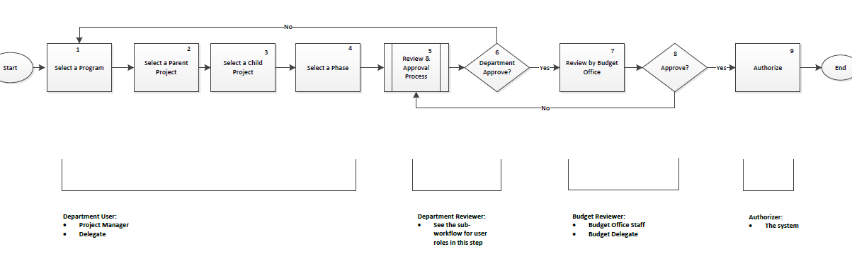
Steps in the Project Authorization Workflow
Step 1 – User selects a program from a list of approved programs.
Step 2 – User selects a parent-project from a list of approved parent-projects.
Step 3 – User selects a child-project from a list of approved child-projects.
Step 4 – User selects a phase(s) from a list of approved phases.
Step 5 – The selected phase(s) will be reviewed by the Department reviewer in this step. This step is a sub-process, Phase Review and Approval.
Step 6 – The Department reviewer will approve or disapprove the selected phase(s).
Step 7 – The selected phase(s) will be reviewed by the Budget Office in this step.
Step 8 - The Budget Office staff will approve or disapprove the selected phases. Disapproved phases will be sent back to prior step for modification follow by another round of review and approval by the Budget Office staff.
Step 9 – After approval is granted, the system will authorize the project phase(s). After this step, all modifications to phases will need to go through project revision process. Project phase identification will be generated after approval and be available for reference.
Users in the Project Authorization Workflow
Department User – Employee with this user role can select a project phase from an existing list. For example, project managers are common users for this role.
Department Reviewer – There are multiple reviewers in the sub-process, Review and Approval. Please see PMT-Diagram-2 for user role details below.
Budget Reviewer – The Budget Office reviews, approves or disapproves the PA request after department approval is granted. Only Budget Office staff can have this user role.
Authorizer – After the request is approved, the system will automatically lock down the project phase information. Future modifications will need to go through the project revision process.

Phase Review & Approval (A Sub Process of the Project Authorization Workflow)
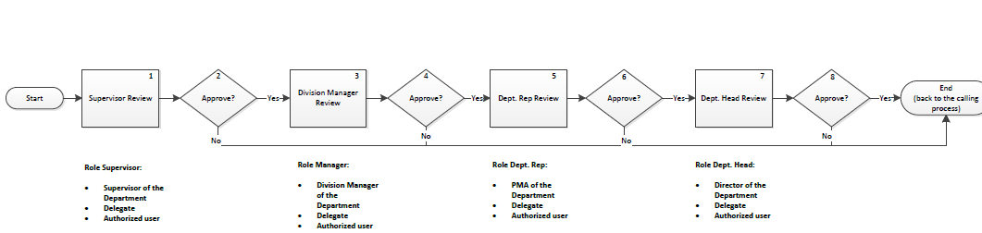
Steps in the Phase Review & Approval (A Sub-Process of Project Authorization Workflow)
Step 1 – Supervisor reviews the information provided in the Project Authorization Workflow and provides comments as appropriate.
Step 2 – Supervisor determines if approval can be granted. If not, it will be forwarded to end of this sub-process; otherwise, it will advance to the next step in the current process.
Step 3 – Division manager reviews the information provided in the Project Authorization Workflow and provides comments as appropriate. Reviewers’ comments are available for viewing throughout the entire process.
Step 4 – Division manager approves or disapproves the request.
Step 5 – Dept. Rep. reviews the information provided in the Project Authorization Workflow and provides comments as appropriate. Reviewers’ comments are available for viewing throughout the entire process.
Step 6 – Dept. Rep. approves or disapproves the request.
Step 7 – Dept. Head reviews the information provided in the Project Authorization Workflow and provides comments as appropriate. Reviewers’ comments are available for viewing throughout the entire process.
Step 8 – Dept. Head approves or disapproves the request.
Users in the Phase Review & Approval (A Sub-Process of Project Authorization Workflow)
Step 1: Role Supervisor – Employee with this user role reviews, provides comments approves or disapproves the PA request. For example, a supervisor in a department is suitable for this role.
Step 3: Role Division Manager – Employee with this user role reviews, provides comments, approves or disapproves the PA request. For example, a Division Manager in a department is suitable for this role.
Step 5: Role Dept. Rep. - Employee with this user role reviews, provides comments, approves or disapproves the PA request. For example, a PMA of a department is suitable for this role.
Step 7: Role Dept. Head - Employee with this user role reviews, provides comments, approves or disapproves the PA request. For example, a Director of a department or Director’s delegate is suitable for this role.

Project Revision Workflow
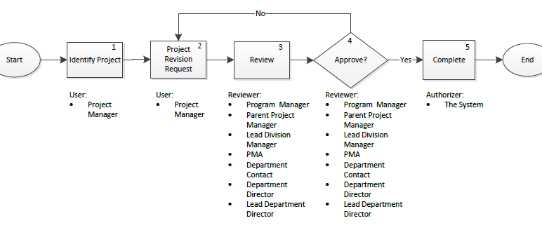
Steps in the Project Revision Workflow
Step 1 – User identifies project for revision
Step 2 – User provides project revision required information
Step 3 – Reviewer reviews project revision request and provides comments
Step 4 – Reviewer provides approval or disapproval for the revision
Step 5 – System finalizes and completes the project revision request
Users in the Project Revision Workflow
Step 1: User – Employee with this user role identifies program, parent-project, and child-project for the project revision request.
Step2: User – Employee with this user role creates the project revision request with details and selects reviewers for the request. For example, project managers will be good candidates for this user role.
Step 3: Reviewer – Employee with this user role reviews project revision request and project information including prior project revision requests. Employees with the authority to approve project revision requests are PMA, division manager, sr. project manager, and directors.
Step 4: Reviewer – Employee with this user role approves the project revision request. Typically, employees with the authority to review requests should have the authority to approve also.
Step 5: Authorizer –The system marks project revision request “complete” post approval.

Job Number Issuance Workflow
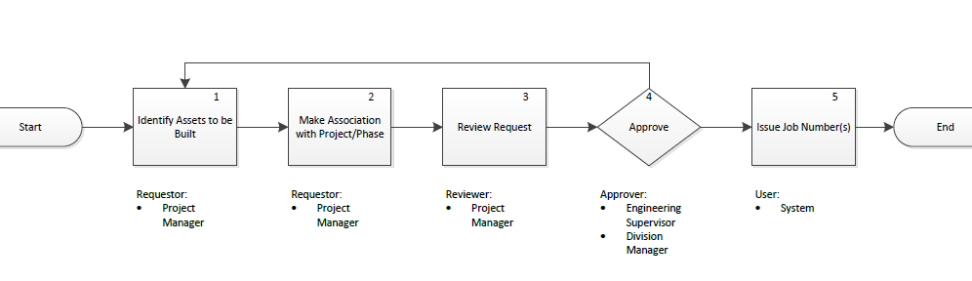
Steps in the Job Number Issuance Workflow
Step 1 – Requestor identifies the asset to be built.
Step 2 – Requestor makes association between project/phase and the asset.
Step 3 – Reviewer reviews the request and provides comments as appropriate.
Step 4 – Approver approves or disapproves the request and provides comments as appropriate.
Step 5 – The system generates a new job number.

Operating Program Creation Workflow
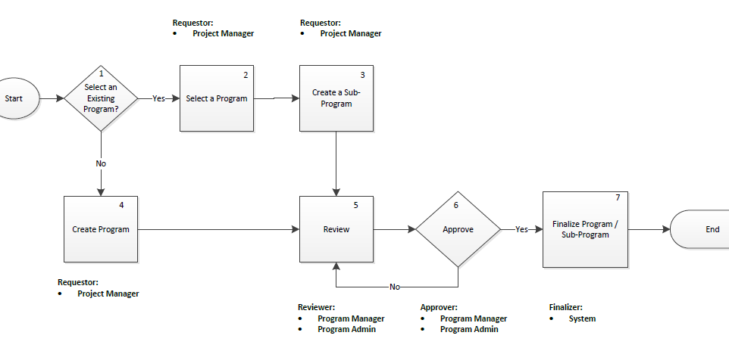
Steps in the Operating Program Creation Workflow
Step 1 – Requestor determines to create a new program or a sub-program.
Step 2 – Requestor determines to create a sub-program by selecting an existing operation program.
Step 3 – Requestor creates a sub-program by providing all required information.
Step 4 – Requestor determines to create a new program and provides all required information.
Step 5 – Reviewer reviews the request and provides comments as necessary
Step 6 – Approver approves the request and provides comments as necessary.
Step 7 – The system saves and finalizes the program or sub-program created so that it can be propagated to existing and/or future EBMUD systems/applications.
Users in Operating Program Creation Workflow
Step 1 - 4: Requestor – Employee with this role determines to create a new program or a sub-program.
Step 5: Reviewer – Employee with this role reviews the programs/sub-programs and provides comments as necessary.
Step 6: Approver – Employee with this role approves or disapproves the program/sub-programs and provides comments as necessary.
Step 7: Finalizer – The system will save and finalize programs/sub-programs.

Glossary

Adopted Budget
A balanced financial plan for a specific period of time authorized by the Board of Directors for expenditure or obligation.
Amended Budget
An adopted balanced financial plan reflecting budgetary transfers that occurred since adoption of the budget. The total budget amount has to stay within the Board approved appropriation limit.
Capital Appropriation
Board approved funding for capital Reference Projects for which relatively accurate time estimates can be made. Unspent appropriations carry forward to the next fiscal year.
Capital Budget
A financial plan for providing the purchase, construction or rehabilitation of fixed assets such as equipment, facilities, and systems.
Cash Flow
Projected cash disbursements for capital projects for a given time period. The estimated capital cash flow is used to determine the amount of revenue required and the rate impacts, or the amount and timing of borrowings to meet the projected expenditure needs for a given time period.
Category
There are three main categories for expenditures which are Labor, Contracts, and Operations.
Department
A major organizational unit with overall managerial responsibility for functional programs of the District.
Division
A major organizational unit of a Department. Most departments have several divisions, each providing different services.
EBMUD
East Bay Municipal Utility District. A publicly owned utility formed in 1923 under the Municipal Utility District Act to provide water service, and in 1944 wastewater service in portions of Alameda and Contra Costa Counties. Also referred to as the District.
Encumbrance
The obligated and unspent portion of a contingent liability established through a purchase order that is chargeable to an account. It ceases to be an encumbrance when paid by the recording of an invoice or reduction of the purchase order outstanding balance.
Expenditure
The payment of an obligation from the District's cash amounts.
Fiscal Year
The 12-month period that begins July 1 and ends June 30 of the following year, also known as budget year.
Fund
A fiscal entity with a set of accounts recording financial resources, together with all related liabilities, which are segregated for the purpose of carrying on specific activities in accordance with special regulations or restrictions. The primary District funds are the Water System General Fund (WSG) and Wastewater General Fund (WWG).
Funded Position
Authorized position means that the Board of Directors has appropriated funding for in a fiscal year.
Hotlist
The Hotlist is a collection of commonly used financial reports that are available to the District employees.
LOE
Level of Effort.
Operating Appropriation
Board approved funding for operating expenses. Unspent appropriations do not rollover to the next fiscal year.
Operating Budget
A financial plan to fund ongoing operations costs incurred to operate the District; excludes the building of capital assets which are included in the capital budget.
Operating Labor
The portion of the District’s labor costs supporting the day-to-day operations.
Organization
A group of staff people organized into one unit or section working under a division or department. This is the lowest level at which operating budgets are developed.
Proposed Budget
The recommended balanced financial plan for a specific period of time submitted for consideration to the Board of Directors prior to the start of the Proposition 218 notification process.
Project Authorization
A formal approval to complete a specified scope of work associated with a child project phase.
Purchase Card (P-Card)
EBMUD issues VISA card with restrictions on Merchant Categories and various dollar limit depend upon the card holder. There are two types of P-Card; Normal P-Card for general purchases and Travel P-Card for all travel related charges.

